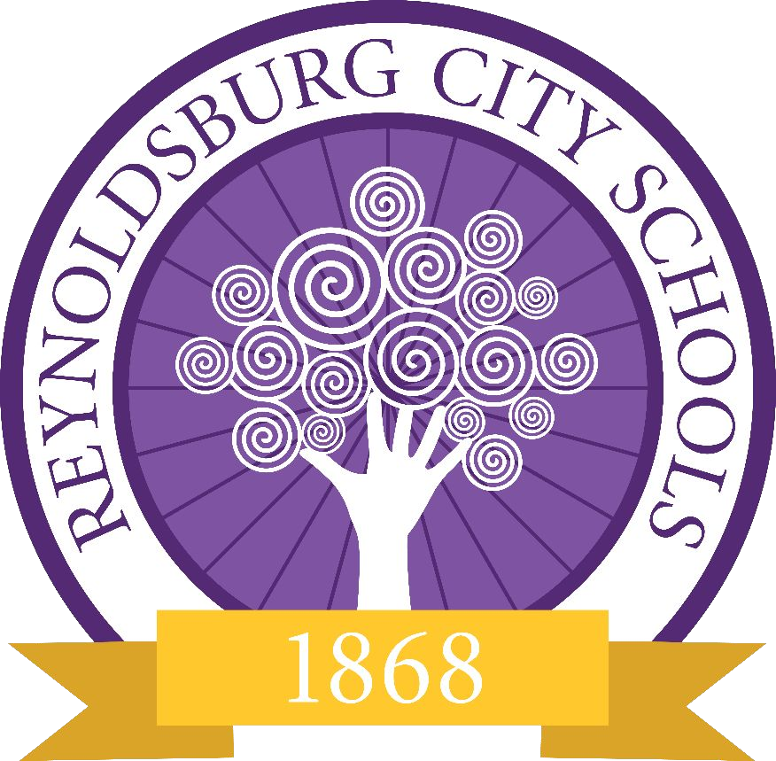

Reynoldsburg City Schools Identifying Student Mental Health

Empowering leaders who impact the NOW and innovate the FUTURE
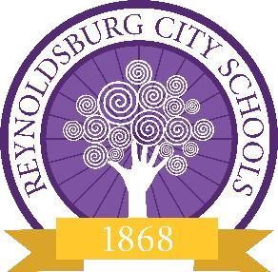
What is mental health?

A person’s condition with regard to their psychological and emotional well being. (Oxford Languages, 2023)

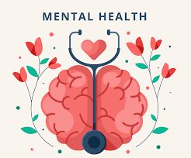
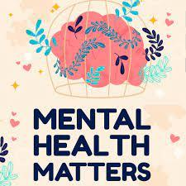
The state of well-being in which the individual realizes their own abilities, can cope with the normal stresses of life, can work productively and fruitfully, and is able to make a contribution to his or her community. (World Health Organization, 2023)
Identifying mental health

• Multi-Tiered Systems of Support (MTSS) • Identify patterns of behavior
• Implementation of interventions based on identified needs • Surveys/Screeners

• Needs assessments

• Culture & climate surveys • Direct referral
• Self referrals

• Parent/guardian referrals • Teacher/staff referrals
Signs and symptoms

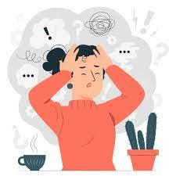
• Changes in behavior

• Disruptive behavior • Destructive behavior
• Acting out physically/verbally • Sleeping in class
• Changes in academic engagement • Skipping class
• Reduced work performance/completion • Changes in attendance/tardiness
Signs and symptoms

• Changes in social engagement or relationships • Self-isolating behavior
• Drastic/sudden changes in social connections/friend groups • Increase in risk taking behavior/high risk behaviors
• Engaging in behaviors that pose a risk to oneself or others. • Self-reported concerns or disclosure of identified changes
• Students share their own personal concerns based on what they notice happening.
• Other students sharing concerns for friends/peers with noticed changes in behavior or engagement.


• Social media/online experiences • Bullying/harassment
Contributing Factors
• Perceptions of expectations or norms


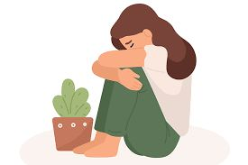
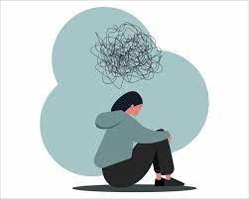
• Online relationships and/or connections • Environmental factors
• Community relationships/engagement

• Lack of support from others in their community • Abuse/neglect
• Loss of housing/limited access to basic needs • Grief/loss
• Severe or long-term stress
Available resources

• School Social Workers

• SRES, WRES, HMES, FRES, RHES, WRJH, SMBR, RHS (both campuses) • School Counselors
• SRES, WRES, TRES, SUES, WRJH, SMBR, RHS (both campuses) • Building partnerships
• Southeast Healthcare prevention services

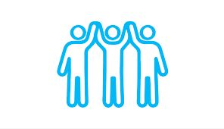
• Nationwide Children’s Hospital school-based behavioral health • The Buckeye Ranch
• The Village Network (SMBR only) • Community providers

Empowering leaders who impact the NOW and innovate the FUTURE

