
ARE YOU STAYING IN ANY OF THESE SETTINGS AT NIGHT

WITH YOUR INFANT OR TODDLER?
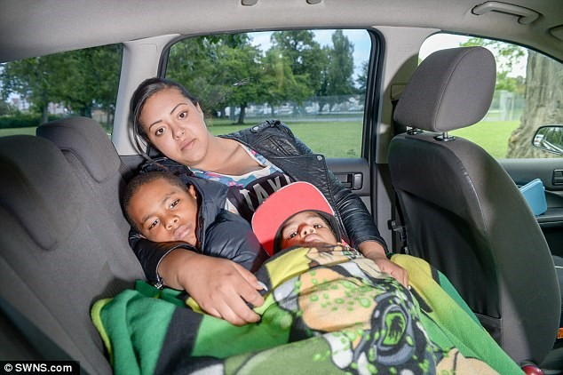
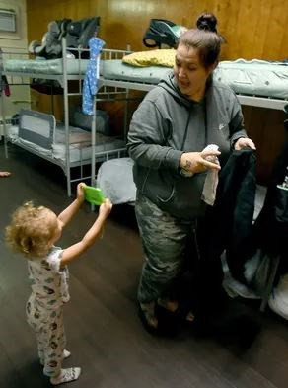
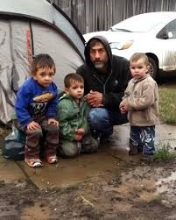

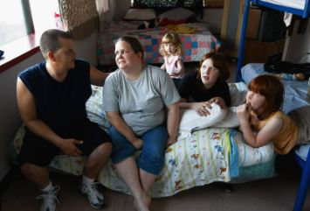
Staying with other people due to loss of housing, economic hardship, or a similar reason (sometimes referred to as
“doubled-up,” or “couch-surfing”)

Staying in motels/hotels due to lack of adequate alternative accommodations, regardless of who pays for the room.

Staying in cars, parks, public spaces, abandoned buildings, substandard housing, bus or train stations, or other similar settings.

Staying in a shelter or
transitional housing, including
domestic violence shelters
or homeless shelters

Ventura County Early Education Partners that can HELP!
Early Start: 805-437-1560
CDR HeadStart: 805.485.7878
Easter Seals: 805.647.1141
Help Me Grow: 805.244.6911
First Five: 805.869.1317
Regional Center: 805.485.3177
VCOE McKinney Vento Liaison: 805.437.1559
Your Local School District
Infants and children who experience homelessness for more than six months
are at a greater risk for developmental delays, poor health outcomes,
hospitalization, and being overweight than children who were
never homeless or homeless for less than six months.

50% of homeless children under the age of four have developmental delays,
a rate which is 3 to 4 times higher than that of children
who do not experience homelessness.

