SUMMARY:
Mu Alpha Theta, the National High School and Two-Year College Mathematics Honor Society, was formed in 1957 at the University of Oklahoma.
We are dedicated to inspiring a keen interest in mathematics, developing strong scholarship in the subject, and promoting the enjoyment of mathematics in high school and two-year college students.
Currently, more than 100,000 students are Mu Alpha Theta members at more than 2,420 schools in the United States and in 23 foreign countries.

[Mu Alpha Theta is] "an organization dedicated to promoting scholarship in mathematics and establishing math as an integral part of high school and junior college education."
Dr. Richard V. Andree, Founder

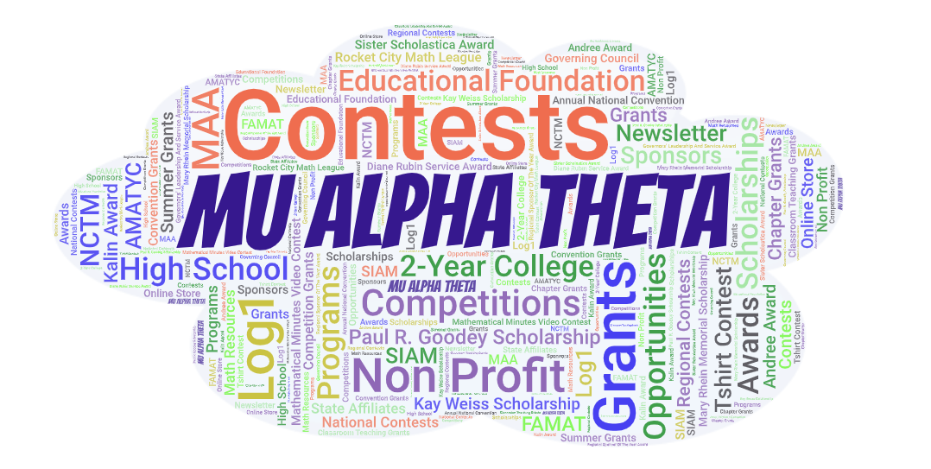

INDUCTION:
At Legend, we are represented by Chapter ID 4340. To be inducted, students must maintain a 3.5 math GPA and have taken or be enrolled in an advanced math course. Once inducted, students will become national members of Mu Alpha Theta.
Students become officially inducted in our Induction Ceremony. They are honored at this ceremony and given their certificate and pin. INDUCTION FEE IS $30. This covers your graduation chord, pin, and national registration fee.

HOW TO APPLY:
Students must fill out the application and turn it in to Mrs. Grzybowski in E206 by the due date. Mu Alpha Theta Membership Application

CORDING: If students are inducted and maintain their membership, they will receive a chord at graduation.

SPONSOR:
Mandi Grzybowski E206

MEETING:
We aim to meet every 1st Monday (when applicable) of each month right after school in E206. Dates can change for our monthly meeting due to activities and events as needed. Once a part of the society, we join a Remind 101, which will also remind members of meeting times.

OFFICERS:
We will vote on officers each year. Positions are President, Vice President, Treasurer, Secretary,

Mu Alpha Theta: https://mualphatheta.org/

