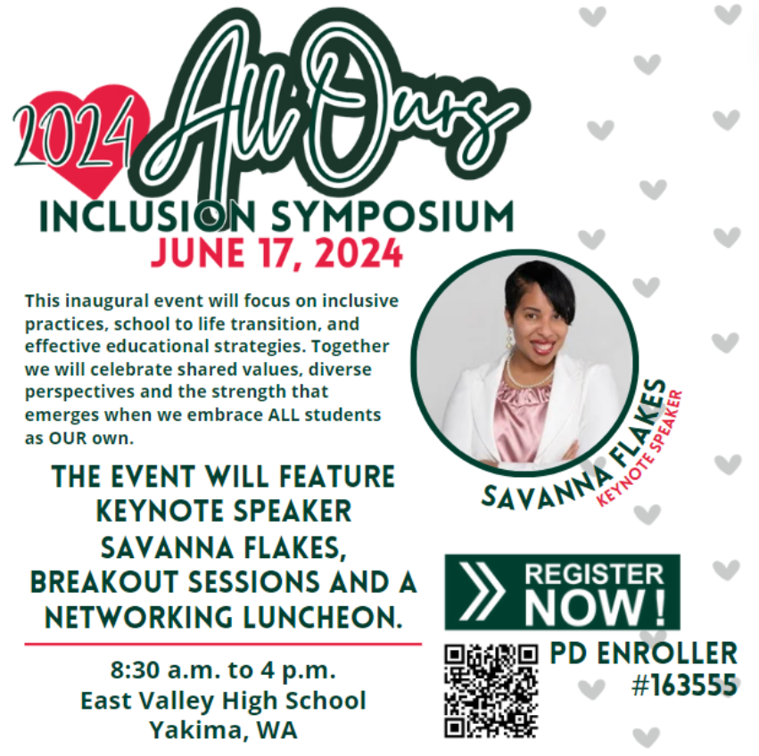

https://www.pdenroller.org/esd105/catalog/event/163555

