STEPS FOR LOGGING INTO GCN TRAINING

From Internet Explorer type in www.gcntraining.com
Click on: Login to View Training



The website will run a Pre-Login Checklist to confirm your computer is has the necessary software to view the tutorials. You should see 4 green checks and a yellow check next to Cache Level. Click on: Login to View Training.
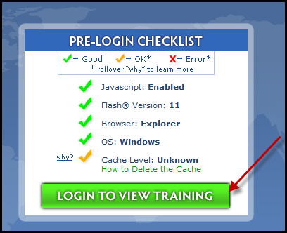

When the next screen comes up click the button next to “New User” then click Next (ANYONE WHO USED THIS IN THE PAST IS AN EXISTING USER AND NEEDS TO CLICK THE FIRST TOGGLE BUTTON. WE DO NOT HAVE YOUR PASSWORDS PLEASE MAKE SURE YOU WRITE THEM DOWN FOR WHEN YOU NEED THEM.
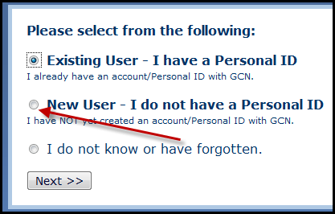

The next screen requires you to enter the ORGANIZATION ID:
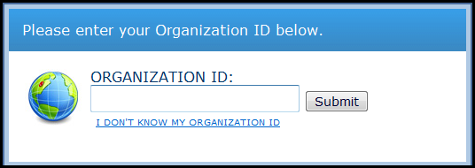
S60021 is our ORGANIZATION ID. You will need to enter this ID # each time you login.
Fill in the required information, your first and last name, email address and then confirm your email address and click Submit.
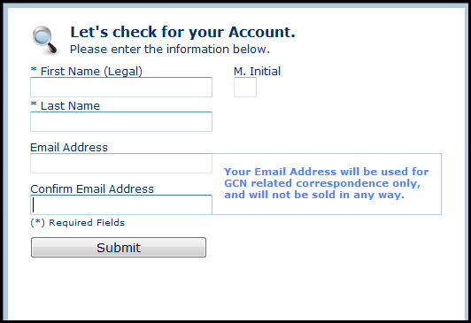

The next screen is where you will select your own Personal ID. You can make it whatever you prefer. You will need to remember this as it will be needed each time you login.
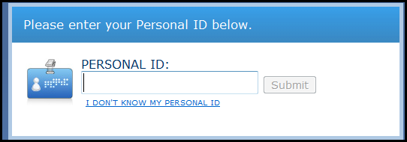
The system will confirm your information. Enter your school building in the field for Department, and click Submit.
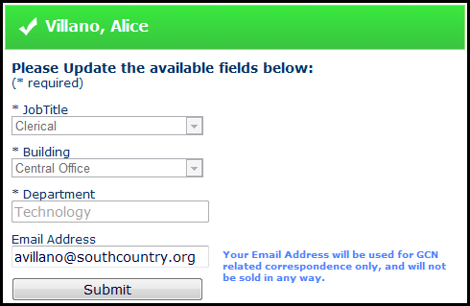

The next screen will show you the Tutorials that you are required to read and the Optional Ones. On the right hand side of the screen you will see a button that you can click to print out your certificates when you are finished with the tutorials.
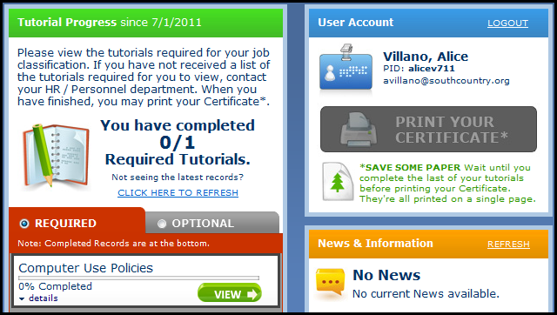
To view the tutorials that are required click the View button under Required and you will be able to begin.
If you wish to view the Optional Tutorials, click the button next to Optional and pick which Tutorial you wish to view.
Make sure that your speakers are on and follow the instructions on the screen to Begin.
When the slide is finished, click Play to go to the next slide. If you need to stop before the tutorial is finished the system allows you to do that. When you resume it will pick up where you stopped.
When you have finished with the tutorial you will be able to print out your certificate to submit to your Supervisor.

