Instructions to pay for Aledo ISD Child Development Center Registration using My School Bucks:
1. Go to https://www.myschoolbucks.com
2. Log in with your existing Aledo ISD account OR sign up for free
• If you do not have an account, you will need to connect yourself with Aledo ISD
• Select Get Started, Add District, select Texas, select Aledo ISD, answer security questions
3. Click on “School Store” at the top of the page
4. Select “featured items”
5. Find Aledo ISD Employee CDC Registration – click “View Details”
6. Fill out the form, then click Buy Now OR Add to Cart to complete the payment
7. Cost is $79.04 per family – only pay once, even if you have multiple kids enrolled

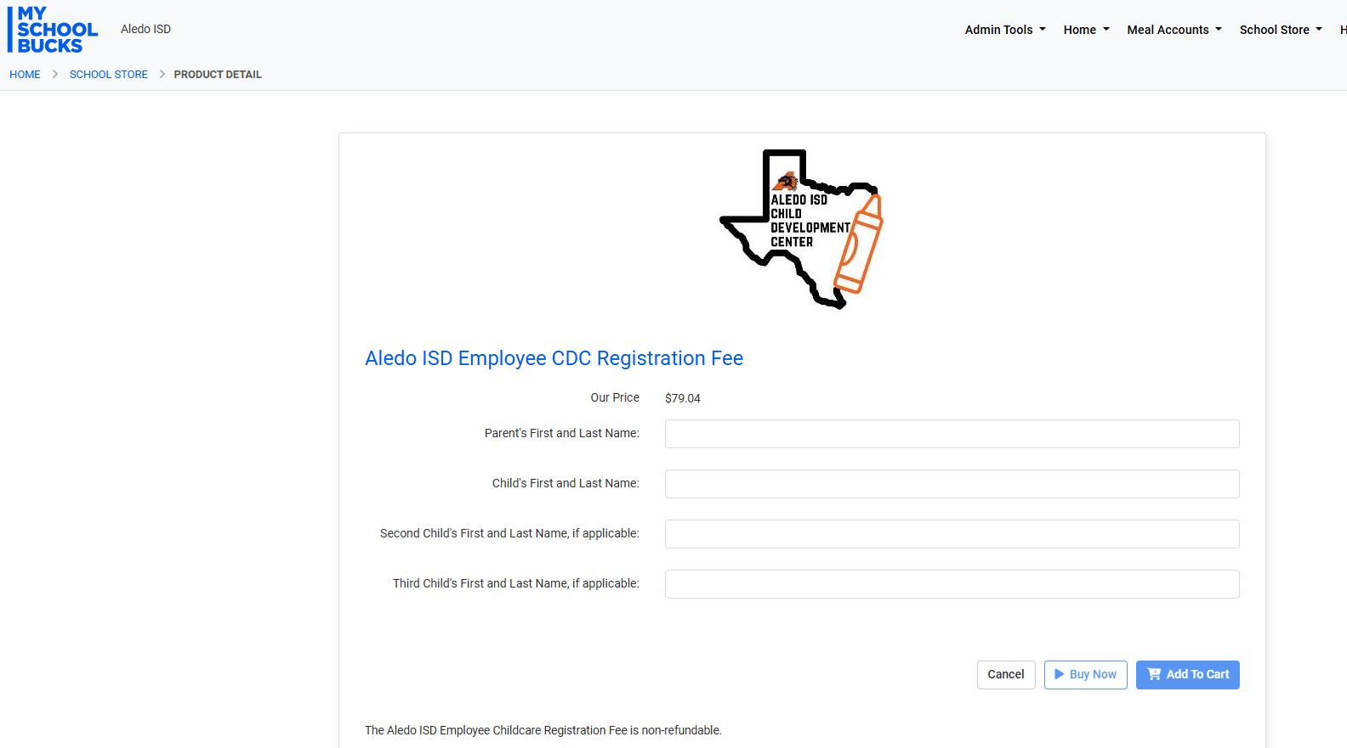

You may also pay by check or money order. Payable to Aledo ISD ($75 per family). Checks should be given directly to Becky or Melinda.

Thanks!

