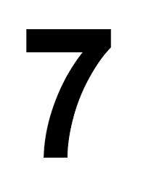
North Lake Middle School
7th Grade Registration
2025-2026 Class of 2031

_______________________________________________________________
Student Name (please print first and last)

Welcome to North Lake Middle School! Please read the course descriptions for details. If you have any questions contact the counseling center at 425-335-1640 or the 7th grade Counselor, Leanne Koenigs at leanne_koenigs@lkstevens.wednet.edu

NOTE: All 7th grade students will take a full year of core classes, which include Language Arts, Social Studies, Math, Science, and Wellness.

1. All students take a Language Arts class. Please select one.

□ Language Arts 7
□ Challenge Language Arts 7 (Prerequisite: See Course Description)

2. Students will take one full year elective class. Please select one.

□ Beginning Band
□ Intermediate Band (Prerequisite: See Course Description)
□ Choir
□ Design and Modeling / Computer Science for Innovators and Makers
(1 semester) (1 semester)

*Leadership & Teachers Assistant/Office Assistant (TA’s) class is by selection only. See course description for further information. Application will be available in May.

3. All students take a Math class. Math placement is determined based on successful completion of their 6th grade math course.

___________________________________ _____________________________________

Parent/Guardian Signature Student Signature

