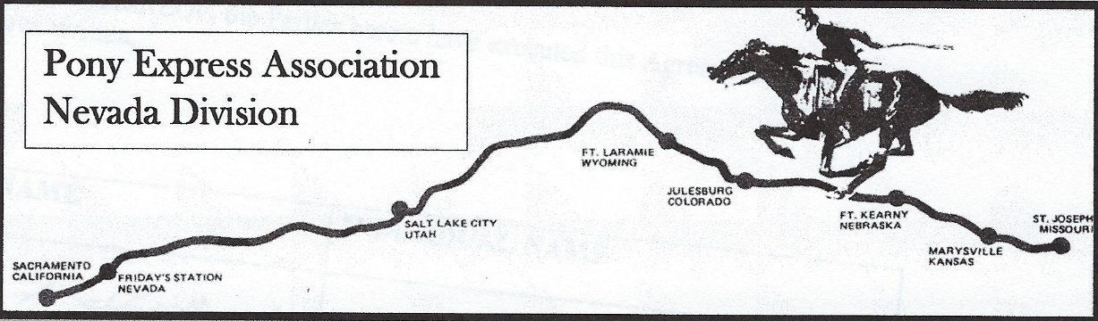

PONY EXPRESS SCHOLARSHIP RULES
Year 2025
The Pony Express Members of the state of Nevada have established a Pony Express Scholarship contest in the amount of $1,000.00. This scholarship will be awarded to the top entry received by the Past Presidents Committee.
- A. The contest is open to those seniors who will graduate at the end of his/her current senior year and plan on a career in Medical or Forestry programs. Also is a resident of Douglas, Carson, Lyon, Churchill, Landers, Eureka, or White Pine Counties.
- Any senior who is a member of good standing or is the child of a parent that is in good standing of the Nevada Division of the National Pony Express Association is automatically eligible to participate regardless of County of residence.
- The completed application package must be returned to your Scholarship Counselor by April 1, 2024, and to this scholarship committee by April 15, 2025. The scholarship must be used to attend any accredited two (2) year college, university, four (4) year college vocational or trade school.
- Remember to include a copy of your high school transcript and as many references as you might provide.
- The Scholarship Committee has the last word on each applicant’s qualification.
Good luck to all applicants.

David Kittle, Past President
1020 Winchester Rd.
Fallon, NV 89406

