

Alabama State Department of Education
Educator Certification Section



This document is intended to provide basic information and will be updated as needed.
Creating an AIM account

- Visit https://aim.alsde.edu.

- Select ‘Need an account.’
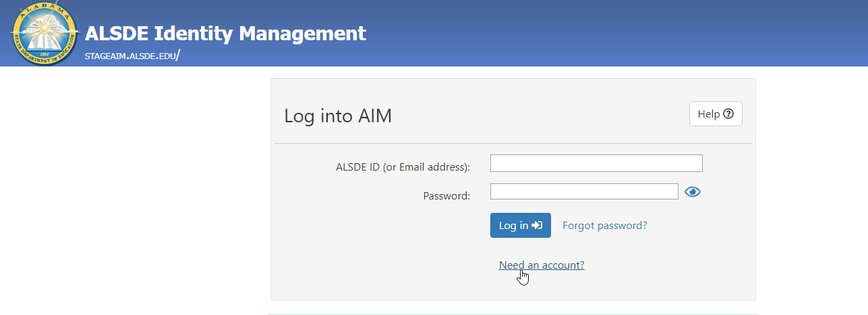

- Enter your email address and select ‘Create Account.’
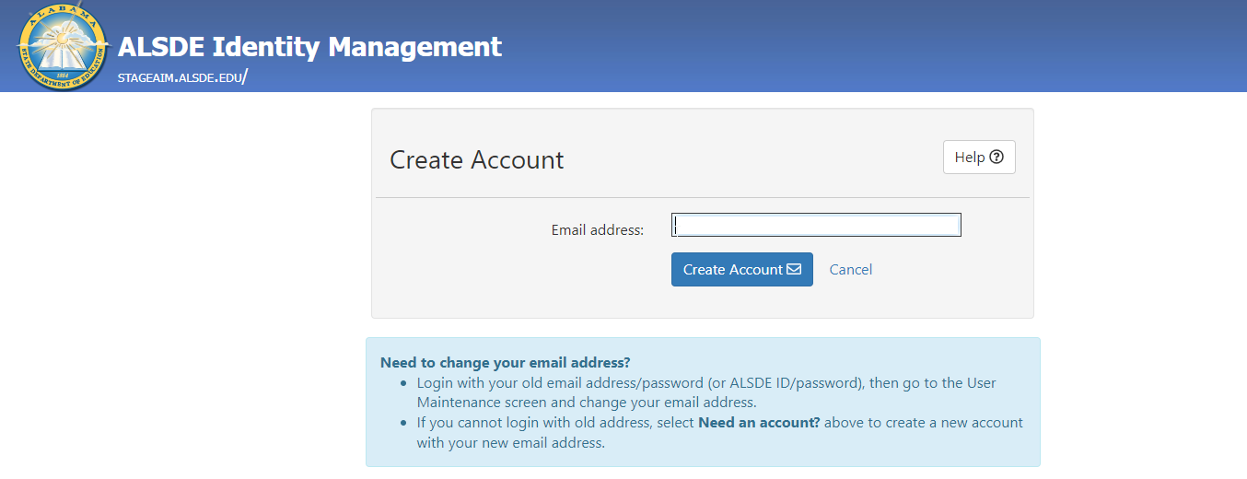

- AIM will send an email to the address provided; go to your email and click the link.
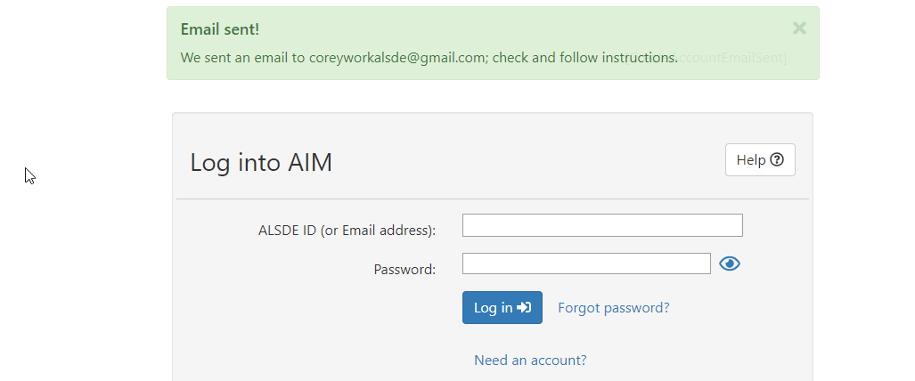

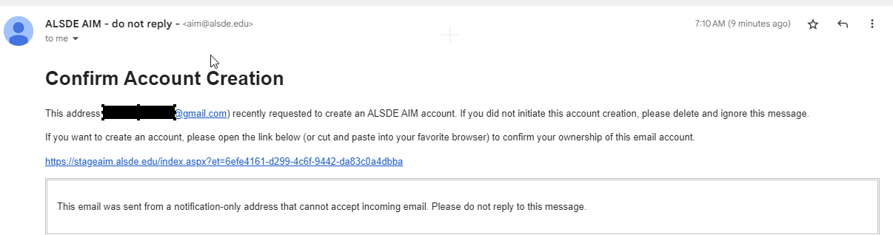

- Provide required details in the Create Account page and select ‘Create Account.’ Note: Be sure to follow password requirements.
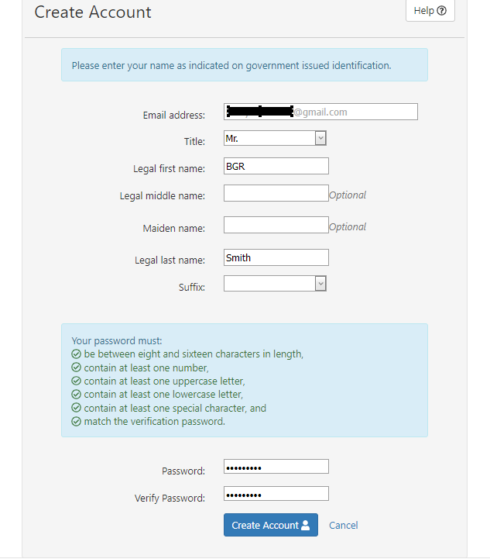

- Select security questions and answers and select ‘Save answers.’
Note: Remember your answers. They will be needed if you ever need to recover your account.

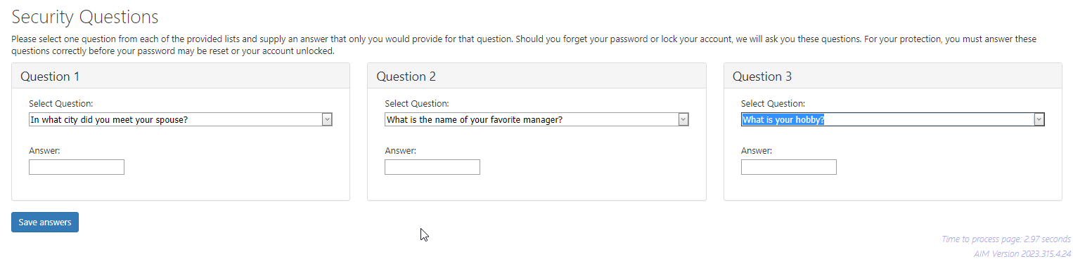

- Acknowledge restrictions, agree to the terms of usage, and select ‘Yes, continue.’
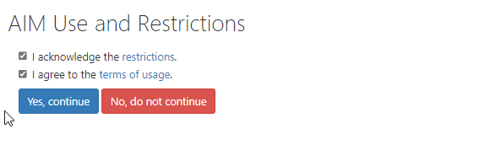

- Enter information on Demographics page and select ‘Save demographics.’
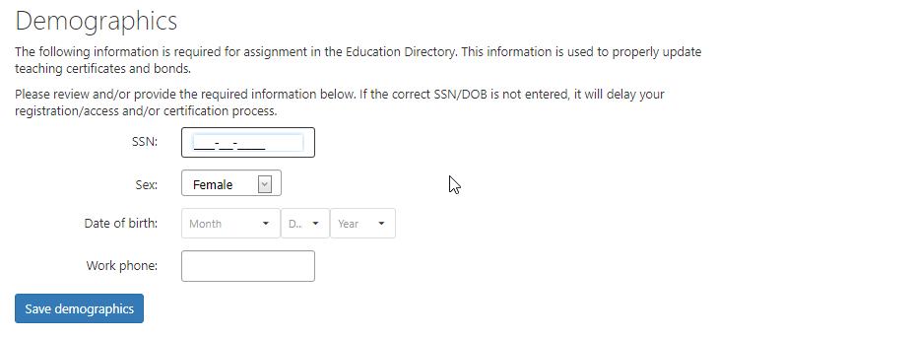

- When AIM registration is complete the applicant will be taken to their home page. Select ‘Fieldprint Background Check’ to start registration for a background check. Note: Be sure to make note of your ALSDE ID#. This will be needed to complete registration with Fieldprint.
