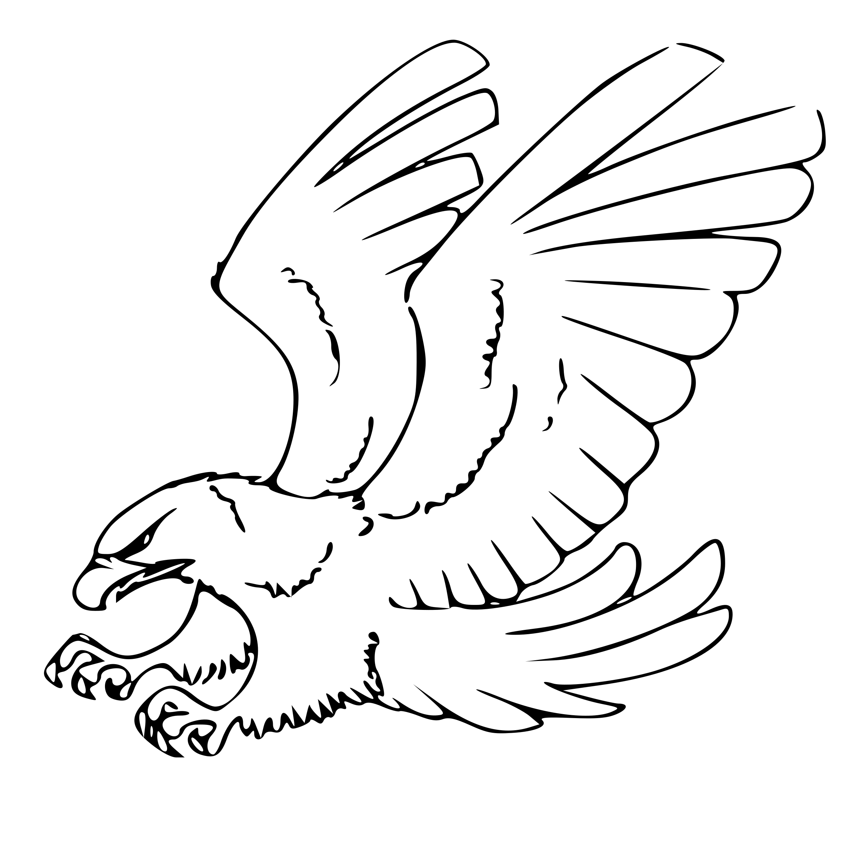

Rock Ridge PTO
400 Heritage Ave, Castle Rock, CO 80104

Rock Ridge PTO Meeting Minutes
Tuesday, January 11, 2022
Meeting held via Zoom
1. Welcome - Allison
- Peter unable to attend
- No grant requests
2. December Minutes Approval - Ashley
Ashley presents the minutes. Lydia motions, 2nd Matt. All for, none against.
3. School Report - Mr. Mosby
- See 1a
4. Treasurer Report - Sarah
Rock Ridge PTO Treasurer Report
Income and expenses and current balance.
INCOME AND EXPENSE REPORT
Balance as of 10/13/2021 27,341.34
Income
11/16/2021 Spirit Wear 35.00
12/4/2021 Corporate Match - Run 128.56
Expenses
11/18/2021 Hot Cocoa Party - Allison (78.88)
11/21/2021 Pie Party (66.09)
11/29/2021 Taylor Connell - gift cards (750.00)
12/6/2021 Allison Uselton - Cocoa party supplies (26.11)
Ending Balance 26,583.82

5. Grant Request - Sarah
- See 1b
- We have $4500 in grant money left this year
  - There is a “community” line item in the budget
  - Ideas for community project
    - Playground equipment
    - Paint the teacher’s lounge, which is currently an awful poop-brown.
6. Mid-Year Budget Review- Allison/Sarah

Rock Ridge PTO Budget
 |  | Proposed Budget | Additional Budget Items | Actual | Actual | Actual
 |  | 2021-2022 |  | January 2022 | April 2022 | EOY 2022
Admin |  | $200.00 |  | $126.33 |  | $126.33
Event Decor |  | $100.00 |  |  |  | $0.00
Photo Booth |  | $100.00 |  |  |  | $0.00
Meet and Greet |  | $100.00 |  |  |  | $0.00
Welcome Back Staff Appreciation |  | $400.00 |  | $246.81 |  | $246.81
Welcome Back to School BBQ |  | $2,000.00 |  | $1,164.40 |  | $1,164.40
Welcome Committee & BooHoo Breakfast |  | $300.00 |  | $334.00 |  | $334.00
Rock Ridge Run |  | $8,000.00 |  | $6,609.76 |  | $6,609.76
Halloween Event (Monster Mash/Pmpkn contest) |  | $400.00 |  | $75.00 |  | $75.00
Thanksgiving Meal Donation |  | $200.00 |  | $0.00 |  | $0.00
Kringle Week |  | $1,200.00 |  | $1,390.70 |  | $1,390.70
Staff Holiday Party |  | $400.00 |  | $400.00 |  | $400.00
Winter Party Hot Chocolate Bar |  | $150.00 |  | $104.99 |  | $104.99
Conferences (spring/fall) |  | $500.00 |  | $295.68 |  | $295.68
Staff Valentine's Appreciation |  | $50.00 |  |  |  | $0.00
Silent Auction |  | $200.00 |  |  |  | $0.00
Chili Cook Off |  | $300.00 |  |  |  | $0.00
Ice Cream Social |  | $200.00 |  |  |  | $0.00
Teacher Appreciation Week |  | $2,000.00 |  |  |  | $0.00
Book Swap |  | $100.00 |  |  |  | $0.00
Paint Night |  | $300.00 |  |  |  | $0.00
Meeting Expenses |  | $800.00 |  | $128.52 |  | $128.52
Spirit Wear |  | $4,000.00 |  | $3,468.29 |  | $3,468.29
Credit Card Fees |  | $100.00 |  | $28.36 |  | $28.36
Misc Grant Requests |  | $7,000.00 |  | $2,274.25 |  | $2,274.25
Community Project |  | $200.00 |  |  |  | $0.00
Teacher classroom fund* |  | $2,850.00 |  | $2,550.00 |  | $2,550.00
Rock Ridge Run Promise to RRE |  | $12,000.00 |  | $15,838.96 |  | $15,838.96
 |  |  |  |  |  | $0.00
Foundation Assessment |  | $600.00 |  | $522.00 |  | $522.00
Thanksgiving Pie party |  | $75.00 |  | $69.03 |  | 69.03
 | Totals | $44,825.00 | $0.00 | $35,627.08 | $0.00 | $35,627.08
*Next year add a note to the budget that Fun Run proceeds are split evenly with the school
7. Kringle Week Review - Allison
- Good feedback - Baked potatoes big hit.
  - Next year more topping for the potatoes; we ran low this year
  - We wrapped 70 gifts for 8 staff members
- Next year there are only 3 days of school the week before Christmas break.
8. Paint Night - Allison
- Ms. Gonzales is doing it
  - Available for all ages
  - January 26th 6-7pm
  - $10 per person - covers all materials
  - Taylor calling HomeDepot to see if they will donate kids building kits as an added gift to those who participate.
9. Staff Valentines - Allison
- $50 Budget
  - Possible Ideas
    - Candy bar in teacher’s lounge
    - Flowers/plants/ small gifts
    - Popcorn with toppings in teacher’s lounge.
      - Have popcorn machine in shed
  - Final decision: Popcorn
10. Silent Auction - Allison
- Not sure on Silent Auction
  - Going to send blind survey to staff to get their input
  - Probably will not be able to have chili cookoff due to ongoing Covid concerns
11. Announcements - Allison
- Ice Cream Social in March
  - Maybe something like an individual cup of vanilla ice cream and a root beer to go.
  - If still being allowed in the school
- Did receive spirit wear order
  - Gabe is getting website up-to-date
- Taylor working on Spirit Nights

