Q. In this proposed budget where is the Pre-K Revenue? Last year in excess of $1 million dollars. Are the Pre-K expenses in the budget?
A. We list the Pre-K revenue and expenses in the first budget amendment, usually in September of the fiscal year the budget was written for.

Q. How many of the 44 teachers ($1,729,421.00) are pre-school? No revenue listed.
A. Zero

Q. How do our supplements compare to other school districts in the region?
A. We conducted a survey and we are in the middle of the pack for our region.
Q. There is a large amount of travel in the proposed budget; please explain the rationale behind these amounts
A. It is crucial that that the directors/coordinators are in the schools where the actual learning is taking place. Without county vehicles, these employees need to be reimbursed for their travel. Examples from the proposed budget:
- Assistant Superintendent of Curriculum and Instruction
$5,000.00 (average of 2-3 trips a day--mileage is reimbursed at the state rate)
- Department of Curriculum and Instruction Staff
$7,500.00 (mileage is also reimbursed at the state rate)
Multiple Staff members travel on a reimbursement basis – both in the county and out of the county.
- Administrative Services
$5,000.00 (average of 2-3 trips a day—mileage reimbursed at the state rate)

Q. Please explain the various supplies and materials line items.
A. Auxiliary Services - $3000/ Finance $1,500/ Human resources $2,000/ Testing $9,000/ Board of Education $2,500. Each department has it’s owns needs. Finance has to purchase W-2/1099 stock and other items. Whereas testing pays for the high school to administer the PSAT out of its department budget. Basically supplies and materials are department specific items needed to conduct the day to day operations of the school system within the respective departments.
Q. What does the Director of testing do?
A. The testing department facilitates all tests throughout the district. This person works with the curriculum and instruction department and the schools to administer all tests. This person is in charge of that department and for presentation of results to internal and external stakeholders.
Q. What is the function of the line items listed for the board of education?
A. In Service Work Shops $12,000.00
Any workshops the BOE is required to attend. They have CEU requirements throughout the year.
Board & Travel and per diem $6,000.00
Out of county travel reimbursements given to the BOE for official school business at various locations.
Membership dues & fees $14,500.00
The BOE are members of various organizations, one being NCSBA. The above amount reflects the dues paid to the organization on behalf of the Board.
Food Purchases/meeting $2,000.00
Any food purchases for monthly/special/called committee meetings.
More supplies & materials $2,500.00
Any supplies needed for the board to conduct their business.

Q. What does the Energy Technician do?
A. This person monitors the energy use in the county and works with the heavy equipment to make sure that it is operating with the highest efficiency possible.

Q. Please explain the supplements for the Principals and Assistant Principals.

A. Supplements - Principals (15) $100,000.00
We pay principals a % of their salary as a supplement for working after hours and/or weekends.
$150,000.00 also listed in employee benefits
We pay for their benefits, used as a recruiting tool.

Supplements - Asst. Principals (14) $43,000.00
We pay APs a % of their salary as a supplement for working after hours and/or weekends.
Also listed in employee benefits
That is their longevity

Q. What is the travel listed for the Principals Office?
A. Any travel for principals/assistant principals/bookkeepers at the request of the central office.

Q. There are various positions listed; Nurses/Social Workers/Media Specialists listed. Is the state not paying for or cutting these positions?
A. The budget has dropped at the state level, therefore to keep these positions when need to pay for them locally. The state has not cut any of these positions per se, they have just cut some of our funding for these positions.
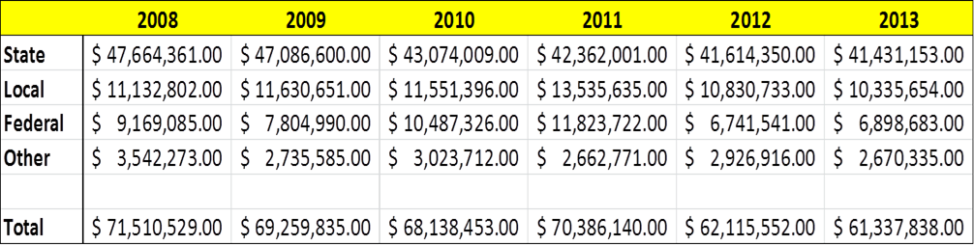

Q. Please explain the supplements and longevity pay listed in the employee benefits section.
A. Benefit Supplements - Principals $150,000.00
How many?
All
$100,000.00 also listed in School Leadership.
We pay principals a % of their salary as a supplement.
Longevity - Principals - AP's $22,000.00
Also listed in School Leadership
This is for their longevity.
Benefits Supplements-Admin. $33,000.00
Who does this cover?
Superintendent/As. Superintendents/CFO/other directors
Longevity Pay - Supporting $15,000.00
Who does this cover?
Maintenance, non-instructional, and transportation staff paid out of local.

Q. Please explain the large dollar amounts in the maintenance budget
A. Operation of Plant:
Utilities Increased
Every year due to inflation the cost of energy increases, therefore we need to budget for such increases.
Maintenance:
Contracted Services $175,000.00
What does this cover?
Annual contracts such as Fire Alarm, Pest Control, HVAC Equipment (Chillers, Cooling Towers etc) Filter Service.
Contracted Repair Maintenance $198,500.00
What does this cover?
80K is for our grounds maintenance and the other 118.5K we transfer to 2.6540.802.325 (the account that has 197,000 in it initially) for projects that pop up for safety or necessity reasons.
Top 10 repairs for FY 14-15 (out of this budget)
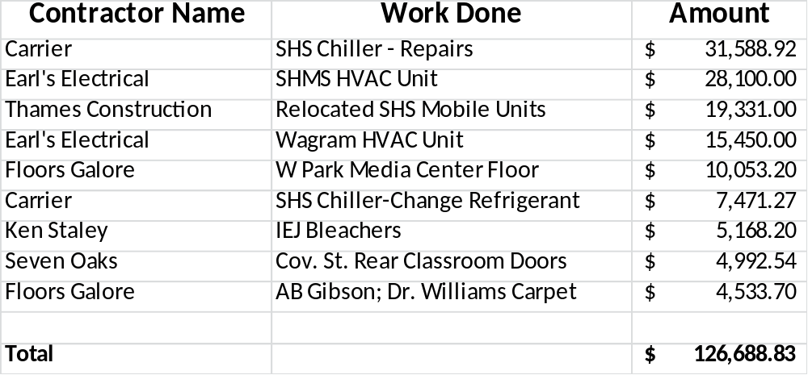
Repair Parts and Materials $320,832.00
All parts and materials ordered by the maintenance department for work by technicians
Also has painting in capital budget.
The painting is in different lines because the capital is routine upkeep whereas the painting in the local budget is for unforeseen circumstances, For example, we had a small fire at a middle school last year and needed to re-paint that room immediately.
What is the breakdown for this?
No breakdown because it is not predictable.
There is also &197,000.00 listed as contracted repairs maintenance
What is this?
Projects throughout the year requested by principals. We contract such services out when they arise

Q. Please give a list of the High School and Middle School coaching supplements and what positions they go to.
A. Coaching Supplements $149,250.00
Who are the coaches covered by this?
All high school coaches
Amount for each.
Sport |  | Amount
Athletic Director |  | $7,700
Assistant |  | $2,600
Baseball (Spring)
Varsity Head |  | $3,000
Assistant #1 |  | $1,300
Assistant #2 |  | $1,300
JV Head |  | $1,300
JV Assistant |  | $1,100
9th Head |  | $850
Basketball (Winter)
Varsity Boys Head |  | $3,000
Assistant |  | $1,300
JV Head |  | $1,300
9th Head |  | $850
Varsity Girls Head |  | $3,000
Assistant |  | $1,300
JV Head |  | $1,300
9th Head |  | $850
Cross Country (Fall)
Boys |  | $1,300
Distance Boy and Girls |  | $1,300
Cheerleading
Varsity Fall |  | $1,100
Varsity Winter |  | $1,100
JV Fall |  | $800
JV Winter |  | $800
9th Fall |  | $700
9th Winter |  | $700
Sport |  | Amount
Football (Fall)
Varsity Head |  | $8,000
Varsity Defense Coordinator |  | $2,500
Varsity Offense Coordinator |  | $2,500
Assistant - Level 1 |  | $2,000
Assistant - Level 1 |  | $2,000
Assistant - Level 1 |  | $2,000
Assistant - Level 1 |  | $2,000
Assistant - Level 2 |  | $1,800
Assistant - Level 2 |  | $1,800
Assistant - Level 2 |  | $1,800
Assistant - Level 2 |  | $1,800
Assistant - Level 3 |  | $1,400
Assistant - Level 4 |  | $1,200
Assistant - Level 5 |  | $1,100
Assistant - Level 5 |  | $1,100
Assistant - Level 5 |  | $1,100
Assistant - Level 6 |  | $900
Assistant - Level 7 |  | $200
Golf
Boys (Spring) |  | $1,300
Girls (Fall) |  | $1,300
Soccer
Varsity Boys (Fall) |  | $2,400
Assistant |  | $1,300
JV Head |  | $1,000
Varsity Girls (Spring) |  | $2,400
Assistant |  | $1,300
JV Head |  | $1,000
Sport |  | Amount
Softball (Spring)
Varsity Head |  | $3,000
Assistant |  | $1,300
Assistant |  | $1,100
JV Head |  | $1,300
JV Assistant |  | $850
Tennis
Boys (Spring) |  | $650
Boys (Spring) |  | $650
Girls (Fall) |  | $1,300
Track (Spring)
Boys |  | $1,800
Assistant |  | $1,000
Girls |  | $1,800
Assistant |  | $1,000
Trainer
Fall Head |  | $2,500
Assistant |  | $1,500
Winter Head |  | $2,000
Assistant |  | $2,000
Spring Head |  | $2,500
Assistant |  | $1,500
Summer # 1 |  | $1,500
Summer # 2 |  | $1,500
Volleyball (Fall)
Varsity Head |  | $2,900
Assistant |  | $1,300
JV Head |  | $1,000
9th Head |  | $750
Wrestling (Winter)
Varsity Head |  | $1,800
Assistant |  | $1,000
Weight Lifting
School Year |  | $800
Summer # 1 |  | $2,500
Summer # 2 |  | $1,250
 |  | $1,250

Start-up funds $10,000.00
Non-recurring cut
Will this amount increase next year?
Unknown at this time. Depends on gate receipts for all sports.

Middle School Athletics:
Coaching Supplements $31,350.00
Name and amount for each coach

Sycamore Lane
Sport |  | Amount
Athletic Director |  | $700
Baseball (Spring)
Head |  | $850
Basketball (Winter)
Boys |  | $850
Girls |  | $850
Cheerleading
Fall |  | $550
Winter |  | $550
Football (Fall)
Head Coach |  | $1,100
Assistant # 1 |  | $900
Assistant # 2 |  | $700
Soccer (Spring)
Boys |  | $850
Girls |  | $850
Softball (Spring)
Head |  | $850
Volleyball (Fall)
Head |  | $850

Carver
Sport |  | Amount
Athletic Director |  | $700
Baseball (Spring)
Head |  | $850
Basketball (Winter)
Boys |  | $850
Girls |  | $850
Cheerleading
Fall |  | $550
Winter |  | $550
Football (Fall)
Head Coach |  | $1,100
Assistant # 1 |  | $900
Assistant # 2 |  | $700
Soccer (Spring)
Boys |  | $850
Girls |  | $850
Softball (Spring)
Head |  | $850
Volleyball (Fall)
Head |  | $850

Spring Hill
Sport | Name | Amount
Athletic Director |  | $700
Baseball Spring)
Head |  | $850
Basketball (Winter)
Boys |  | $850
Girls |  | $850
Cheerleading
Fall |  | $550
Winter |  | $550
Football (Fall)
Head Coach |  | $1,100
Assistant # 1 |  | $900
Assistant # 2 |  | $700
Soccer (Spring)
Boys |  | $850
Girls |  | $850
Softball (Spring)
Head |  | $425
Head |  | $425
Volleyball (Fall)
Head |  | $850

Start-up Funds $21,000.00
$7,000 per school
There is $10,000.00 at start-up funds in High School Athletics. What does Start-Up Funds cover?
Varies year to year. There are schedules that require certain equipment to be replaced every year and at the school level, they follow those schedules.

