Searching Destiny Discover, our District Library Catalog:

Clever > Research/eBooks > Destiny > Login > Eau Claire Area School District

Start your search in Clever, under the Research/eBooks category. You will see the district link to Destiny Discover.
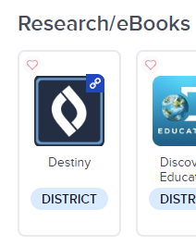
In Destiny, choose the Login option in your top bar.
Do NOT log in with any credentials. Instead choose the blue button that says ECASD.

You will be logged in through Clever and you will see your name appear in the top right.

You can now search for books in our library. Books with the “IN” symbol are available in the library.
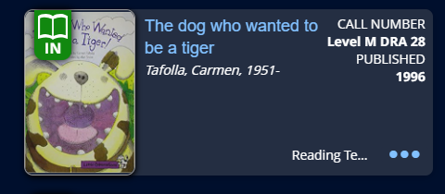

Books with the “Out” Symbol are currently checked out.

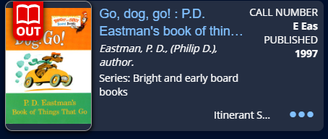

You will likely want to search ALL our district libraries or by level (lower, middle, high school) to locate a given book. First, enter the Title, Author or Topic.


Then, to adjust the filters click this symbol:



The screen below will appear.

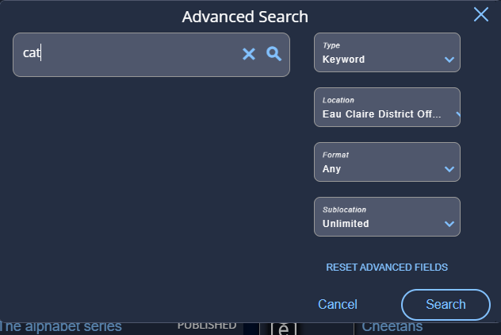

You will likely want to select Eau Claire Area School District Libraries in order to search all schools.
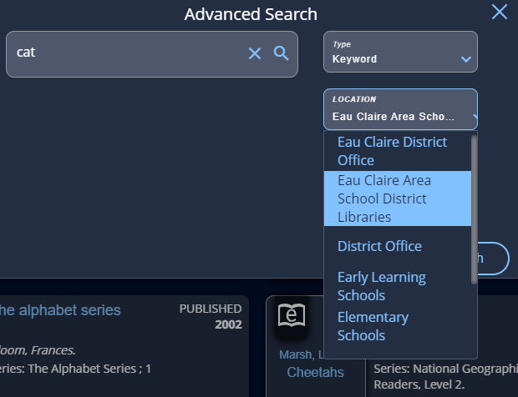

To request a book, please click on the title. There will be a box labelled “Hold.” Please click on this box.

. 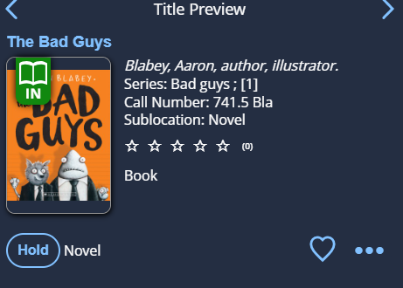

The book will be sent through Interlibrary Loan and delivered to you.

If you have any questions about searching for books, please contact cakervik@ecasd.us.

