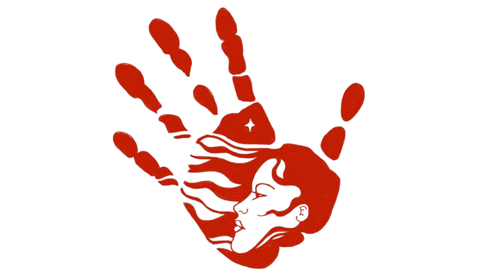

“Missing and murdered indigenous women (MMIW) have disappeared not once, but three times. In life, in the media, and in the data.” – Missing and Murdered Native American Women Report, Washington State Patrol.

Sunday, May 5th is Missing & Murdered Indigenous Women’s (MMIW) Day.

MMIW is an epidemic in the United States and Canada:

Data shows:
- Native American women are 10-times more likely to be killed than any other race

- Homicide is the 3rd leading cause of death among Native women between the age of 10-24

- In 2016 there were 5,712 reports of missing American Indian/Alaska Native women but only 116 cases were in the federal Department of Justice database

- Washington state is the second highest in the nation for MMIW cases with Seattle #1 in the nation and Tacoma 7th in the nation

Families of victims, tribal communities, and tribal leaders have significantly raised awareness on the issue over the past several years and have gained the attention of federal, state, and local governments and law enforcement agencies to work to end this epidemic.

To raise awareness some of our Native American students in our school today are wearing MMIW shirts (which includes the symbol of a red handprint over the mouth) or red and black clothing.

