

Setting Up Your GVSD ClassLink Parent Portal Account
1. Using a web browser, navigate to: https://parents.classlink.com/greatvalley
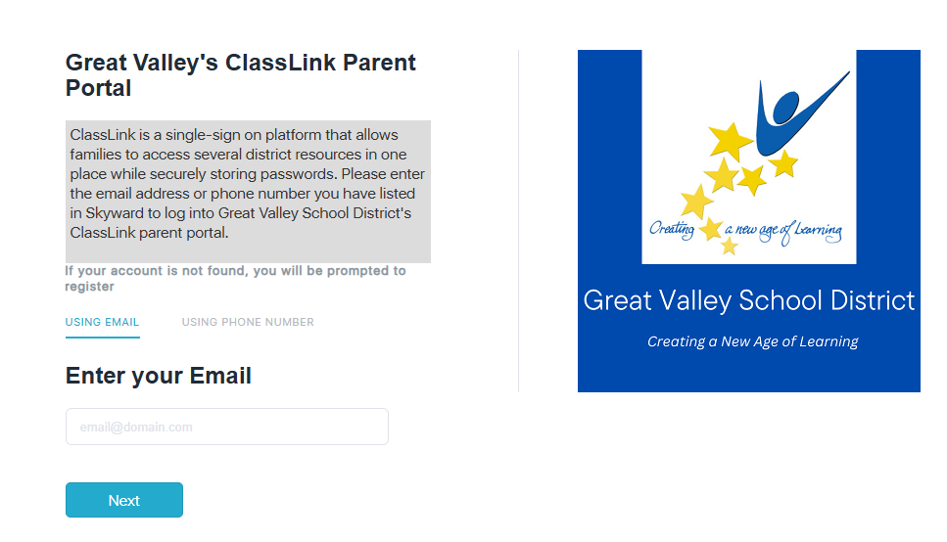
2. Please enter your email address or phone number you have on record in Skyward and click Next.
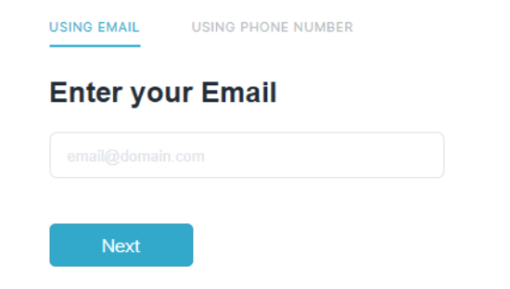

3. If the email you entered is the one on file in Skyward, you will be asked to verify your email address. Enter the one – time password sent to that email address.
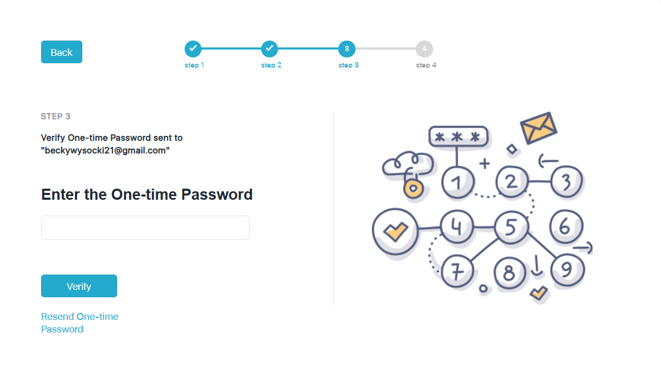
If you are redirected and see an error message it could mean a few things:
a. The email you input is not the one attached to your household in Skyward. You will need to reach out to your child’s school about the email on file.
4. Once you have entered your email and password one time successfully, you will be asked to provide your full name and create your own secure password. 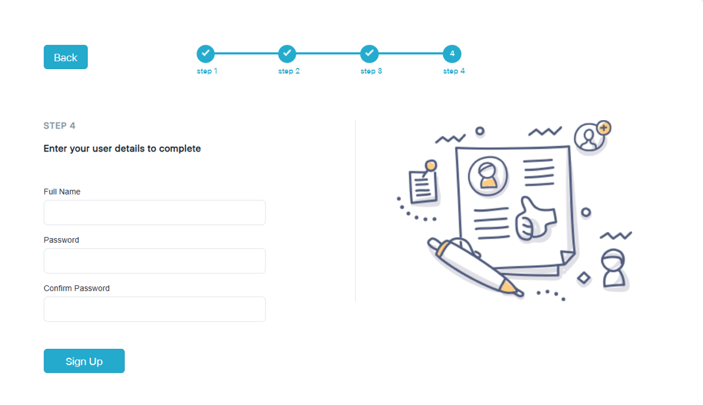

5. Your launchpad in ClassLink is now ready to use! You will now see apps you can use to access various resources as a parent.
6. The first time you access an application from the launch pad, you will be prompted to enter your login credentials for that particular app / website. Please note that your login for Payschools, Skyward, etc. may be different than the one you just created for ClassLink.
In the example image below, when you attempt to access Skyward Family you will need to enter your parent username and password for Skyward Family. Once you click this task for the first time, ClassLink will save these credentials for you and will log you in automatically on future visits to the application through your ClassLink launch pad.
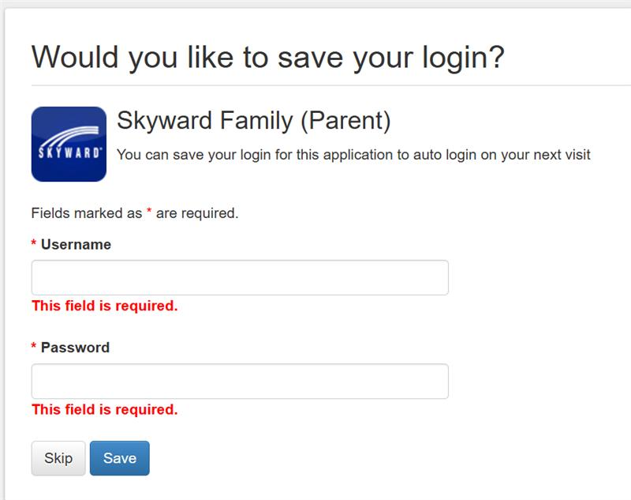

7. Moving forward, you will be able to access the ClassLink Parent Portal from a web browser or the ClassLink mobile app.
Accessing the ClassLink Parent Portal Moving Forward
COMPUTER    - Go to https://parents.classlink.com/greatvalley from a browser.  - Use your Skyward email address or phone number to set up your account.  - A message will prompt you to install a ClassLink browser extension after accessing your first application. | MOBILE    - Download the ClassLink app.  - Search for Great Valley School District. You only need to do this the first time.  - Enter your login credentials and sign in.

