

6th Grade
Tier 2 Intervention Lessons

Readiness Standard 4 - 5.NF.1

Learning Target: I will add and subtract mixed numbers with different denominators

Readiness for 6.EE.7: Solve 1-step equations

Table of Contents_____________________________________

Session 1: Planning Guide ………………………………………………………………………………………………………… p. 4

Session 1: Re-engagement Lesson Resources ………………………..……………………………………………. p. 5-13

Sessions 2 through 8: Planning Guide ……………………………………………………………………………………… p.14

Sessions 2 through 8: Lesson Resources ……………………………………………………………………………. p. 15-56

Independent Practice Activities: “Addition/Subtraction Match-up!” .………………..…………........p. 57-64

Classroom Poster: Questions for Solving Word Problems ………………………………………………………. p. 65

Tier 1 Support Classroom Poster: Steps for Solving Word Problems ………………………………………. p. 66

IES Recommendations for Tier 2 and 3 intervention lessons:
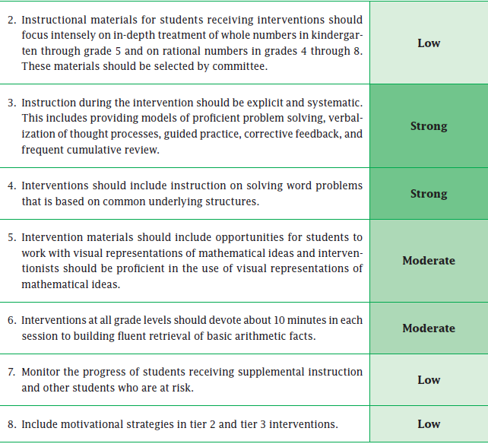

(Institute of Educational Sciences, Assisting Students Struggling with Mathematics:
Response to Intervention (RtI) for Elementary and Middle Schools, 2009, p. 6)

Gradual release of responsibility model
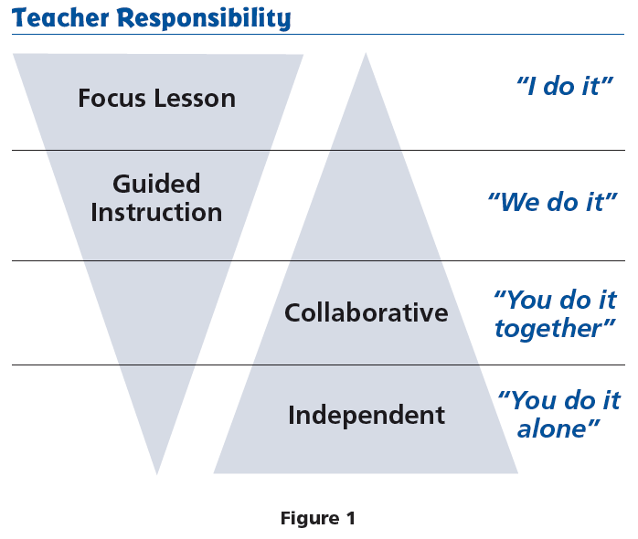

(Dr. Douglas Fisher, Effective Use of the Gradual Release of Responsibility Model)


Planning Guide: Session 1
6th Grade - Readiness Standard 4 - 5.NF.1

Learning Target: I will add and subtract mixed numbers with different denominators
Readiness for solving 1-step equations

Recommended Actions
Beginning  (15 min.) | - Review the readiness standard with the intervention group using the Guided Review  - Introduce the learning target and why it is important for future learning  - Read each question on the Guided Review and ask students to share what they remember from the previous school year.
Middle  (5 min.) | - Ask students to reflect on their progress towards the learning target  - What did I remember about the learning target?  - What did I learn today about the learning target?  - How confident do I feel about doing the learning target on my own?
End  (10 min.) | - Assess each student’s progress using Quick Check – Form A  - Guide students to self-correct their Quick Check – Form A  - Guide students to chart their progress by recording the date and Quick Check score  in their Growth Chart  - Collect each student’s Quick Check and Growth Chart
After | - Create sub-groups to differentiate the middle of sessions 2 through 8  - Group 1 – Include students who did not meet the learning goal  - Group 2 – Include students who met or exceeded the learning goal

6th Grade Fall Guided Review
Readiness Standard 4 - 5.NF.1

Name__________________________________ Date________

Learning Target: I will add and subtract mixed numbers with different denominators.

1.
Add:
$$2 \frac{3}{4}$$

$$+ 1 \frac{3}{5}$$

$3\frac{6}{9}$ $3\frac{6}{20}$ $3\frac{7}{20}$ $4\frac{7}{20}$

2.
Subtract:
$$7$$

$$- 2 \frac{3}{5}$$

$4\frac{2}{5}$ $4\frac{3}{5}$ $5\frac{2}{5}$ $5\frac{3}{5}$

6th Grade Fall Guided Review
Readiness Standard 4 - 5.NF.1 (continued)

3.
Subtract:
$$8 \frac{2}{5}$$

$$- 3 \frac{1}{2}$$

$4\frac{1}{10}$ $4\frac{9}{10}$ $5\frac{1}{10}$ $5\frac{9}{10}$

6th Grade Winter Guided Review
Readiness Standard 4 - 5.NF.1

Name__________________________________ Date________

Learning Target: I will add and subtract mixed numbers with different denominators.

1.
Add:
$$4 \frac{1}{3}$$

$$+ 2 \frac{3}{4}$$

$6 \frac{1}{12}$ $6 \frac{4}{12}$ $7 \frac{1}{12}$ $6 \frac{4}{7}$
2.
Subtract:
$$6$$

$$- 2 \frac{3}{4}$$

$4 \frac{1}{4}$ $3 \frac{1}{4}$ $4 \frac{3}{4}$ $3 \frac{3}{4}$

6th Grade Winter Guided Review
Readiness Standard 4 - 5.NF.1 (continued)

3.
Subtract:
$$5 \frac{1}{2}$$

$$- 1 \frac{2}{3}$$

$4\frac{5}{6}$ $4 \frac{1}{6}$ $3 \frac{1}{6}$ $3 \frac{5}{6}$

6th Grade Spring Guided Review
Readiness Standard 4 - 5.NF.1

Name__________________________________ Date________

Learning Target: I will add and subtract mixed numbers with different denominators.

1.
$$4 \frac{3}{5}$$

$$+ 3 \frac{1}{2}$$
Add:

$8 \frac{1}{10}$ $7 \frac{4}{10}$ $7 \frac{1}{10}$ $7 \frac{4}{7}$
2.
Subtract:
$$8$$

$$- 2 \frac{1}{6}$$

$5 \frac{1}{6}$ $6 \frac{5}{6}$ $6 \frac{1}{6}$ $5 \frac{5}{6}$

6th Grade Spring Guided Review
Readiness Standard 4 - 5.NF.1 (continued)

3.
$$6 \frac{1}{5}$$

$$- 1 \frac{2}{3}$$
Subtract:

$4\frac{1}{2}$ $5 \frac{8}{15}$ $4 \frac{8}{15}$ $5 \frac{7}{15}$

Session 1: Self-Reflection
6th Grade - Readiness Standard 4 - 5.NF.1

Learning Target: I will add and subtract mixed numbers with different denominators

Briefly discuss student responses:
- What did I remember today about adding and subtracting
mixed numbers with different denominators?

- What did I learn today about adding and subtracting
mixed numbers with different denominators?

- How confident do I feel about adding and subtracting
mixed numbers with different denominators on my own?
(Thumbs up, down, or sideways)

Quick Check - Form A
6th Grade - Readiness Standard 4 - 5.NF.1

Name__________________________________ Date________

Learning Target: I will add and subtract mixed numbers with different denominators.

Directions: Write the answer to each problem. (Work time: 4 minutes)
1.  $$4 \frac{1}{6}$$  $$+ 3 \frac{2}{3}$$ | 2.  $$2 \frac{2}{5}$$  $$+ 6 \frac{2}{3}$$
3.  $$5 \frac{3}{4}$$  $$- 2 \frac{1}{3}$$ | 4.  $$7 \frac{1}{10}$$  $$- 5 \frac{5}{6}$$
Growth Chart
6th Grade - Readiness Standard 4 - 5.NF.1

Name__________________________________ Date________
Learning Target: I will add and subtract mixed numbers with different denominators.
Goal: 3 out of 4 correct

4

3

2

1
Number
Correct

A B C D E F G H
Quick Check Form

Intervention | Date | Score
Session 1:
Session 2:
Session 3:
Session 4:
Session 5:
Session 6:
Session 7:
Session 8:
Planning Guide: Sessions 2 Through 8
6th Grade - Readiness Standard 4 - 5.NF.1

Learning Target: I will add and subtract mixed numbers with different denominators
Readiness for solving 1-step equations

Recommended Actions
Beginning  (5 min.) | - Review the learning target with the whole group and ask each student to set a goal for today’s learning
Middle  (15 min.) | Group 1: (Students who did not meet the learning  goal on the previous Quick Check)  - Model solving a word problem – “I do”  - Guided Practice – “We do together/  You do together”  Session 2: Use fraction strips to add/subtract mixed  numbers with different denominators  Session 3: Use number lines to add/subtract mixed  numbers with different denominators  Session 4: Use understanding of whole numbers and  fractional parts to add/subtract mixed  numbers with different denominators | Group 2: (Students who met the learning  goal)  - Independent practice – “You do alone”  Activity: Addition/Subtraction Match-up!  (Look for additional activities in  5th grade core instruction resources.)
End  (10 min.) | - Bring the students back together.  - Ask students to reflect on their progress towards the learning target  - What did I learn today about adding and subtracting mixed numbers with the different denominators?  - How confident do you feel about adding and subtracting mixed numbers with the different denominators on my own? (Thumbs up, down, or sideways)  - Assess each student’s progress using the next Quick Check form  - Guide students to self-correct their Quick Check  - Guide students to chart their progress in their Growth Chart  - If not using Delta Math lessons, record the activity in the table  - Collect each student’s Quick Check and Growth Chart
After | - Regroup students to differentiate the middle of sessions 3 through 8  - Promote students who met the learning goal to group 2  - Exit students who met the learning goal for a third time  - Problem solve with a team to plan additional support for students who did not exit
Session 2: Modeling (I Do)
6th Grade - Readiness Standard 4 - 5.NF.1

Learning Target: I will add and subtract mixed numbers with different denominators
Readiness for solving 1-step equations

Annie and her friend both had a string of licorice that was 1 foot long. After eating some, Annie had
of a foot left and her friend had of a foot left. If they combine their remaining licorice, how much do they have left altogether?
$$\frac{2}{3}$$
$$\frac{3}{4}$$

$$0$$
$$1$$
$$2$$

Session 2: Modeling (I Do – Visual Support)
6th Grade - Readiness Standard 4 - 5.NF.1

Learning Target: I will add and subtract mixed numbers with different denominators
Readiness for solving 1-step equations

Annie and her friend both had a string of licorice…how much do they have left altogether?
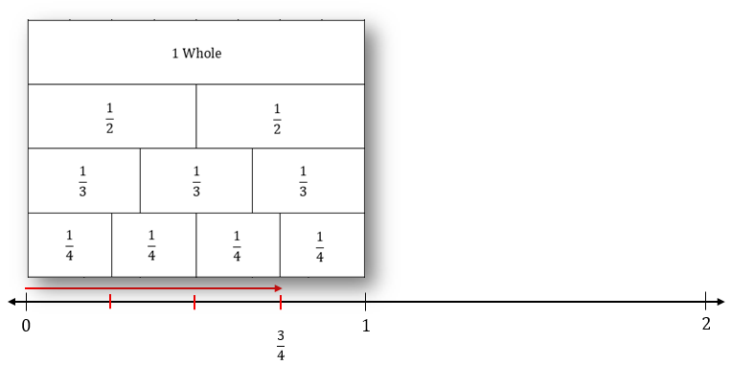

$$\frac{3}{4}$$
Step 1: Draw on the number line

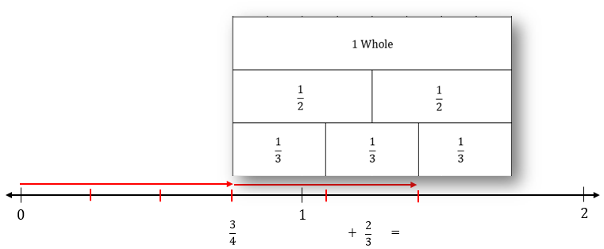

$$\frac{3}{4}$$
$$\frac{2}{3}$$
Step 2: Draw added to

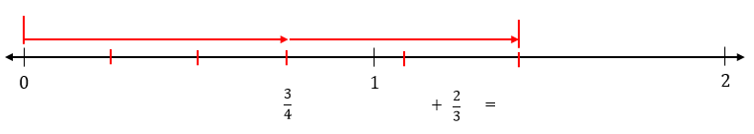

Step 3: Mark the total

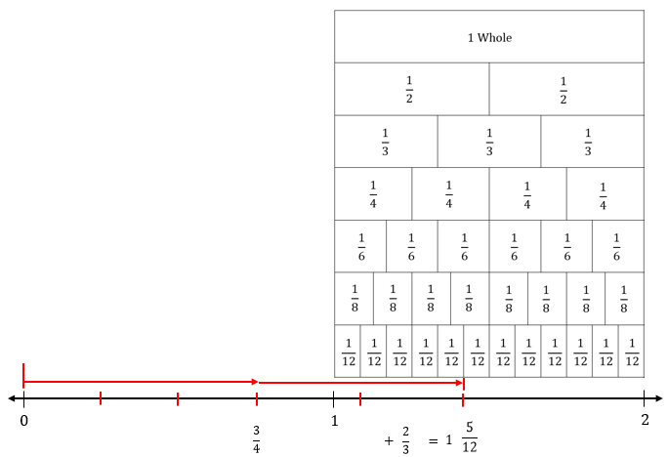

Step 4: Find the total

Session 2: Modeling (I Do - Teacher Notes)
6th Grade - Readiness Standard 4 - 5.NF.1

Learning Target: I will add and subtract mixed numbers with different denominators
Readiness for solving 1-step equations
Annie and her friend both had a string of licorice…how much do they have left altogether?
I am going to think aloud to model solving this problem.

Your job is to watch, listen, think and ask questions.

First, it is important to know what the problem is about.
This problem is about Annie and her friend eating string licorice.
Second, I need to determine what I need to find.
I need to find how much they have left after each of them ate some.
Third, I need to determine what I know.
$$\frac{3}{4}$$
I know that they each began with 1 foot of licorice. And, after they both ate some, Annie had of a foot left and her friend had of a foot left.
$$\frac{2}{3}$$
Fourth, I need to figure out what I can try.
$$\frac{2}{3}$$
$$\frac{3}{4}$$
I am going to try using fraction strips and a number line to add and .
(Hold up a template of fraction strips and write $\frac{3}{4}+\frac{2}{3}$ on the “Modelling” paper.)
I am going fold my fraction template to so that the “fourths” are visible as the bottom row…
(Fold the template so that four-fourths are visible at the bottom.)
Since Annie had 3 fourths of a foot left, I will use the fraction strips to mark 3 fourths on the number line.
(Draw 3 marks to separate the fourths and draw a fraction arrow with a length of 3 fourths.)
To add 2 thirds of a foot, I will fold the template so that the “thirds” are the bottom row and add 2 of them.
(Place the left side of the template to the right of the fraction arrow and mark off 2 thirds.)
The total is the distance from zero to the end of the 2 thirds.
(Draw vertical marks above the 0 and the end of the 2 thirds arrow.)
I see that the total is more than 1, but I’m not sure what fractional part this mark is at.
(Write 1 under the number line.)
To find this fractional part, I remember that I can use a common denominator…and since 4 is not a multiple of 3…I can multiply them to get twelfths.
(Use the twelfths on the template to match the fractional total to 5 twelfths.)
It looks like Annie and her friend have 1 whole foot and 5 twelfths of a foot of licorice left.
(Write 1 $\frac{5}{12}$ under the number line.)
Last, I need to make sure that my answer makes sense.
I found that Annie and her friend have 1 and 5 twelfths feet of licorice left. It makes sense because I used a fraction template to represent both fractional amounts on a number line and then use a common denominator to help find the total.
Name ______________________________ Date _________
6th Grade - RS 4 - 5.NF.1
Learning Target: I will add and subtract mixed numbers with different denominators

Session 2: Guided Practice (We Do)

We Do Together: (Teacher Actions)
- Use fraction strips and number lines to add or subtract.
$$\frac{2}{3}$$
1.
+
$$\frac{5}{6}$$
=
$$1$$
$$\frac{1}{4}$$
$$\frac{3}{8}$$
=
$$\frac{2}{3}$$
$$\frac{1}{2}$$
=
$$1$$
$$\frac{3}{4}$$
$$\frac{2}{3}$$
=

$$0$$
$$1$$
$$2$$

2.
–

$$0$$
$$1$$
$$2$$

3.
+

$$0$$
$$1$$
$$2$$

4.
–

$$0$$
$$1$$
$$2$$

Name ______________________________ Date _________
6th Grade - RS 4 - 5.NF.1
Learning Target: I will add and subtract mixed numbers with different denominators

Session 2: Guided Practice (We Do - Continued)

You Do Together: (As a class, or in small groups)
- Students take turns leading using fraction strips and number lines to add or subtract.
$$\frac{3}{4}$$
5.
+
$$\frac{5}{8}$$
=
$$1$$
$$\frac{1}{2}$$
$$\frac{5}{8}$$
=
$$\frac{2}{3}$$
$$\frac{3}{4}$$
=
$$1$$
$$\frac{1}{2}$$
$$\frac{2}{3}$$
=

$$0$$
$$1$$
$$2$$

6.
–

$$0$$
$$1$$
$$2$$

7.
+

$$0$$
$$1$$
$$2$$

8.
–

$$0$$
$$1$$
$$2$$

Name ______________________________ Date _________
6th Grade - RS 4 - 5.NF.1
Learning Target: I will add and subtract mixed numbers with different denominators

Session 2: Guided Practice (We Do – Teacher Notes)

We Do Together: (Teacher Actions)
- Use fraction strips and number lines to add or subtract.
- Draw both fractional parts
- Use a common denominator to find the total (Since 6 is a multiple of 3, use sixths)
- Simplify the total
$$\frac{3}{6}$$
$$\frac{1}{2}$$
1.
$$\frac{2}{3}$$
$$\frac{2}{3}$$
1 = 1
+
$$\frac{5}{6}$$
=
$$1$$
$$\frac{1}{4}$$
$$\frac{3}{8}$$
=
$$\frac{1}{2}$$
=
$$1$$
$$\frac{3}{4}$$
$$\frac{2}{3}$$
=

$$0$$
$$1$$
$$2$$

- Draw the total
- Take away the known part (3 eighths)
- Use a common denominator to find the unknown part
(Since 8 is a multiple of 4, use eighths)

$$\frac{7}{8}$$
2.
–

$$0$$
$$1$$
$$2$$

- Draw both fractional parts
- Use a common denominator to find the total
(Since 3 is not a multiple of 2, multiply them and use sixths)
$$\frac{1}{6}$$
3.
1
+

$$0$$
$$1$$
$$2$$

- Draw the total
- Take away the known part (2 thirds)
- Use a common denominator to find the unknown part
(Since 3 is not a multiple of 4, multiply them and use twelfths)
$$\frac{1}{12}$$
4.

1
–

$$0$$
$$1$$
$$2$$

Fraction Strips (4 Sets)
6th Grade - Readiness Standard 4 - 5.NF.1

Directions: Each student should receive two sets of strips…do not cut into individual strips.
(Note: The templates below include twelfths and are different from the 4th and 5th grade templates.)
$$1 Whole$$
$$1 Whole$$

$$\frac{1}{2}$$
$$\frac{1}{2}$$
$$\frac{1}{2}$$
$$\frac{1}{2}$$

$$\frac{1}{3}$$
$$\frac{1}{3}$$
$$\frac{1}{3}$$
$$\frac{1}{3}$$
$$\frac{1}{3}$$
$$\frac{1}{3}$$

$$\frac{1}{4}$$
$$\frac{1}{4}$$
$$\frac{1}{4}$$
$$\frac{1}{4}$$
$$\frac{1}{4}$$
$$\frac{1}{4}$$
$$\frac{1}{4}$$
$$\frac{1}{4}$$

$$\frac{1}{6}$$
$$\frac{1}{6}$$
$$\frac{1}{6}$$
$$\frac{1}{6}$$
$$\frac{1}{6}$$
$$\frac{1}{6}$$
$$\frac{1}{6}$$
$$\frac{1}{6}$$
$$\frac{1}{6}$$
$$\frac{1}{6}$$
$$\frac{1}{6}$$
$$\frac{1}{6}$$

$$\frac{1}{8}$$
$$\frac{1}{8}$$
$$\frac{1}{8}$$
$$\frac{1}{8}$$
$$\frac{1}{8}$$
$$\frac{1}{8}$$
$$\frac{1}{8}$$
$$\frac{1}{8}$$
$$\frac{1}{8}$$
$$\frac{1}{8}$$
$$\frac{1}{8}$$
$$\frac{1}{8}$$
$$\frac{1}{8}$$
$$\frac{1}{8}$$
$$\frac{1}{8}$$
$$\frac{1}{8}$$

$$\frac{1}{12}$$ | $$\frac{1}{12}$$ |  | $$\frac{1}{12}$$ | $$\frac{1}{12}$$ | $$\frac{1}{12}$$ |  | $$\frac{1}{12}$$ | $$\frac{1}{12}$$ | $$\frac{1}{12}$$ |  | $$\frac{1}{12}$$ | $$\frac{1}{12}$$ | $$\frac{1}{12}$$ |  | $$\frac{1}{12}$$ | $$\frac{1}{12}$$ | $$\frac{1}{12}$$ |  | $$\frac{1}{12}$$ | $$\frac{1}{12}$$ | $$\frac{1}{12}$$ |  | $$\frac{1}{12}$$ | $$\frac{1}{12}$$ | $$\frac{1}{12}$$ |  | $$\frac{1}{12}$$ | $$\frac{1}{12}$$ | $$\frac{1}{12}$$ |  | $$\frac{1}{12}$$
$$1 Whole$$
$$1 Whole$$

$$\frac{1}{2}$$
$$\frac{1}{2}$$
$$\frac{1}{2}$$
$$\frac{1}{2}$$

$$\frac{1}{3}$$
$$\frac{1}{3}$$
$$\frac{1}{3}$$
$$\frac{1}{3}$$
$$\frac{1}{3}$$
$$\frac{1}{3}$$

$$\frac{1}{4}$$
$$\frac{1}{4}$$
$$\frac{1}{4}$$
$$\frac{1}{4}$$
$$\frac{1}{4}$$
$$\frac{1}{4}$$
$$\frac{1}{4}$$
$$\frac{1}{4}$$

$$\frac{1}{6}$$
$$\frac{1}{6}$$
$$\frac{1}{6}$$
$$\frac{1}{6}$$
$$\frac{1}{6}$$
$$\frac{1}{6}$$
$$\frac{1}{6}$$
$$\frac{1}{6}$$
$$\frac{1}{6}$$
$$\frac{1}{6}$$
$$\frac{1}{6}$$
$$\frac{1}{6}$$

$$\frac{1}{8}$$
$$\frac{1}{8}$$
$$\frac{1}{8}$$
$$\frac{1}{8}$$
$$\frac{1}{8}$$
$$\frac{1}{8}$$
$$\frac{1}{8}$$
$$\frac{1}{8}$$
$$\frac{1}{8}$$
$$\frac{1}{8}$$
$$\frac{1}{8}$$
$$\frac{1}{8}$$
$$\frac{1}{8}$$
$$\frac{1}{8}$$
$$\frac{1}{8}$$
$$\frac{1}{8}$$

$$\frac{1}{12}$$ | $$\frac{1}{12}$$ |  | $$\frac{1}{12}$$ | $$\frac{1}{12}$$ | $$\frac{1}{12}$$ |  | $$\frac{1}{12}$$ | $$\frac{1}{12}$$ | $$\frac{1}{12}$$ |  | $$\frac{1}{12}$$ | $$\frac{1}{12}$$ | $$\frac{1}{12}$$ |  | $$\frac{1}{12}$$ | $$\frac{1}{12}$$ | $$\frac{1}{12}$$ |  | $$\frac{1}{12}$$ | $$\frac{1}{12}$$ | $$\frac{1}{12}$$ |  | $$\frac{1}{12}$$ | $$\frac{1}{12}$$ | $$\frac{1}{12}$$ |  | $$\frac{1}{12}$$ | $$\frac{1}{12}$$ | $$\frac{1}{12}$$ |  | $$\frac{1}{12}$$
Session 2: Self-Reflection
6th Grade - Readiness Standard 4 - 5.NF.1

Learning Target: I will add and subtract mixed numbers with different denominators

Briefly discuss student responses:
- What did I learn today about adding and subtracting
mixed numbers with different denominators?

- How confident do I feel about adding and subtracting
mixed numbers with different denominators on my own?
(Thumbs up, down, or sideways)

Quick Check - Form B
6th Grade - Readiness Standard 4 - 5.NF.1

Name__________________________________ Date________

Learning Target: I will add and subtract mixed numbers with different denominators.

Directions: Write the answer to each problem. (Work time: 4 minutes)
1.  $$2 \frac{1}{4}$$  $$+ 3 \frac{1}{3}$$ | 2.  $$4 \frac{2}{3}$$  $$+ 2 \frac{5}{6}$$
3.  $$8 \frac{3}{5}$$  $$- 5 \frac{1}{4}$$ | 4.  $$6 \frac{1}{3}$$  $$- 4 \frac{1}{2}$$
Session 3: Modeling (I Do)
6th Grade - Readiness Standard 4 - 5.NF.1

Learning Target: I will add and subtract mixed numbers with different denominators
Readiness for solving 1-step equations

Lori is preparing for a running race. As part of her practice schedule, she ran $\frac{1}{2}$ of a mile on the first day of practice and ran $\frac{2}{3}$ of a mile on the second day. How far did she run during her first two days of practice?

$$0$$
$$2$$
$$1$$

Session 3: Modeling (I Do – Visual Support)
6th Grade - Readiness Standard 4 - 5.NF.1

Learning Target: I will add and subtract mixed numbers with different denominators
Readiness for solving 1-step equations

Lori is preparing for a running race. As part of her practice schedule, she ran $\frac{1}{2}$ of a mile on the first day of practice and ran $\frac{2}{3}$ of a mile on the second day. How far did she run during her first two days of practice?

Rename with equal-sized parts

x 3
x 3
$$\frac{3}{6}$$

$$+ \frac{4}{6}$$
$$\frac{1}{2}$$

$$+ \frac{2}{3}$$
$$\frac{7}{6}$$

x 2
x 2

$$= 1 \frac{1}{6}$$

$$0$$
$$2$$
$$1$$
$$\frac{7}{6} = 1 \frac{1}{6}$$

Session 3: Modeling (I Do - Teacher Notes)
6th Grade - Readiness Standard 4 - 5.NF.1

Learning Target: I will add and subtract mixed numbers with different denominators
Readiness for solving 1-step equations
Lori is preparing for a running race. As part of her practice schedule, she ran $\frac{1}{2}$ of a mile on the first day of practice and ran $\frac{2}{3}$ of a mile on the second day. How far did she run during her first two days of practice?
I am going to think aloud to model solving this problem.

Your job is to watch, listen, think and ask questions.

First, it is important to know what the problem is about.
This problem is about Lori preparing for a race.
Second, I need to determine what I need to find.
I need to find how far she ran during two days of practice.
Third, I need to determine what I know.
I know that Lori ran 1-half of a mile on the first day and 2-thirdss of a mile on the second.
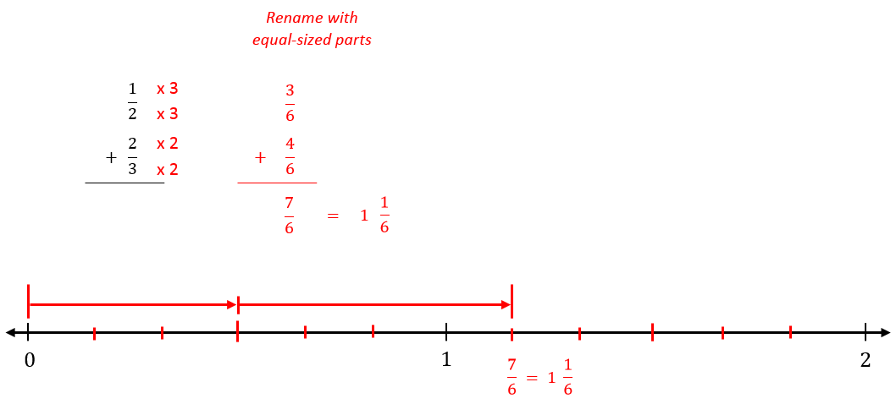
Fourth, I need to figure out what I can try.
I am going to try drawing and combining both
fractions on a number line to find their total.
(Write the addition problem above the number line.)
To begin this addition drawing, I am going to draw
the first fractional part, 1 half.
(Mark the number line half-way between 0 and 1.
Then draw an arrow with vertical lines above the
number line at 0 and 1 half.)
The second fraction does not have the same size parts, so I will find a common denominator to make them equal.
(Point to the denominators 2 and 3.)
Since 3 is not a multiple of 2, I will multiply them to find a common denominator of 6ths…I can mark these by breaking each half into 3 equal parts.
(Draw a vertical marks to break the first half into 3 equal parts and the second half into 3 equal parts.)
Now I will rename each fractional part as 6ths…by multiplying the numerator and denominator of 1 half by 3, I can rename it to 3 sixths…and if I multiply the numerator and denominator of 2 thirds by 2, I can rename it to 4 sixths.
(Write the multipliers next to each numerator and denominator. “x 2” for 1 half and “x 3” for 2 thirds.)
I already have 3 sixths drawn, so now I need to draw 4 sixths…this will go past 1 whole, so I need to separate the second whole into sixths…first into halves, then each half into 3 equal parts.
(Count 2 fourths and draw a vertical mark above the number line, then the arrow.)
I will count 4 sixths to find the total...7 sixths.
(Count 4 sixths and draw a longer vertical mark above the number line, then an arrow between 3 sixths and 7 sixths.)

Session 3: Modeling (I Do - Teacher Notes Cont.)
6th Grade - Readiness Standard 4 - 5.NF.1

Learning Target: I will add and subtract mixed numbers with different denominators
Readiness for solving 1-step equations
Lori is preparing for a running race. As part of her practice schedule, she ran $\frac{1}{2}$ of a mile on the first day of practice and ran $\frac{2}{3}$ of a mile on the second day. How far did she run during her first two days of practice?

Last, I need to make sure that my answer makes sense.
I found that Lori ran 1 and 1 sixth of a mile during her first two days of practice. It makes sense because I drew both fractions using a common denominator on a number line to see that 3 sixths plus 4 sixths is the same as 1 half plus 2 thirds.

Name ______________________________ Date _________
6th Grade - RS 4 - 5.NF.1
Learning Target: I will add and subtract mixed numbers with different denominators

Session 3: Guided Practice (We Do)

We Do Together: (Teacher Actions)
Use common denominators on number lines to add or subtract fractions.
$$\frac{2}{3}$$

$$+ \frac{5}{6}$$
1.

$$0$$
$$2$$
$$1$$

$$1 \frac{1}{4}$$

$$- \frac{3}{8}$$
2.

$$0$$
$$2$$
$$1$$

$$1 \frac{1}{4}$$

$$- \frac{2}{3}$$
3.

$$0$$
$$2$$
$$1$$

Name ______________________________ Date _________
6th Grade - RS 4 - 5.NF.1
Learning Target: I will add and subtract mixed numbers with different denominators

Session 3: Guided Practice (We Do - Continued)

You Do Together: (As a class, or in small groups)
- Students take turns leading using common denominators on number lines to add or subtract.
$$\frac{3}{4}$$

$$+ \frac{5}{8}$$
4.

$$0$$
$$2$$
$$1$$

$$1 \frac{2}{3}$$

$$- \frac{5}{6}$$
5.

$$0$$
$$2$$
$$1$$

$$1 \frac{1}{2}$$

$$- \frac{2}{3}$$
6.

$$0$$
$$2$$
$$1$$

Name ______________________________ Date _________
6th Grade - RS 4 - 5.NF.1
Learning Target: I will compare two fractions with different numerators and different denominators

Session 3: Guided Practice (We Do – Teacher Notes)

We Do Together: (Teacher Actions)
- Use common denominators on number lines to add or subtract fractions.
x 2
x 2
$$\frac{4}{6}$$

$$+ \frac{5}{6}$$
$$\frac{2}{3}$$

$$+ \frac{5}{6}$$
$$\frac{9}{6}$$
1.
- Draw both fractional parts
- Use a common denominator to find the total (Since 6 is a multiple of 3, use sixths)
- Simplify the total

$$= 1 \frac{1}{2}$$

$$= 1 \frac{3}{6}$$

$$0$$
$$2$$
$$1$$

0
$$\frac{10}{8}$$

- Draw the total
- Rewrite the problem with common denominators
(Since 8 is a multiple of 4, use 8ths)
- Ungroup the whole to provide enough 8ths
- Take away the known part (3 eighths)

x 2
x 2
$$1 \frac{1}{4}$$

$$- \frac{3}{8}$$
$$\frac{7}{8}$$
$$1 \frac{2}{8}$$

$$- \frac{3}{8}$$
2.

$$0$$
$$2$$
$$1$$

0
$$\frac{15}{12}$$
- Draw the total
- Rewrite the problem with common denominators
(Since 4 is not a multiple of 3, multiply them and use 12ths)
- Ungroup the whole to provide enough 12ths
- Take away the known part (3 eighths)

$$1 \frac{1}{4}$$

$$- \frac{2}{3}$$
$$\frac{7}{12}$$
x 3
x 3
$$1 \frac{3}{12}$$

$$- \frac{8}{12}$$
3.
x 4
x 4

$$0$$
$$2$$
$$1$$

Session 3: Self-Reflection
6th Grade - Readiness Standard 4 - 5.NF.1

Learning Target: I will add and subtract mixed numbers with different denominators

Briefly discuss student responses:
- What did I learn today about adding and subtracting
mixed numbers with different denominators?

- How confident do I feel about adding and subtracting
mixed numbers with different denominators on my own?
(Thumbs up, down, or sideways)

Quick Check - Form C
6th Grade - Readiness Standard 4 - 5.NF.1

Name__________________________________ Date________

Learning Target: I will add and subtract mixed numbers with different denominators.

Directions: Write the answer to each problem. (Work time: 4 minutes)
1.  $$5 \frac{1}{2}$$  $$+ 3 \frac{1}{4}$$ | 2.  $$7 \frac{1}{6}$$  $$+ 4 \frac{8}{9}$$
3.  $$6 \frac{4}{5}$$  $$- 1 \frac{1}{3}$$ | 4.  $$8 \frac{3}{5}$$  $$- 3 \frac{3}{4}$$
Session 4: Modeling (I Do)
6th Grade - Readiness Standard 4 - 5.NF.1

Learning Target: I will add and subtract mixed numbers with different denominators
Readiness for solving 1-step equations

Gina was making braided necklaces out of yarn for her classroom’s end of year celebration. She began with
9 $\frac{1}{4}$ feet of yarn and used 5 $\frac{2}{3}$ feet to make the necklaces. How many feet of yarn does she have left?

Session 4: Modeling (I Do – Visual Support)
6th Grade - Readiness Standard 4 - 5.NF.1

Learning Target: I will add and subtract mixed numbers with different denominators
Readiness for solving 1-step equations

Gina was making braided necklaces out of yarn for her classroom’s end of year celebration. She began with
9 $\frac{1}{4}$ feet of yarn and used 5 $\frac{2}{3}$ feet to make the necklaces. How many feet of yarn does she have left?

$$Feet of Yarn$$
$$\frac{15}{12}$$
–
$$\frac{2}{3}$$
$$5$$
$$8$$
x 3
x 3
$$\frac{3}{12}$$
$$9$$
$$5$$
$$9$$
$$\frac{1}{4}$$

x 4
x 4
–
$$\frac{8}{12}$$

$$\frac{7}{12}$$
$3$

Session 4: Modeling (I Do - Teacher Notes)
6th Grade - Readiness Standard 4 - 5.NF.1

Learning Target: I will add and subtract mixed numbers with different denominators
Readiness for solving 1-step equations
Gina was making braided necklaces out of yarn for her classroom’s end of year celebration. She began with
9 $\frac{1}{4}$ feet of yarn and used 5 $\frac{2}{3}$ feet to make the necklaces. How many feet of yarn does she have left?
I am going to think aloud to model solving this problem.
Your job is to watch, listen, think and ask questions.
First, it is important to know what the problem is about.
This problem is about Gina making necklaces out of yarn for her classroom’s end of year celebration.
Second, I need to determine what I need to find.
I need to find how much yarn she has left.
Third, I need to determine what I know.
I know that she began with 9 and 1 fourth feet of yarn and used 5 and 2 thirds feet to make necklaces.
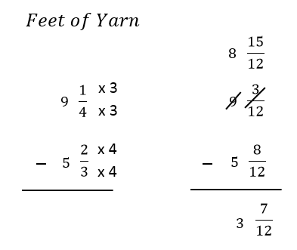
Fourth, I need to figure out what I can try.
I am going to try using my understanding of whole numbers and fractional parts
to subtract 5 and 2 thirds from 9 and 1 fourth.
(Write the label and subtraction problem.)
I need to rewrite the thirds and fourths into common parts of a foot to help me
subtract without a drawing.
One denominator is not a multiple of the other, so I will multiply them to get twelfths…
each of the 4 parts is broken into 3 equal parts…and each of the 3 parts can be broken into 4 equal parts
(Write “x 3” and “x 4” next to the numerator and denominator of 2 thirds and 1 fourth)
9 and 1 fourth is equal to 9 and 3 twelfths and 5 and 2 thirds is equal to 5 and 8 twelfths.
(Write the equivalent fractions next to the original problem.)
Next I see 3 twelfths and need to subtract 8 twelfths…so I have to ungroup a whole for more twelfths.
(Point to the fractional parts of each mixed number.)
When I ungroup one of my 9 wholes, I am left with 8 wholes.
(Cross off the 9 and write the whole number “8” above it.)
One whole ungroups into 12 twelfths, so I now have 12 plus 3 which is 15 twelfths as the fractional part.
(Cross off the 3 twelfths and write 15 twelfths above it.)
Now I can subtract the “like” values…8 wholes minus 5 whole is equal to 3 wholes.
(Write the whole number 3 under the subtraction line.)
And, 15 twelfths minus 8 twelfths is equal to 7 twelfths.
(Write the fractional part 7 twelfths under the subtraction line.)
Gina has 3 and 7 twelfths feet of yarn left.
(Point to the answer)
Last, I need to make sure that my answer makes sense.
I found that Gina had 3 and 7 twelfths feet of yarn left. It makes sense because I used common denominators to help me subtract. Then, I ungrouped a whole to make enough twelfths to subtract the amount she used.
Name ______________________________ Date _________
6th Grade - RS 4 - 5.NF.1
Learning Target: I will add and subtract mixed numbers with different denominators

Session 4: Guided Practice (We Do)

We Do Together: (Teacher Actions)
- Use your understanding of whole numbers and fractional parts to add or subtract.

1. | 2.  $$4 \frac{3}{8}$$  $$- 2 \frac{3}{5}$$  $$1 \frac{9}{10}$$  $$+ 2 \frac{3}{5}$$  $$4 \frac{1}{4}$$  $$+ 1 \frac{5}{6}$$  $$10 \frac{1}{2}$$  $$- 5 \frac{7}{8}$$
3. | 4.

Name ______________________________ Date _________
6th Grade - RS 4 - 5.NF.1
Learning Target: I will add and subtract mixed numbers with different denominators

Session 4: Guided Practice (We Do - Continued)

You Do Together: (As a class, or in small groups)
- Take turns leading to use your understanding of whole numbers and fractional parts to add or subtract.
$$3 \frac{5}{7}$$

$$+ 2 \frac{3}{4}$$
5.  $$6 \frac{2}{5}$$  $$- 3 \frac{5}{6}$$  $$8 \frac{1}{6}$$  $$- 2 \frac{4}{5}$$  $$5 \frac{2}{3}$$  $$+ 3 \frac{3}{5}$$ | 6.
7. | 8.

Name ______________________________ Date _________
6th Grade - RS 4 - 5.NF.1
Learning Target: I will add and subtract mixed numbers with different denominators

Session 4: Guided Practice (We Do – Teacher Notes)

We Do Together: (Teacher Actions)
- Use your understanding of whole numbers and fractional parts to add or subtract.
$$\frac{1}{12}$$
1.  $$1$$  $$2$$  $$\frac{9}{10}$$  $$\frac{6}{10}$$  $$1 \frac{9}{10}$$  $$+ 2 \frac{3}{5}$$  +  x 2  x 2  $3$  $$\frac{15}{10}$$  $$\frac{5}{10}$$  $= 4$= 4 | 2.  $$4$$  $$1$$  $$\frac{6}{24}$$  $$\frac{20}{24}$$  x 6  x 6  $$4 \frac{1}{4}$$  $$+ 1 \frac{5}{6}$$  +  x 4  x 4  2 x 1  2 x 5  1 x 5  $$\frac{2}{24}$$  $$\frac{26}{24}$$  $$\frac{1}{2}$$  $5 = 6 = 6$  2 x 12
3.  $$3$$  $$4$$  $$2$$  $$\frac{15}{40}$$  $$\frac{55}{40}$$  $$\frac{24}{40}$$  x 5  x 5  $$4 \frac{3}{8}$$  $$- 2 \frac{3}{5}$$  x 8  x 8  –  $$\frac{31}{40}$$  $1$ | 4.  $$9$$  $$10$$  $$5$$  $$\frac{4}{8}$$  $$\frac{12}{8}$$  $$\frac{7}{8}$$  x 4  x 4  $$10 \frac{1}{2}$$  $$- 5 \frac{7}{8}$$  –  $$\frac{5}{8}$$  $$4$$

Session 4: Self-Reflection
6th Grade - Readiness Standard 4 - 5.NF.1

Learning Target: I will add and subtract mixed numbers with different denominators

Briefly discuss student responses:
- What did I learn today about adding and subtracting
mixed numbers with different denominators?

- How confident do I feel about adding and subtracting
mixed numbers with different denominators on my own?
(Thumbs up, down, or sideways)

Quick Check - Form D
6th Grade - Readiness Standard 4 - 5.NF.1

Name__________________________________ Date________

Learning Target: I will add and subtract mixed numbers with different denominators.

Directions: Write the answer to each problem. (Work time: 4 minutes)
1.  $$4 \frac{1}{2}$$  $$+ 3 \frac{1}{4}$$ | 2.  $$3 \frac{4}{7}$$  $$+ 2 \frac{4}{5}$$
3.  $$8 \frac{6}{7}$$  $$- 2 \frac{1}{5}$$ | 4.  $$6 \frac{2}{5}$$  $$- 4 \frac{2}{3}$$

Name ______________________________ Date _________
6th Grade - RS 4 - 5.NF.1
Learning Target: I will add and subtract mixed numbers with different denominators

Session 5: Guided Practice (We Do)

We Do Together: (Teacher Actions)
Use common denominators on number lines to add or subtract fractions.
$$\frac{2}{3}$$

$$+ \frac{4}{6}$$
1.

$$0$$
$$2$$
$$1$$

$$1 \frac{1}{8}$$

$$- \frac{3}{4}$$
2.

$$0$$
$$2$$
$$1$$

$$1 \frac{1}{3}$$

$$- \frac{3}{4}$$
3.

$$0$$
$$2$$
$$1$$

Name ______________________________ Date _________
6th Grade - RS 4 - 5.NF.1
Learning Target: I will add and subtract mixed numbers with different denominators

Session 5: Guided Practice (We Do - Continued)

You Do Together: (As a class, or in small groups)
- Students take turns leading using common denominators on number lines to add or subtract.
$$\frac{3}{4}$$

$$+ \frac{7}{8}$$
4.

$$0$$
$$2$$
$$1$$

$$1 \frac{1}{6}$$

$$- \frac{2}{3}$$
5.

$$0$$
$$2$$
$$1$$

$$1 \frac{1}{4}$$

$$- \frac{2}{3}$$
6.

$$0$$
$$2$$
$$1$$

Session 5: Self-Reflection
6th Grade - Readiness Standard 4 - 5.NF.1

Learning Target: I will add and subtract mixed numbers with different denominators

Briefly discuss student responses:
- What did I learn today about adding and subtracting
mixed numbers with different denominators?

- How confident do I feel about adding and subtracting
mixed numbers with different denominators on my own?
(Thumbs up, down, or sideways)

Quick Check - Form E
6th Grade - Readiness Standard 4 - 5.NF.1

Name__________________________________ Date________

Learning Target: I will add and subtract mixed numbers with different denominators.

Directions: Write the answer to each problem. (Work time: 4 minutes)
1.  $$4 \frac{1}{6}$$  $$+ 3 \frac{2}{3}$$ | 2.  $$2 \frac{2}{5}$$  $$+ 6 \frac{2}{3}$$
3.  $$5 \frac{3}{4}$$  $$- 2 \frac{1}{3}$$ | 4.  $$7 \frac{1}{10}$$  $$- 5 \frac{5}{6}$$

Name ______________________________ Date _________
6th Grade - RS 4 - 5.NF.1
Learning Target: I will add and subtract mixed numbers with different denominators

Session 6: Guided Practice (We Do)

We Do Together: (Teacher Actions)
Use common denominators on number lines to add or subtract fractions.
$$\frac{1}{2}$$

$$+ \frac{3}{4}$$
1.

$$0$$
$$2$$
$$1$$

$$1 \frac{2}{3}$$

$$- \frac{5}{6}$$
2.

$$0$$
$$2$$
$$1$$

$$1 \frac{1}{3}$$

$$- \frac{1}{2}$$
3.

$$0$$
$$2$$
$$1$$

Name ______________________________ Date _________
6th Grade - RS 4 - 5.NF.1
Learning Target: I will add and subtract mixed numbers with different denominators

Session 6: Guided Practice (We Do - Continued)

You Do Together: (As a class, or in small groups)
- Students take turns leading using common denominators on number lines to add or subtract.
$$\frac{3}{8}$$

$$+ \frac{3}{4}$$
4.

$$0$$
$$2$$
$$1$$

$$1 \frac{1}{3}$$

$$- \frac{4}{6}$$
5.

$$0$$
$$2$$
$$1$$

$$1 \frac{1}{6}$$

$$- \frac{1}{4}$$
6.

$$0$$
$$2$$
$$1$$

Session 6: Self-Reflection
6th Grade - Readiness Standard 4 - 5.NF.1

Learning Target: I will add and subtract mixed numbers with different denominators

Briefly discuss student responses:
- What did I learn today about adding and subtracting
mixed numbers with different denominators?

- How confident do I feel about adding and subtracting
mixed numbers with different denominators on my own?
(Thumbs up, down, or sideways)

Quick Check - Form F
6th Grade - Readiness Standard 4 - 5.NF.1

Name__________________________________ Date________

Learning Target: I will add and subtract mixed numbers with different denominators.

Directions: Write the answer to each problem. (Work time: 4 minutes)
1.  $$2 \frac{1}{4}$$  $$+ 3 \frac{1}{3}$$ | 2.  $$4 \frac{2}{3}$$  $$+ 2 \frac{5}{6}$$
3.  $$8 \frac{3}{5}$$  $$- 5 \frac{1}{4}$$ | 4.  $$6 \frac{1}{3}$$  $$- 4 \frac{1}{2}$$

Name ______________________________ Date _________
6th Grade - RS 4 - 5.NF.1
Learning Target: I will add and subtract mixed numbers with different denominators

Session 7: Guided Practice (We Do)

We Do Together: (Teacher Actions)
- Use your understanding of whole numbers and fractional parts to add or subtract.

1. | 2.  $$6 \frac{5}{8}$$  $$- 4 \frac{3}{5}$$  $$1 \frac{7}{10}$$  $$+ 3 \frac{4}{5}$$  $$5 \frac{3}{4}$$  $$+ 2 \frac{5}{6}$$  $$8 \frac{1}{2}$$  $$- 3 \frac{5}{8}$$
3. | 4.

Name ______________________________ Date _________
6th Grade - RS 4 - 5.NF.1
Learning Target: I will add and subtract mixed numbers with different denominators

Session 7: Guided Practice (We Do - Continued)

You Do Together: (As a class, or in small groups)
- Take turns leading to use your understanding of whole numbers and fractional parts to add or subtract.
$$4 \frac{6}{7}$$

$$+ 2 \frac{3}{4}$$
5.  $$5 \frac{3}{5}$$  $$- 1 \frac{7}{9}$$  $$7 \frac{1}{5}$$  $$- 4 \frac{5}{6}$$  $$6 \frac{2}{3}$$  $$+ 3 \frac{4}{5}$$ | 6.
7. | 8.

Session 7: Self-Reflection
6th Grade - Readiness Standard 4 - 5.NF.1

Learning Target: I will add and subtract mixed numbers with different denominators

Briefly discuss student responses:
- What did I learn today about adding and subtracting
mixed numbers with different denominators?

- How confident do I feel about adding and subtracting
mixed numbers with different denominators on my own?
(Thumbs up, down, or sideways)

Quick Check - Form G
6th Grade - Readiness Standard 4 - 5.NF.1

Name__________________________________ Date________

Learning Target: I will add and subtract mixed numbers with different denominators.

Directions: Write the answer to each problem. (Work time: 4 minutes)
1.  $$5 \frac{1}{2}$$  $$+ 3 \frac{1}{4}$$ | 2.  $$7 \frac{1}{6}$$  $$+ 4 \frac{8}{9}$$
3.  $$6 \frac{4}{5}$$  $$- 1 \frac{1}{3}$$ | 4.  $$8 \frac{3}{5}$$  $$- 3 \frac{3}{4}$$

Name ______________________________ Date _________
6th Grade - RS 4 - 5.NF.1
Learning Target: I will add and subtract mixed numbers with different denominators

Session 8: Guided Practice (We Do)

We Do Together: (Teacher Actions)
- Use your understanding of whole numbers and fractional parts to add or subtract.

1. | 2.  $$4 \frac{3}{8}$$  $$- 2 \frac{5}{6}$$  $$3 \frac{9}{10}$$  $$+ 4 \frac{1}{2}$$  $$4 \frac{1}{5}$$  $$+ 1 \frac{5}{6}$$  $$10 \frac{1}{3}$$  $$- 5 \frac{7}{9}$$
3. | 4.

Name ______________________________ Date _________
6th Grade - RS 4 - 5.NF.1
Learning Target: I will add and subtract mixed numbers with different denominators

Session 8: Guided Practice (We Do - Continued)

You Do Together: (As a class, or in small groups)
- Take turns leading to use your understanding of whole numbers and fractional parts to add or subtract.
$$3 \frac{5}{7}$$

$$+ 2 \frac{3}{5}$$
5.  $$6 \frac{3}{5}$$  $$- 3 \frac{2}{3}$$  $$8 \frac{1}{2}$$  $$- 2 \frac{7}{8}$$  $$5 \frac{4}{7}$$  $$+ 3 \frac{5}{8}$$ | 6.
7. | 8.

Session 8: Self-Reflection
6th Grade - Readiness Standard 4 - 5.NF.1

Learning Target: I will add and subtract mixed numbers with different denominators

Briefly discuss student responses:
- What did I learn today about adding and subtracting
mixed numbers with different denominators?

- How confident do I feel about adding and subtracting
mixed numbers with different denominators on my own?
(Thumbs up, down, or sideways)

Quick Check - Form H
6th Grade - Readiness Standard 4 - 5.NF.1

Name__________________________________ Date________

Learning Target: I will add and subtract mixed numbers with different denominators.

Directions: Write the answer to each problem. (Work time: 4 minutes)
1.  $$4 \frac{1}{2}$$  $$+ 3 \frac{1}{4}$$ | 2.  $$3 \frac{4}{7}$$  $$+ 2 \frac{4}{5}$$
3.  $$8 \frac{6}{7}$$  $$- 2 \frac{1}{5}$$ | 4.  $$6 \frac{2}{5}$$  $$- 4 \frac{2}{3}$$
Independent Practice (You Do)
6th Grade - Readiness Standard 4 - 5.NF.1

Learning Target: I will add and subtract mixed numbers with different denominators
Readiness for solving 1-step equations

Title of Game: Play “Addition/Subtraction Match-up!”

Number of Players: 2

Objective: To match your answer cards to unknown problem cards.

Materials:
- 1 set of Problem and Answer cards per group
- 1 recording sheet per player

Set-up:
- Deal all 10 Problem cards face down in a row.
- Deal 5 Answer cards face up to each player.

Directions:
- Player 1 goes first
  - Take a card from the row of face down Problem cards and turn it face up
  - Write the problem on the recording sheet
  - And, find the answer in simplest form
- If Player 1 has the Answer card, place it face up on top of the Problem card, take both cards and say:
“The answer to ___ is equal to ___.”
- If Player 1 does not have the answer to the Problem card, turn the Problem card back over.

- Players 1 and 2 alternate turns. The winner is the first player to match all 5 of their cards.

Names ______________________________ Date _________
6th Grade - RS 4 - 5.NF.1
Learning Target: I will add and subtract mixed numbers with different denominators

Independent Practice: Addition/Subtraction Match-up!
(Recording Sheet)
Problem Cards (Set A)
6th Grade - Readiness Standard 4 - 5.NF.1

Storage Suggestions: Copy the Problem (Set A) cards and Answer (Set A) cards in two different colors.
Store 1 set of each in a sealable bag for each pair of students.
Set A₁ | $$6 \frac{1}{2}$$  $$+ 2 \frac{2}{3}$$  Set A | $$6 \frac{2}{3}$$  $$+ 2 \frac{3}{4}$$  Set A  Set A | $$5 \frac{1}{4}$$  $$+ 2 \frac{2}{3}$$ | $$5 \frac{1}{2}$$  $$+ 2 \frac{3}{4}$$  Set A  Set A | $$6$$  $$- 2 \frac{1}{4}$$  Set A
Set A₁ | $$6 \frac{1}{4}$$  $$- 2 \frac{2}{3}$$  Set A | $$5 \frac{2}{3}$$  $$- 2 \frac{3}{4}$$  Set A | $$5 \frac{3}{4}$$  $$- 2 \frac{2}{3}$$  Set A | $$6 \frac{1}{3}$$  $$- 2 \frac{1}{2}$$  Set A | $$6$$  $$- 2 \frac{3}{4}$$
Set A₂ | $$6 \frac{1}{2}$$  $$+ 2 \frac{2}{3}$$  Set A | $$6 \frac{2}{3}$$  $$+ 2 \frac{3}{4}$$  Set A  Set A | $$5 \frac{1}{4}$$  $$+ 2 \frac{2}{3}$$ | $$5 \frac{1}{2}$$  $$+ 2 \frac{3}{4}$$  Set A  Set A | $$6$$  $$- 2 \frac{1}{4}$$  Set A
Set A₂ | $$6 \frac{1}{4}$$  $$- 2 \frac{2}{3}$$  Set A | $$5 \frac{2}{3}$$  $$- 2 \frac{3}{4}$$  Set A | $$5 \frac{3}{4}$$  $$- 2 \frac{2}{3}$$  Set A | $$6 \frac{1}{3}$$  $$- 2 \frac{1}{2}$$  Set A | $$6$$  $$- 2 \frac{3}{4}$$
Answer Cards (Set A)
6th Grade - Readiness Standard 4 - 5.NF.1

Storage Suggestions: Copy the Problem (Set A) cards and Answer (Set A) cards in two different colors.
Store 1 set of each in a sealable bag for each pair of students.

Set A₁  Set A  Set A  Set A |  | Set A₂  Set A  Set A  Set A  Set A  Set A  Set A  Set A  Set A  Set A  Set A  Set A  Set A  Set A  Set A  Set A  Set A  Set A
$$9 \frac{1}{6}$$ | $$3 \frac{7}{12}$$ | $$9 \frac{1}{6}$$ | $$3 \frac{7}{12}$$
$$9 \frac{5}{12}$$ | $$2 \frac{11}{12}$$ | $$9 \frac{5}{12}$$ | $$2 \frac{11}{12}$$
$$7 \frac{11}{12}$$ | $$3 \frac{1}{12}$$ | $$7 \frac{11}{12}$$ | $$3 \frac{1}{12}$$
$$8 \frac{1}{4}$$ | $$3 \frac{5}{6}$$ | $$8 \frac{1}{4}$$ | $$3 \frac{5}{6}$$
$$3 \frac{3}{4}$$ | $$3 \frac{1}{4}$$ | $$3 \frac{3}{4}$$ | $$3 \frac{1}{4}$$

Problem Cards (Set B)
6th Grade - Readiness Standard 4 - 5.NF.1

Storage Suggestions: Copy the Problem (Set B) cards and Answer (Set B) cards in two different colors.
Store 1 set of each in a sealable bag for each pair of students.
Set B₁ | $$5 \frac{1}{3}$$  $$+ 2 \frac{5}{6}$$  Set B | $$4 \frac{1}{4}$$  $$+ 2 \frac{5}{6}$$  Set B  Set B | $$4 \frac{5}{6}$$  $$+ 2 \frac{2}{3}$$ | $$4 \frac{2}{3}$$  $$+ 2 \frac{3}{4}$$  Set B  Set B | $$5$$  $$- 2 \frac{5}{6}$$  Set B
Set B₁ | $$6 \frac{1}{6}$$  $$- 2 \frac{3}{4}$$  Set B | $$5 \frac{2}{3}$$  $$- 3 \frac{5}{6}$$  Set B | $$5 \frac{1}{3}$$  $$- 2 \frac{3}{4}$$  Set B | $$6 \frac{3}{4}$$  $$- 2 \frac{2}{3}$$  Set B | $$5$$  $$- 2 \frac{1}{6}$$
Set B₂ | $$5 \frac{1}{3}$$  $$+ 2 \frac{5}{6}$$  Set B | $$4 \frac{1}{4}$$  $$+ 2 \frac{5}{6}$$  Set B  Set B | $$4 \frac{5}{6}$$  $$+ 2 \frac{2}{3}$$ | $$4 \frac{2}{3}$$  $$+ 2 \frac{3}{4}$$  Set B  Set B | $$5$$  $$- 2 \frac{5}{6}$$  Set B
Set B₂ | $$6 \frac{1}{6}$$  $$- 2 \frac{3}{4}$$  Set B | $$5 \frac{2}{3}$$  $$- 3 \frac{5}{6}$$  Set B | $$5 \frac{1}{3}$$  $$- 2 \frac{3}{4}$$  Set B | $$6 \frac{3}{4}$$  $$- 2 \frac{2}{3}$$  Set B | $$5$$  $$- 2 \frac{1}{6}$$
Answer Cards (Set B)
6th Grade - Readiness Standard 4 - 5.NF.1

Storage Suggestions: Copy the Problem (Set B) cards and Answer (Set B) cards in two different colors.
Store 1 set of each in a sealable bag for each pair of students.

Set B₁  Set B  Set B  Set B  Set B  Set B  Set B  Set B  Set B  Set B  Set B  Set B  Set B  Set B  Set B  Set B  Set B |  | Set B₂  Set B  Set B  Set B  Set B
$$8 \frac{1}{6}$$ | $$3 \frac{5}{12}$$ | $$8 \frac{1}{6}$$ | $$3 \frac{5}{12}$$
$$7 \frac{1}{12}$$ | $$1 \frac{5}{6}$$ | $$7 \frac{1}{12}$$ | $$1 \frac{5}{6}$$
$$6 \frac{1}{2}$$ | $$2 \frac{5}{12}$$ | $$6 \frac{1}{2}$$ | $$2 \frac{5}{12}$$
$$7 \frac{5}{12}$$ | $$4 \frac{1}{12}$$ | $$7 \frac{5}{12}$$ | $$4 \frac{1}{12}$$
$$2 \frac{1}{6}$$ | $$2 \frac{5}{6}$$ | $$2 \frac{1}{6}$$ | $$2 \frac{5}{6}$$

Problem Cards (Set C)
6th Grade - Readiness Standard 4 - 5.NF.1

Storage Suggestions: Copy the Problem (Set C) cards and Answer (Set C) cards in two different colors.
Store 1 set of each in a sealable bag for each pair of students.
Set C₁ | $$3 \frac{1}{4}$$  $$+ 2 \frac{5}{8}$$  Set C | $$4 \frac{3}{5}$$  $$+ 2 \frac{5}{8}$$  Set C  Set C | $$4 \frac{2}{5}$$  $$+ 2 \frac{1}{4}$$ | $$4 \frac{3}{4}$$  $$+ 2 \frac{7}{8}$$  Set C  Set C | $$5$$  $$- 2 \frac{3}{8}$$  Set C
Set C₁ | $$6 \frac{1}{5}$$  $$- 1 \frac{5}{8}$$  Set C | $$5 \frac{3}{4}$$  $$- 1 \frac{7}{8}$$  Set C | $$5 \frac{3}{8}$$  $$- 2 \frac{4}{5}$$  Set C | $$6 \frac{1}{4}$$  $$- 2 \frac{4}{5}$$  Set C | $$5$$  $$- 2 \frac{7}{8}$$
Set C₂ | $$3 \frac{1}{4}$$  $$+ 2 \frac{5}{8}$$  Set C | $$4 \frac{3}{5}$$  $$+ 2 \frac{5}{8}$$  Set C  Set C | $$4 \frac{2}{5}$$  $$+ 2 \frac{1}{4}$$ | $$4 \frac{3}{4}$$  $$+ 2 \frac{7}{8}$$  Set C  Set C | $$5$$  $$- 2 \frac{3}{8}$$  Set C
Set C₂ | $$6 \frac{1}{5}$$  $$- 1 \frac{5}{8}$$  Set C | $$5 \frac{3}{4}$$  $$- 1 \frac{7}{8}$$  Set C | $$5 \frac{3}{8}$$  $$- 2 \frac{4}{5}$$  Set C | $$6 \frac{1}{4}$$  $$- 2 \frac{4}{5}$$  Set C | $$5$$  $$- 2 \frac{7}{8}$$
Answer Cards (Set C)
6th Grade - Readiness Standard 4 - 5.NF.1

Storage Suggestions: Copy the Problem (Set C) cards and Answer (Set C) cards in two different colors.
Store 1 set of each in a sealable bag for each pair of students.

Set C₁  Set C  Set C  Set C  Set C  Set C  Set C  Set C  Set C  Set C  Set C  Set C  Set C  Set C  Set C  Set C  Set C |  | Set C₂  Set C  Set C  Set C  Set C
$$5 \frac{7}{8}$$ | $$4 \frac{23}{40}$$ | $$5 \frac{7}{8}$$ | $$4 \frac{23}{40}$$
$$7 \frac{9}{40}$$ | $$3 \frac{7}{8}$$ | $$7 \frac{9}{40}$$ | $$3 \frac{7}{8}$$
$$6 \frac{18}{20}$$ | $$2 \frac{23}{40}$$ | $$6 \frac{18}{20}$$ | $$2 \frac{23}{40}$$
$$7 \frac{5}{8}$$ | $$3 \frac{9}{20}$$ | $$7 \frac{5}{8}$$ | $$3 \frac{9}{20}$$
$$2 \frac{5}{8}$$ | $$2 \frac{1}{8}$$ | $$2 \frac{5}{8}$$ | $$2 \frac{1}{8}$$

Questions for Solving Word Problems

Q₁

What is the problem about?

Q₂

What do I need to find?

Q₃

What do I know?

Q₄

What can I try?

Q₅

Does my answer make sense?

Steps for Solving Word Problems

Q₁. What is the problem about?

Q₂. What do I need to find?

Q₃. What do I know?

Q₄. What can I try?

Q₅. Does my answer make sense?

