Montessori Market Meal Bags
FAQ’s

Q: Is there an income limit? Do I have to qualify to participate in the program?
A: No, there are no income limits or qualifications to participate in the program. All students are welcome to receive meals.

Q: Does each child receive their own bag or do we only get one bag per family? A: Each child in your family that registers will receive their own bag of food.

Q: How does the food get home? When does the food get sent home?
A: Registered students will receive a bag at the end of each week. Families can select whether they would like to pick up the bag from school or have the bag sent home with the student.

Q: What happens during extended school breaks?
A: Students may receive a larger amount of food before an extended school break. For inclement weather days, we will watch for possible snow days and send a bag home the day before, if possible.

Q: What if I change my mind or have questions? Who can I contact about the program? A: Contact your child’s school Partnership Coordinator (Gin Winter, vwinter@ecasd.us) if you have questions or if you no longer wish to participate in the program.

Q: Can my younger children who aren’t in school yet receive bags of food?
A: No, only students enrolled in CVMCS can receive the meal bags at this time.

Q: Are some of the foods in the bags “expired”?
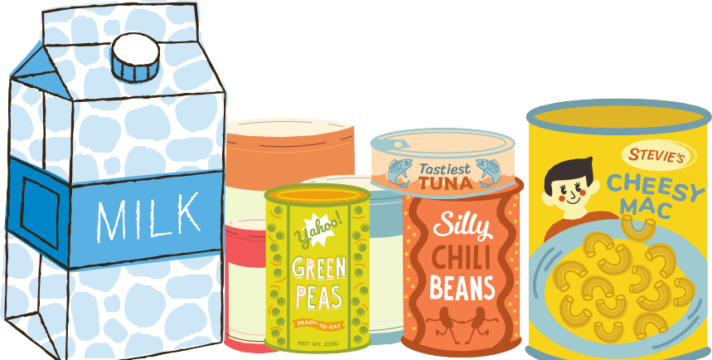
A: The food items in the bags are not expired, but they may be past their sale-by or best-by date. The food given is not expired and is still safe to eat. Concerned families can check out the USDA’s website or www.stilltasty.com

