Educational Service District 113
Capital Region Information Service Center

Qmlativ Food Service

Point of Sale & Daily Reports
March 2023



TERMS OF USE: The information contained herein is licensed, trade-secret and proprietary and may not be used, disclosed or reproduced without permission of the licensing authorities, WSIPC, Skyward, Inc. and/or the Information Service Center. As a condition of use, the User agrees to protect and keep the information from disclosure or falling into the public domain. The failure to comply with this agreement may result in the immediate termination of the User’s right to access the information.

Original Publication developed in collaboration between:

Capital Regional Information Service Center (CRISC)

All rights reserved. Reproduction of any part of this manual, in any medium without written permission of Regional Information Service Centers is prohibited.
This edition is printed in the United States of America and the contents are subject to change without notice.
Skyward ® is the registered trademark for Skyward, Inc. located in Stevens Point, Wisconsin

Point of Sale

- Make sure you are in your school (top of screen) and click the green 3 bar menu button. Go to Administrative Access > Food Service > Features - Point of Sale
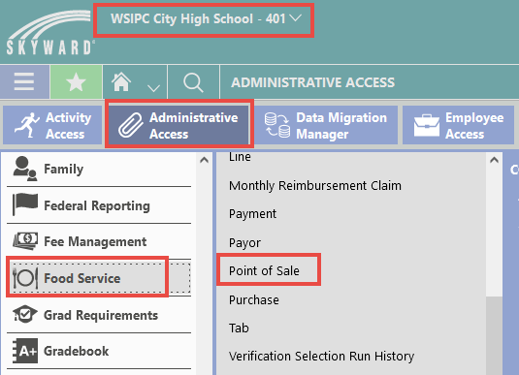

- Choose your Line:
  - Each building has one or more lines for cashiers to select from depending on your district configurations

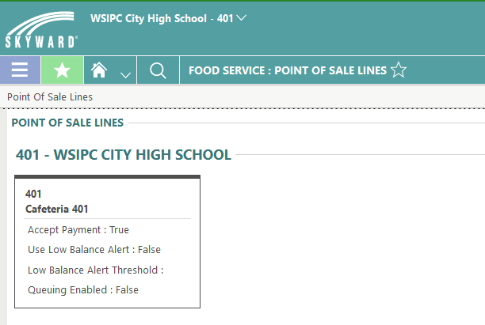

3. In the top right corner of your screen, click POS Settings
- This allows you to Disable the standard item, the default is Enabled which means a standard item (breakfast or lunch) will be added for EVERY student that goes through the line
  - This is helpful to speed up the line
- If you have an A La Cart line, no default item would be used so you would disable the Standard Item
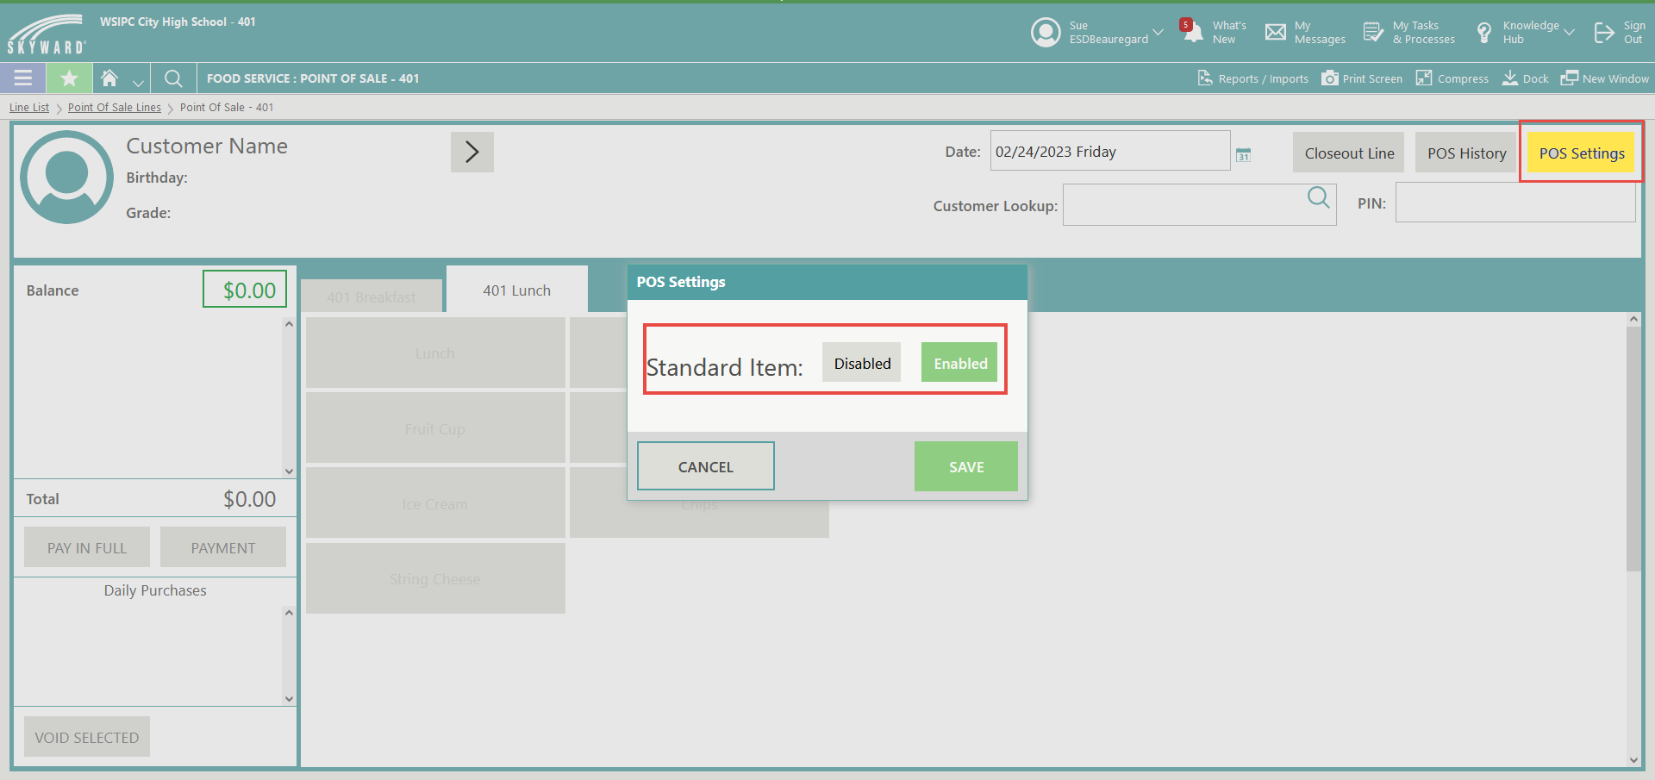
- There is no other configuration or setup on the Point of Sale Screen

How to Use:
- Lunch and Breakfast Standard Items will default based on the time of day
- On the Key Pad, enter the pin of the student
  - The leading zero must be entered as part of the pin
- Or, where available, use Barcode Scanner to scan student barcode
- Alternately, use the Customer Lookup to search for a student enrolled in your building
  - Note: Kitchen Managers can also look up students and staff from other buildings if necessary
- Food Buttons are dependent on the Tab selected and the time of day
- Breakfast, Lunch, A la Cart
- Breakfast and Lunch items can only be served between specific times
- If standard item is enabled:
  - Student enters PIN or barcode is scanned
  - Standard item displays
  - Click buttons to select additional items, if applicable
  - Enter PIN or scan barcode for next student, the previous student is saved automatically
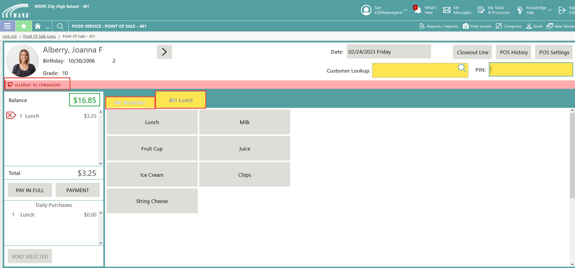
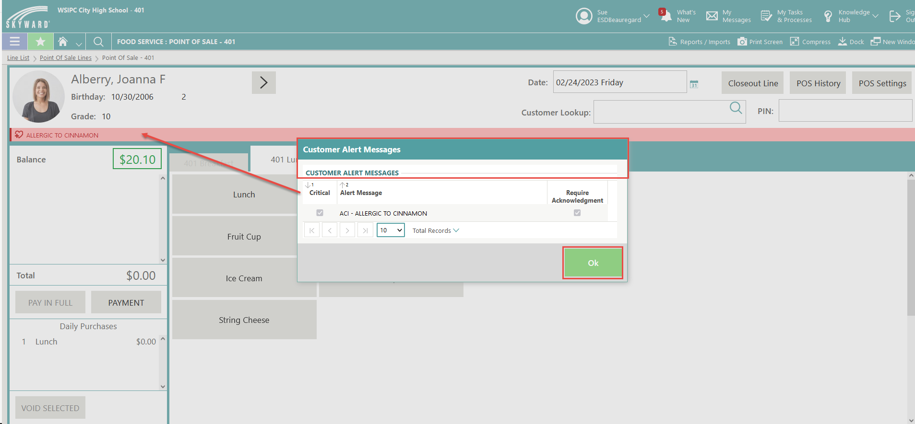
- Student Alerts will show in red, if the alert is configured to Require Acknowledgement, a pop-up screen will display for cashier to acknowledge the Critical Alert Message, select OK to continue to enter in purchase items

Corrections
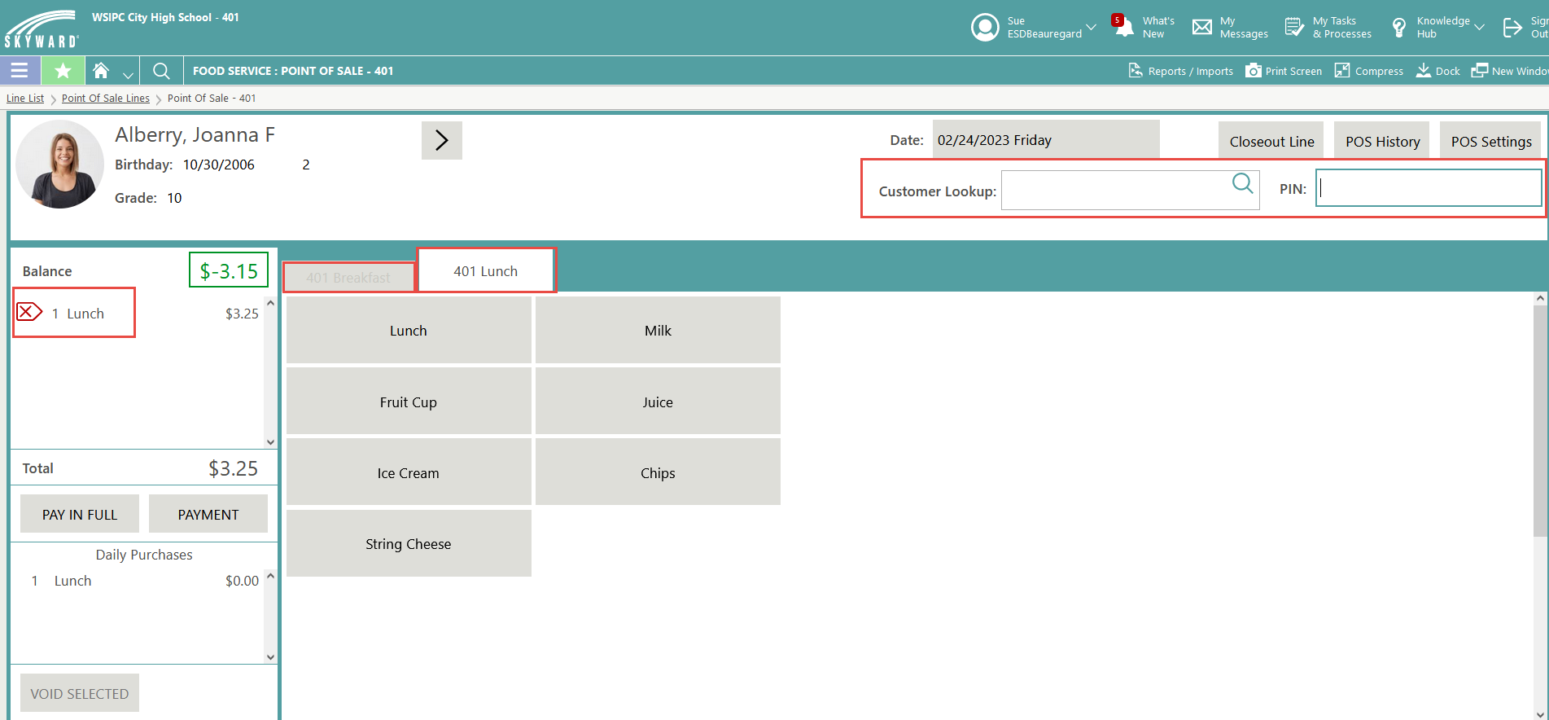
- Use the Red X to delete the item(s) from the customer:

- If you have navigated away from customer, use the Customer Lookup field to search for their name or enter their customer Pin to bring them back up.
  - Highlight the item and click Void Selected to delete the purchase and refund the account where applicable.
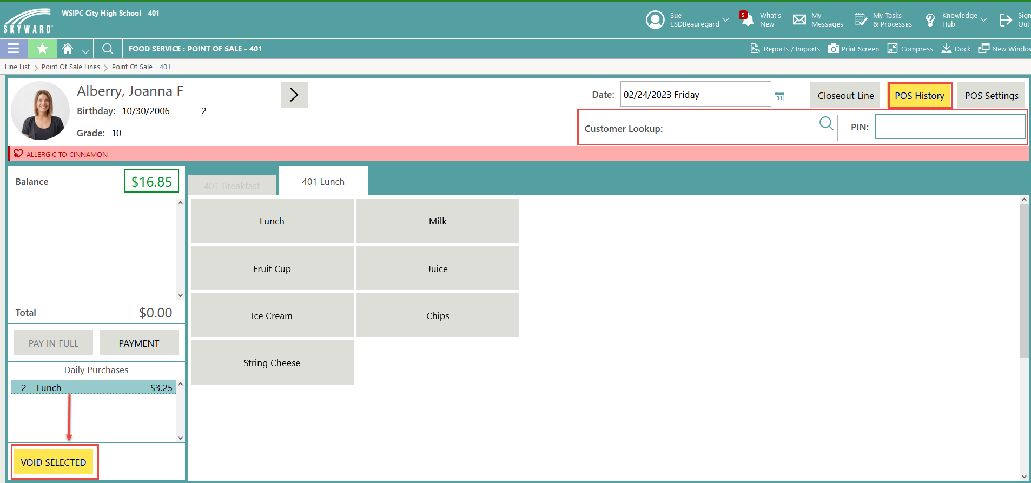
  - Note: You can use the POS History button to view previous saved purchases to determine if an item was added in error.

Cashier Close Out - End of Day (if applicable)
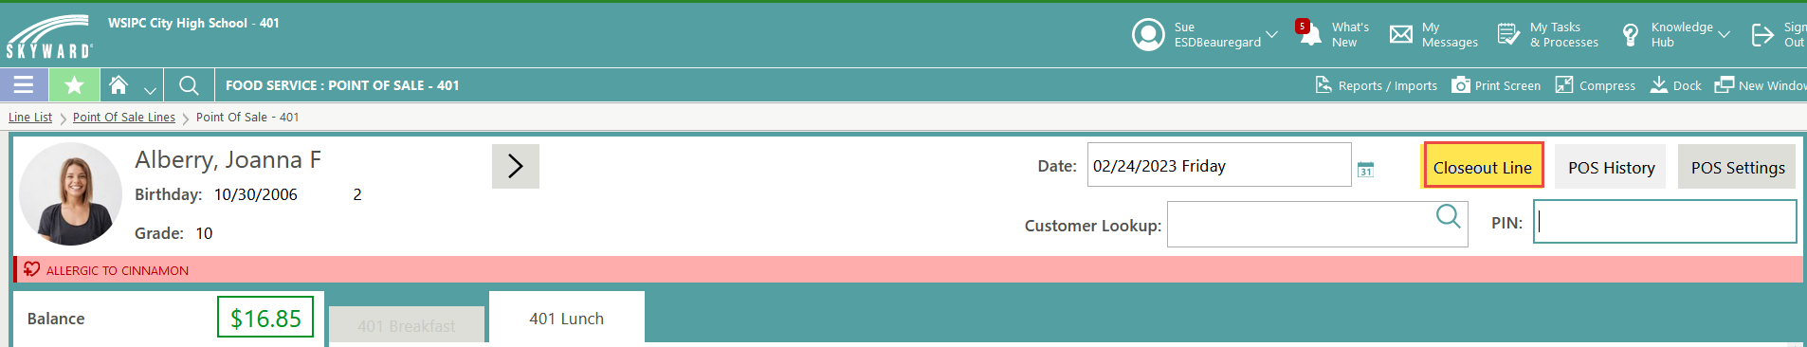
- Once purchases are complete, click Closeout Line on the Point of Sale Screen.
- A warning appears, click Yes, Closeout to confirm
- Fill out the following screen fields to reconcile your till
  - Enter the Starting Balance
  - Enter Coins and Bills and any Checks received
- Click Save and View Summary (at the top of the screen)
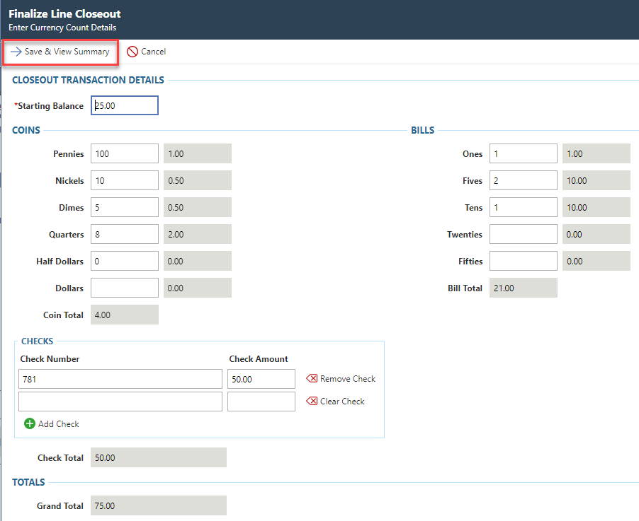

- The Finalize Line Closeout confirmation screen appears- you have the ability to make adjustments where needed.
  - Within each section of Cash, Checks, and Totals, the closeout and expected balances should have 0.00 Difference.
  - If an error was made, click Try Again to update/adjust numbers.
  - Choose Finalize to complete and close your day.

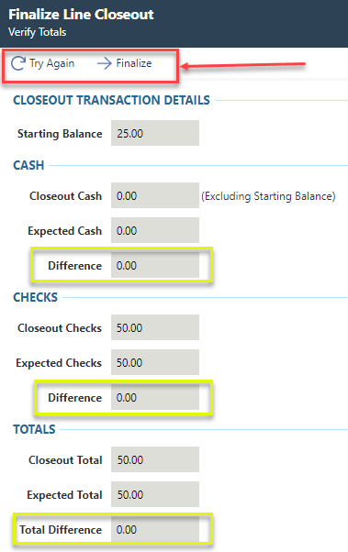

Payments in the POS line:
Make sure you are on the customer you are receiving the payment from. Some examples:
- If Amount Applied is the same as amount received, the balance will go into their account (no change).
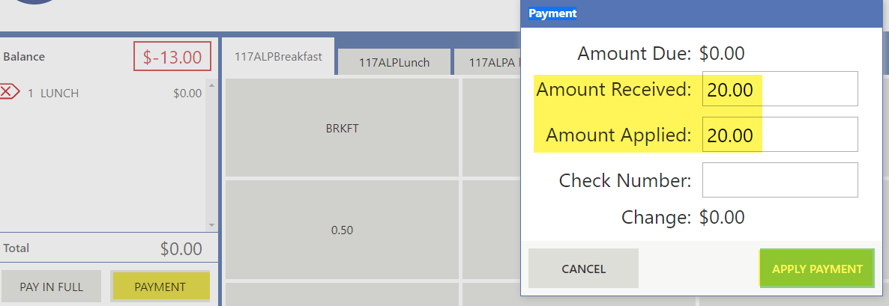

- If Amount Received is More than Amount Applied, change will be given.
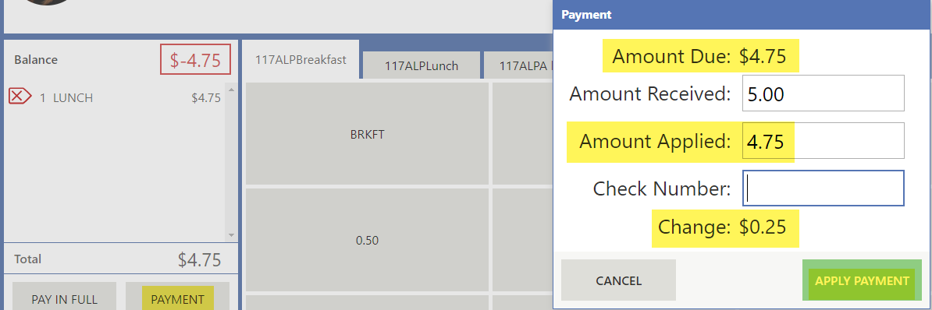

- Use Pay in Full if the customer gave exact amount due.
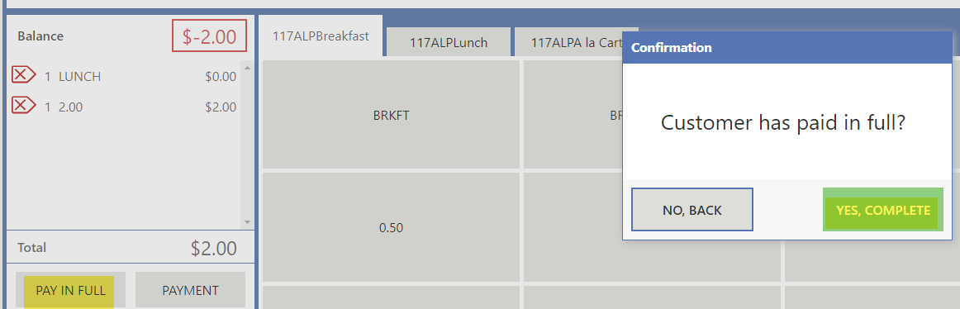

Q & A
- - When we have already done the closeout for the line, then we see a mistake and we go back and void it, the system will not let us do another closeout. Is there some way to save what we have done besides entering another student.
  - If you enter the line again just to void a sale, you will bring up the student highlight the item to void, then click the next arrow at the top. You will get the following message, click yes Complete.
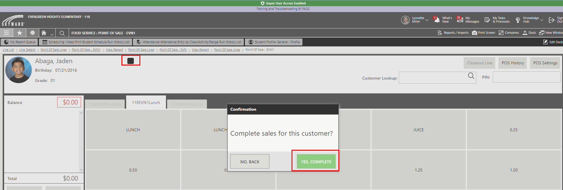

  - Once complete if you exit the line and come back in, you can Closeout the Line- it will become sensitized. The sales activity report will show multiple closeouts.
  - Hopefully most mistakes will be found as part of the closeout where you can "Try Again".
  - Sales Activity report example with multiple closeouts:

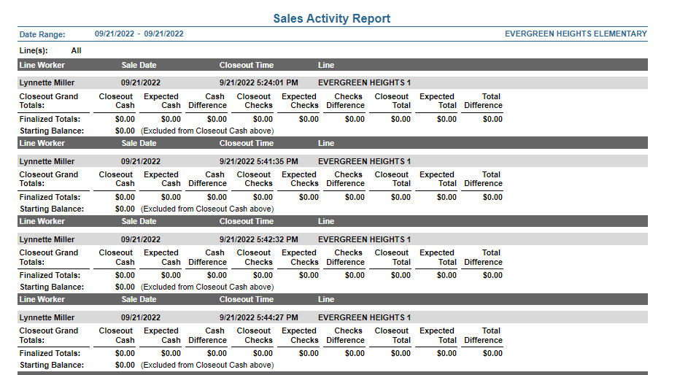

- Is there any way that when we scan the student, we can look up their number besides doing the POS history?
  - If you start typing their name in the customer lookup, you can see the pin:
