Canvas Observer Accounts

Canvas Observer accounts are a great way to observe your student’s online classroom. With an observer account you will be able to view class announcements, view assignments, and view the class calendar.

To create an account on your computer, please follow these steps:
- Log into your Infinite Campus parent portal account, https://campus.rockdale.k12.ga.us/campus/portal/parents/rockdale.jsp
- Click on “More” and then “Canvas Observer Account Info”
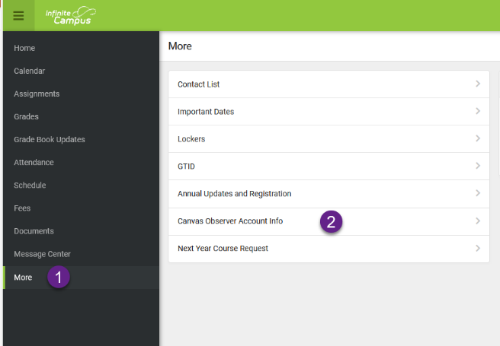
- Check the box for “I want a Canvas Observer Account” and then click “Save”
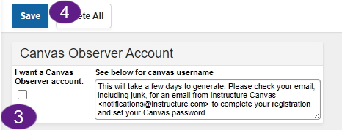
- Within the next few days (it is not immediate) continue to check your email inbox linked to your Infinite Campus Parent Portal account, for an email from Instructure Canvas notifications@instructure.com. Please check junk/spam/clutter/etc as well.
- The email you will receive will resemble the screenshot below. It's important to be aware that the link included in the email will be valid for a single use within seven days of being sent. We encourage you to promptly set up your account using the provided link.
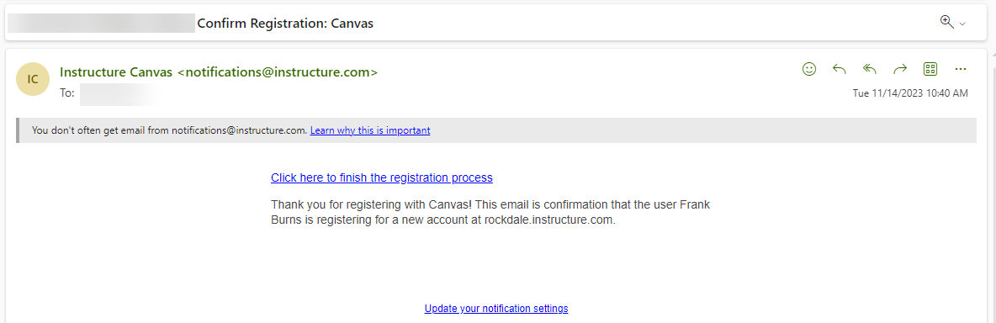
- Once setup, you can access your account from https://rockdale.instructure.com/login/canvas on your computer. You can also login from the cellphone app by
  - Download the Canvas Parent app by Instructure from the Google Play or Apple Stores
  - Click Find School
  - Choose Rockdale County Public Schools – Parents
