ACCESSING THE FORM
1. Select the SPPS Fed Form
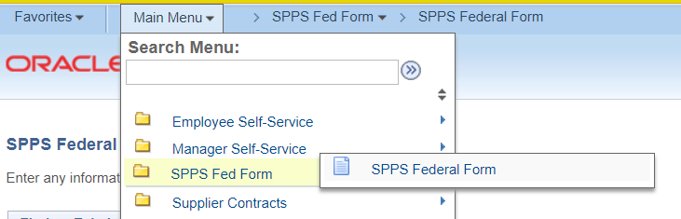

2. Click on the Tab “Add a New Value” 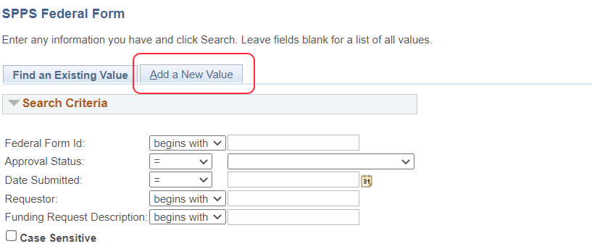

3. Click the Add Button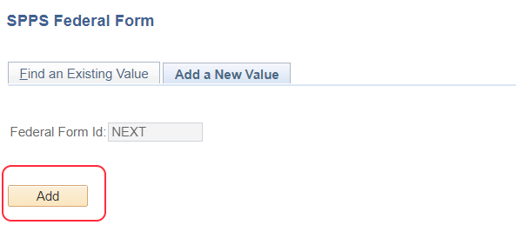
4. This brings you to the first page of the form. Note there are two tabs on this form and both have to be filled out before submitting. Note that the form changes depending on the *Transaction Type. 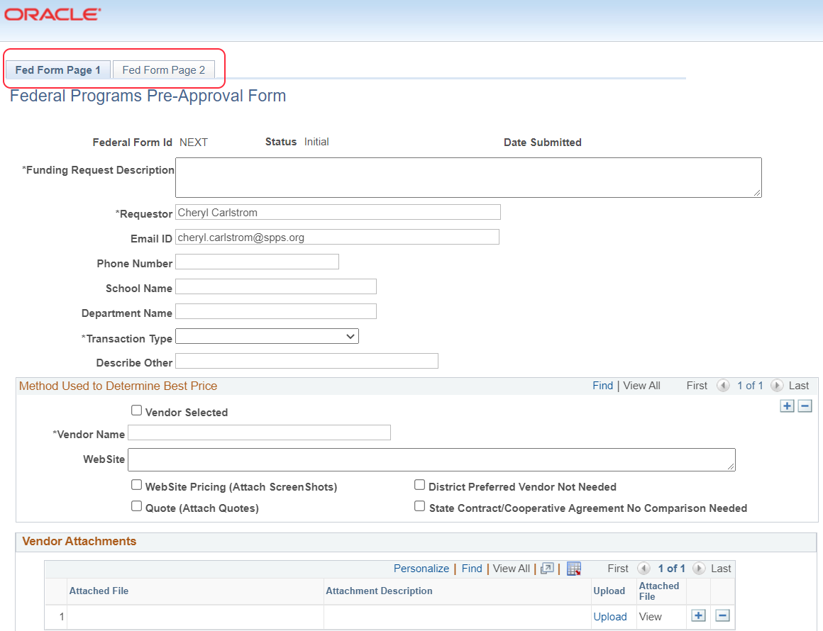

DETAILS ABOUT FILLING OUT THE FORM
1. * Funding Request Description (this can be seen from the approval list) before the form is opened. It is helpful if you are very descriptive here: [Name of Funding Source] [Name of School or program] [What is being ordered] Here are a few examples:
2. The *Requestor and *Email ID are auto filled in with the name and email of the person initiating the form.
3. Other contact information. 

4. Transaction Type – This is important to select because the form will change on tab two depending on what is chosen. Title I schools will request preapproval for these items and orders on PCards.
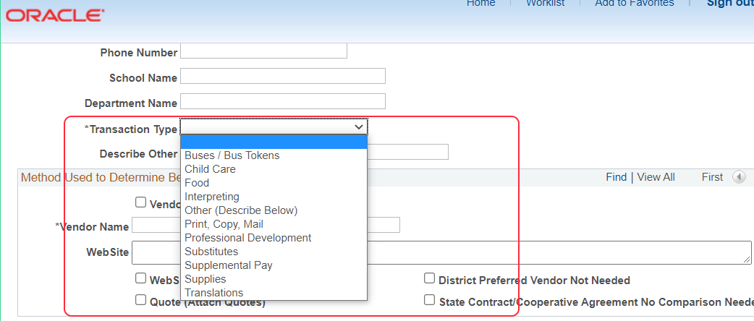

5. Show best value (Vendor Comparison Pricing) Put the first vendor into the form. If it is the vendor you will be purchasing from, click the Vendor Selected box. If you compared pricing on the web, put in the website where you got the information. Chose other options as they apply. NEXT: Click the plus sign and add the second vendor that you compared pricing with. Do the same as you did for the vendor selected. (if you didn’t compare on a website, then upload the quote, or other documentation to show how you arrived at your choice in the Vendor Attachments).
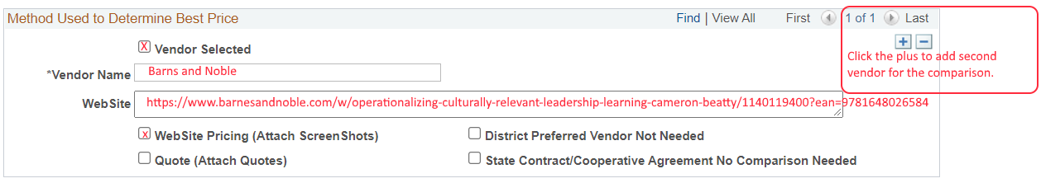
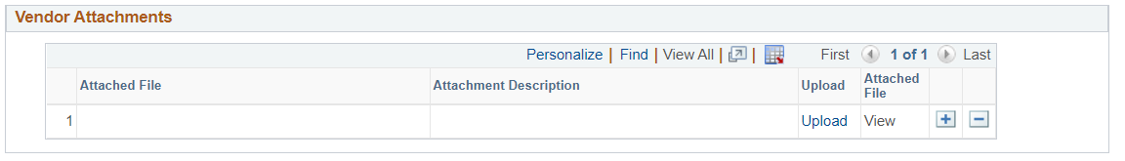
6. Budget for order. Please put the budget codes into the form for what you are ordering. If you would like you can show how things will be split funded if that is something you wish to do. To add additional budget lines click the plus sign. The totals can only add up to 100% or you will get an error.
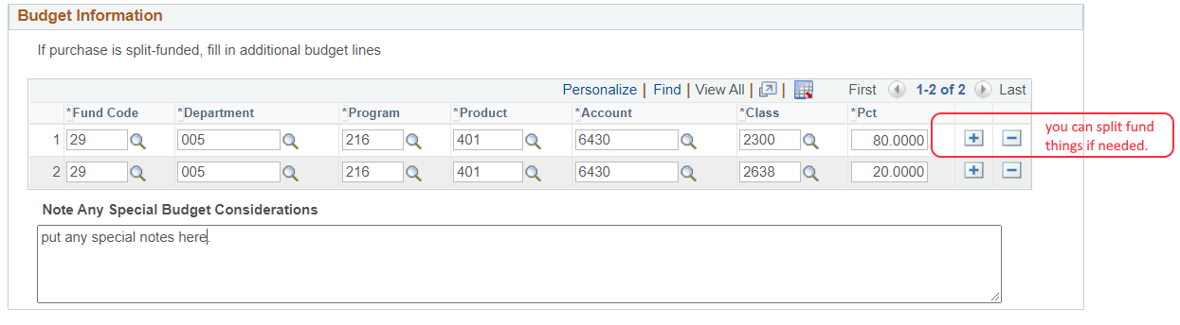
7. Go to next tab in the worksheet. This page will change depending on the type of transaction you selected on the first page. 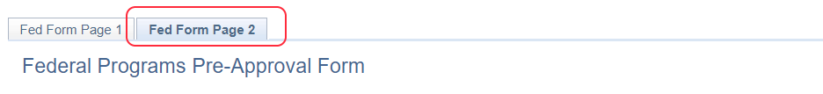

8. Items to be ordered. Please list the items to be ordered here. The process for this part of the form changes depending on what you are doing.
- For Professional Development – attach the PD agenda, conference paperwork, etc to the Vendor Attachments area. Then fill out this part of the form on page with
  - # attendees (quantity), name of conference (description), unit price cost, total cost per participant will be calculated.
- For supplies, list the supplies. Click the plus sign to add more rows. If you have a huge order, then put in one line that says
  - Quantity 1, Description –See attached order (upload into the Vendor Attachments Area), Unit Price put in the total cost.
Examples of different ways to fill out this part of the form.
Listing items for a simple order.
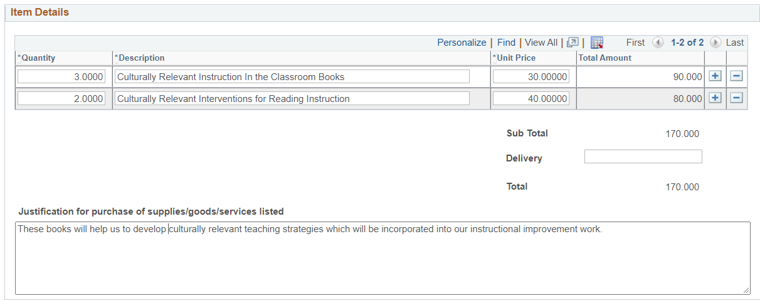
For a large order and you don’t want to list each item.
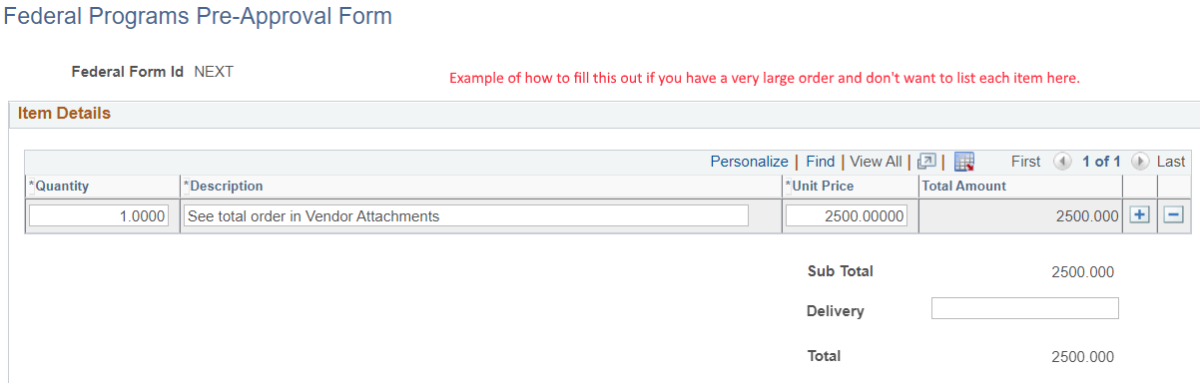

Remaining Sections of the Second Page
9. The last half of the page will change depending on what transaction type you chose. See examples below.
Example of Food Order Request
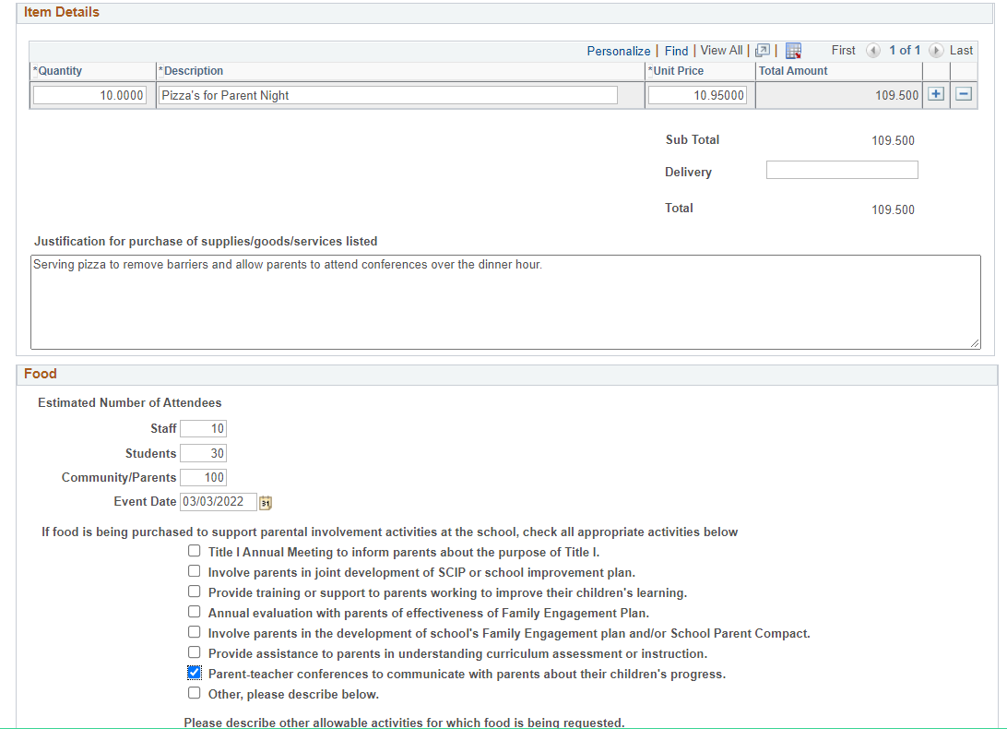

Example of Professional Development
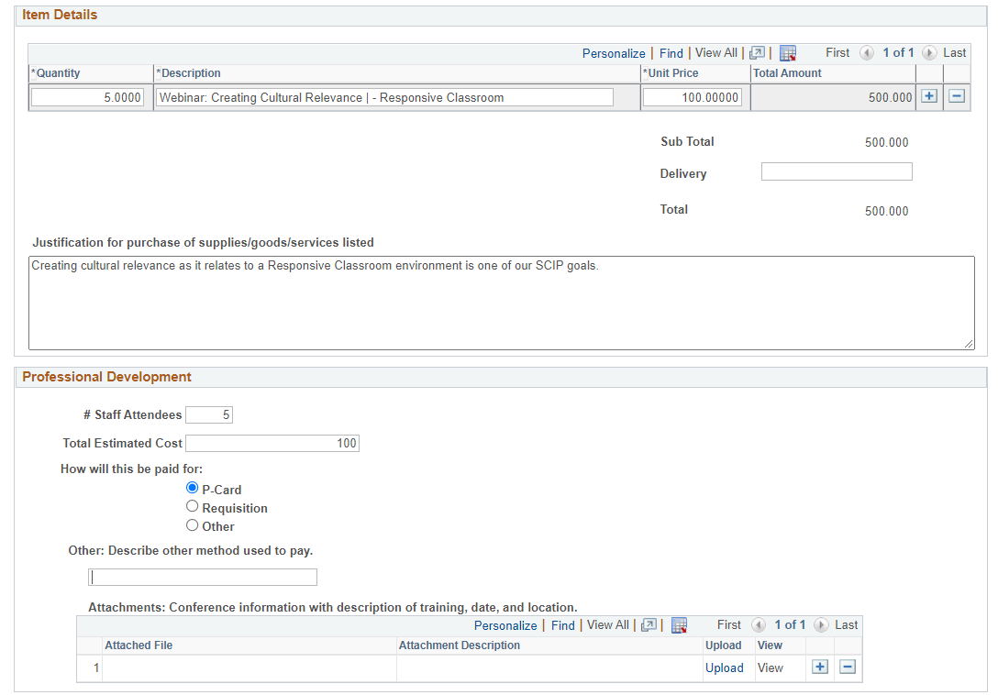
Example of Interpreters
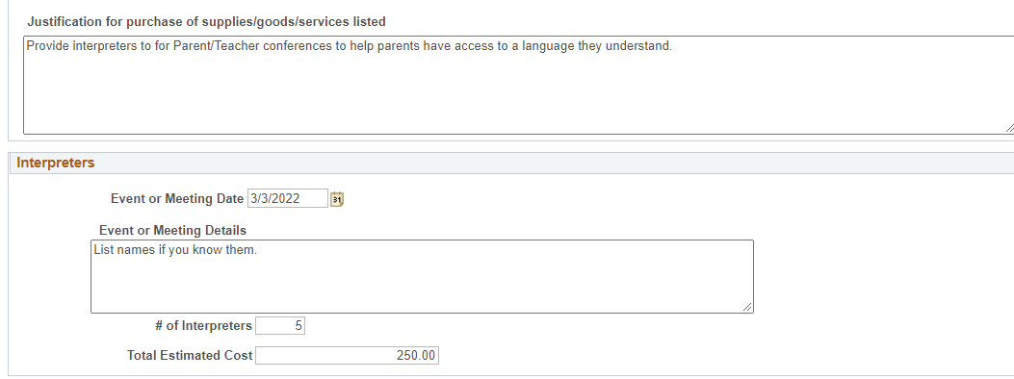

For the remaining types of transactions, refer to the Title I website for the information that is needed. https://www.spps.org/Domain/10168. Examples are listed for each budget code and purchase.
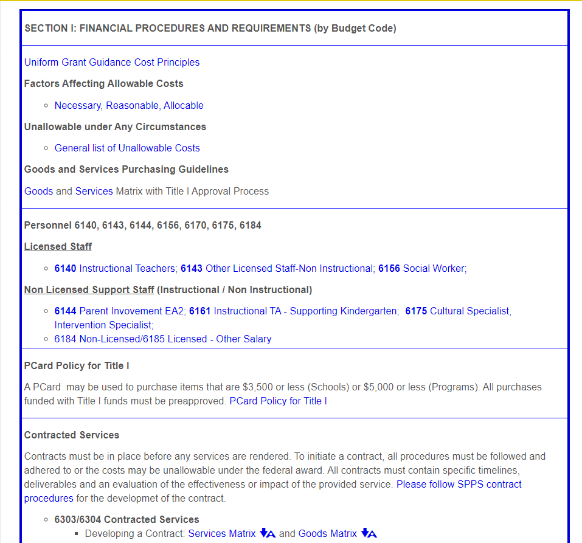

Approvals and Denials
10. Once you have completed the form, submit it for approval: The routing for the order form follows:

For additional assistance, please reach out to the Title I office team.

