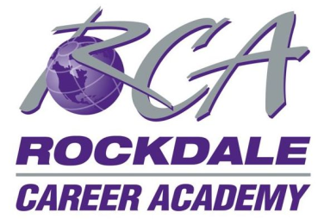
Rockdale Career Academy Board of Directors Special Called Meeting
Wednesday, March 7, 2018, 9:15 am, Conference Call Online Meeting

Present: Benny Atkins, Sherry Lowery, Marty Jones, Katy Zahradnik, Gina Hartsell, Laurent Ditmann, Mark Kennedy, Marianne Freeman, Courtney Jeffcoat, Dionne Johnigan, Larry Perry, Cathy Smiley, Irvin Clark, Monica Crafts
Chairman Sherry Lowery welcomed everyone to check in to be marked as present, and called the meeting of the Rockdale Career Academy Board of Directors to order at 9:15am. Sherry Lowery confirmed that 13 of 14 board members were present, making a quorum.
Chairman Sherry Lowery announced that the purpose of the special called meeting of the RCA BOD is to officially vote on the RCA Governance Committee’s formal recommendation of the top candidate for the position of CEO/Principal of Rockdale Career Academy (that was previously held by Dr. Edwards in 2017). Sherry Lowery recapped the highlights of the Governance Committee’s previous meetings with RCPS administrators and BOE members regarding the recommendation of candidate, etc., specifically that from 29 original applications, top 10 candidates were chosen for review. The top 10 candidates were narrowed down to 6, with the final top candidate chosen by the RCA Governance Committee to recommend to the full RCA BOD for approval to be presented to the RCPS Administrators for recommendation to the RCPS BOE on March 8th, 2018. The RCPS BOE will formally vote on the recommendation at the March 28th RCBOE meeting. General discussion followed.
Sherry Lowery called for the formal motion to approve the recommendation of candidate discussed to the RCPS Administrators. Marty Jones made the motion to approve and Benny Atkins seconded the motion. Each member present individually spoke their vote of yes and the motion carried.
Sherry Lowery stated that at the end of the meeting she would send the follow up email to RCPS Administrators Mary Ann Suddeth and Shirley Chesser advising them of the RCA BOD’s recommendation.
The next scheduled meeting of the Rockdale Career Academy Board of Directors is March 28th, 2016 at 10 a.m. at RCA.
There being no further business, Sherry Lowery asked for a motion to adjourn. Katy Zahradnik made the motion and Mark Kennedy seconded the motion. The meeting adjourned at 9:40 a.m.
Respectfully submitted,
Gina Hartsell
RCA BOD Secretary

