Getting Email Updates on Your Child's Work (Parents)

/
Once you have logged into Renaissance Home Connect, you can set up email updates about your child's work. Depending on the software that your school has and the settings they have chosen, you may be able to get emails when your child takes Star tests or Accelerated Reader quizzes or when your child finishes assignments for Accelerated Reader 360, Accelerated Math Instructional Practice, or Star Custom. Each email will show you the score for the activity that your child completed.

 Emails about your child's work will come from autodelivery@renlearnrp.com; make sure this email address is exempted from junk or spam email filters.

Follow the steps below to set up email updates. You may add up to six email addresses per student.

How to Get to the Page
- Log in to Renaissance Home Connect. To do this, go to the website address that your school provided, and enter your user name and password. Then, select Log In.

 If you have more than one child using the software, you must log in separately with each child's user name and password and set up your email
preferences for that child.

- Once you are logged in, select Get Email Updates on the right side of the page. Note: This button is not available if your school's preferences don't allow emails to be sent for any programs.

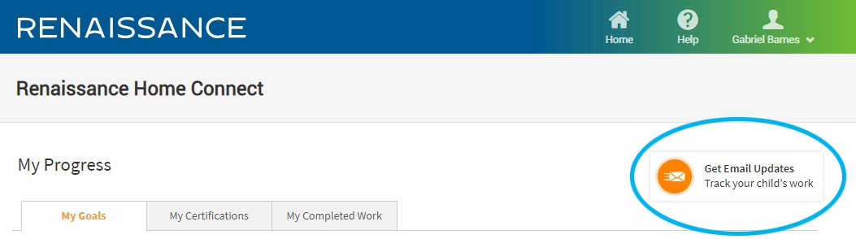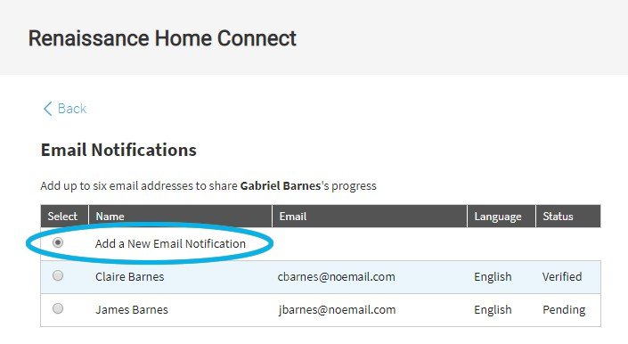

/

How to Add a New Email
- If this is the first email address you're adding, go to step 2.

If you have already entered other email addresses, make sure Add a New Email Notification is selected at the top of the page.

- On the Email Notifications page, enter your name under "New Email Details." Then, enter your email address in the two blanks provided.

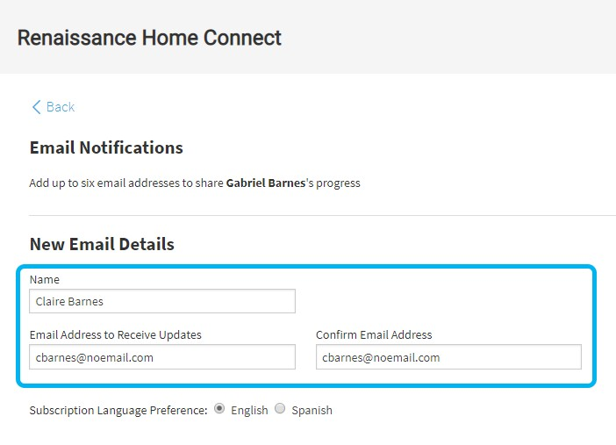

/

- Under the fields for your name and email address, choose whether to receive email updates in English or Spanish.

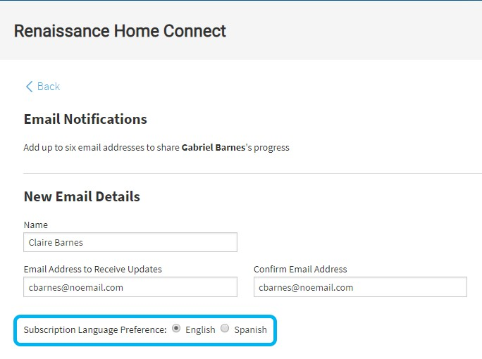

/

- Under Email Notifications Preferences, check the boxes for the activities that you'd like to receive updates about. The activities that you can check depend on the software that your school has and the emails that the school has chosen to allow. The choices that you make apply to the email address that you are adding.

Star Early Literacy, Star Math, and Star Reading assessments are short tests that provide teachers with learning data. Star tests are computer-adaptive, which means they adjust to each answer your child provides. This helps teachers get the best data to help your child in the shortest amount of testing time (about one- third of the time other tests take). Star tests may be available for early literacy, math, or reading, and they may be available in English or Spanish.

Star Custom gives students brief tests on specific skills.

Accelerated Reader quizzes show how well students understand the books they are reading. Students take quizzes on books they have chosen; they may also take quizzes on stories they've read in their textbook.

In Accelerated Reader 360 Instructional Practice, students read nonfiction articles, answer questions about the articles, and take a quiz. These assignments

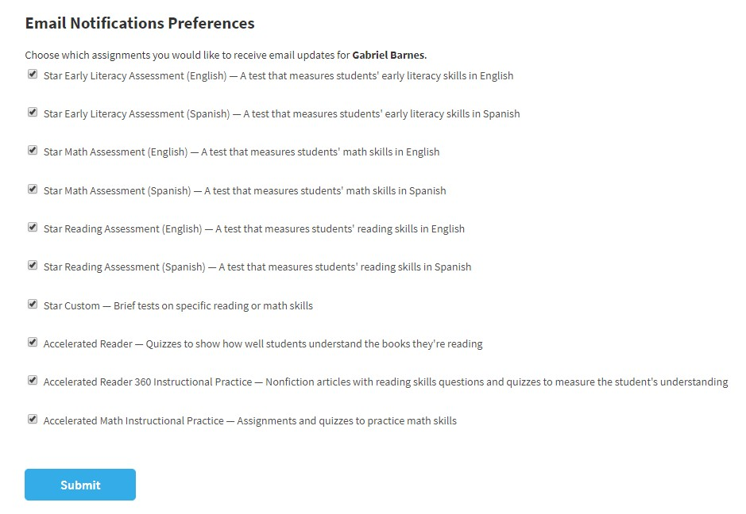help teachers understand how students are doing on specific reading skills.

/

Accelerated Math Instructional Practice assignments help students practice the math skills that they are learning at school.

- When you're done, select Submit.

- A message will tell you that a verification email has been sent. Click OK in the message.

- When you receive the verification email, click Verify Email Address in the email to verify your email address. You will be taken to the Email Verified page to confirm that this has been done.
The next time you go to Renaissance Home Connect, you will see your email address listed in a table at the top of the Email Notifications page. You can repeat these steps to add up to six total email addresses, all of which would be listed in the table. The table shows you which email addresses have been verified; only those addresses will receive emails.

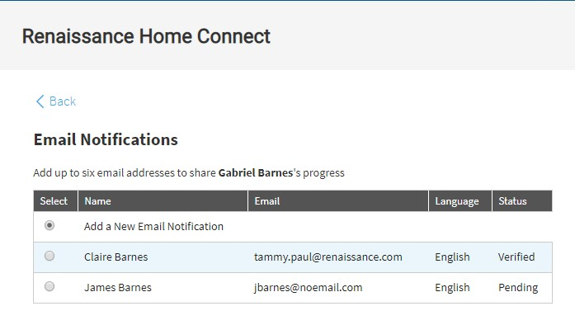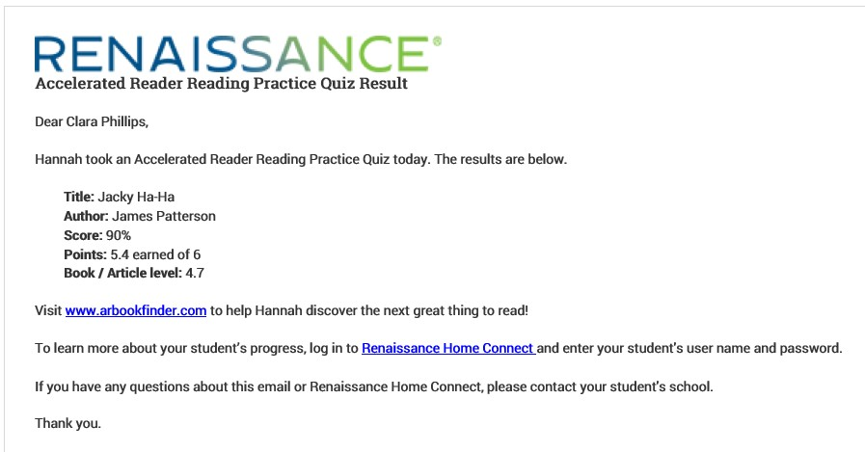

/

When your child completes one of the activities that you chose, you will receive an email. The example below shows an email about a child's Accelerated Reader quiz:

How to Change the Emails You Receive, Your Name, or Language Preferences
If you want to change which activities that you will receive emails about, on the Email Notifications page, select the circle next to your name.

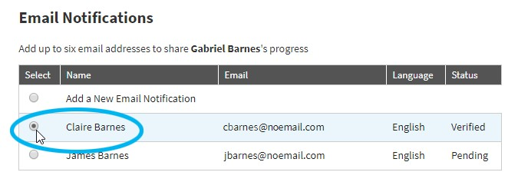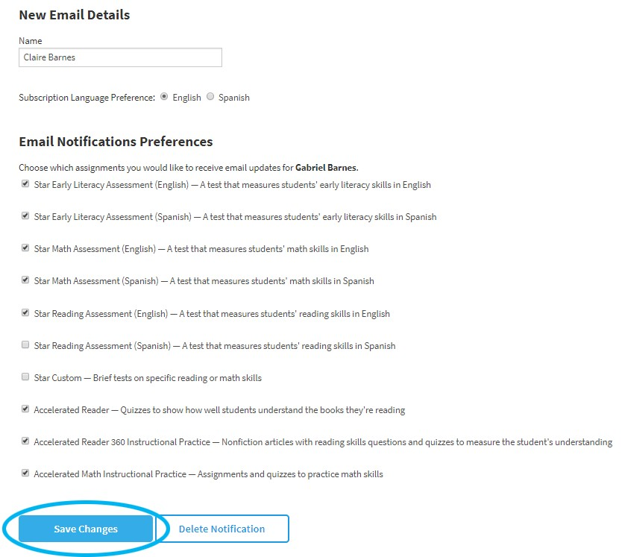

/

You can then change your name, language preference, or the activities that you will receive emails for. When you have finished, select Save Changes at the bottom of the page.

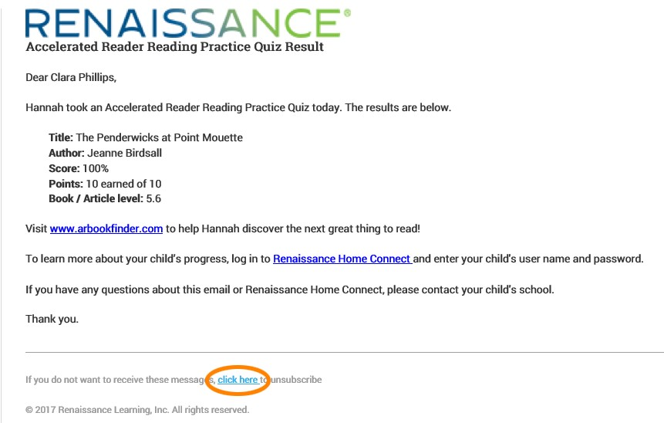How to Unsubscribe from Email Updates

/
If you no longer want to receive email updates, there are two ways to do this:

Use the Link in an Email
  - When you receive an email update from Renaissance Home Connect, you can select the link for unsubscribing (shown below):

  - The link will open the login page for Renaissance Home Connect. Log in with the student user name and password.
  - To confirm that you want to unsubscribe from emails, select Confirm.

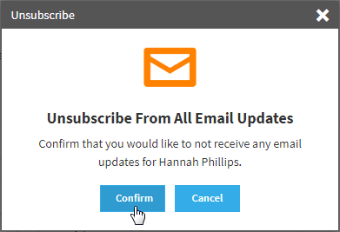

/

  - When a message tells you that you have been unsubscribed from all email updates, select OK.

Remove the Email from the List on the Email Notifications Page
- Go back to the Email Notifications page as described above.

- In the table, select the circle next to your name.

- At the bottom of the page, select Delete Notification.

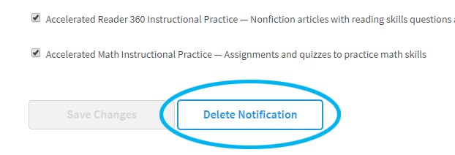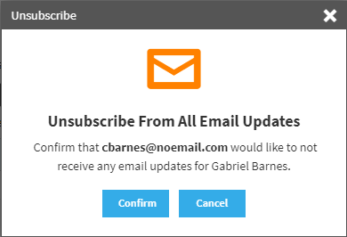

/

- To confirm that you want to unsubscribe from emails, select Confirm.

- When a message tells you that you have been unsubscribed from all email updates, select OK.

 Véase la versión en español de este tema de ayuda. (24007Sp)

Related Topics:
Viewing Your Child's Reading Goals (Older Students) (24001)

Viewing Your Child's Reading Goals (Primary Students) (24002)

Viewing Your Child's Reading Certifications (24003)

Viewing Your Child's Completed Work (24005)

TOPS Reports (24006)

© 2020 Renaissance Learning. All Rights Reserved.

/

