Committed to World-Class

Star 360:
What is it, why and how we use it, and interpreting your student’s report

Parent Academy September 26, 2020

Opportunities and
Possibilities
Andrea Pritchett, Director of Curriculum and Instruction Charlene McGlockling, Reading Coach

RCPS: Vision & Mission

The Vision of RCPS is to be a world-class learning community where all students graduate college and career ready in a progressive and interconnected society.

The Mission of RCPS is to ensure student success for all through a world-class education with advanced opportunities and personalized support.

Are students learning?

The only way to know whether learning is taking place is to measure it. By doing so, we are able to:

Provide | students with the appropriate level of instruction.
Identify | students who need additional assistance and enrichment.

Analyze

problems occurring within grades or classes, set learning goals, and make plans for meeting those goals.

Determine

whether the instruction and interventions provided are effective.

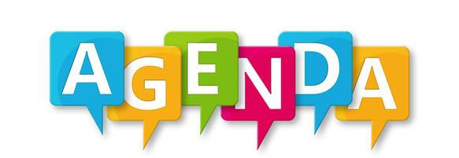

•What are Star Assessments and what do they measure?
•Why do we utilize Star assessments?
•How long does it take to complete a Star assessment?
•What are the questions like?
•What kind of scored does your child receive?
•How are the results used?
•How will you know how your child is performing?
•What are some resources available for me to use as a parent?

What are Star Assessments?

•Star assessments are:
- short tests that provide teachers with data about learning early literacy skills, reading, and math.
- computer-adaptive tests, which means they adjust to each answer your child provides
  - If your child answers a question correctly, the next one is more difficult.
  - If he or she answers incorrectly, the next one is easier.
  - Provides educators with quick and accurate estimates of developed skills

•STAR assessments are used for screening and progress-monitoring.

•Star assessments are rated as accurate, reliable, and valid by the National Center on Response to Intervention.

How does computer-adaptive testing work?

More Difficult

Easier

Items answered by a student

Correct
Response
Incorrect Response
Standard Error of
Measurement

Renaissance Learning

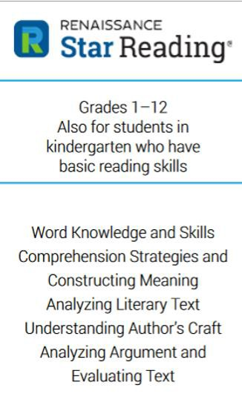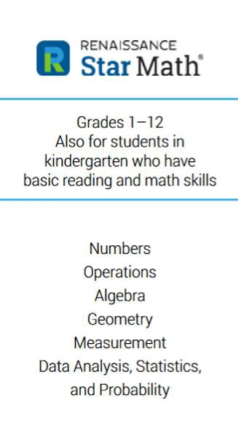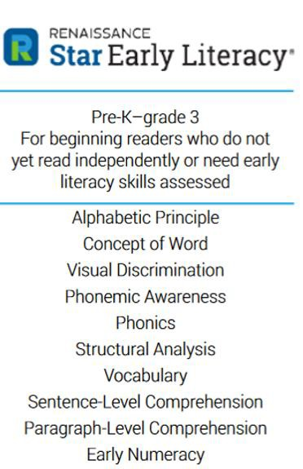What does each assessment measure?

Why do we utilize Star Assessments?

•Identify which students are reaching expected benchmarks
and which need intervention.
•Identify what skills students are ready to learn.
•Helps to design instruction for students at all levels.
•Monitor growth within the school year and year-to-year.
•Gives teachers an early warning of which students may be at risk of not meeting proficiency requirements.
•Helps to identify trends, patterns,and effectiveness across the district.
•Forecasting state test proficiency.

STAR assessments are designed to be
as efficient as possible.

Students should be able to complete
test in about 15-20 minutes.

Students with an Individual Education Plan (IEP) are provided more time if required.

How long does it take to complete a Star assessment?

How will students’ results be used?

- Star results are used for one or more of the following reasons:
  - measuring your child's general achievement in reading, math, or early literacy.
  - identifying what skills he or she is ready to learn.
  - helping plan instructional support activities.
  - tracking his or her progress toward academic targets.
  - estimating his or her proficiency on state tests.
  - estimating his or her mastery of standards.

How often is Star administered?

Screening | Progress Monitoring
- All K-12 Students; 4 times a year  - Testing windows are set for the entire  district  - August 24- September 18  - November 30-December 11  - March 1- 12  - May 17-June 10 | - Given to groups of students who are  performing below grade level standards  - As often as every 3 to 4 weeks  - Used to help show if the instructional intervention is helping students to show academic growth

Each test takes approximately 15-20 minutes

12

What are the questions like?

Star Reading- Download sample items

Star Math- Download sample items

Star Early Literacy- Download sample items

Video: Administering Star Assessments Remotely

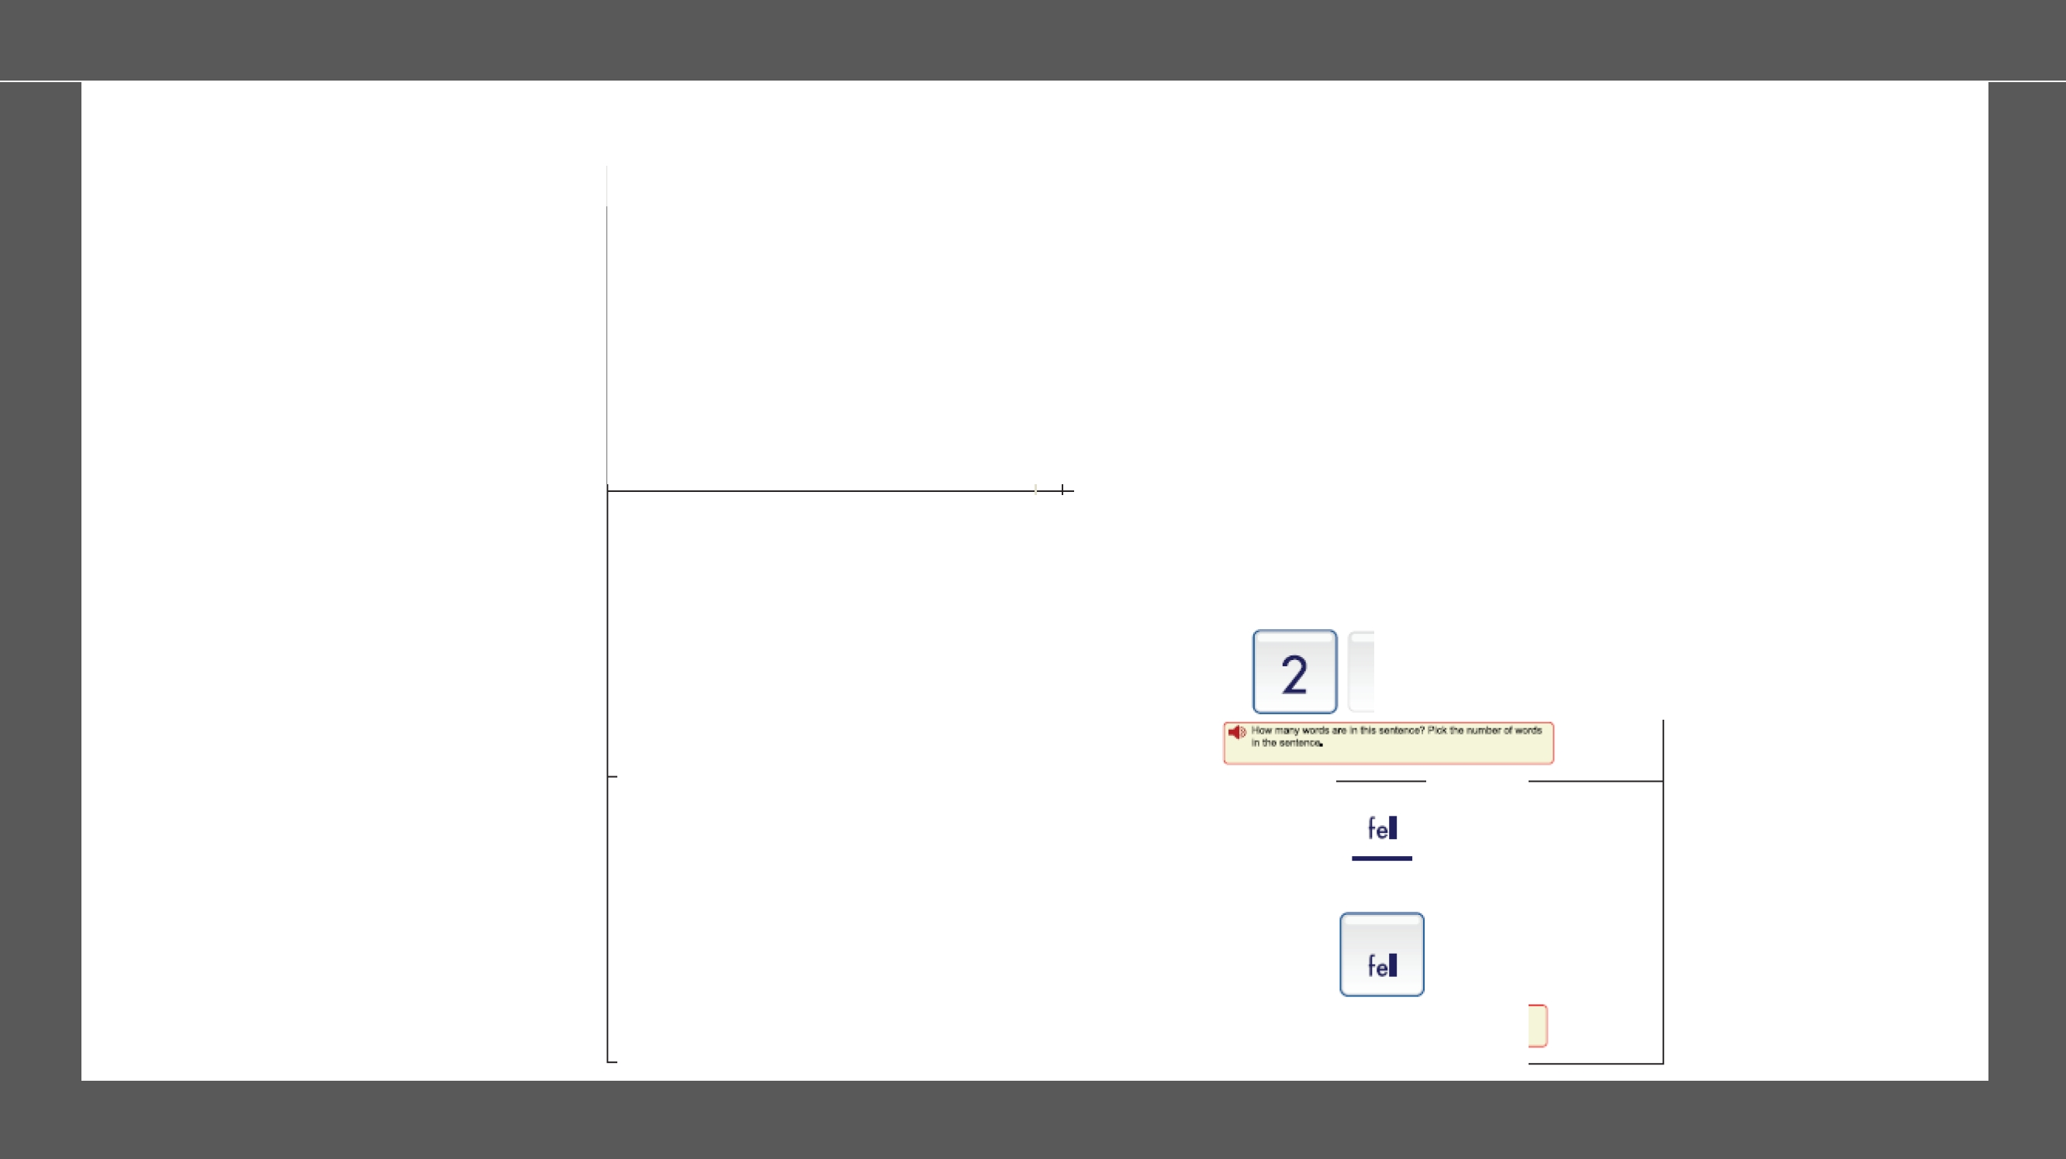Sample items
Domain

Alphabetic Principle

COYers knowledge of the namesandsounds associated w rth printed letters; the ab1hty to match upper- and
lows-case letters;knowledge of alphabeticsequence;ao:I abi rty to recognize letter sounds.

Concept of Word

COYers knowledge of the concepts about pnnt: word length. word borders;d1stmguish1ng words fromletters.

VisualDiscrimination (VS)

Focuses ontheab1lrty tomatch ord1smmnate Visually presented symbols:included symbolsareupper-and lows-case letters:also included 1s theabilrtyto
distinguishdifferences inwords.

Kindergarten
-k
h [I] t
[•Fl:llloltlllr<t:..:mal<H lllo""""" J<.
D.icb wm. 2

3 4

tell tel
.. Lo:•.•I1"0 .,._,... wo"lk. T'#0 D.."11 tJM ..,, ....j °"" II(tMero'1.
Fick '10 WO<ll ..d! IIdlllten'-

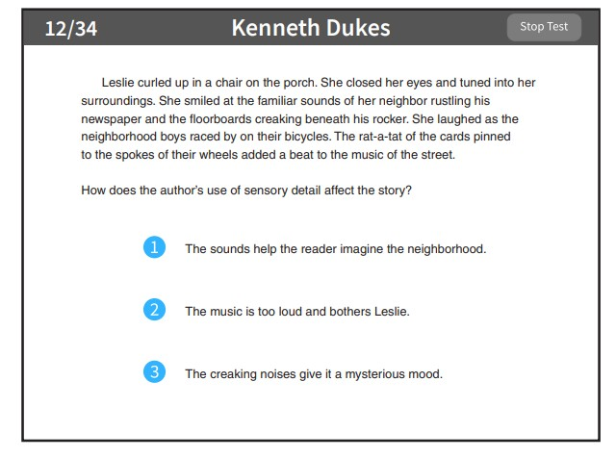

This is what the short-answer test questions looks like.

RCPS Domain
KJnd·ergarten
-man
sad him
:"41) .'"i<h ct how words bc;lmodh ti..,..lidfml? Pl<: 1to0 """'
tN< bo!lr•..tll.m!.

Domain not appticable at Grade K.
-
'4) U6on ea Ji••" oht1I ...,-: -e,-41. Pd< f'•
-..0
•l""'f
·t-4\.
Phonemic Awareness

Cova-s the understanding of rhymingwords:abilityto blend and segment words.word parts.and phoneme!;: ability to dismmmate between sounds.and theability to
identify manipulate phonemes.
Phonics

Cova-s the understanding of longvowels.short vowels, beg1nn1ng and end1ngoollSona nts.oonsona ntand vowel replacement wordfamilies (ollSet and rime).ronsona nt blends.clusters and digraphs :ability to understandthe sound-symbolcorrespondence invowels and consonants.
St,ructural Analysis

Deals with theunderstandifl!J of the structure and relationshp of words and word parts.Structuralanalysis indudes ulldersta.nd1ngthe meanlfl!J of affixes.pnnoples of sy llabrficat1on. and 1den ifyifl!J anddec:odinq compound words.



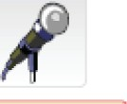



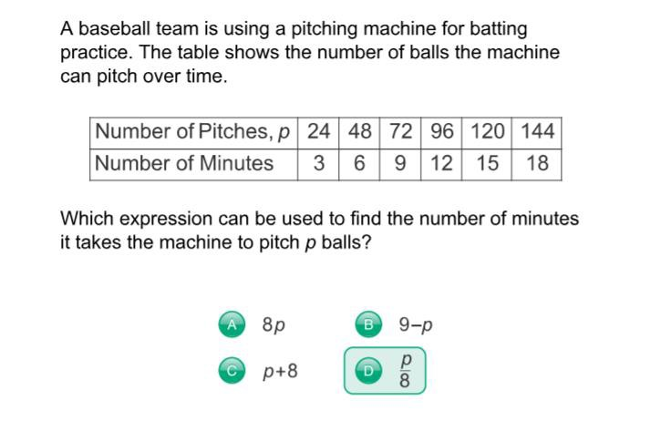Math Example
©Copyright 2017 Renaissance Learning, Inc. All rights reserved. 16

- 1st – 12th grade
- Audio support for students in grade 1
- 34 items
- Assess skills within four major domains of mathematics
  - Numbers and operations
  - Algebra
  - Geometry and measurement
  - Data analytics,statistics, and probability

16

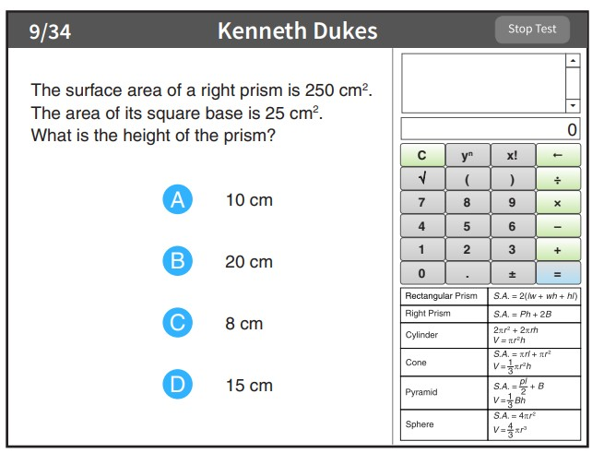Use of calculator

Some algebra and geometry questions will have an on-screen calculator and an on- screen formula reference sheet that you can use to answer the questions.

Student will click or tap the calculator buttons or press the keys on the keyboard to use the calculator. Use the scrollbar on the formula reference sheet to move up and down within it.

What kind of score does your child receive?

Scaled Score (SS)

Star Reading & Star Math range from 0 - 1400

Star Early Literacy range from 300-900
The Scaled Score is based on the difficulty of the questions and the number of correct answers.

Scaled Scores are useful for comparing your child’s performance over time and across grade levels.

The Scaled Score is not a pass or fail grade. This score is used to plan instruction.

What kind of scores does your child
receive?

▪The Percentile Rank score compares your child’s test performance with that of other students across the country in the same grade.
▪For example, with a PR of 50, your child’s math skills are greater
than 50% of students nationally in the same grade.
▪The PR Range indicates that, if your child had taken the STAR test numerous times, most of his/her scores would likely have fallen within this range.

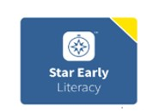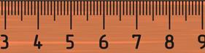
Star Early Literacy
300-900

Scaled Score

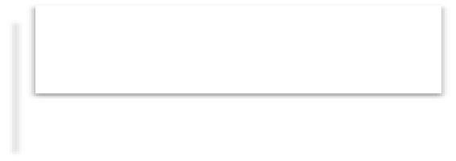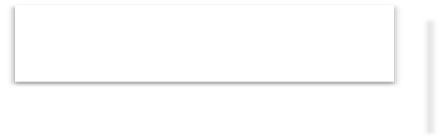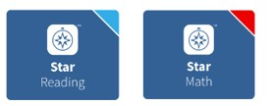
1400 SS
0 SS

Star Reading and Star Math 0-1400

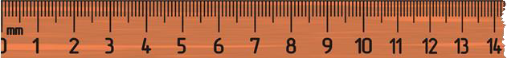

How will you know how your child is
doing?
- Your child’s teacher will share results from the Star assessments
through various reports.

- Your child’s teacher may also share ways that you can help
strengthen skills that are measured by Star tests.

RCPS
Star Reading Parent Report
School Teach er Cl ass Grade Test Date

Dear Parent or Guardian of '---------------'
._ ,!has taken a Star Reading computer-adaptive reading tesL ThlS report summarizes your child's scores on the test. As with any test,many factors can affect a student's scores. It is
Important to understand that these test scores provide only one picture of how your childis doing in school

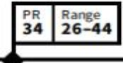

A.-age

936 Score is based on the difficulty of questions and the number of correct responses. The Enterprise scale has a range of 1400.

Scaled Score
-------

34 '--- - - - lskills are higher than 34% of students nationally in the same grade. This scoreis at average. The PR Range indlcates that,ifl Ihad taken the

Percentile Ra.nk
Star Reading test many times, most of his/her scores would likely have been between 26 - 44.

8.2 IRL is the grade level at which I Iis at least 80% proficient recognizing words and comprehending reading materials.I Iachieved an IRL score of

Instructional Reading Level
  - ., meaning he/ sheis at least 80% proficient at reading eighth grade level materials.

1105l - 1255l The Lexile• Range spans readinglevels that are appropriately challenging for reading practice. I - - - Ishould be selecting booksin this range for optimal
Lex.He•Range growth in reading.This range is approximate.Success at any readinglevel depends on your child's interest and prior knowledge of a book's content.

Iwill be using these Star Reading test scores to help I - - - Ifurther develop his/her reading skills for reading practice at school. If you have any questions about your child's scores or these recommendations, please contact me at your convenience.

Teacher Signatu re
Date
Parent Signature
Date


Ad:ftou/ comments may be.dtRd on the l»ck althtssheet

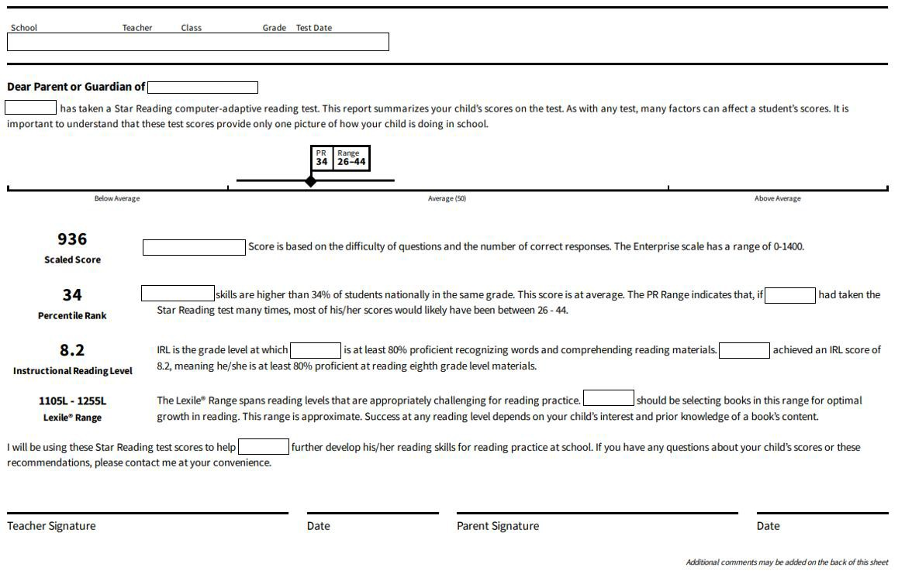
Star Reading Parent Report
Test Information

Name

Scaled Score is the most useful information. Decisions for instruction arebased on the Scaled Score.

Percentile rank is a norm-reference score
that provides a measure of a student’s
reading ability compared to other students
in the same grade nationally.
(ranges from 1-99)

Instructional Reading Level indicates the highest reading level at which a student is 80 percent proficient at comprehending material with assistance.

Lexile measures reading ability

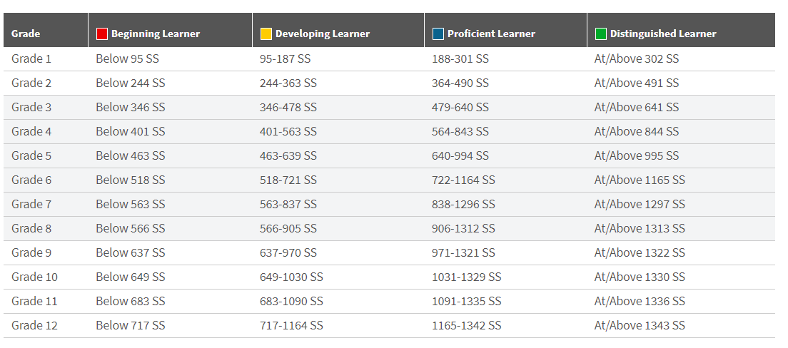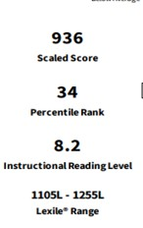

Star Reading
Scale Score Benchmark Expectations

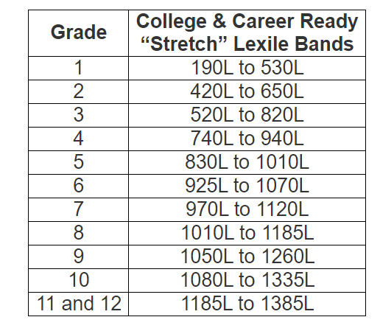Lexile Targets

- Matches a student’s reading ability
with difficulty of text material
- Interpreted as the level of book that a student can read with 75% comprehension
- 75% comprehension is the level identified by experts as offering the reader a certain amount of comfort and yet still offering a challenge

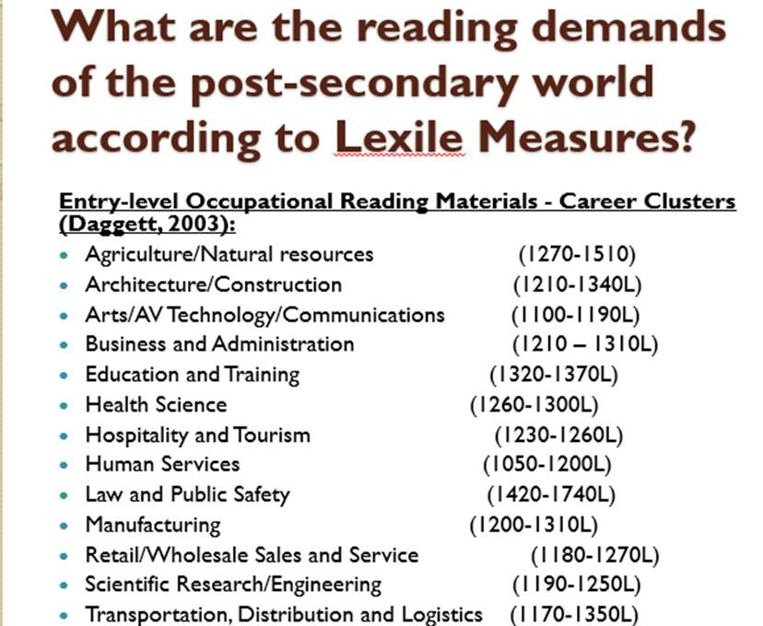

Jobs and Careers related to Lexile Measures

The Lexile Scale

Lexiles typically range from 200 for beginning readers to 1700 for advanced readers.
  - Lexile text below 200L represents beginning-reading material.
̶ A student’s Lexile score may have a number in the 100s or
the code of BR (for Beginning Reader).
  - Applies to both reader ability and text difficulty
̶ When reader and text measures are the same, the student is expected to read with 75% comprehension.
  - Can be used to track reading growth over time
Richard Woods, GGeeoorrggiiaa’’ss SScchhooooll SSuuppeerriinntteennddeenntt ““EEdduuccaattiinngg GGeeoorrggiiaa’’ss FFuuttuurree””
 gadoe.org

27

Nancy Guinn Memorial Library
Register your child for a library card to receive access to thousands of books, videos and services through Georgia
PINES Library System available at our local library.

https://conyersrockdalelibrary.org/
https://gapines.org/eg/opac/home

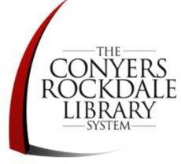https://gapines.org/eg/opac/register

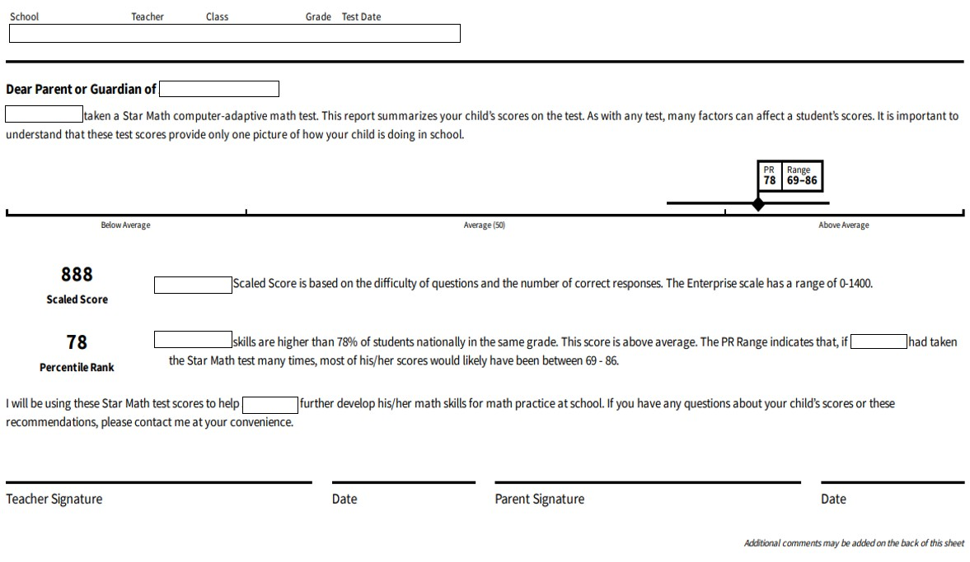 Star Math Parent Report
Test Information

Name

Scaled Score is the most useful
information. Decisions for
instruction arebased on the Scaled Score.

Percentile rank is a norm- reference scorethat provides a measure of a student’s reading ability compared to other
students in the same grade
nationally. (ranges from 1-99)

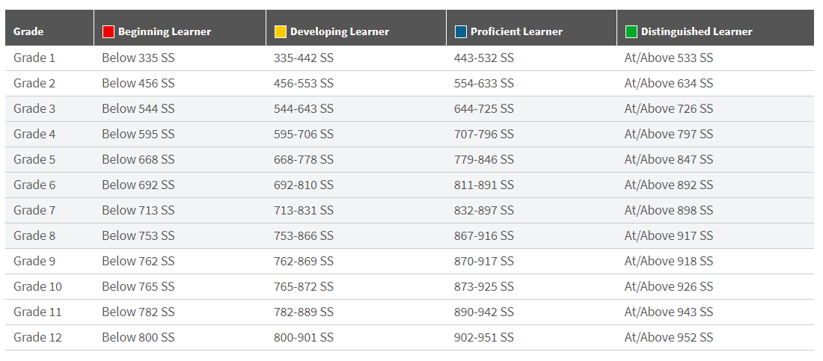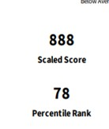Star Math
Scale Score Benchmark Expectations

RCPS
RENA ISSA NCE

Reading

    - Enter your class-leveldata.

Grade 6 v Month
August v
Benchmark
SAT Math
STAR ACT/SAT Bench mark Tool

Math

    - Enter each student's Star Math Enterprise scaled score. You can press the tab key to create a new row.

Data row Star Math Score SAT Ma h ACT Math

National v
+ Add row
ACT Math

Walk-t rough demonstrat on How to nterpret this report Print this report
Improve student performance

    - . Use the blue buttons above to select the data to display in the graph below.

SAT Math:Grade 6,August

'400

1200

1000

400

200

0

RCPS
Star Math Parent Report
School Teacher Class Gradi! Test Date

Dear Parent or Guardian of ------
- - - ltaken a Star Math com puter-ada ptive math test This report summarizes your child 'sscores on the test As with any test, many factors can affect a studentts scores.It isimportant to understand tha t these test scores provide only one picture of how your child is doing in school.

. I I

PR Range
I I
78 69-86
.

888 --- !Scaled Score is based on thedifficulty of questions and the number of correct responses. The Enterprise scale has a range of 0-1400.
Scaled Score

78 - - - lskills are higher than 78% of students nation a lly in the same grade.This score is above average.The PR Range indicatesthat. if I - - Ihad taken

Percentile Rank
the Star Math test many times, most of his/her scores would likely have been between 69- 86.


Attitixu/ comments may beadde.d an the back of this sht!et
Iwill beusingthese Star Math test scores to help I Ifurther develop his/her math skills for math practice at school. If you haveany questions about your child's scores or these
recommend ations, please contact me at your conven ience.

Teacher Signature Date Parent Signature Date

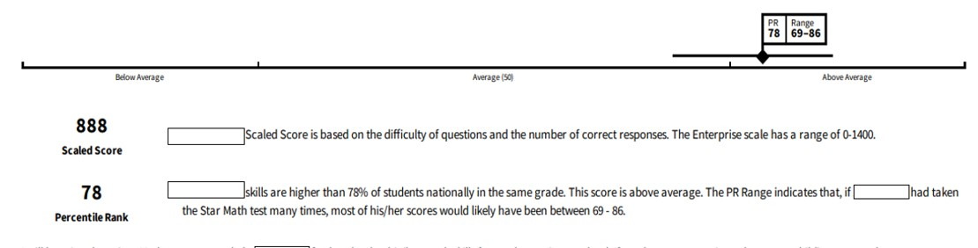

Star Math Parent Report

Scaled Score is the most
useful information. Decisions for instruction are based on the Scaled Score.

Percentile rank is a norm- reference score that provides a measure of a student’s reading ability compared to other students in the same grade nationally.

How will you receive your child’s report?

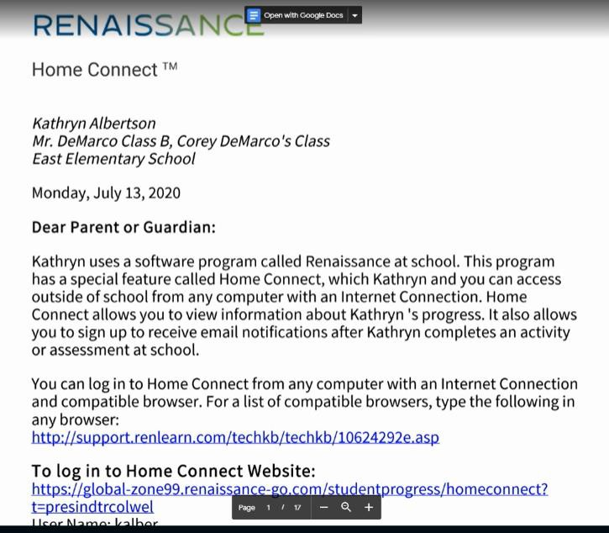The teacher or school will generate and send you a letter that contains your child’s Renaissance information.

Use this information to log in and set up your Home Connect account.
R E N A I S S A N C E H O M E C O N N E C T V I D E O

Setting Up Home Connect Account

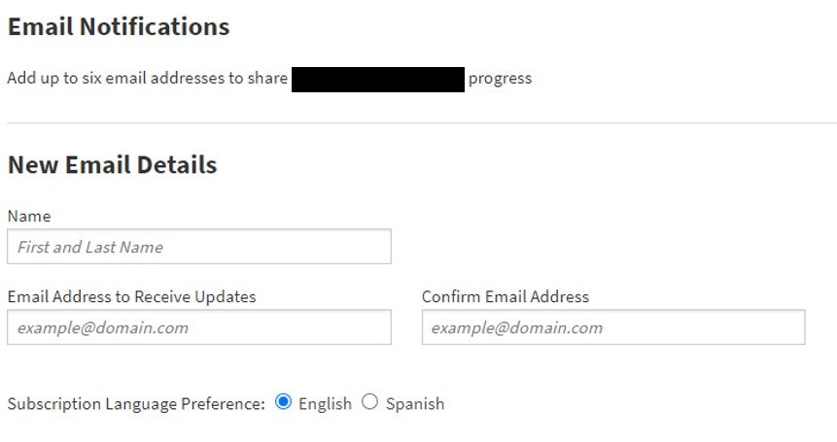

RCPS Email Notifications Preferences
Choose wh ich assignments you wou ld like to receive em ail u pdates for 

!i Star Early Literacy Assessmen t (English) -A test th at measures stud ents' early literacy skills in English

0 Sta r Early Literacy Assessmen t (Spanish) -A test t hat measu res stu d ents' early literacy skills in Spanish

!i Sta r Math Assessmen t (English) -A test th at measures students' m ath skills in English

0 Star Math Assessmen t (Spanish) -A test that measu res stu dents' math sk i lls in Spanish

!i Sta r Read ing Assessment (English) -A test that measu res students' reading skills in English 0 Sta r Read ing Assessment (Spanish) -A test that measu res studen ts' rea d ing skills in Spanish 0 Star Cu stom - Brieftests on specific reading or ma th skills
!i Accele rated Reader -Quizzes to show now we ll stu d ents u nderstan d the books they're reading

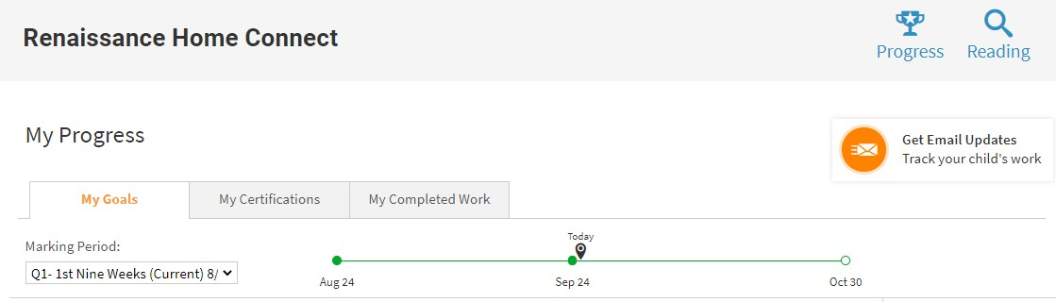How will you receive your child’s report?

R E N A I S S A N C E H O M E C O N N E C T V I D E O

How can I help my child with their
Star Assessments?

The best way to help your child with Star Assessments is to help them
understand why they are taking the test:
so their teacher knows exactly how to help them learn!
For anxious children, it may be important to tell them that they cannot fail a Star test—as long as they do their best, the data generated from the test will help their teacher teach them more great things!

To motivate your child to do their best, set goals after reviewing reports.

Resources

•Renaissance Learning's Parent Resources
•Lexile Framework for Reading Parent Guide
•Lexile Find A Book
•Accelerated Reader Bookfind
•Parent's Guide to Star Assessments
•STAR ACT/SAT Benchmark Tool
•The Conyers Rockdale Library System
•Georgia PINES Library System Information Page
•Georgia PINES Library System Registration Page
•Setting Up Home Connect
•Administering Star Assessments Remotely Family Guide
•Star Reading Sample Items
•Star Math Sample Items
•Star Math Sample Items

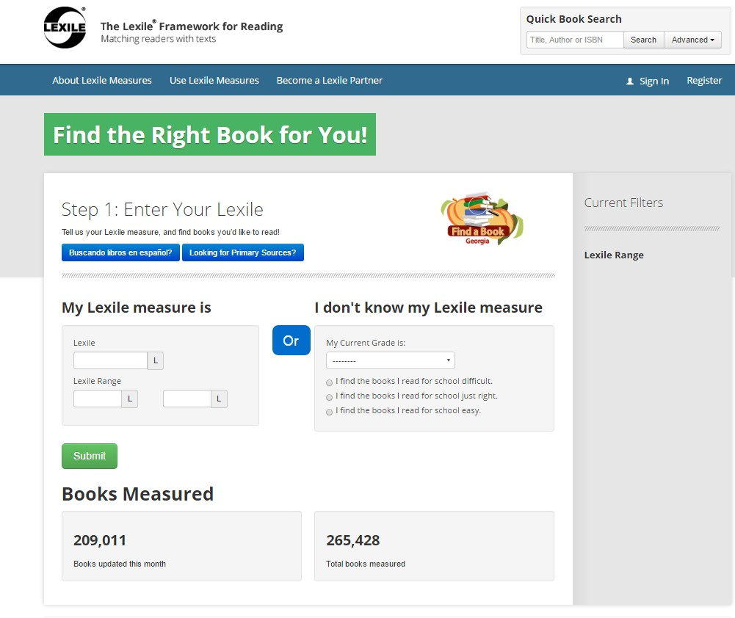

Accessing the Find A Book Tool
http://lexile.com/fab/GA

40

Source: GA Department of Education
41

Parents Can Use Lexiles

Promotes family-school connections.
Know your child’s Lexile measure. Know your child’s Lexile range.
- 50L above and 100L below their reported Lexile measure. This range represents the boundaries between the easiest kind of reading material for your child and the hardest level at which he/she can read successfully.
Use the Lexile Find a Book Database (at http://lexile.com/fab/) to find books in the child’s Lexile range.

Source: http://cdn.lexile.co m/m/c ms_pa ge_ me dia/135/Lexiles -at-Ho me_2.pdf


Parents Can
Use Lexiles
- Ensure that your child reads every day.
- Parents should read to set a good example. Reading newspapers and magazines will show children that reading is a wonderful pastime as well as a window to the world of learning.
- Ask school or library for book lists within Lexile range.
- Student’s interests should play a part in book selection.
- Visit public libraries often.
- Participate in summer reading programs.

Source: http://cdn.lexile.com/m/cms_page_media/135/Lexiles-at- Home_2.pdf

Source: GA Department of Education 42

Parents Can Use Lexiles
43

When a reading assignment proves to be too difficult, provide adult- directed assistance:
      - Review words and definitions from the glossary or dictionary.
      - Review questions at the end of a chapter before child reads text.
      - Pair-share read – Parent and student alternate reading the text. Stop, discuss, and ask questions along the way to see that student understands.
      - Return to end of chapter questions and glossary to make certain your child understands the material.
Celebrate your child’s reading accomplishments.
      - Set goals –
        - number of books read
        - variety of books
        - stretch to books at higher Lexile
Source: http://cdn.lexile.com/m/cms_page_media/135/Lexiles-at- Home_2.pdf

Questions?



Committed to World-Class
Star 360:
What is it, why and how we use it, and interpreting your student’s report

Parent Academy September 26, 2020

Opportunities and
Possibilities
Andrea Pritchett, Director of Curriculum and Instruction Charlene McGlockling, Reading Coach

