How It Works: Tutor.com Classroom
Connecting with expert tutors for on-demand, 1:1 help
The expert tutors at Tutor.com can help you work through a tough homework problem, improve your writing skills, study for a test, review a difficult concept, and so much more!


Step 1: Get started
- Go to: [Enter program URL or access
instructions.]

- Click on Tutor.com.
- Create or sign in to your free Tutor.com account.
4. Click on Connect with a Tutor.

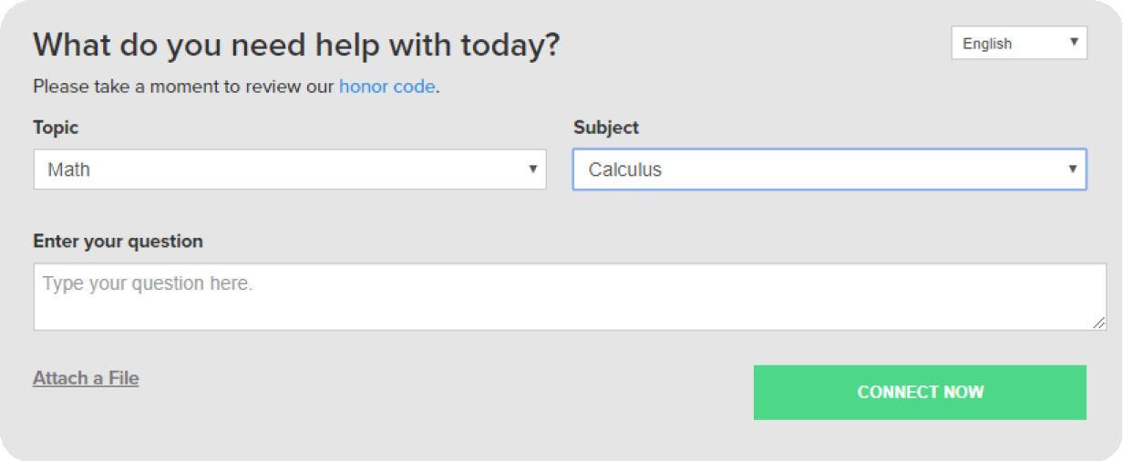
Step 2: Get the right tutor
Fill in the quick pre-session questionnaire. Using this information, we will match you with the first available tutor best qualified to assist you.

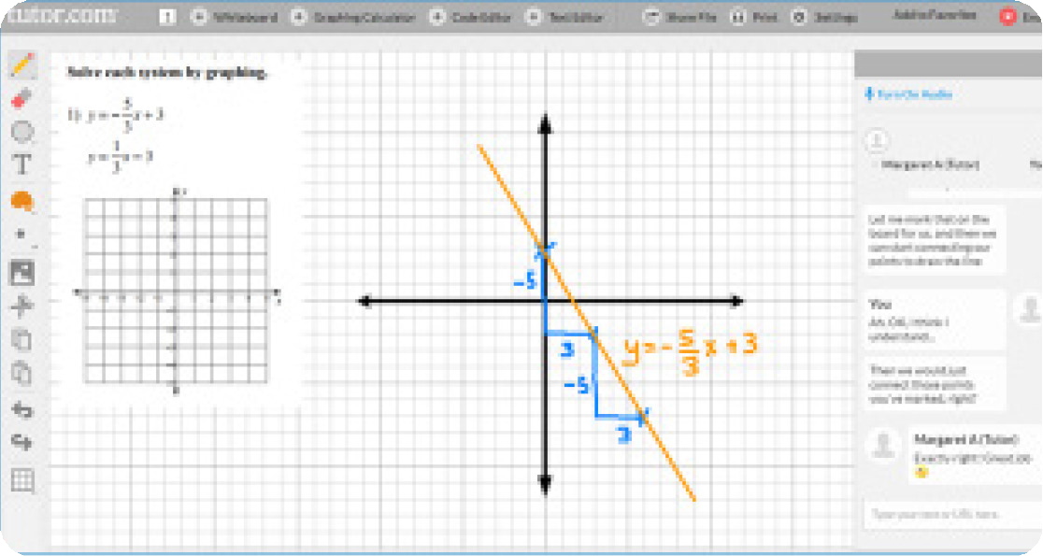
Step 3: Communicate
Use your chat box or an audio connection to instant message or speak with your tutor in the online classroom. You and the tutor may also use the interactive whiteboard to share work and ideas. All activity in the classroom is recorded for review and quality control.

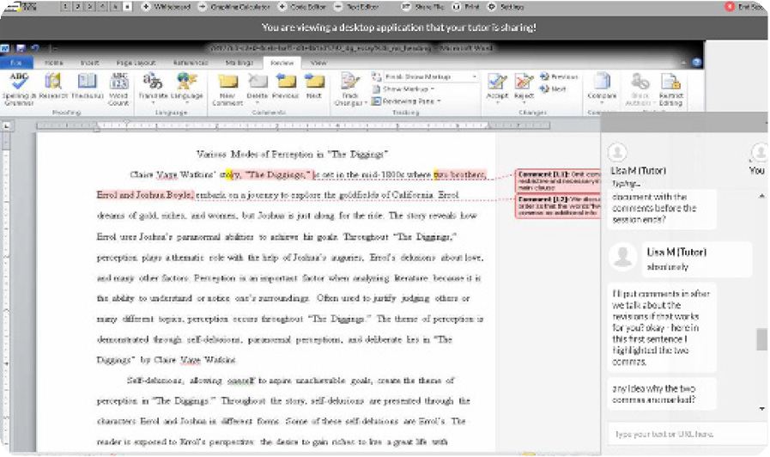
Step 4: Share a file
You can share many types of files with your tutor in the classroom. Upload an essay, your lab report, a PowerPoint presentation, and more. You and your tutor will be able to view the file together in the classroom.
MORE

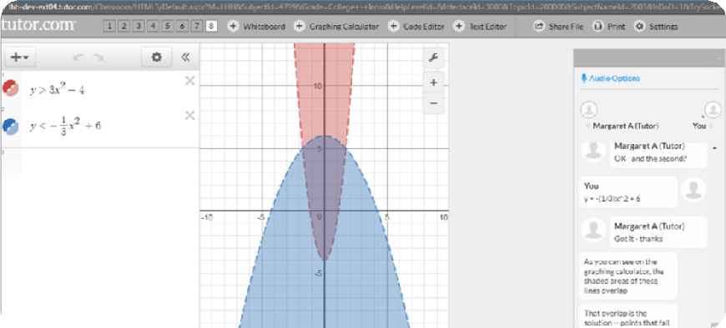
Step 5: Use special tools
The classroom includes a graphing calculator, text editor, and code editor that you can use when working on subject material that may require these special tools. Open them by using the buttons above the whiteboard.

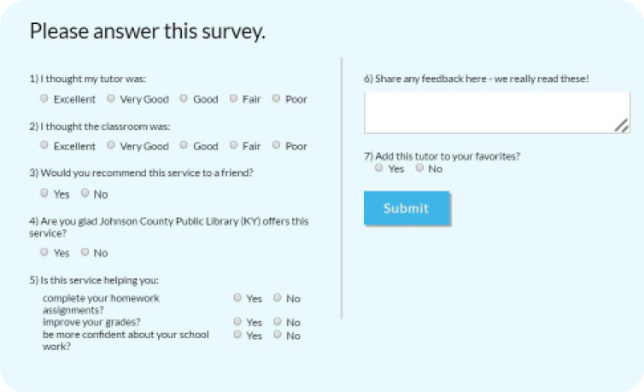
Step 6: Rate and review your session
After each session, be sure to let us know how we did! Complete the survey and share your comments. Then you’ll have the option to play a video of your session and email or print the chat log and whiteboards.

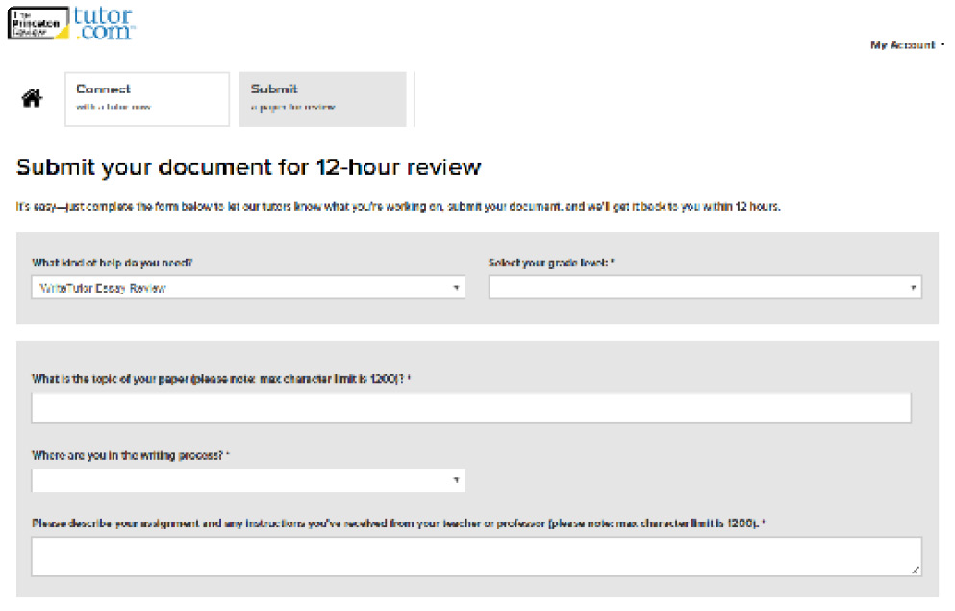
Step 7: Submit your paper
Our Drop-Off Review service allows you to get expert help from a tutor without having to connect for a real-time session. Upload your writing assignment and get detailed feedback and explanations within 12 hours. Retrieve your tutor’s completed review under My Sessions.

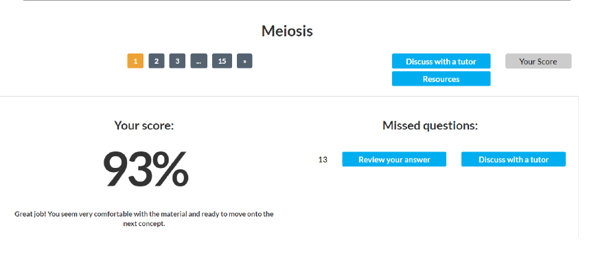
Step 8: Practice for a test
Use our practice quizzes to assess your level of knowledge and practice for upcoming tests or quizzes in math, science, and English. Take a quiz, review your results, and
connect with a tutor to discuss any missed questions.

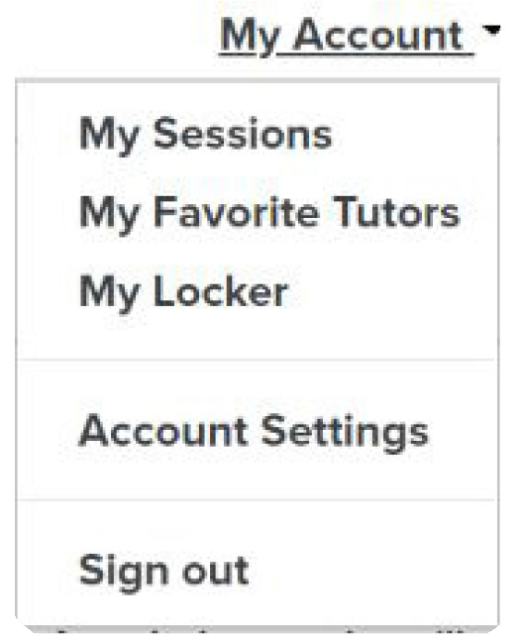
Step 9: Use My Account
- Review previous sessions and retrieve drop-off reviews from My Sessions. Be sure to tag your favorite tutors when reviewing your sessions.
- Reconnect with your favorite tutors or see when they are next scheduled from the My Favorite Tutors section.
- Access files you have saved or those you have shared in session with your tutors from My Locker.

The Princeton Review is not affiliated with Princeton University.

