a

“Painting Bright Futures at J.H. House”

J. H. House Elementary
2024-2025
Parent/Student Handbook
1300 Zingara Road
Conyers, GA 30012
(770)483-9504
Fax: (770)483-0397

Press “0” for the Secretary
Press “4” for Spanish

Dr. Kenneth Vaughn, Principal
kvaughn@rockdale.k12.ga.us

Tonya S. Price, Assistant Principal
tprice@rockdale.k12.ga.us



Dear J. H. House Families,

On behalf of the staff at JHH, welcome to a new school year!
Parents are a child’s first and most important teacher. Working together, we can provide a learning environment which will support as well as challenge your child to achieve excellence.
Your children are very precious to us, and we take our job of educating and caring for them seriously. Our goal is to provide an excellent education and to make sure they are safe when they are with us.
This handbook gives an overview of a few procedures and expectations for our school.
Please let us know how we can be of service to you. It is going to be a great year!

Dr. Kenneth Vaughn
Proud Principal of JHH

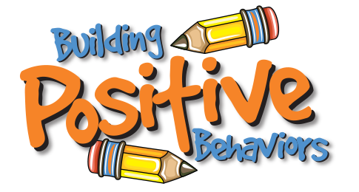

Positive Behavior Intervention and Support (PBIS)
We are a PBIS school. We teach positive behavior strategies. Our motto is, “Be like an Eagle. Be Safe, Be Kind, and Be Ready!


Our Vision
WE BELIEVE THAT family is the most important factor in the development of the individual.
WE BELIEVE THAT a safe and orderly environment is essential to teaching and learning.
WE BELIEVE THAT education is the most important asset in maximizing the opportunities of an individual and a community.
WE BELIEVE THAT every person deserves a voice and is worthy of respect.
WE BELIEVE THAT all human beings have the capacity to learn.
WE BELIEVE THAT every person deserves the opportunity to succeed.
WE BELIEVE THAT each person is responsible for his or her own actions.
WE BELIEVE THAT faith gives meaning and purpose to life.
WE BELIEVE THAT students are at the core of all educational decision-making.
WE BELIEVE THAT diversity strengthens our local and global community.

Our Mission
The mission of J.H. House Elementary School, a safe and nurturing environment where all students can achieve their highest academic and social potential, is to equip students with the knowledge, skills, and qualities required to meet the challenges of a constantly changing world through:
· High academic and behavioral expectations for all students;

· Focused and effective teaching and support services;

· The availability of academic and technological resources at school and home;

· Opportunities that promote actively involved families and communities.

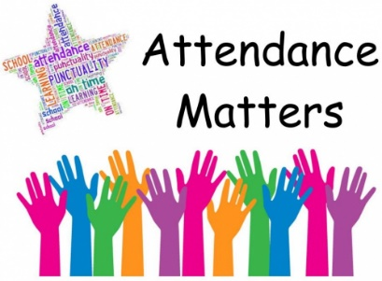

Attendance
Attendance in all grades is extremely important. Students do better in school when they attend consistently. Absences may cause students to fall behind in class.
If your child gets sick during the school day, we have a clinic aide who will call you if it is necessary to pick up your child.
If your child must be absent, he/she must bring a written excuse within three days of his/her return to school. Otherwise, the absence is unexcused. Please review the Rockdale County Public Schools Handbook for the attendance policy as well as the reasons for which absences will be excused.
Please review the RCPS Attendance Policy here: RCPS Attendance Protocol_May 2022.pdf (sharpschool.com)
Tardiness
- The tardy bell rings promptly at 7:35 a.m. If a child is not in class at that time, he/she is considered tardy and MUST BE CHECKED IN BY AN ADULT.
- Notes also need to be written for late check-in and early check out.
- Checking in late or checking out early is considered a “tardy.” Please try to make appointments for your child after the school day ends.
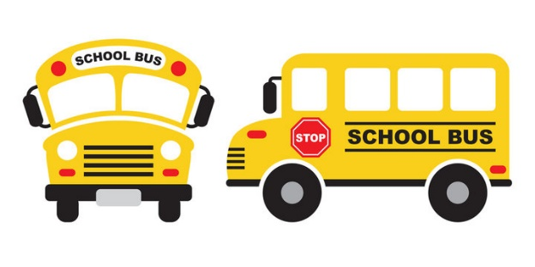


Buses
- We currently have 12 buses which serve the J. H. House district.
- For safety reasons, good behavior is always expected on the buses. (See Bus Rules form in Rockdale Co. Public Schools handbook.)
- Buses unload each morning beginning at 7:00 a.m.
- Cars must stay in the car line in the front of the building and let your child out where adults are posted to assist your child and monitor for safety.
- Do not let your child out in the parking lot at any time.
- Do not park in the drop-off lane or along the front drive of the school.
- Any changes in afternoon transportation MUST BE IN WRITING. We cannot make changes over the phone. Remind your child to turn in this written request to his/her teacher first thing in the morning so all adults involved in the dismissal of students are notified. All transportation changes must be submitted in writing to the office no later than 1:00pm.
- Changes in bus transportation depend upon approval plus room on the bus.

Car Riders/Day Care
If your child is a car rider in the afternoons, please be aware that you should be here no later than 2:25 p.m. Car rider and day care pick up will be in the front of the school while buses are loading at the same time on the side of the school. Be sure to make your day care center aware of the time for pick up.
To reduce confusion at the end of the school day, we ask that you not come into the school to check out your child after 1:45. At this time, we are preparing for and beginning dismissal procedures. The front office and administrative staff must remain focused on a safe and orderly dismissal.
When checking out a student, please be prepared to show a valid picture ID. Please be sure that your Parent Portal in Infinite Campus is updated to include names of people who are authorized to pick up your child. Please communicate with your child’s teacher if the transportation changes.
Please REMAIN IN YOUR CAR, and we will bring your child to your car as you drive up. Car rider tags will be given out at Open House. If you switch cars or someone else is picking up your child, please put this pick-up tag in the different car. Otherwise, the driver will need to come inside, show ID, and check out the child through the office.
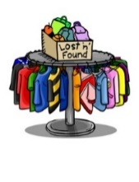
Personal Items
Please label hats, coats, sweaters, etc. Labeling will help us get the lost item to the owner. If your child loses an item, tell him/her to check the Lost and Found, after he/she has checked in the classroom and on the bus. After a reasonable amount of time, unclaimed clothing will be donated to charity.


Sending Money
If you send money to school, please put the money in an envelope for the teacher. Write your child’s name and the purpose for the money so that the money is placed in the correct hands.



Birthdays
We do not have birthday parties at school. However, parents may bring or send cupcakes to school to be enjoyed during the assigned lunch time. Our office staff will make sure the cupcakes get to the class. Please remember that the cupcakes should be store bought -not homemade.



Phones/Phone Calls
Unless allowed by an IEP or a 504 Plan, a student shall not use or otherwise operate a cell phone or similar electronic communication device during the school day on school property. If they have a cell phone it must always remain in their book bag and remain turned off. Cell phones as well as other electronic devices will be confiscated and may be redeemed by student’s parent/guardian in the front office. The school system accepts no liability for any confiscated electronic device.
Students are allowed to call home using the school phone if the teacher determines that it is necessary. Students will not be called to the office to receive phone calls. However, parents may call the office to leave an important message for their child.


Student Medications:
In order to have prescription medicine administered by the school, the parents must provide the following:
- Parents must request in writing that school personnel administer the medication. (Form JGCD-E-1 must be signed and submitted.)
- Medication must be in a prescription bottle properly labeled with specific orders for administering the medication.
- Over the counter medication must be brought to the school in the original container with written directions from the parent on how and when to administer.
- Parents, please do not send medication on the bus. Please bring it into the school to avoid a potential harmful situation.
The school clinic aide will administer medications. Her hours are (7:00 a.m. -2:00 p.m.) Medications will be dispensed after that time by the principal’s designee.

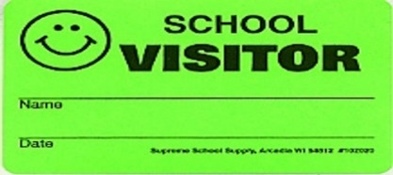

Parents and Visitors:
We welcome parents to our building. For the safety and order of the school, ALL PARENTS/VISITORS NEED TO BRING A VALID ID AND CHECK IN AT THE OFFICE, during school hours regardless of the length of the visit.
On the Parent Portal through Infinite Campus, parents are asked to give the names of all people that may have access to your child. This would include those that are allowed to pick up the child from school in the event the parents are unable to be reached as well as anyone the parents give permission to have lunch with their child.
All visitors are expected to wear a visitor badge in plain sight while in the building.
Safety is a top priority. Visitors should enter through the front doors of the school and directly to the office to sign in, have their identification verified and receive a visitor badge. Upon exiting the building, visitors should check out with the office.

In an effort to protect the instructional time, we ask that you call or write a note to your child’s teacher if you need to speak with him/her. We want to have open communication with parents, so please know that the teacher will get back to you in a timely fashion when he/she doesn’t have students.

Scheduled visits to the classroom are permissible for 30 minutes. These visits must be scheduled 24 hours in advance with the homeroom teacher and front office. ‘Pop-in’ visits are not allowed. Parents should remain in the area designated by the teacher and must refrain from engaging with the students. Recording devices and pictures are not permitted.

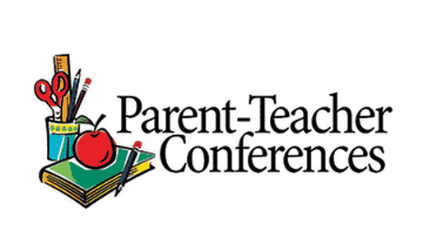

Conferences
Conferences are planned within the RCPS school calendar although parents can request a conference at any time.


Breakfast
CHILDREN WHO ARE EATING BREAKFAST MUST BE IN THE CAFETERIA BY 7:30 to pick up their breakfast.
Students who ride the bus will have no problem getting to the cafeteria on time. If you bring your child to school, just be aware of this time if he/she wishes to eat breakfast. Since we begin school at 7:35 a.m., we close the cafeteria doors at 7:30a.m. so there is sufficient time for students to get to class to begin their instructional day.

Lunch
Parents and guests are welcome to have lunch with us on Tuesdays, Wednesdays, and Thursdays. Please notify the front office the day before, so that our lunchroom staff can prepare enough food.
We also ask that you do not bring in fast food which creates a competition for our school lunch program.
Students who bring lunch from home should not bring carbonated drinks, anything in glass containers, or food from area restaurants. **Students do not have access to heat food in microwaves or utilize staff refrigerators.


Discipline Code of Conduct:
The behavior code for students enrolled in Rockdale County Public Schools is based on the philosophy of our school board that each student has a right to expect to be able to learn in an environment free from distractions and duress of any sort. Students are expected to demonstrate respect for self and others, demonstrate courtesy of others, behave in a responsible manner, take school seriously, dress appropriately and avoid violation of the student Code of Conduct. Below you can see the main rules in the Code of Conduct. The complete Code of Conduct with full descriptions can be found in the RCPS Parent Handbook which is provided at the start of each school year.

Rule 1..... Disruption and Interference With School
Rule 2..... Damage, Destruction, or Theft of School Property
Rule 3..... Damage, Destruction, or Theft of Private Property
Rule 4..... Assault and/or Battery on a School Employee
Rule 5..... Fighting and/or Battery to a Person Not Employed by the School
Rule 6..... Bullying/Teasing
Rule 7..... Weapons and Dangerous Instruments
Rule 8..... Narcotics, Alcoholic Beverages, Stimulant Drugs, Controlled Substances or Medications
Rule 9..... Disregard of Directions or Commands
Rule 10... Unexcused Absences and Tardiness
Rule 11... Dress and Grooming
Rule 12... Parking and Traffic-Related Violations on Campus
Rule 13... Refusal to Accept Disciplinary Action
Rule 14... Use of Profane, Vulgar, or Obscene Words, Gestures, Pornographic/Vulgar Materials or Actions Which Disrupt School System Operations
Rule 15... Gambling on School Property or at a School Function
Rule 16... Misbehavior on Bus
Rule 17... Criminal Law Violations
Rule 18... Sexual Misconduct or Inappropriate Display of Affection
Rule 19... Rude and Disrespectful Behavior
Rule 20... Tobacco/Smoking-Related Offenses
Rule 21... Cheating, Plagiarism, or Academic Dishonesty
Rule 22... Altering Records, Misrepresenting Information, Forgery
Rule 23... Misuse of Computer, Network, Internet, or Intranet
Rule 24... Loitering, Trespassing, or Breaking and Entering
Rule 25... Other Misbehavior
Rule 26... Misbehavior While Off School Property
Rule 27... Cumulative Offenses

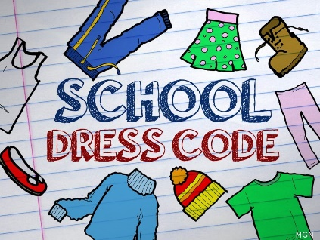

Dress Code
Children come to school to learn and often what a child is wearing influences his attitude toward working and learning.
Please consider the following when sending your child to school:
- Clothes should be neat and clean.
- Students may wear shorts to school. They must be non-clinging (no spandex) and should be to the child’s top of the knee when the child is standing.
- The length of dresses and skirts should be to the top of the knee when the child is standing.
- Leggings or Jeggings may be worn with a dress, skirt or shirt that reaches the top of the knee.
- Tops must completely cover the midriff when arms are raised. (Sleeveless shirts are fine provided they have a collar and are not a tank top.)
- For safety, please remember appropriate shoes for PE. Areas of our playground are rocky and uneven so please be sure your child wears sensible support shoes to school every day. (Flip-flop type, slip on, or dressy-heeled shoes are not safe in the school environment.)
- All long shirts must be tucked in and pants must be worn at the waist.

The following list is just a few things that will not be allowed. This list is not all inclusive.
- See-through or mesh clothing
- Tank tops or spaghetti straps (must have shirt or sweater over)
- Leggings or jeggings (without something over that is touching the knee)
- Hats/bandanas/kerchiefs/visors
- Clothing displaying alcohol, tobacco, drugs or objectionable language or pictures
- High heeled shoes, cleats or skate shoes, flip flops
- Brightly colored hair that is disruptive to the learning environment. (pink, purple, blue, green, etc.)
- Any article of clothing, accessory or personal decoration deemed disruptive to the learning environment
- Face piercing (nose, eyebrow)
- Low-cut top clothing or too short bottom clothing (short-shorts, mini-skirts)



Specials

MUSIC
Music education plays a very important part in the education of the JHH student. Each student is instructed through general music lessons once a week. In these classes, students learn basic ideas and concepts of music to help them develop an appreciation for all types of music. Our 4th and 5th grade students are offered a chorus program by audition.

ART
The Art Program at JHH provides students with opportunities to explore their creative potential in many different ways. We use a variety of materials and methods to draw, paint, sculpt, build, shape, scratch, and squish our way through a hands-on experience of the world of art. All projects that we are work on based on learning and using the elements of art and principles of design. These include concepts such as line, shape, form, value, color, texture, contrast, balance, and space. In art class, we will look at and talk about artwork from famous artists of various cultures and time periods.

PHYSICAL EDUCATION
Opportunities are provided to participate in a variety of activities that focus on small and large motor skills. Physical fitness testing is an important part of our program, and we are now participating in the FitGA Physical Fitness Testing program in conjunction with the Georgia SHAPE Act. Students should wear comfortable moving clothes and athletic shoes on class days. Students are expected to participate unless medical information is provided prior to class. Student medical/health information regarding allergies, medications, and other special conditions should be on file with the school office, clinician, classroom teacher, and PE teacher.

MEDIA CENTER
In the media center, we seek to serve the JHH community by providing resources to enhance the curriculum and to encourage reading for enjoyment. Some of our goals are to promote students’ interest in reading, teach them strategies needed to access information, and develop their abilities to use that information effectively.

SEL LAB
In the Social Emotional Learning Lab (SEL) students of all ages work to better comprehend their emotions, to feel those emotions fully, and demonstrate empathy for others. These learned behaviors are then used to help students make positive, responsible decisions; create frameworks to achieve their goals, and build positive relationships with others.


COUNSELING PROGRAM
The mission of the JHH counseling program is to provide a comprehensive, developmental counseling program that addresses the academic, career, and personal/social development of all students. The school counselor will collaborate with faculty, staff, parents, and community members working together as a team to ensure a safe and orderly learning environment that is academically challenging, stimulating, and productive. The school counselor will act as an advocate to help guarantee all students possess a solid academic foundation. The school counseling program will:
- value each student as a unique individual with physical, social, emotional, and intellectual needs.
- actively engage all students in the learning process through challenging, adaptive, creative, and effective learning experiences that promote appropriate behavior and interpersonal skills that will enhance academic potential.
- Integrate technology and other resources whenever possible in order to improve student learning and critical thinking in the areas of academic, career, and personal/social development.
- Be fully aligned with the school standards in educational instruction in order to lead all students towards their maximum potential while establishing productive, responsible, and respectful citizens of tomorrow and a lifetime love of learning.

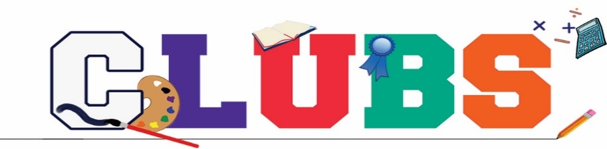

The JHH Chorus was established to recognize those students who exemplify talents in the area of singing. Membership is open to all 4th and 5th graders who audition at a qualified level. They demonstrate their musical abilities through an audition conducted by the music teacher. Guidelines are used to make the final decision. The chorus meets weekly rehearsals.

The Rockdale Honor Chorus is a chorus made up of 10 students from each elementary school in Rockdale County. Students from JHH 5th grade chorus are then chosen again by audition in December. The students participate in the county’s performance during the 3rd quarter.

The JHH News Crew Club was established for the purpose of providing a format to inform all JHH students of the schedule of events within the school through a daily news show. Also, the News Crew utilizes the news show to promote school spirit, celebrate individual and group accomplishments, and to promote attendance. Membership is open to all third, fourth and fifth grade students whose applications are accepted based on previous good attendance, responsibility, teacher recommendations, and availability of slots to be filled. The club is divided into four teams which rotate through fall and spring semesters. One of the four teams meet every morning before school begins. Club activities include producing a daily news show, which entails such activities as acting as news host, or weather anchor; preparing scripts; and operating a computer or video and sound equipment. Club members may take a field trip to a professional news or production studio and enjoy a year-end celebration.

The 4-H Club was established for the purpose of enriching the Science curriculum and is aligned with the Language Arts and Science CCGPS curriculum. Membership is open to all fifth-grade students. The club meets 9 times a year (once a month). Club activities include learning to give an oral presentation, exploring different Science topics, and contributing to the community through Community Service projects.

The Reading Bowl Team was established for 4th and 5th grade members to read at least four of the Georgia Book Award Nominees. Members review and discuss the books in preparation to compete for spots on the Reading Bowl Team. Ten members will be selected to compete in the Rockdale County Reading bowl.

The Math 24 Team Club was established to expose students to advanced concepts of mathematics, deepening their understanding of mathematics, enhancing problem-solving skills, and competing in a math competition. Students in grades 3-5 are invited to participate in this after-school club based on their math performance.


Safety Patrols

The Safety Patrols is an organization that assist with the safe travel of students in the hall, carpool and bus area during arrival and dismissal.
Students apply in early May, through an application process. Students are then selected based on grades, behavior and teacher recommendations.

Policy JAA: Student Non-Discrimination Policy & Complaint Procedure
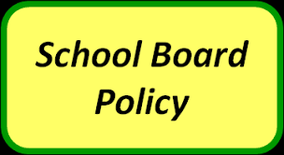

- Non-Discrimination Policy

The Rockdale County Board of Education (“Board”) prohibits unlawful discrimination against students because of race, color, national origin, sex, religion, age, disability, or other protected group status or activity (e.g. opposition to prohibited discrimination or participation in the statutory complaint process) in its programs and activities or employment in its programs or activities. In keeping with this commitment, the Board will not tolerate harassment, discrimination, or other unlawful treatment of its students. It is the policy of the Board to comply fully with the requirements of Title VI, Title IX, Section 504 of the Rehabilitation Act of 1973, the Americans with Disabilities Act and all accompanying regulations. As set forth herein, the Board designates the following employee of Rockdale County Public Schools (“District”) to handle inquiries regarding the District's non-discrimination policies:
Director of Community and Student Support (or designee)
Rockdale County Public Schools
960 Pine Street
Conyers, Georgia 30012
T: (770) 483-4713
http://www.rockdaleschools.org/
2024-2025 School Calendar
