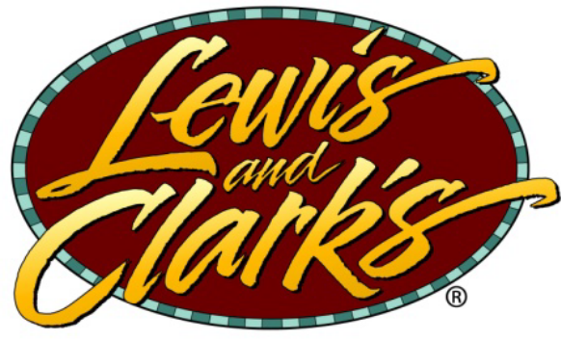

217 SOUTH MAIN ST.
ST. CHARLES, MO 63301

WE ARE NOW HIRING

Hostess, Busser and Kitchen Positions

Full or Part Time

We would Love to have you Join our Staff!

~ Perfect for first time jobs ~

We are a Family Owned business

Please stop by or call (636) 947-3334
Ask for Dan, Karen or Emily

