
417-625-9785 3950 E. Newman Rd, Joplin, MO 64801

MSSU DUAL CREDIT & DUAL ENROLLMENT
  - Student Guide to Online Application, Registration, & Payment

Contents
Before you get started you will need … 2
Step 1: Create Your DualEnroll.com Account (New Students)/Login to your DualEnroll.com Account
Returning Students 2
New Students 2
All Students: Parent/Guardian Consent 5
All Students: High School Information 6
All Students: Authorization to Release (FERPA)…………………………………………………………………………………6
Step 2: Select Your Courses 7
Narrow Your Search 7
By Term 7
By Keyword 7
By Course Type 7
By Schedule 7
Step 3: Next Steps 9
High School: Provide Transcript/Test Scores & Approve Student Enrollment 9
College: Review Forms & Process Course Registration 10
Registration Complete 10
Provide Payment 10
Abandonments, Drops, & Withdrawals 10
Abandonments 10
Drops 10
Withdrawals 11
HELP 11
DualEnroll.com Help Desk Button 11
High School Counselor 11
MSSU Office of Academic Outreach 11
APPENDIX A: Open Class List Explanation 12

Before you get started you will need …
- Social Security Number (New Students)
- DualEnroll.com Username & Password (Returning Students)
- Parent/Legal Guardian Email Address

Step 1: Create Your DualEnroll.com Account (New Students)/Login to your DualEnroll.com Account (Returning Students)
Go to mssu.dualenroll.com to get started

Returning Students
Log in to the DualEnroll.com system by entering your login and password information. If you forgot your username or password, use the “Forgot your username or password?” hyperlink to reset your account information.
Returning students please skip to Step 2 of this document for further instructions.

New Students
Select the “For Students” section of the screen on the right hand side.


Use the red “Click Here to Register” button to start creating your DualEnroll.com account.


Enter your personal information into the New Student Registration screen. We highly recommend entering both an email address and a cell phone number. These pieces of information are important for quick account confirmation, and it enables MSSU to contact you in a variety of ways regarding your dual credit/dual enrollment experience.
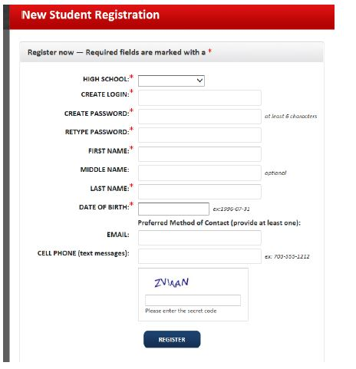

You should receive an account confirmation code on your cell phone or through your email. For email confirmation: Use the link within the email to confirm your account. For text confirmation: use the link at the bottom of the login screen to type your confirmation code.
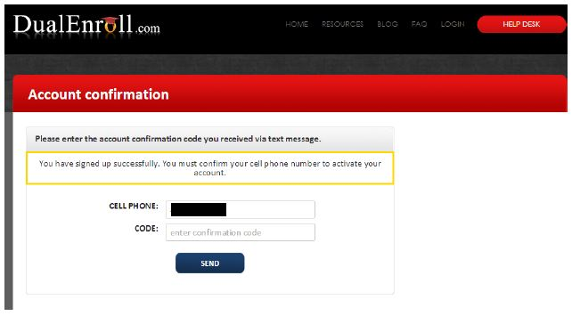

As a new student, you will need to complete the MSSU Admissions application before you may begin selecting courses. Use the “Click here” hyperlink to complete the MSSU online application. It is important that dual credit students use this link to apply to the dual credit/dual enrollment program. There is no application fee, and there never will be, should you choose MSSU as your institution of choice after high school. Please note: You will need your Social Security Number to complete the application.
Once you complete the online application, your student ID number (SID) should automatically populate in the appropriate field (pictured below). Write this number down, and keep it in a secure place. Should you need to reference this number again, please refer to your Profile tab.
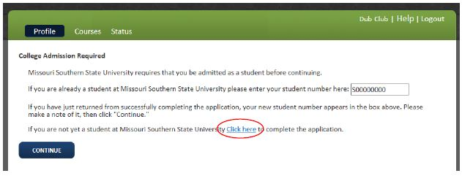
When you finish the application, your MSSU Student ID Number (SID) should automatically populate into the box on the screen. Click the “Continue” Button to proceed. If for some reason your SID does not appear in the box, please contact the Office of Academic Outreach for your SID.

All Students: Parent/Guardian Consent
Taking dual credit or dual enrollment courses does require your parent/legal guardian’s consent. Obtaining consent is easy and completed electronically through the DualEnroll.com system. Provide a parent/legal guardian email address in the boxes provided, then click the “Next” button.
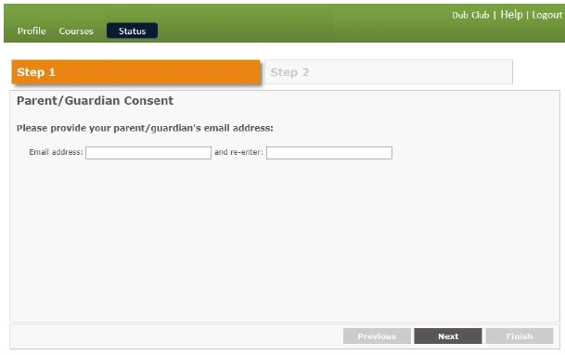
Parents/guardians must approve courses once per semester. An e-mail messages will be sent from DualEnroll to your parent/guardian at the e-mail you provided. They will need to click on the link within the e-mail to provide their consent. If your parent does not get the e-mail, your counselor or the Dual Credit office can re-send the message to the e-mail address that you provided.

All Students: High School Information
Confirm your high school and your high school guidance counselor. This assures that once you make your course selections it will be automatically sent to your high school counselor. Click the “Finish” button.
Home-school students, please select the home school option, or not listed.
If your high school or your high school counselor are not listed in the system, please contact the Office of Academic Outreach for setup or select the home school/school not listed option on the drop down menu.
All Students: Authorization to Release (FERPA Form)
The Authorization to Release is now available for you to electronically sign and submit as a part of your DualEnroll.com information. You are not required to fill this form out but you are strongly encouraged to as it helps MSSU share information with your high school. If you do not fill it out at online, you can fill out the paper form and turn it in to the Dual Credit Coordinator at your school.

Step 2: Select Your Courses
Critical to your success in using our new DualEnroll.com system is that you select the appropriate courses. DualEnroll.com has a great tool to help you narrow down your search to find exactly what you are looking for! Courses are listed in alphabetical order by the course prefix and number (e.g., MATH130). Scroll through the list alphabetically, or use the features described below. Open courses may also be found on the MSSU open class list. Further information about the open class list and its relationship to DualEnroll.com can be found in Appendix A.

Narrow Your Search

By Term
Narrow down the list significantly by selecting the term for which you would like to enroll.

By Keyword
If you know a keyword in the name of the course(s) you wish to take, type it into the box.

By Course Type
This feature is probably the most important one out of your options as a dual credit/dual enrollment student. Pay close attention to the icons when making final course selections.

By Schedule
This feature is great for dual enrollment students searching for on-campus classes. Use this feature to narrow your selection down by day/time.
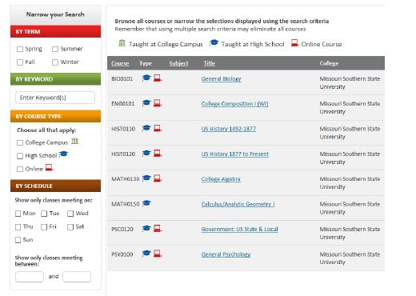

When you click on the course title you will be able to see course details, and you will be able to see all of the sections of the course that are available. Once you’ve found the class you want, click the “Register” button. If you need to add more than one course, click on the “Courses” tab at the top left of the screen to search for more courses.
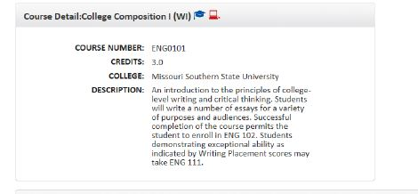
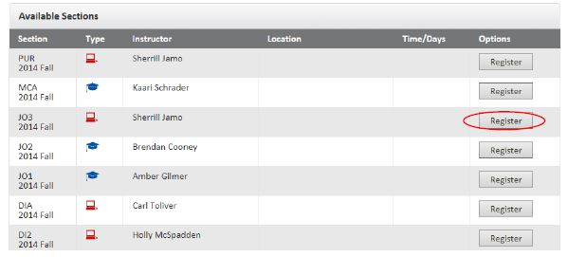

The following picture illustrates what your screen will look like after you’ve selected multiple classes. If you accidentally chose the wrong course, use the “Abandon” hyperlink to request to remove the course from your schedule. Then, click on the Courses tab to go and find the correct course. Abandonments must be approved by your high school counselor and/or MSSU before you can make another course selection.
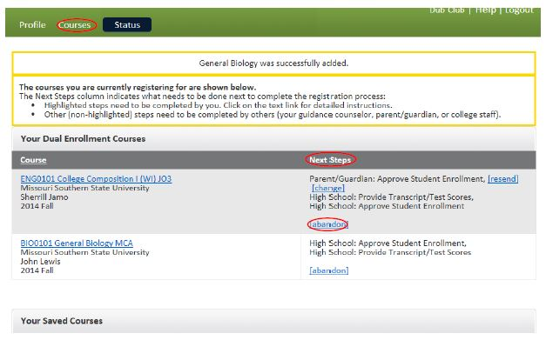

Step 3: Next Steps
As a student, once you’ve selected your course(s), your work is mostly done! Please note that you may log back in to the system any time, click on the “Status” tab, and check the “Next Steps” column to see what steps need to be completed in order for your enrollment to process. If a step needs to be completed by you, it will be highlighted in yellow. Here’s what happens after you select classes:

High School: Provide Transcript/Test Scores & Approve Student Enrollment
Notifications are automatically generated by the DualEnroll.com system and are sent to your high school counselor indicating your use of the system and your desire to take select dual credit and/or dual enrollment courses.
  - Your high school counselor will upload your transcripts and test scores in the DualEnroll.com system.
  - Your high school counselor will approve (or disapprove) your enrollment.

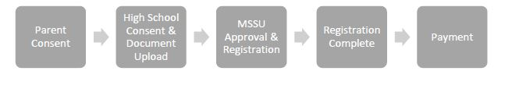

For Home School students, MSSU will act as the high school counselor. Notarized transcripts and test scores should be sent directly to the MSSU Office of Academic Outreach.

College: Review Forms & Process Course Registration
Once your parent/legal guardian provides consent for each course and your high school counselor uploads required documents and approves you, DualEnroll.com automatically notifies MSSU to take a look at your file. MSSU verifies your eligibility for the course(s) you selected by reviewing the uploaded documents. Then, MSSU processes the course for registration. Once registration is complete, you are officially enrolled in the course. Be on the lookout for an email from DualEnroll.com that confirms you were enrolled in the course. If for any reason you receive a registration failure notification, please contact your high school counselor and/or the Office of Academic Outreach for assistance. Most of the time these issues can be resolved quickly.

Registration Complete
Once the student’s enrollment is processed, “Registration Complete” will show up for you in the “Next Steps” column.

Provide Payment
When you receive the email notification from DualEnroll.com that you have been successfully registered in the course, your bill should be ready for payment. Payment information is available within the confirmation email, either through mail or through the high school. Payments can be made at any time online through the student’s MSSU Payment Portal or by contacting the Bursar’s Office.

Abandonments, Drops, & Withdrawals

Abandonments

The Abandon button is available when the student has not been enrolled in the course yet. Students, counselors, or the university may use the Abandon button. Check to see which step the student is in to determine if the student has been enrolled in the course(s) or not; Registration Complete means the student is enrolled. When a student or counselor user clicks Abandon, a field appears and a message can be typed in to describe the reason for the abonnement of the course(s). That text is sent along with the abandonment request. Abandonment requests are approved by the Office of Academic Outreach and must be processed by the University prior to the student being able to select another course, if desired.

Drops
The Drop button is available when a student is enrolled in a class, but wishes to remove a class prior to the fourth Friday of classes on the MSSU semester calendar. A dropped class never shows up on a student transcript, and students are not charged for dropped classes. Once the Drop button is used by the student, an email notification is sent to the Parent/Guardian email address to make them aware of the student’s desire to drop. The high school counselor is also notified through the system, and must approve the drop request. Once the drop is complete, the student, parent/guardian, high school counselor and university are all sent a confirmation email that the drop has been processed.

Withdrawals
A Withdrawal button is available when a student is enrolled in a course, then chooses to remove the course from the schedule after the fourth Friday on the MSSU semester calendar. A Withdrawal will show up as a “W” on the student transcript, and the student does still pay for the course. Once the Withdrawal button is used by the student, the parent/guardian and high school counselor are sent approval requests. When the parent/guardian and high school counselor approve the withdrawal request, the request is sent to the university for final approval and processing. Once the withdrawal is complete, the student, parent/guardian, high school counselor and university are all sent a confirmation email that the withdrawal has been processed.

HELP
If at any time you need help with the DualEnroll.com system, you have a variety of options from which to seek help.

DualEnroll.com Help Desk Button
Click on the red “Help Desk” button at the top right-hand corner of the screen if you need help with the DualEnroll.com system.

High School Counselor
Contact your high school counselor if you need help while using the DualEnroll.com system.

MSSU Office of Academic Outreach
Contact MSSU for help: 417-625-9785 or 417-625-9731
dualcredit@mssu.edu or meeker-b@mssu.edu
Hearnes Hall 315, 3950 E Newman Rd, Joplin, MO 64801

APPENDIX A: Open Class List Explanation

Overview
The open course list, available on MSSU’s website, is the official list of all open classes at MSSU for any given term. Select 100 and 200 level courses are being sent from the open course list directly in to MSSU.DualEnroll.com. This “data exchange” occurs every hour. The open course list operates in real-time; therefore, it is possible that MSSU.DualEnroll.com could be behind.

Course List in MSSU.DualEnroll.com
Here’s a screenshot of how course sections look in MSSU.DualEnroll.com:
These four digits represent the CRN – Course Registration Number. These four digits are listed on the open class list (and printed schedule booklet).
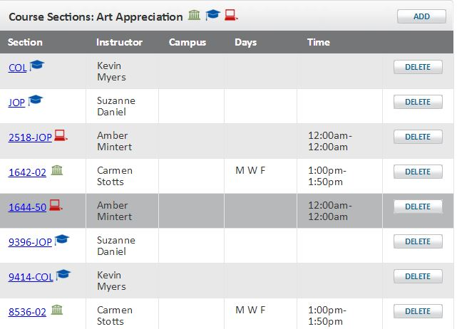
The numbers or letters after the dash represent the Section Number.
- Letters – represent classes at the high school campus (Ex: JOP = Joplin)
- Numbers beginning with “1” = on MSSU Campus
- Numbers beginning with “5” = online

Course List Online – Open Class List
Here’s a screenshot of how course sections look on the Open Class List:
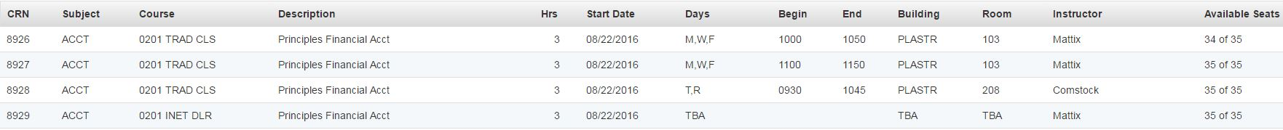

Tips
Match classes between the two systems using the CRN. You can also match the instructor name for an additional checkpoint.

