On July 1st 2024 this release was sent to The Brentwood Press & Publishing Corporation at 248 Oak St. Brentwood, Ca. 94513. www.thepress.net .
Editor Contact: Greg Robinson email: editor@brentwoodpress.com phone: (925) 634-1441 ext. 110
Rosy Ayers Food Service Director 7-1-24
Signature Title Date
School Year 2024-25
Public Media Release for Universal Meals

Liberty Union High School District and Byron Union School District announce its policy to serve nutritious meals every school day under the National School Lunch Program and School Breakfast Program. Breakfasts and lunches will be served free of charge every school day due to Universal Meals, but Liberty and Byron Districts are still required to make eligibility determinations for free and reduced-price meals. Effective July 1, 2024 through June 30, 2024, children are considered eligible for free or reduced-price meals if the household income is less than or equal to the federal guidelines.

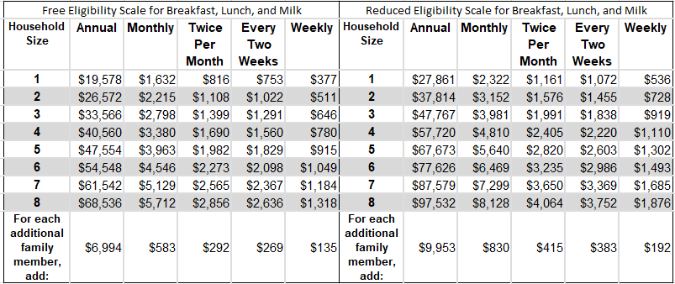

Households do not need to turn in an application when the household receives a notification letter saying that all children automatically qualify for free meals when any household member receives benefits from CalFresh, CalWORKs, or FDPIR. Children who meet the definition of foster, homeless, migrant, or runaway, and children enrolled in their school’s Head Start program are eligible for free meals. Contact school officials if any child in the household is not on the notification letter. The household must let school officials know if they do not want to be considered eligible for free or reduced-price meals.

Applications will be sent to the household with a letter about the school meal program. While breakfasts and lunches will be provided free of charge every school day, determining eligibility for free and reduced-price meals is still necessary and these determinations can be used to qualify households for other benefits. Households interesting in establishing eligibility for meal benefits, must fill out one application for all children in the household and give it to the nutrition office at each school. For a simple and secure method to apply, use The LUHSD online application at https://linqconnect.com/public/meal-application/new or the Bryon online app at https://www.myschoolapps.com/Application Contact your school for help filling out the application. The school will provide notification regarding the outcome of your applications.

Households may turn in an application at any time during the school year. If you are not eligible now, but your household income goes down, household size goes up, or a household member starts receiving CalFresh, CalWORKs, or FDPIR, you may turn in an application at that time. Information given on the application will be used to determine eligibility and may be verified at any time during the school year by school officials. The last four digits of the Social Security number from any adult household or checking that you do not have a Social Security number is required if you include income on the application.

Households that receive Special Supplemental Nutrition Program for Women, Infants, and Children (WIC) benefits, may be considered eligible for free or reduced-price meals by filling out an application.

Foster children are considered eligible for free meals and may be included as a household member if the foster family chooses to also apply for the non-foster children on the same application. Including foster children as a household member may help the non-foster children qualify for free or reduced-price meals. If the non-foster children are not eligible, this does not keep foster children from being considered eligible for free meals.

Your child’s eligibility status from last school year will continue into the new school year for up to 30 school days or until the school processes your new application, or your child is otherwise certified for free or reduced-price meals. School officials do not have to send reminder or expired eligibility notices.

If you do not agree with the decision or results of verification, you may discuss it with school officials. You also have the right to a fair hearing, which may be requested by calling or writing the hearing official for each school district

This institution is an equal opportunity provider.

