Meeting Agenda

Meeting | District Educational Improvement Committee
Date | November 20, 2024
Time | 4:30 PM – 6:00 PM
Location | MISD Professional Development Room
Participants | Parents, Community Members, and Staff
Purpose | Communication, Input, and Planning
Facilitators | Dr. Edie Martin, Superintendent  Dale Latham, Deputy Superintendent

Agenda Topic | Facilitator
Welcome | E. Martin
Introductions
Mission/Vision/Values – A PREMIER vision
Superintendent’s Report
DEIC Training, Including District Goals | D. Latham
Millsap ISD Priorities & District Improvement Plan on a Page | E. Martin & D. Latham
Initial Discussions 25-26 School Calendar | E. Martin
Low Attendance Waiver | D. Latham
Future Meetings (Jan. 15, March 5, April 30)
Closing / Evaluation

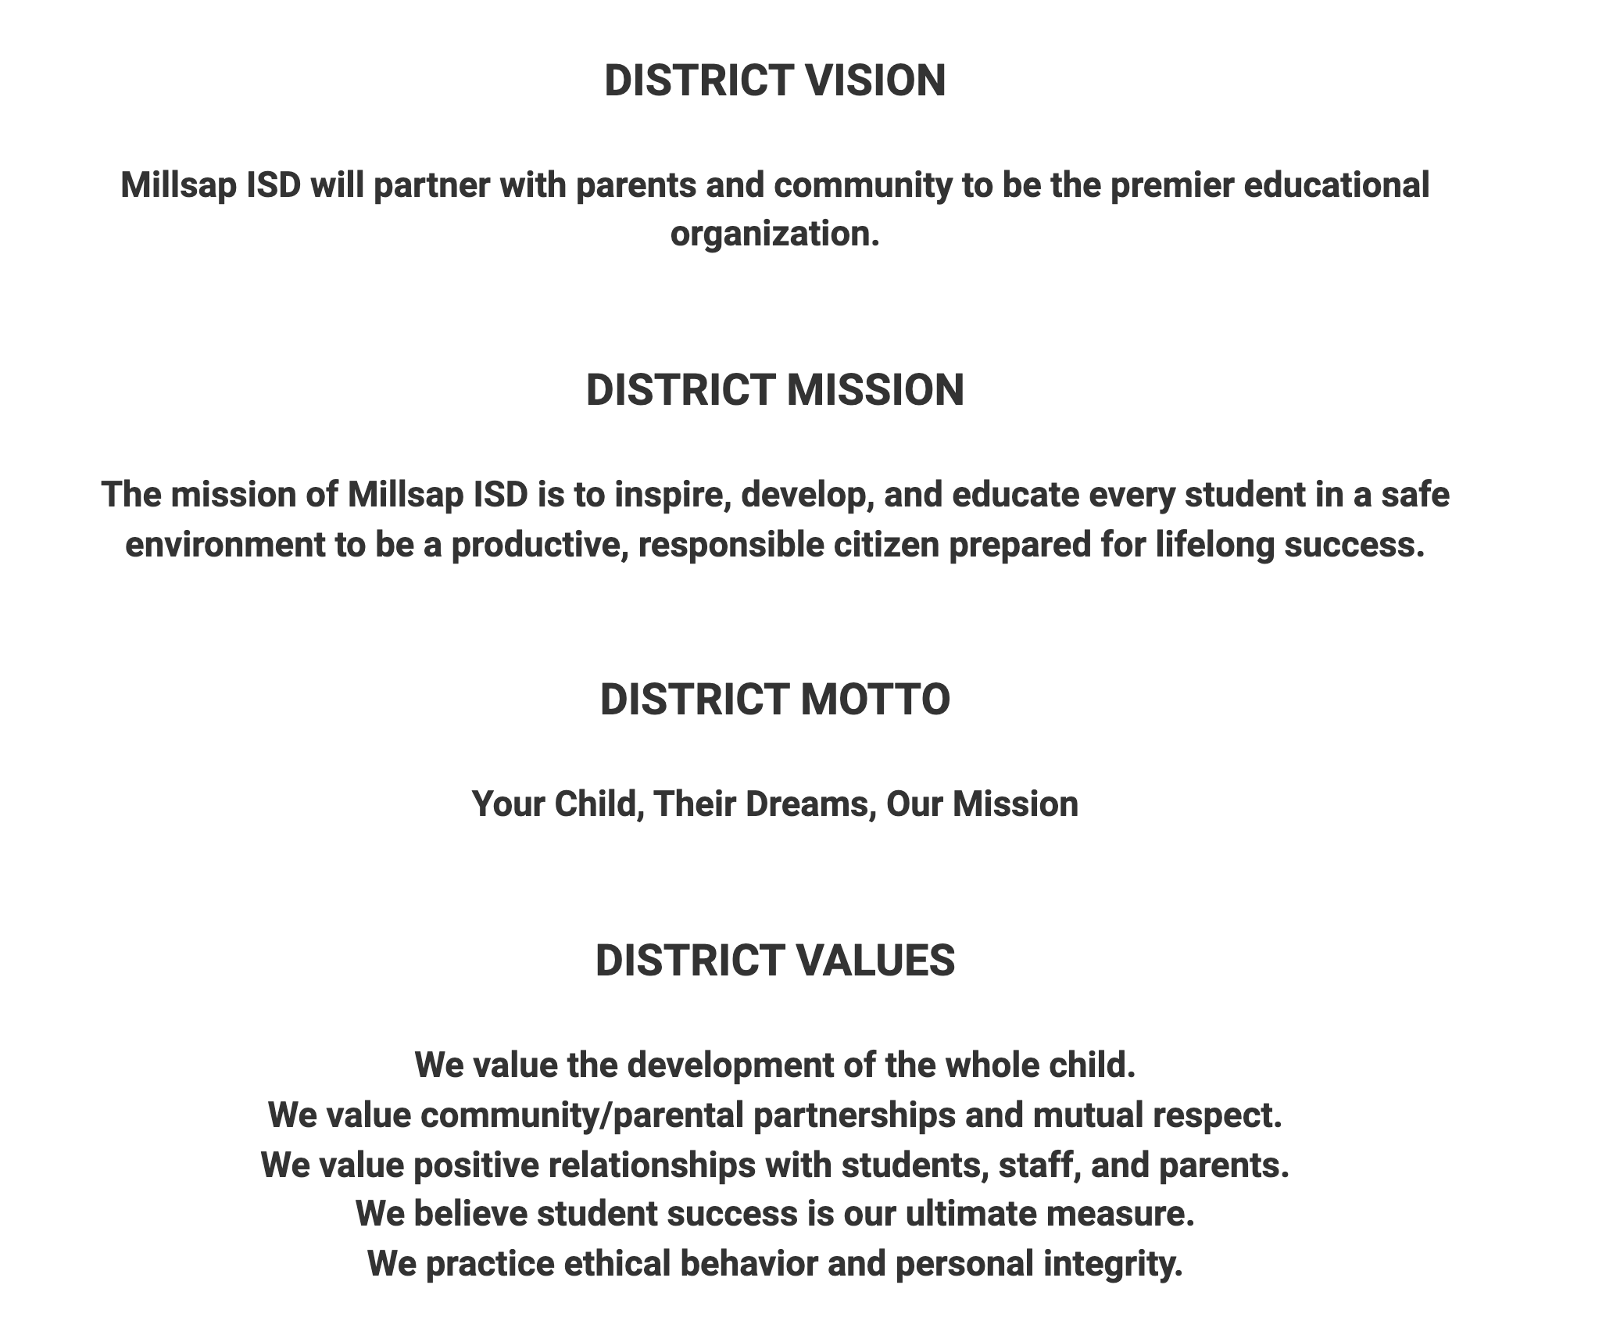

MINUTES 11/20/2024

Members Present:

4:31 - Dr. Martin calls the meeting to order.
Introductions of the members
4:37 - What are you proud of being a Bulldog?
- Spanish club is making a movie in Spanish. (cross curricular Literary/Spanish)
- MES is planning many fun Christmas activities for students and families.
- The Band qualified for Area competition. / Sign language is being offered during Bulldog Business at MMS. / Parent & Family Engagement nights are being successful at MMS. / PTO is working with all three campuses to serve all district students.
- Brag on BETA students helping at the Hootenanny showing great leadership
- “You’re going to love Millsap” was shared at New Teacher Orientation and she is a believer.
- MES has formed a Second Destination Imagination team.
- Parent engagement night is asking students to step out of comfort zone. A student shared about leading the Parent & Family Engagement nights and speaking about their learning.
- 67 0f 78 seniors have already completed their College Career Military Readiness requirement for graduation.
- Culinary Arts are making Pies for “Treat of the Month” that will be distributed to ordering staff.
- MHS is Spotlighting students. This month CTE programs and students are being highlighted.
- MHS has set up students for success. Testing environment changes are providing a testing environment that promotes success.
- MHS BETA has qualified for National competition.
- Fall sports all advanced to post-season play - Volleyball, Football, and Band. Cross Country advanced to State!

4:55 - DEIC training provided by Mr. Latham -
- Discussed legal foundations and purpose of the District Education Improvement Committee (DEIC)
- Purpose of the DEIC and the makeup of the committee members
- DEIC is used as a Continuous Improvement Process

5:05 Dr Martin shares Strategic Plan and beliefs - on website
Priorities 1, 2, 3, and 4
- Showed the website Construction Update (P4), Strategic Plan with Foundational Beliefs, and Proud to be a Bulldog (P3)

5:24 - Mr. Latham District Improvement Plan on a Page
- Details provided on our Key Strategic Actions that will help MISD continue to improve in our defined areas.

5:35 - Discussion on 24-25 School Calendar - Input Collected

5:50 - Low Attendance Waiver -
- The Safety Issue on August 19, 2024, resulted in a delayed start to the school day.
Our Instructional Calendar is built on instructional minutes but due to the safety issue, we had very low attendance. MISD can apply for a low attendance waiver from TEA to prevent encountering financial sanctions for low attendance.
- Lisa Deaver moved that we apply for the attendance waiver and it was seconded by Mrs. Thomas. All voted in favor of applying for the waiver.
- The Board of Trustees will vote on the application at the December 16, 2024 board meeting.

6:00 Meeting Closure

