The Buzz!
September 6, 2024
Rossville ES 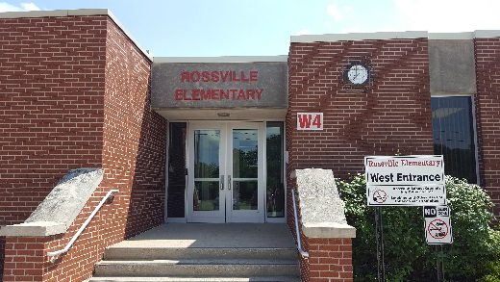
Important Dates 
September
11 4th grade field trip
12 6:00 VB vs. G. Wells
14 Cross Country meet
16 Bullying presentation
18 6:00 VB vs. St. Lawerence
19 Kindergarten field trip
19 6:00 VB vs. C. Prairie
19 Cross Country meet
20 3rd-5th Movie Night
23 Mobile dentist
24 Cross Country meet
27 4th grade field trip
27 Pk-2nd Movie Night

1 Robert Egly Drive; Rossville, IN 46065
www.rcsd.k12.in.us T: 765-379-2119 F: 765-379-9236
Instagram rossvilleelementary
Twitter @RossvilleES
Facebook @RossvilleSchools
Chad Dennison, Principal (Ext. 310)
Mike Feagans, Assistant Principal (Ext. 312)
Tammy Hauser, Secretary (Ext. 311)
Notes from Mr. D….
What a great start to our school year! Students are getting into routines and demonstrating Hornet Citizenship. Staff is working hard to meet the needs of our students, and we are looking forward to parent-teacher conferences. Conferences are being scheduled by teachers over the next few weeks. We thank you in advance for taking the time to meet. We strongly believe this is a partnership, so thank you!
Visitors are welcome and encouraged! All visitors will need to report to the elementary office through door E5 and then up the stairs on the left. You will be asked to scan in at iPAD outside the elementary office doors prior to entering the office. Please make sure to have your driver’s license or government issued ID card handy.

Attendance policy change
The Rossville School Board approved the Section 4320-Attendance Policy during their Board meeting on September 3, 2024. A copy of the updated policy was sent via ParentSquare and a hard copy was sent home with families without internet access last week.
All Board policies can be accessed https://www.rcsd.k12.in.us/about/legal-policies
If you have any questions, please let us know. Thank you in advance.


Parent Advisory Council (PAC)
We are excited to have our first movie nights of the year! Our 3rd-5th graders movie will be showing on September 20th (The form sent home last week said Tuesday, but it’s on Friday, 9/20) and our Pk-2nd graders movie will be on September 27th.
What is movie night? This is one of PAC’s fundraising events. Funds will be used by PAC for various events and helping RES teachers in the classroom.
Please make sure to return your child’s permission form by September 19th; however, we will accept walk-ins. We just ask parents to bring their child inside and sign her/him in.

Registration and ParentSquare
Have you completed your child’s registration yet? If not, please do so ASAP. Updated information is required each year for the safety of the students, transportation, etc. If you need help, please contact the elementary office at 379-2119 ext. 308 or 311.
Rossville Schools will be utilizing ParentSquare as our main communication platform. Please make sure to update your notifications located under your account information. We suggest allowing notifications for emails, alerts and texts. If you need assistance, please contact Dustin Shadbolt at 379-2119 ext. 308

