The Buzz!
October 4, 2024
Rossville ES 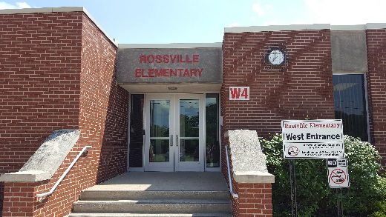
Important Dates 
October
3 Picture retakes
4 H.L.H. field trip
4 End of Quarter 1
8 Volleyball at St. Lawrence
8 1st and 4th grade field trips
9 1st and 2nd Farm to School
10 Kindergarten field trip
11 Report Cards go home
11 Popcorn & Water sale
14-18 Fall break!
29 Walk-a-thon forms due
30 Walk-a-thon
31 Happy Halloween

1 Robert Egly Drive; Rossville, IN 46065
www.rcsd.k12.in.us T: 765-379-2119 F: 765-379-9236
Instagram rossvilleelementary
Twitter @RossvilleES
Facebook @RossvilleSchools
Chad Dennison, Principal (Ext. 310)
Mike Feagans, Assistant Principal (Ext. 312)
Tammy Hauser, Secretary (Ext. 311)
Notes from Mr. D….
We have come to the end of our first grading period! Time sure does fly! This is the time of the school year to reflect on how students are progressing and what changes do we need to make instructionally to best meet our students’ needs. Report cards will be sent home with students on October 11. Please take a moment to go over your child’s progress with your child. If you have any questions, please contact your child’s teacher. We are here to help answer any questions you may have.
Rossville Schools worked with Healthy Communities of Clinton County over the past few years along with many other districts in our surrounding area. Our focus was on preventing youth suicide initiative. We learned best practices in the field and have implemented many changes as a school system. Our goal was to help meet our students, K-12th, where they’re at emotionally, provide supports for our students, and finally provide a common curriculum focusing on mental health. I am happy to report our district has purchased, and we are ready to implement our curriculum Second Step.
Second Step curriculum will cover the following common units:
Growth Mindset & Goal setting: Children learn how to pay attention and manage distractions,
develop a growth mindset and apply goal-setting strategies to their social and academic lives.

Emotion Management: Children learn how to identify and label emotions and use emotion management
strategies—including stress management for older students—to calm strong feelings.

Empathy & Kindness: Children learn how to recognize kindness and act kindly, have empathy for
others and take others’ perspectives, and recognize kind acts and empathy as important elements of
building and maintaining relationships.

Problem-Solving: Children learn how to identify and state a problem, recognize if a problem is an
accident, and use the STEP problem-solving process:
S: Say the problem
T: Think of solutions
E: Explore the outcomes
P: Pick a solution

More information will be sent home with students prior to us launching the new curriculum in your child’s classroom. Thank you in advance for your support.

Parent Advisory Council (PAC)
Our students are EXCITED about our walk-a-thon fundraiser!!! Many have already donated through our PAC Venmo account! So far, every Venmo donation has specified a student’s name. Please continue to do this as this will help us determine potential prizes.
Reminder, all student calendars are due by October 29th.
Highlights….
- Individual Top 3 Earners will eat lunch with a staff member of their choice and get Subway
- Top 2 Fundraising Classes will celebrate with a pizza party
- Class with the most participation will earn extra recess with the principals
- IF the whole school raises $2,500, Mr. Dennison and Mr. Feagans will dye their hair for Halloween!
If you’d like to donate using our Venmo, here’s our QR code
Let’s Go Hornets!!!

Spirit wear orders
1. Spirit wear orders will be taken next week with a cut off of Friday 10/11 to order, and extra forms are in the office if needed!

2, Senior Sucker Sales will be 11/4 - 11/15! Teachers will send home order forms for each child soon, and students will receive their choices after processing once they are turned in. $2.00 each with different shapes and flavors that will be listed on their slips.... watch for those to come home after Fall Break!

Hornet Little Hoosiers
Hornet Little Hoosier will have their popcorn fundraiser the week before Fall Break. Bring in $1 any day Oct. 7-11 to preorder your popcorn treat to enjoy on Friday afternoon in class. All proceeds go toward our 4th grade history club.

Book Fair Time!!!

October 7-11
RES Library

The Book Fair will be open to students all day on Monday-Thursday and until noon on Friday. The Book Fair will be open to parents and grandparents on October 9 from 5:30-7:00.

