The Buzz!
December Newsletter
Rossville ES 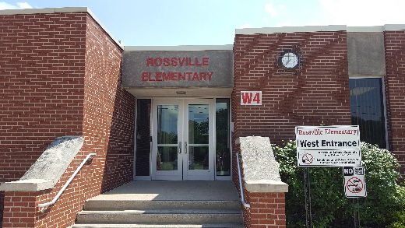
Important Dates 
December
3 7:00 Board Meeting
4 2-hour delay start day
9-20 NWEA benchmark testing
13 11:00-12:00 Staff luncheon
18 6:00 Winter Concert for Singing Stingers and 3rd graders
20-January 6 Winter break

1 Robert Egly Drive; Rossville, IN 46065
www.rcsd.k12.in.us T: 765-379-2119 F: 765-379-9236
Instagram rossvilleelementary
Twitter @RossvilleES
Facebook @RossvilleSchools
Chad Dennison, Principal (Ext. 310)
Mike Feagans, Assistant Principal (Ext. 312)
Tammy Hauser, Secretary (Ext. 311)
Notes from Mr. D….
I want to wish everyone a Happy Thanksgiving! Enjoy your time relaxing, laughing and eating with family and friends.
December brings lots of excitement for our little Hornets! We have 3 weeks until Christmas break, and we want to finish 2nd semester strong. Continue encouraging your child(ren) to do their personal best each day. That’s the Hornet way!
What a blessing it is to serve our community! Currently, we have 36 people willing to shop for families in need through our Christmas Angel program. Even though funding is much lower this year, these shoppers are stepping up to the plate to make a positive difference. Reminder for our families who came to our Bountiful Food Harvest, I will be contacting you the week of December 16th to come get the gifts for your child(ren).
Shoppers, please have the gifts back to the RES office by Friday, December 13th. Please follow the specific wrapping directions which came with your families’ wish list.
Rossville Schools worked with Healthy Communities of Clinton County over the past few years along with many other districts in our surrounding area. Our focus was on preventing youth suicide initiative. We learned best practices in the field and have implemented many changes as a school system. Our goal was to help meet our students, K-12th, where they’re at emotionally, provide supports for our students, and finally provide a common curriculum focusing on mental health. I am happy to report our district has purchased, and we are ready to implement our curriculum Second Step.
Second Step curriculum will cover the following common units:
Growth Mindset & Goal setting: Children learn how to pay attention and manage distractions,
develop a growth mindset and apply goal-setting strategies to their social and academic lives.

Emotion Management: Children learn how to identify and label emotions and use emotion management
strategies—including stress management for older students—to calm strong feelings.

Empathy & Kindness: Children learn how to recognize kindness and act kindly, have empathy for
others and take others’ perspectives, and recognize kind acts and empathy as important elements of
building and maintaining relationships.

Problem-Solving: Children learn how to identify and state a problem, recognize if a problem is an
accident, and use the STEP problem-solving process:
S: Say the problem
T: Think of solutions
E: Explore the outcomes
P: Pick a solution

Teachers will begin with a few lessons in December and start fresh in January with at least one lesson per week.
Notes from Mr. Mullen
Congratulations to our state honor choir members: Karey Pritchett, Jensen Douglas, and Rylynn Maish! These students were chosen to be part of an approximately 150-member choir from over a thousand entries. Way to go, Hornets!
Attention Singing Stingers and 3rd Grade Parents,
We would like to cordially invite you to attend this year’s Winter Concert on December 18th starting at 6:00 p.m. The event will take place in our beautiful auditorium. Singing Stingers are asked to wear their choir shirts and blue jeans while our 3rd graders are asked to wear jeans and a nice shirt. All students are encouraged to also wear any Christmas festive gear like a Santa hat, reindeer antlers, etc.
Save the date…Cheer Clinic
Cheer clinic will be held on Saturday, January 11, 2025, for all Kindergarten-5th grade students! More information will be shared with parents soon!

