

Student Government

Date: January 31, 2025

Location: Virtual/in-person via WebEx

Time: 9:30 am - 10:30 am

Call to Order | Roll Call
Officers Present:
- Cedar Fernandez
- Emerald Otradovec
- Jeremiah Moses
- Tanya Skenandore
- Krysanda Bissonette
- Dakota Waupoose
Officers Absent:
- Tashina Guzman

Staff/Faculty Present:
- Lloyd Frieson
- President Caldwell
- Lorenzo Warrington
- Dr. Candy
- Tracy Wilber

Agenda Items:
Moment of Silence | Prayer

Treasurer's Report | $4,600 (keep AIHEC in mind)

Old business:
- N/A

New business:
- President Caldwell updated the students about the current administration in an email directed toward the students. Wanted to clarify that they [CMN] is committed to mission, decisions are made based around the values of CMN. Pushing back on internships until February 15th. Federal Financial Aid is NOT part of pause. Rumors of ICE being on campus were false, CMN administration looked through security footage, same with the Rez in general Chairwoman Gena Kakkak confirmed. Guidance and tips about travels (keeping tribal IDs or Indian Blood certification on hand with photos or actual copies). No new purchase orders/contracts until February 15th.
- Dr. Candy brought an idea to have Student Government Goals that way there is structure to what Student Government wants to support and keep in mind throughout the terms. Goals to be set for future Student Government as well.

Tabled discussions:
- AIHEC budget and bylaws/constitution allocation funds.

Other Business:
- Student body concerns google form/survey for various issues.
- Farmer’s Market

Adjournment
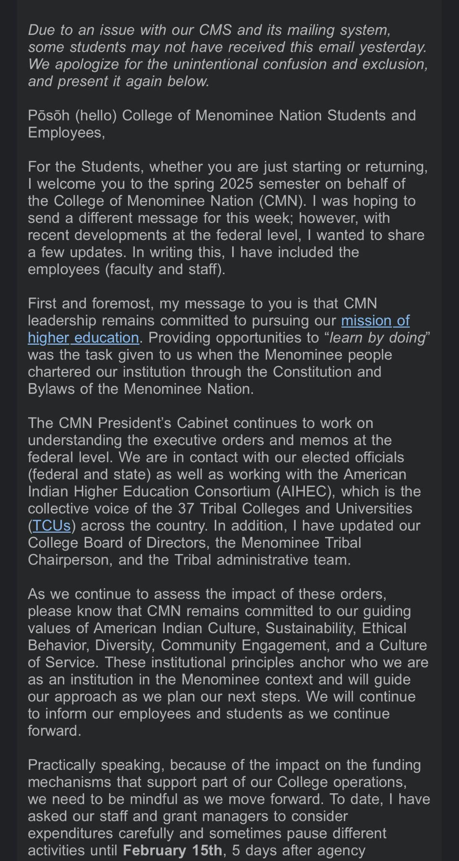
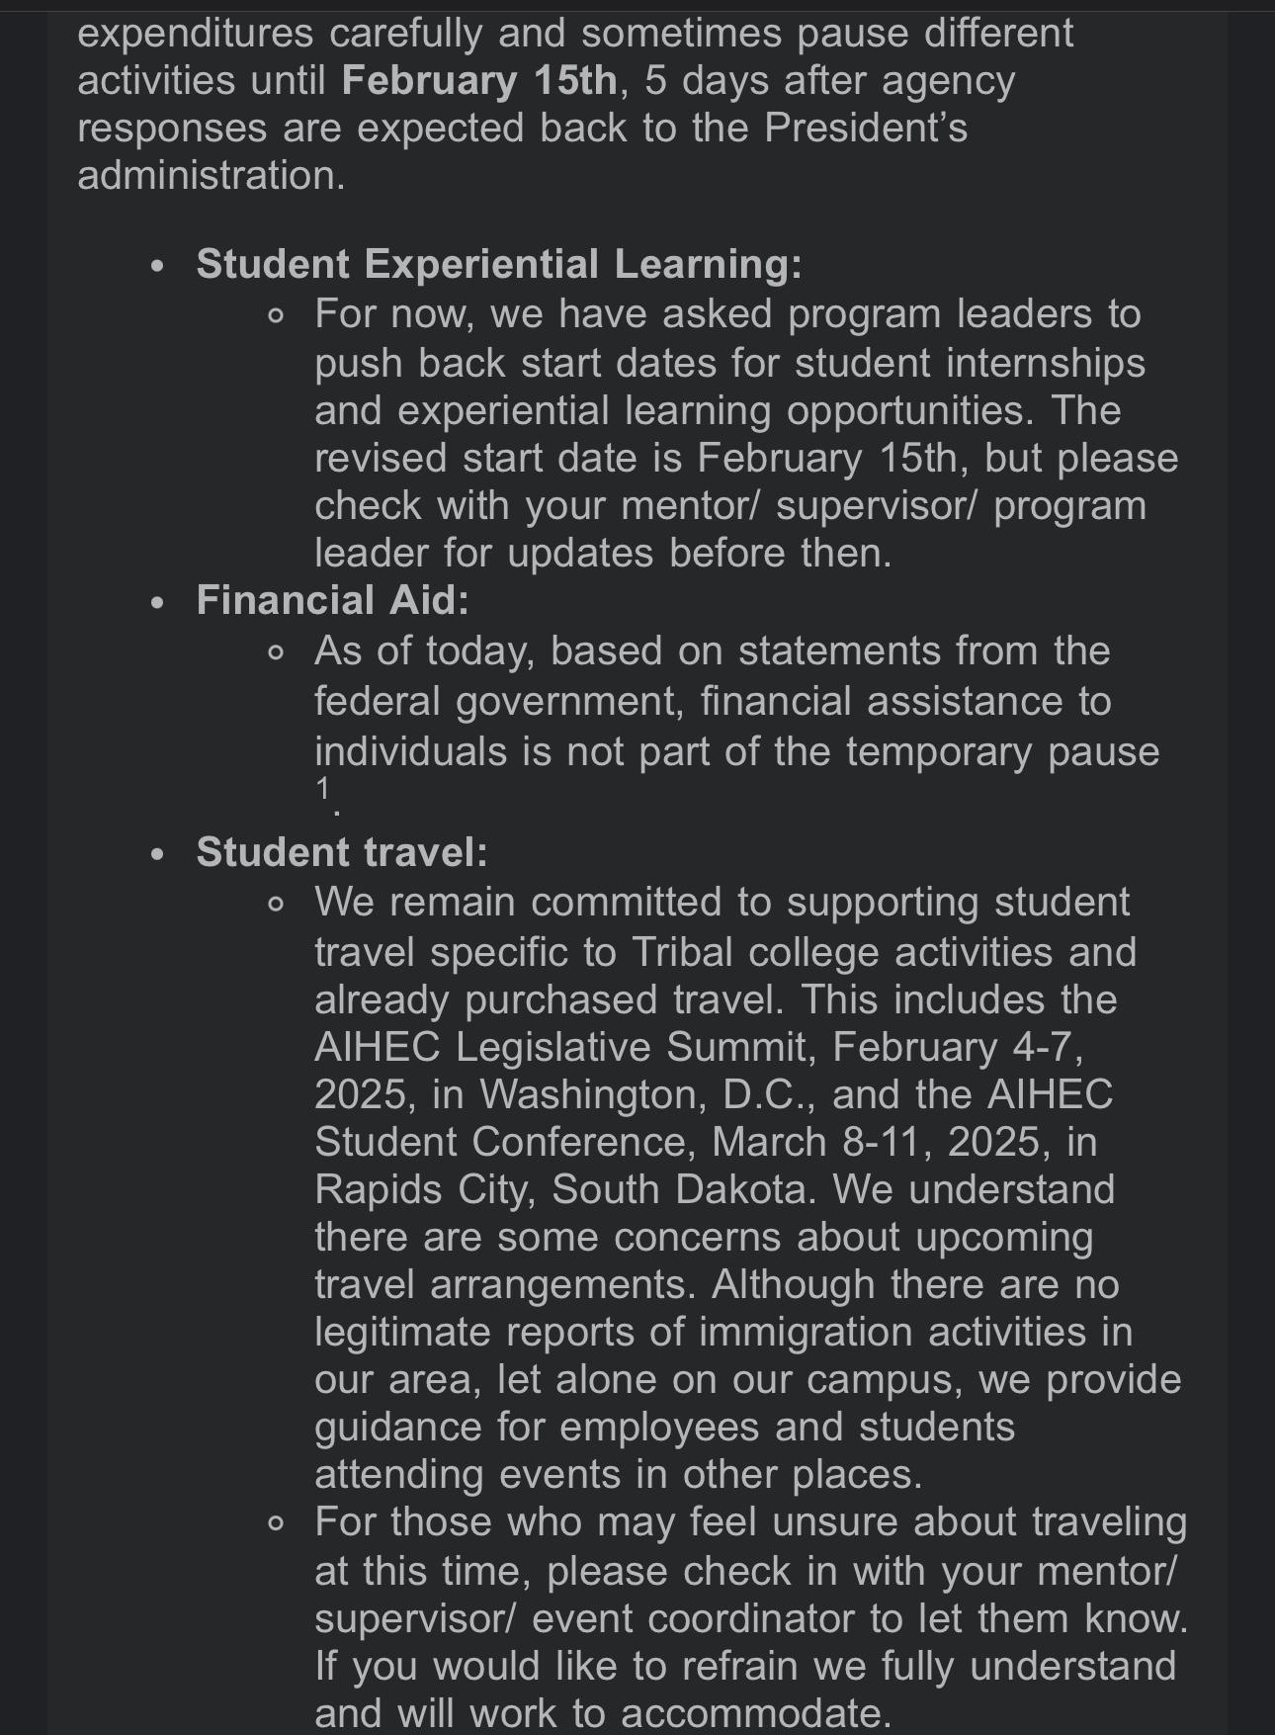
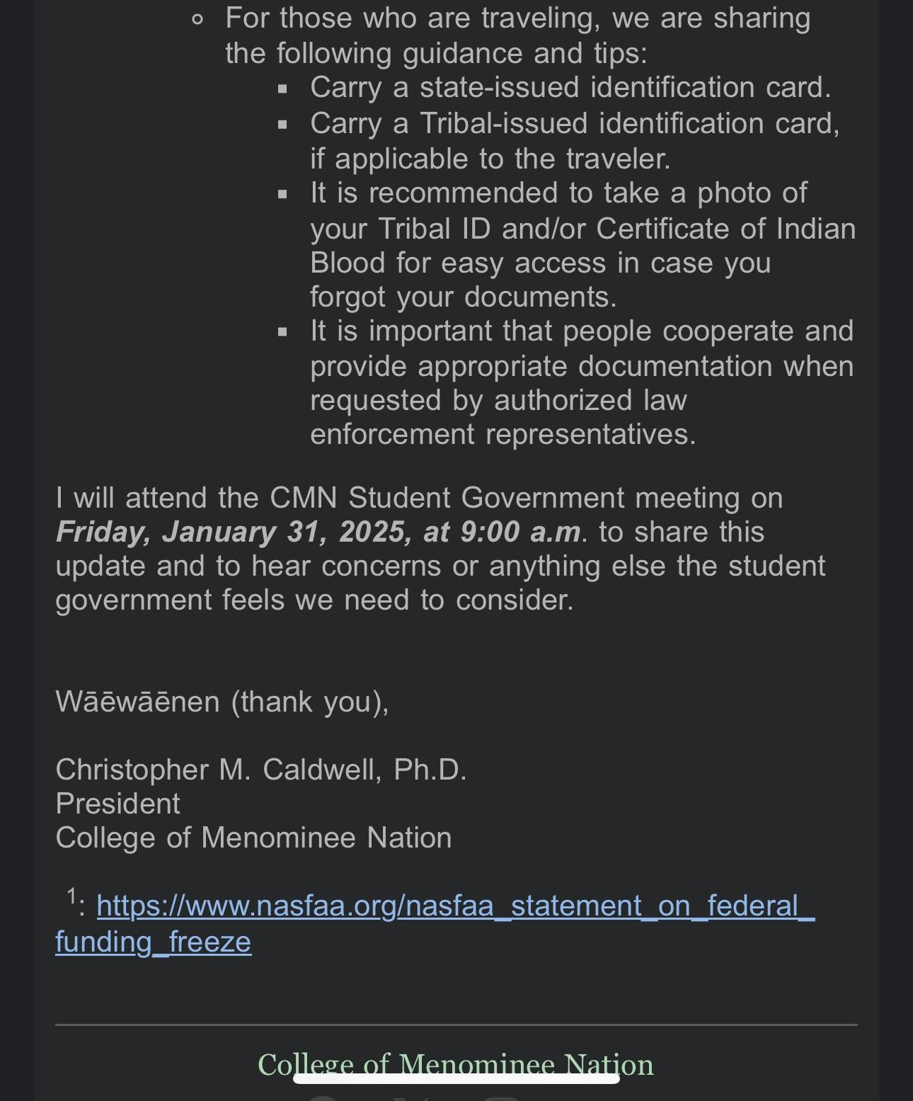
https://www.nasfaa.org/nasfaa_statement_on_federal_funding_freeze
mission of higher education
TCUs

