Women in the Woods
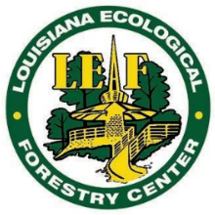
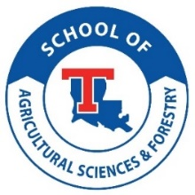
April 5 – 7, 2024 Louisiana Ecological Forestry Center
Florien, Louisiana

We are providing a free 3-day, 2-night annual workshops for 11th – 12th grade girls to learn about forestry from women foresters. They will teach you the basic skills of a forester and share with you their work and life experiences!

We would love all young women who are passionate about the outdoors and genuinely want to learn about forestry to participate in this event. However, we are only able to accommodate 40 participants. Thus, all participants must be (1) female, (2) a resident of the state of Louisiana, and (3) in the 11th or 12th grade during the 2024-2025 academic year. Additionally, young women who meet the aforementioned criteria must complete the following application and email it to Dr. Heidi Adams (hadams@latech.edu) by 5:00 PM CST on Friday, March 1, 2024. Late applications will not be accepted. Questions may be directed to Dr. Heidi Adams.

Full Name: Click or tap here to enter text.

Home Address: Click or tap here to enter text.

Age: Choose an item. T-shirt Size: Choose an item. Grade in 2024-2025: Choose an item.

Name of High School: Click or tap here to enter text.

Address of High School: Click or tap here to enter text.

---------------------------------------------------------------------------------------------------------------------------------------

Responses to the following questions should be 200 words or less.

QUESTION #1 Tell us about yourself. What hobbies do you enjoy? What are your favorite subjects in school and why? What extracurricular activities are you or have you participated in?

Click or tap here to enter text.

QUESTION #2 Describe your favorite outdoor experience. How did this experience positively influence your view of nature?

Click or tap here to enter text.

QUESTION #3 What are your future career goals?

Click or tap here to enter text.

QUESTION #4 How would attending this workshop help you in achieving your career goals?

Click or tap here to enter text.

QUESTION #5 Explain the importance of forestry in today’s society, as well as in your own life.

Click or tap here to enter text.

QUESTION #6 If you are selected to participate in this workshop, is their anything we should know ahead of time regarding your health and well-being (i.e., allergies, physical limitations, dietary restrictions, etc.)?

Click or tap here to enter text.

