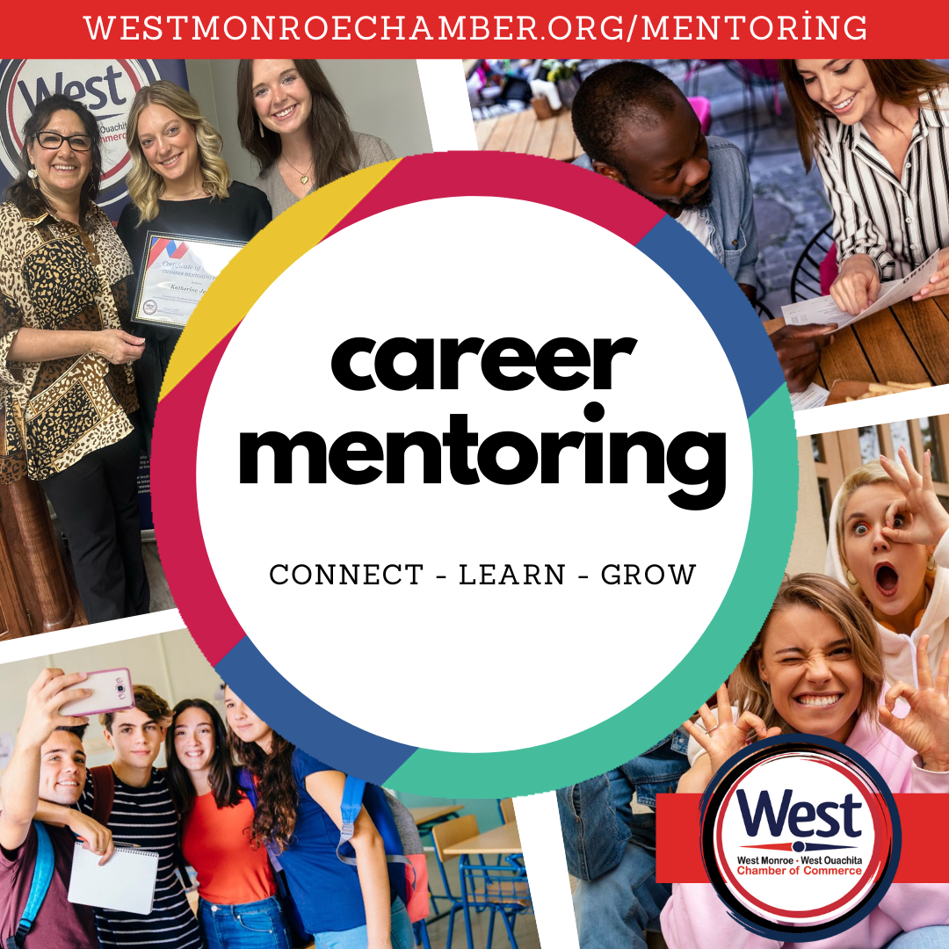

Unlock Your Teen’s Potential:
Join Our FREE 6-Month Program!
Enrolling now for January 2025 Start!
Act Now: Registration Closes December 13

Are you ready to set your high school student up for success? Enroll them in our FREE 6-month program designed to enhance their future!
- Life and Career Skills Development: Equip your teen with essential skills for personal and professional growth.
- Job Shadowing Opportunities: Gain firsthand experience in various career fields.

- And Much More: Exciting workshops, networking, and more!
Find out more online:
westmonroechamber.org/mentoring
(318) 325-1961

