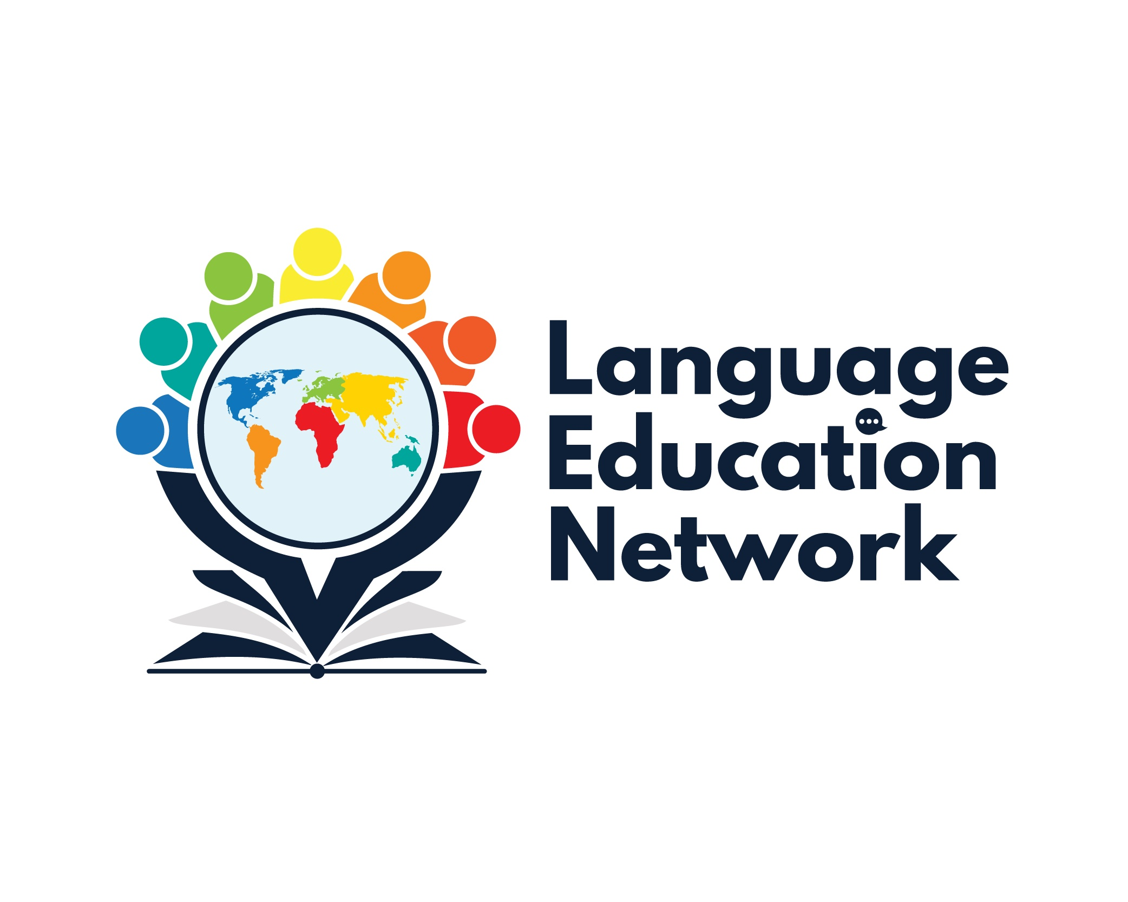

January 31, 2025
12:30 – 3:00 p.m.
AGENDA

Purpose: The purpose of our network is to come together to align current research and policy with the work that is required to prepare our English learners and multilingual students for college and career.
WELCOME!  ¡BIENVENIDOS! | - Meeting Agenda  - Presentation Slides  Facilitators:  Carlos Pagán: cpagan@sbceo.org  Melissa Garcia: mgarcia@sbceo.org

SECTION | TOPIC | LINKS & RESOURCES
1  (12:30 – 1:00) | 12:30 -12:45 Lunch and Networking  12:45 -1:00 Grounding  2024-2025 Meeting Dates:  September 27, 2024  January 31, 2025  March 21, 2025  May 9, 2025 | - SBCEO Professional Learning Opportunities Webpage  - Language Education Network (LEN) Webpage
2  (1:00- 2:00) | Title III Updates  Tara Clarke, Coordinator III  English Language Development  Curriculum and Instruction  Kern County Superintendent of Schools  - General Title III Announcements and Updates  - Reclassification of Dually Identified Students  - Long-Term English Learners (LTELs) on the CA School Dashboard | - Slide Deck  - Initial and Summative ELPAC Domain Exemption Decision-Making Tool  - Reclassification Considerations for Dually Identified Students  - Domain Exemption Considerations  - 2024-2025 ELPAC Information Guide  - The Role of Comprehensive, Multidisciplinary IEP Teams in Supporting Dually Identified Students
10-Minute Break 2:00-2:15
3  (2:15 – 2:30) | ELPAC Announcements – Melissa Garcia | CAASPP & ELPAC Website
4  (2:30-2:45) | BCN Updates  - State Seal of Biliteracy (SSB)  (2023-2024 Data)  - Observational Protocol for Teachers of English Learners (OPTEL) Tool & Modules  - ELPAC Announcements & Questions | SSB (2023-2024 Data)  - OPTEL Tool  - OPTEL Modules
5  (2:45 – 3:00) | Announcements & Closure  - DLI Institute – June 16-17, 2025  Topics: Spanish Writing Process (DLI); Designated and Integrated ELD in DLI Programs  - Educator Workforce Investment Grant (EWIG)  - Bilingual Teacher Professional Development Program Grant (BTPDP)  - Battle of the Books  - Upcoming Professional Learning Opportunities | - EPiCC Professional Opportunities Statewide HUB  - Bilingual Authorization Program

