 | Arts/Wellness Department  Art Curriculum  Grades K-5 | 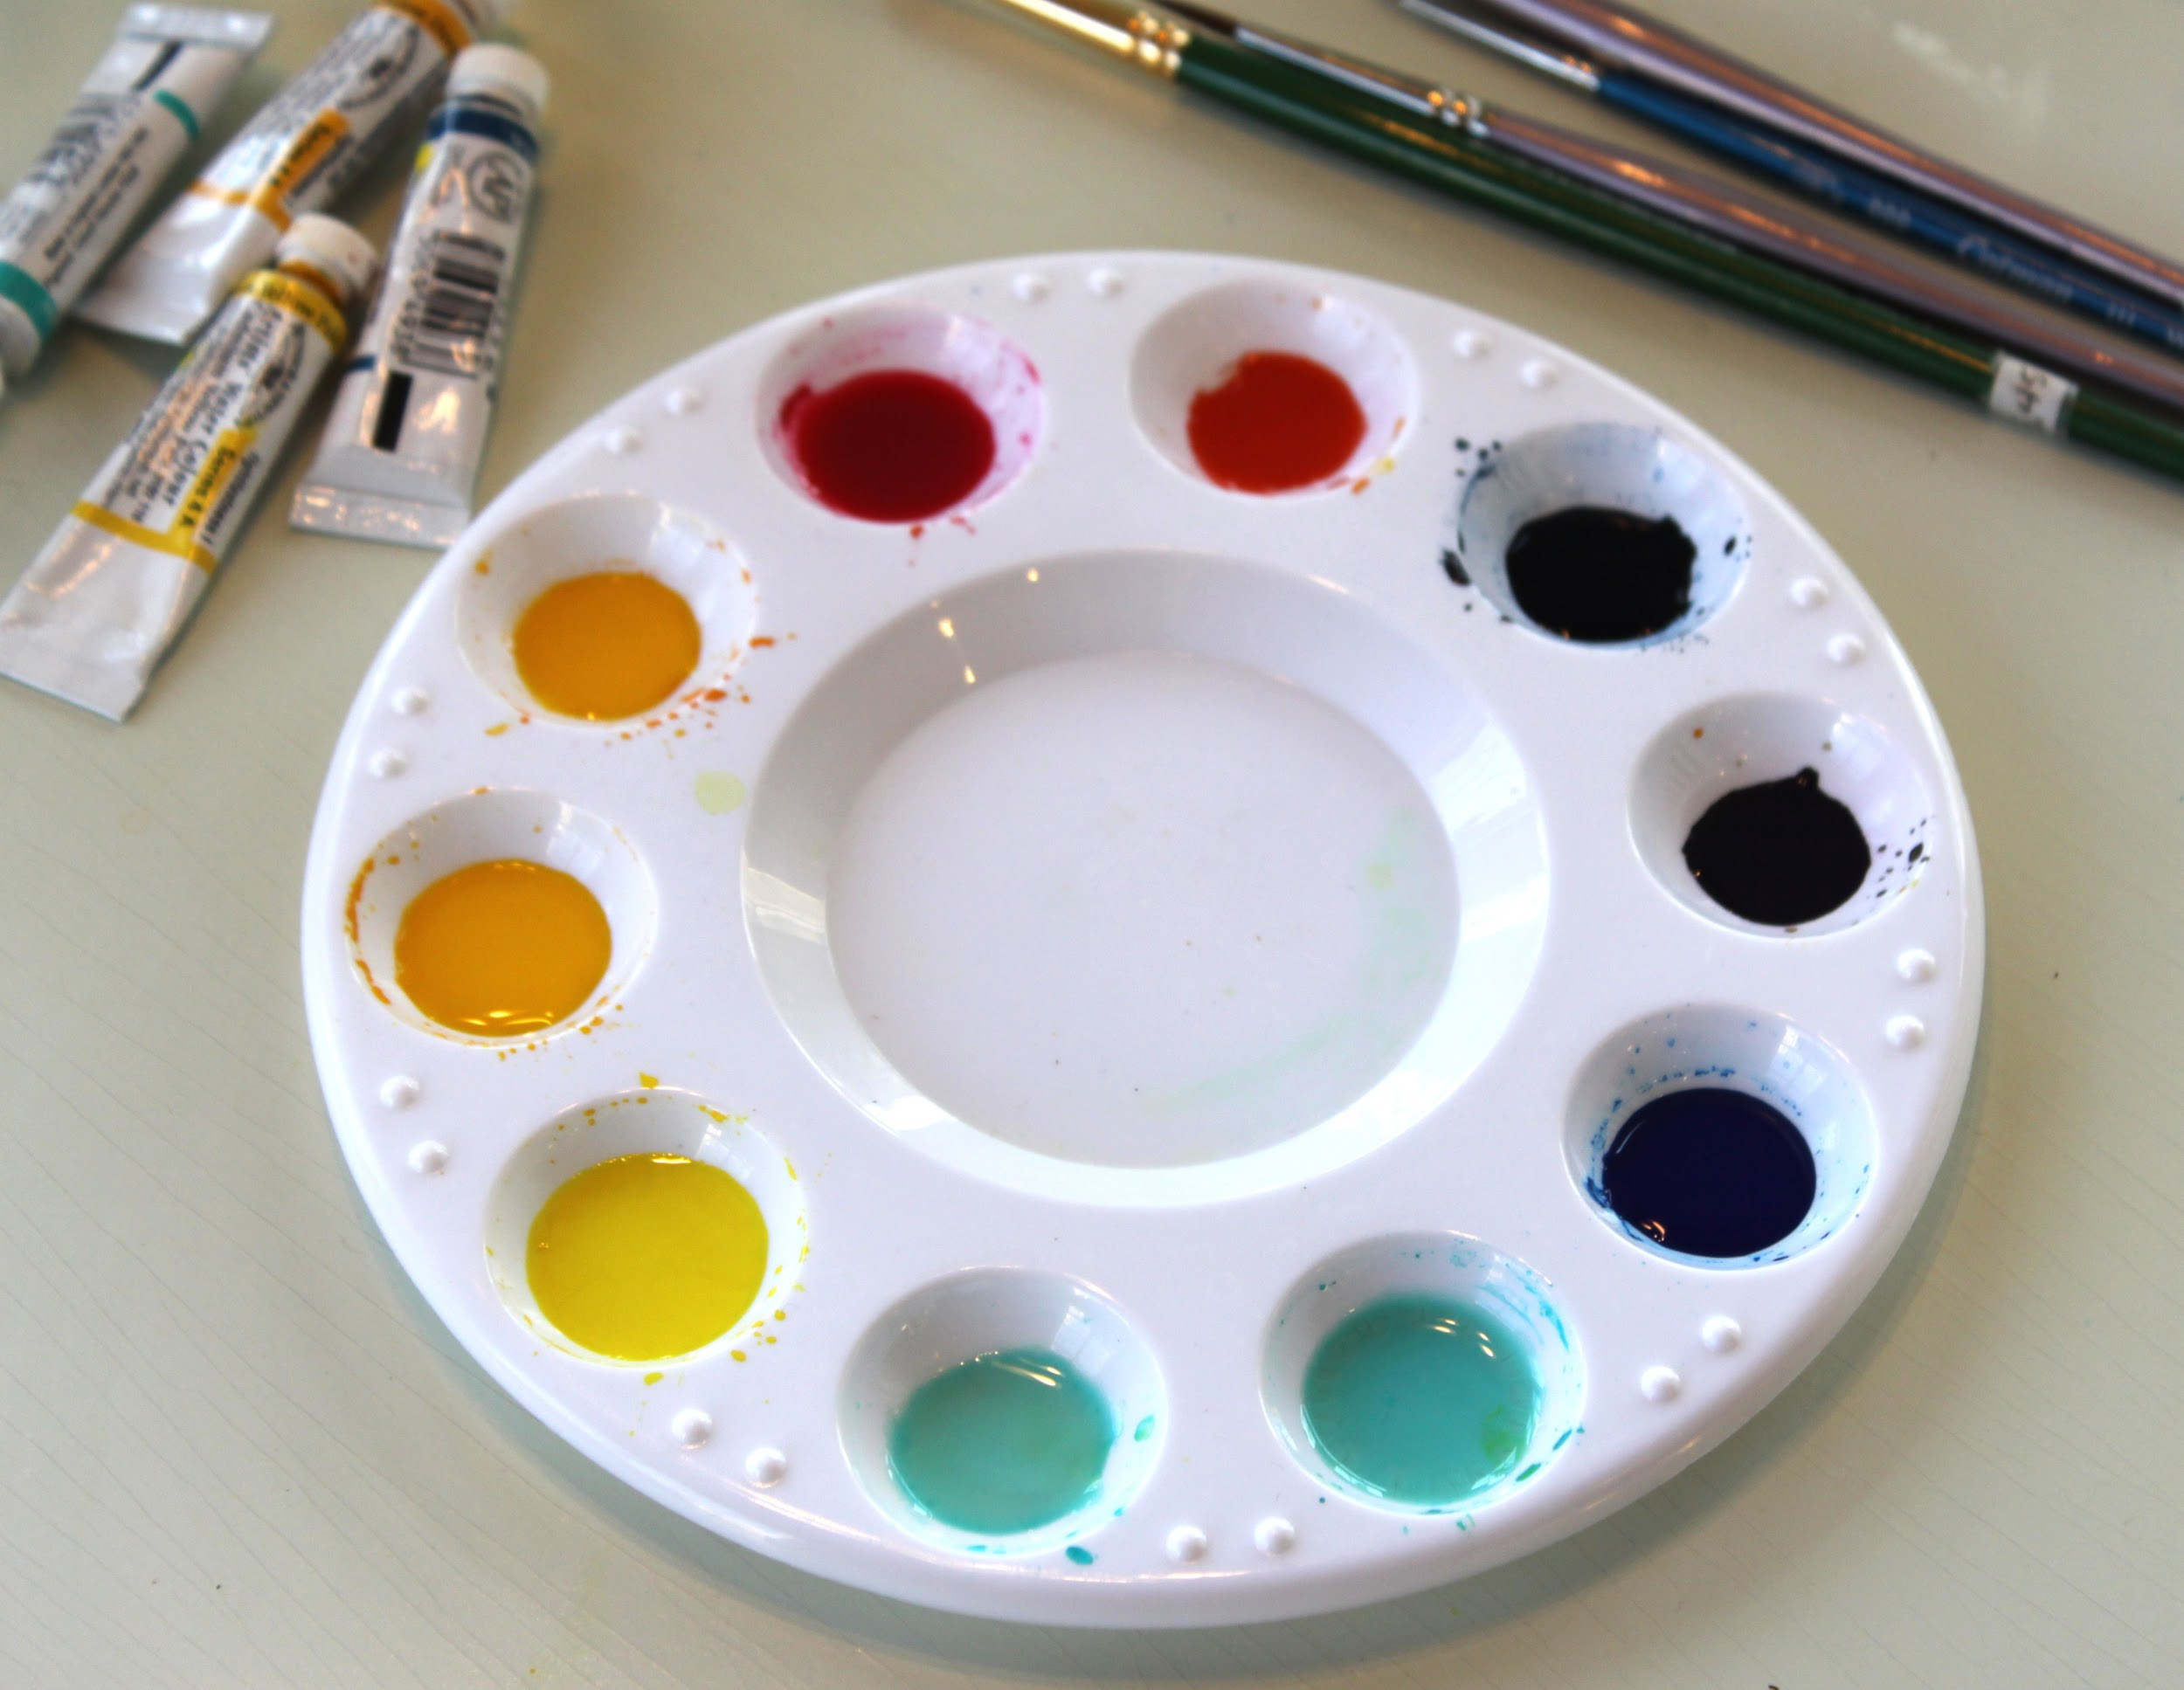

Norwell Public Schools’ grade K-5 art curriculum is aligned to the Massachusetts Arts Curriculum Framework, last revised in 2019, through its weekly 45-minute classes. The art program at the Cole and Vinal Schools is primarily designed to address students at the developmental level specified by the Massachusetts Department of Elementary and Secondary Education as by the end of grade 4, and in some cases by the end of grade 8, and to prepare them with the technical and expressive skills necessary to continue the study of visual art at the middle school level and to become lifelong artists and knowledgeable consumers of art.

Visual art at the Cole and Vinal Schools takes place in an environment that fosters curiosity, exploration, and independent thinking through the creation of art. Students problem-solve and respond through a variety of concepts, materials, and processes in order to unpackage the concept of creativity. Students are given access to language and information that will aid in their growth as both artists and culturally minded people. Students gain experience through failures and successes throughout the artistic process and by participating in conversations with their peers that promote personal reflection and discovery. Concepts and skills listed below are reinforced with greater depth and complexity as students grow and mature.

The Arts/Wellness Department believes that students proficient in the visual arts should have the opportunity to engage meaningfully with visual art through the four processes summarized best by the 2016 National Core Arts Anchor Standards. | - Creating: Conceiving and developing new artistic ideas and work.  - Presenting: Interpreting and sharing artistic work.  - Responding: Understanding and evaluating how the arts convey meaning.  - Connecting: Relating artistic ideas and work with personal meaning and external context.

Grades K-2  Line Variety/Direction  Texture  Primary/Secondary Colors, Color Mixing  Observation Drawing  Collage  Basic 3D Art  Basic Shape, Organic/Geometric Shape, Symmetry  Pattern and Design | Grades 3-5  Line Thickness  Using Line to Create Texture/Movement  Color Wheel, Tertiary Colors, Value  One-Point Perspective, Near/Far  Landscape  Formal Portraits/Feature Division

2019 Massachusetts Arts Curriculum Framework
2016 National Core Arts Standards

