LAGRANGE ELEMENTARY SCHOOL
SPECIAL-CALLED SBDM Meeting
January 28, 2025 | 2:40 p.m.| SBDM Council
______________________________________________________________________________

Council Members
Heather Thomas, Chair| Melinda Hadley, Teacher| Karla J-Stewart, Teacher| Jamie Parker, Teacher| Tovah Jeffries, Parent| Kylie Walker, Parent|
______________________________________________________________________________
Agenda Item Lead
______________________________________________________________________________

Welcome, Review Norms & Roll Call H. Thomas
- Council discussions stay within the group until the action item has been approved by the Council
- Start on time and end on time
- Maintain a focus on ensuring the learning of all students
- Be willing to share ideas and open to new learning
Approval of Agenda H. Thomas

Approval of Minutes from — Meeting H. Thomas

Council Action Items
- Policy Review of 3001 and 4002 (Enclosure A)
- Enter Closed Session to Discuss Certified Personnel Selection per KRS 61.801 (1) (f) for discussions that might lead to the recommendation of an individual employee

Committee Reports

Comprehensive School Improvement Plan (CSIP) Update
- iReady January Data Update H. Thomas

Public Comment

Principal’s Report
- Budget review H Thomas

Adjournment H Thomas

La Grange Elementary
School-Based Decision-Making Council
November 25, 2024
The La Grange Elementary School Site Based Decision Making Council met in the library for the regularly scheduled monthly meeting with the following members in attendance: Jamie Parker - Teacher Rep, Kiley Walker – Parent Rep, Tovah Jeffries – Parent Rep, Melinda Hadley – Teacher Rep, Karla J-Stewart – Teacher Rep and Heather Thomas - Chair. Brent Deaves, Interim Deputy Superintendent, also joined the meeting.
Mrs. Thomas called the meeting to order at 2:40 pm.
1) A motion was made by Melinda Hadley to accept the agenda. The motion was seconded by Kylie Walker and the motion carried with no opposition.
2) The Council discussed Policy1003 – Staff Time Policy. Mrs. Thomas recommended changes to the section titled Procedures. Within this section, it stated, “school council shall establish specific timeframes”. Mrs. Thomas recommended that the wording be changed to “the School Council shall approve the recommendations submitted by the school leadership.” Mrs. Thomas also recommended that the sentence “All certified and classified instructional staff’s time during the school day shall be equitably distributed amongst La Grange Elementary School’s instructional staff members.” be removed from the end of the first paragraph. At the beginning of the second paragraph, Mrs. Thomas recommended the word “classroom” be removed as it also needs to apply to all certified teachers. In the third paragraph, Mrs. Thomas recommended that “resource special education” be changed to “specialist area teachers” to include EL teachers and thus to include “PSP” after “IEPs” so EL’s student plans are included.
Kylie Walker motioned to approve changes. Tovah Jeffries seconded the motion.
3) Mrs. Hadley shared our Student Technology Funds update.
4) The Council reviewed and discussed the 2024-25 CSIP (Comprehensive School Improvement Plan). Tovah Jeffries motioned to approve. Jamie Parker seconded the motion.
**Mr. Deaves asked the School Council if there were any questions, needs or recommendations. Discussed intervention equity, EL staff, and GATES.
With no additional business, a motion was made by Kylie Walker to adjourn. The motion was seconded by Karla J-Stewart and the Council adjourned at 3:47 pm.

La Grange Elementary
School-Based Decision-Making Council
December 9, 2024
The La Grange Elementary School Council met in a special-called session in the library of La Grange Elementary School with the following members in attendance: Kiley Walker (parent), Melinda Hadley (teacher), Jamie Parker (teacher), Tovah Jefferies (parent) and Heather Thomas (chair), called the meeting to order.
1. The meeting was called to order at 8:10 AM
2. The Council reviewed and approved the agenda.
3. The Council entered a closed session to discuss certified personnel selection as
provided by KRS 61.810 (1)(f) at 8:11 AM..
4. The Council resumed open session at 8:30 AM.
5. With no further business, the Council adjourned.

La Grange Elementary
School-Based Decision-Making Council
January 24, 2025
The La Grange Elementary School Council met in a special-called session in the library of La Grange Elementary School with the following members in attendance: Melinda Hadley (teacher), Jamie Parker (teacher), Tovah Jefferies (parent) and Heather Thomas (chair), called the meeting to order.
1. The meeting was called to order at 7:45 AM
2. The Council reviewed and approved the agenda.
3. The Council entered a closed session to discuss certified personnel selection as
provided by KRS 61.810 (1)(f) at 8:45 AM..
4. The Council resumed open session at 7:50 AM.
5. With no further business, the Council adjourned.

January 27, 2025
Enclosure A

La Grange Elementary School Council
Oldham County Schools

CONCERN:

The phrase council policies refer to what the school council develops and adopts concerning how the school operates. This includes such items as curriculum development, determining school schedules and technology use in schools. Policies are the rules, guidelines and procedures for school operations.

DISCUSSION:

School council policies need to contribute to raising student performance and keep a focus on achieving our mission and goals. As our goals and procedures evolve, the council needs to review our policies to determine if and how they need to be revised.
In regards to policy 3001 School Budget, the policy states, the budget shall include a complete financial forecast of both anticipated receipts and the expenditures for the school year, including staffing, and shall be prepared on forms approved by the Superintendent.
In regards to policy 4002 Determination of Curriculum, the council needs to further discuss what is now required of schools. Kentucky Revised Statute (KRS) 160.345 requires school councils adopt a writing program consistent with local board policy and that the principal ensure its implementation into the curriculum. ​ The​​​​ passing of Senate Bill 1 (2022) amends KRS 158.6453 to require that the Kentucky Department of Education provide school districts guidelines for including an effective writing program within the curriculum. Does La Grange need both a writing policy and curriculum policy? No. KRS 160.345​ requires SBDM councils to include in its curriculum policies the responsibilities under KRS 158.6453(19) outlining the school's writing program. As a council, we need to discuss the merger of part of our Writing Policy with our Curriculum Policy.

RECOMMENDATION:

Discuss council policy 3001 and 4002 make revisions, ask questions and seek additional information if needed. Pending no additional questions, approve policy revision as presented.

LAGRANGE ELEMENTARY SCHOOL COUNCIL POLICY
SCHOOL BUDGET 3001
TOPICS | STATEMENTS
a. Budgeting Process | In compliance with KRS 160.345(3), a school budget shall be prepared annually based on the allocation from the Board. All funds received by the school from the Board shall be included in the budget. The budget shall include a complete financial forecast of both anticipated receipts and the expenditures for the school year, including staffing, and shall be prepared on forms approved by the Superintendent  Prior to the end of the school year, each staff group which will be involved in a particular activity account shall be required to develop a working budget and a narrative explanation of expenditures. This budget shall be the work of the members of the group.
b. Council Approval | The Principal, with assistance from the Team Leaders if there are changes in the budget according to SBDM approved per grade amounts, shall submit and recommend a draft budget within the allocation level approved by the Board for the Council's consideration. The principal shall recommend approval of the annual school budget by the Council for the preceding year or no later than three weeks after receipt of notice of final allocation of funding from the Board.
c. Expenditures | Expenditures of funds allocated to the school shall be pursuant to all fiscal policies of the Board. Funds may be moved from one activity account to another only with the approval of the principal. The principal shall approve each expenditure. Expenditures shall not exceed appropriations.
d. Audit | Accounting for funds shall be pursuant to all fiscal and audit policies of the Board. The audit shall be reported to the Council.

LAGRANGE ELEMENTARY SCHOOL COUNCIL POLICY

Writing and Communications Plan Policy 4003
Required Components | Criteria for Evaluation of Required Component
Multiple opportunities are provided for students to develop complex communication skills for a variety of purposes. | Multiple opportunities are provided for students to develop complex writing and communication skills for a variety of purposes by:  - Utilizing the writing curriculum from EL Education, aligned to the KAS, as well as appropriate and relevant to the 21st Century Learning, teachers will:  - Explicitly teaching skills identified in the Kentucky Academic Standards. Students will have multiple opportunities to demonstrate higher-order thinking and understanding across all content areas through oral and written responses, as well as monitoring learning through written reflection.  - Intentionally plan during Professional Learning Communities for the integration of various modes of writing within daily ELA instruction.  - Participate in on-going analysis of student writing to inform classroom and whole school instructional strengths and areas of need.  - The school’s writing and communication plan has been developed and implemented as a component of the school’s literacy program. Experiences may include, but are not limited to:  a).intentional planning of opportunities for writing to demonstrate learning, as well as analysis of writing opportunities during grade level PLCs.  b). authentic, meaningful writing opportunities  i. utilizing EL Education that teach the criteria for each genre/mode of writing as outlined in the KAS  ii. that include writing for various audiences based on the particular mode of writing  iii. that create personal expression of identity and experience within EL Education modules through student choice  iv. differentiated learning activities using student experiences to enhance and further develop communication skills  c). Using EL Education modules to provide writing experiences in which students demonstrate an understanding of the writing process within all modes of writing from drafting through publication.  d). opportunities for immediate feedback related to the mode and content of mini-lesson, as well as set goals for writing next steps.  e). including on-demand timed writing experiences three times per year that are analyzed for next steps, as well as used to compare growth over time; and writing over time through daily writing experiences of the core curriculum or content area writing.  f). intentionally planned learning opportunities within and across grade levels designed to help students demonstrate learned writing skills that enhance oral communication over diverse cultures.
A variety of language resources are embedded within writing instruction. | Within literacy instruction, allow students to read and analyze a variety of print and non-print tasks by embedding a variety of language resources.  This instruction should enable students to:  - develop as writers in the three modes of writing through the analysis of exemplars/mentor texts using the EL Education modules for each grade.  - read and analyze a variety of multimodal texts to implement into their own writing.  - learn from differentiated instructional strategies, (i.e., conferring, small group instruction, feedback, setting writing goals) across grade levels.
A variety of technological tools are used in the writing process. | A variety of technological tools are used in the writing process that allows students to: Added a statement  - demonstrate understanding of the writing process within all modes of writing from drafting through publication using multiple digital platforms (google docs, google slides, flipgrid, etc).  - digitally publish writing assignments and content area writing using multiple digital platforms (google docs, google slides, flipgrid, etc).  - use Nearpod to take virtual field trips that connect to core reading lessons, followed by students demonstrating learning through written responses.  - produce graphic novels using Google Slides.

Additional Components | Criteria Additional Components
Implementation | The La Grange SBDM Council shall be responsible for monitoring the school’s writing policy in accordance with KRS 158.6453, the Kentucky Academic Standards and the Oldham County Schools Communication Plan.  The La Grange council monitors the Oldham County Communication Plan which establishes procedures to:  - Analyze and evaluate strengths and needs of the communication plan;  - Support the professional development needs for the plan based on analysis and evaluation and make recommendations to the school’s administration  - Develop recommendations regarding writing instruction as part of the annual writing program review.
Teacher and Administrator Responsibilities | The teachers and principal will ensure that students are actively engaged in using communication skills regularly in every class, across all grades and content areas. Teachers will look for evidence of student understanding and application of the above through:  - Student and teacher conferring:  a). Teachers confer with students to give feedback to improve student writing/communication skills – teachers will provide regular feedback (conferring, descriptive feedback, electronic comments and/or use of rubrics) about their writing throughout the writing process (pre-writing through publication).  b). Student goal setting to target individual student needs.  c). On-going analysis of writing to inform classroom instruction.  - Writing to demonstrate learning:  a). Authentic writing experiences across content areas to gauge student understanding.  - Individual communication folders will house:  - 3 CBMs completed through the year  - A minimum of one piece that represents one of the five types of communication: research, analysis, creative, short-timed writing, and presentations.

LAGRANGE ELEMENTARY SCHOOL COUNCIL POLICY

CURRICULUM 4002

Definitions | Text in bold italics addresses legal requirements.  Standards are what students need to know and be able to do to meet an expected level of performance. Standards are the target.  Curriculum identifies the specific content, skills, and learning experiences students need to master the standards. The curriculum is the map for how to get to the standards/target.  Instructional Materials include the supplies, equipment, software, and texts to help students learn the curriculum and master the standards. Instructional materials are what teachers and students use to enable students to reach the target.  Student Support Services are additional services provided to students that include, but are not limited to, counseling, FRYSC services and community support referrals. Student support services are given to students who need more support to reach the target.
Kentucky Academic Standards - Curriculum Areas | The curriculum is a roadmap for student mastery of the Kentucky Academic Standards. The standards define what students are expected to know and be able to do at each level in each subject area:  - Reading and Writing  - Math  - Science  - Social Studies  As well as:  - Health and Physical Education  - Visual and Performing Arts  - Computer Science/Technology  - Career Studies  - Library Media  Those standards are adopted by the Kentucky Board of Education based on national and international models. The standards are reviewed and revised through a years-long process that invites participation from every part of the school community.
Curriculum Selection Process | Beginning with the 2022-23 school year, the SBDM law gives the superintendent the authority to determine the following for each school:  - Curriculum  - Instructional materials (which includes textbooks)  - Student support services  Before making those selections, the superintendent will:  - Consult with the local board of education  - Offer a reasonable review and response period for stakeholders in accordance with local board policy  - Consult with the principal and the school council  When consulting with the superintendent, the council will:  - Ensure students, families, school staff, district leaders, and community members have opportunities to provide feedback on CURRICULUM strengths and areas of need.  - Request INSTRUCTIONAL MATERIALS that are:  - Matched to the unique strengths and needs of the school.  - Backed by research and evidence of success in a similar school setting.  The curriculum document(s) and the LaGrange Elementary Curriculum Overview, can be found on the school website or reviewed in the school office.
Implementation of the Curriculum | The SBDM Council will:  Use applicable areas of decision-making to ensure each student has:  - a learning environment where educators and staff are supported and empowered to be successful with students.  - an equitable opportunity to master the state standards:  - grade-appropriate assignments aligned to the standards.  - additional time and support to master the state standards.  All teachers will:  - Disseminate the curriculum expectations to families and to students in age-appropriate ways.  - Ensure students have an equitable opportunity to master the state standards with assignments congruent to the grade-level.  - Contribute to discussions of needed changes in the curriculum and instructional materials.  The principal (or designee) will:  - Ensure that the standards and curriculum for the school are available for student, family, and community review.  - Meet with all teachers to review this policy and the sections of the curriculum that apply to each teacher’s assignment.  - Report to the council annually on progress towards curriculum implementation, including ensuring 100% of students are doing assignments congruent to the grade-level standards (meaning the student work is at the same level of difficulty as the standard).  - Coordinate resources and support that include, but not limited to, curriculum coaches, district instructional leaders, educators in other district schools, other educators with expertise, sources for evaluating the evidence of effectiveness, etc.
Multiple opportunities are provided for students to develop complex writing and communication skills for a variety of purposes by:
- Utilizing the writing curriculum from EL Education, aligned to the KAS, as well as appropriate and relevant to the 21st Century Learning, teachers will:
- Explicitly teaching skills identified in the Kentucky Academic Standards. Students will have multiple opportunities to demonstrate higher-order thinking and understanding across all content areas through oral and written responses, as well as monitoring learning through written reflection.
- Intentionally plan during Professional Learning Communities for the integration of various modes of writing within daily ELA instruction.
- Participate in on-going analysis of student writing to inform classroom and whole school instructional strengths and areas of need.
- A variety of technological tools used in the writing process.

- The school’s writing and communication plan has been developed and implemented as a component of the school’s literacy program. Experiences may include, but are not limited to:
a).intentional planning of opportunities for writing to demonstrate learning, as well as analysis of writing opportunities during grade level PLCs.
b). authentic, meaningful writing opportunities
i. utilizing EL Education that teach the criteria for each genre/mode of writing as outlined in the KAS
ii. that include writing for various audiences based on the particular mode of writing
iii. that create personal expression of identity and experience within EL Education modules through student choice
iv. differentiated learning activities using student experiences to enhance and further develop communication skills
c). Using EL Education modules to provide writing experiences in which students demonstrate an understanding of the writing process within all modes of writing from drafting through publication.
d). opportunities for immediate feedback related to the mode and content of mini-lesson, as well as set goals for writing next steps.
e). including on-demand timed writing experiences three times per year that are analyzed for next steps, as well as used to compare growth over time; and writing over time through daily writing experiences of the core curriculum or content area writing.
f). intentionally planned learning opportunities within and across grade levels designed to help students demonstrate learned writing skills that enhance oral communication over diverse cultures.
The La Grange SBDM Council shall be responsible for monitoring the school’s writing policy in accordance with KRS 158.6453, the Kentucky Academic Standards and the Oldham County Schools Communication Plan.
The La Grange council monitors the Oldham County Communication Plan which establishes procedures to:
- Analyze and evaluate strengths and needs of the communication plan;
- Support the professional development needs for the plan based on analysis and evaluation and make recommendations to the school’s administration
- Develop recommendations regarding writing instruction as part of the annual writing program review.
Policy Evaluation | The council will evaluate the effectiveness of this policy through an annual review.

Adopted: La Grange Elementary SBDM Council – September 19, 1995; Revised July 8, 1997;
Revised: March 16, 1999; April 18, 2000; September 26, 2000; September 25, 2001; March 27, 2006; August 1, 2007; June 30, 2011; August 27, 2013; August 25, 2014, September 23, 2019; July 24, 2023; January 27, 2025

iReady Data Review
Reading
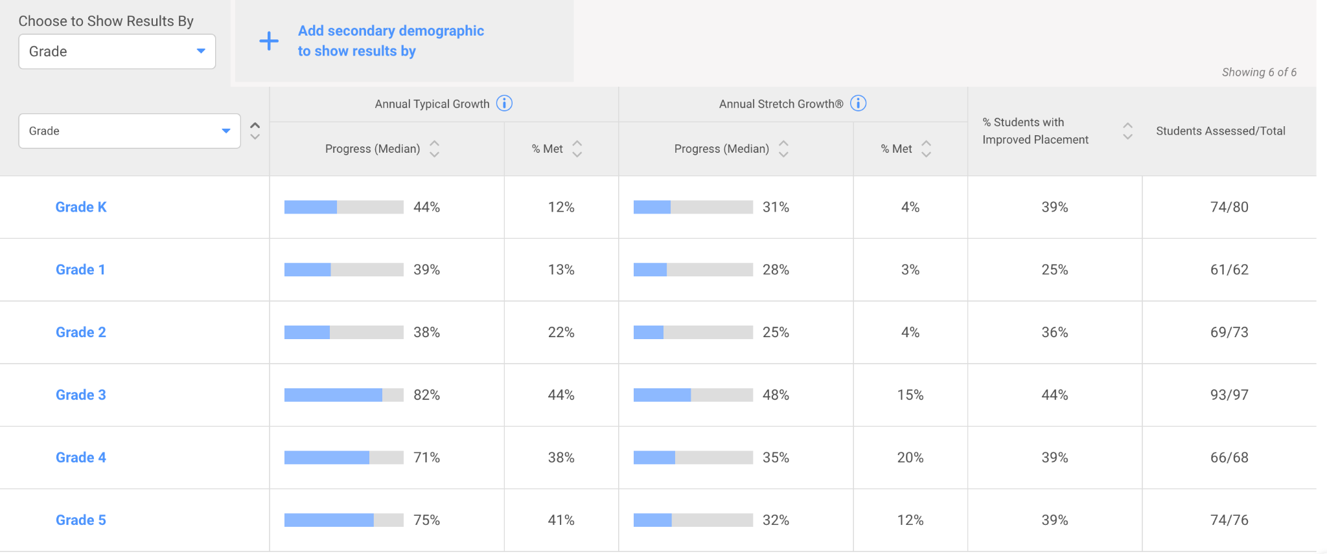
Math
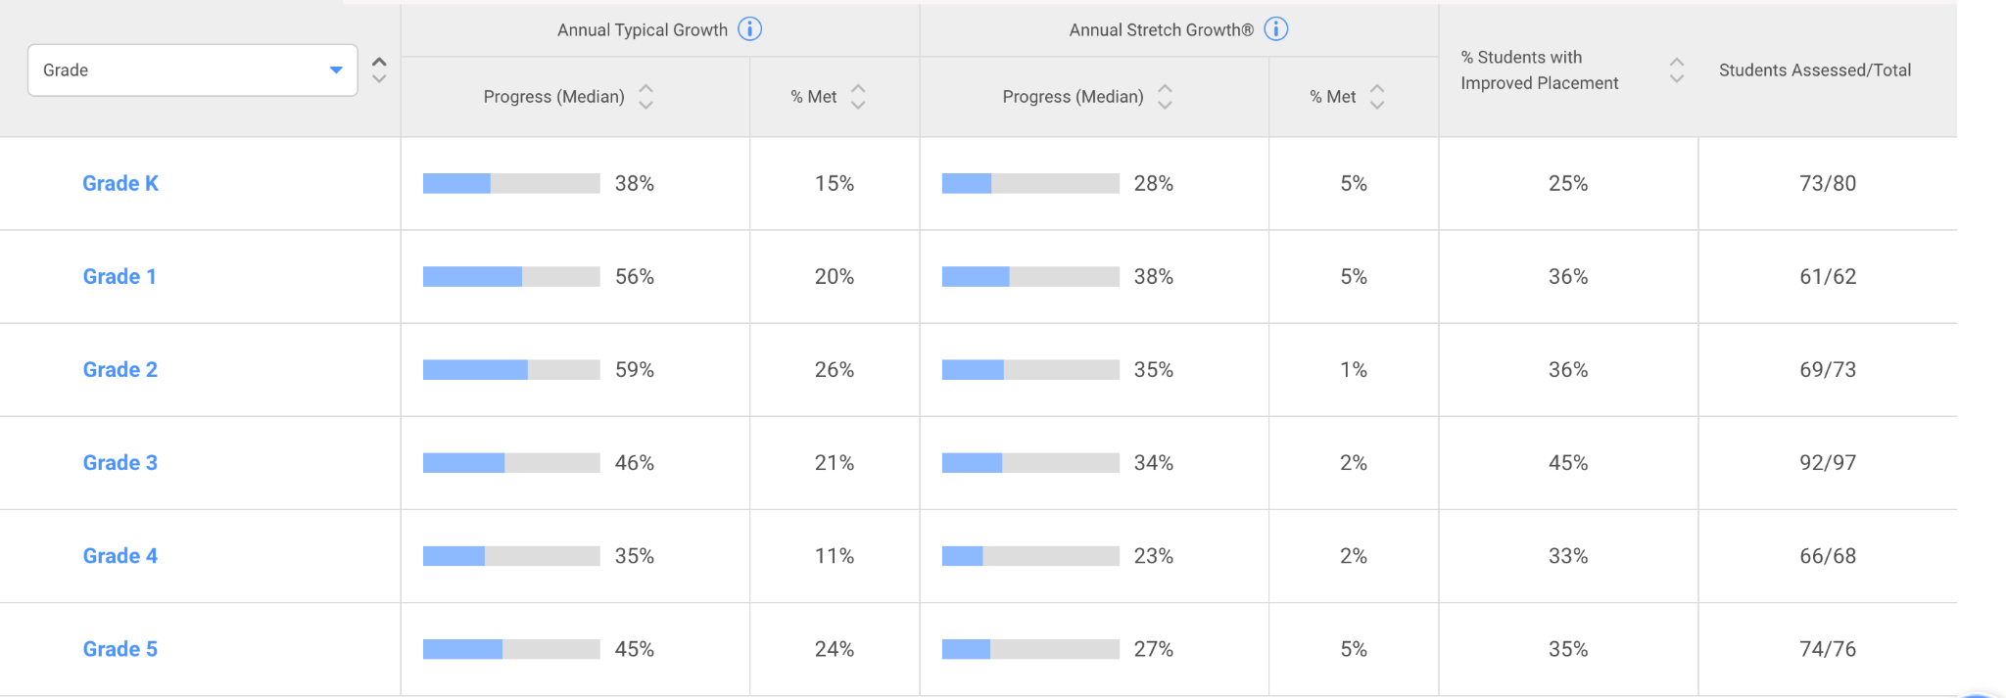

Free/Reduced Lunch Funding Plan

DATA: Below is the data from our winter iReady in both reading and math:

READING
Grade | 2 or more grade levels below | 1 grade level below
K | n/a | 43
1 | 3 | 47
2 | 16 | 28
3 | 25 | 27
4 | 13 | 24
5 | 25 | 29
TOTAL | 82 | 198

In reading, our current intervention team, ECE and EL teams are providing support for 73 of the 82 students two or more grade levels below. The team is providing support for 77 of the 198 students one grade level below. Homeroom teachers work with the remaining students through Tier II.

In reviewing our iReady Winter reading data, students two or more grade levels below, especially in 3rd with136%, 4th with 93% and 5th grade with 135% are making significant progress. Our concern is primarily with students one-grade level below with a school average of 42% growth in reading progress.

MATH
Grade | 2 or more grade levels below | 1 grade level below
K | n/a | 54
1 | 3 | 47
2 | 16 | 37
3 | 15 | 48
4 | 4 | 36
5 | 14 | 36
TOTAL | 52 | 258
In math, our current intervention team and ECE staff are providing support for 25 of the 52 students two or more grade levels below. We service fewer students in math due to a lower number of students identified with a math disability and our EL team focuses on language acquisition and reading. The team is providing support for 18 of the 258 students one grade level below. Homeroom teachers work with the remaining students through Tier II.

In reviewing our iReady Winter math data, students two or three grade levels below, again in 3rd with 80%, 4th with 74% and 5th grade with 97% are making significant progress. Our concern is primarily with students one-grade level below with a school average of 45% growth in reading

As a school with a transient population, we must also address the needs of incoming students. For example, on the week of January 13th, we registered 14 new students. After assessing our new student 13 of those students need significant interventions.

Plan:
Our plan is to hire an intervention teacher 4 days/week for the remainder of the school year. The number of days LaGrange can employ the interventionist depends on who is hired. Different options are listed below:
- If the person was hired as a long-term substitute, the cost would be approximately $150 per day which would allow the interventionist to remain on staff for the rest of the year.
- If the position is posted and a teacher with limited experience is hired, F/R funds should be able to cost for the remainder of the year.
- If the position is posted and filled by a retired teacher, they would be paid their daily wage threshold. This would be the most qualified for the position, however, their days would be limited based on their pay. For example, a retired teacher could cost $300+ a day which would limit the length of the position until late April or early May, which can work.

With the addition of a new reading and math intervention staff member, La Grange will be able to add 2 kindergarten groups, 1 first grade group, 3 second grade groups, 1 third grade group and 1 fourth grade group. There is also room in this schedule for two additional groups once need is determined. With an average of 5 students per group, La Grange will provide additional services for a minimum of 40 students but potentially more depending on the size of the groups.

