Library Survival Manual: Table of Contents

Topics | Section, Page Number
Section 1: Welcome to the Library | Section 1, page 1
Mission Statement | Section 1, page 2
Role of the School Library | Section 1, page 2
Technology Statement | Section 1, page 3
Library Learning Commons | Section 1, page 3
Objectives of Library Program | Section 1, page 3
Month by Month Guide to Library Management | Section 1, page 4
Setting Up a Filing System | Section 1, page 10
Definitions | Section 1, page 13
Role of the Teacher-Librarian | Section 1, page 21
Responsibilities of Teacher-Librarian | Section 1, page 21
Collaborative Teaching | Section 1, page 22
Open Access and Flexible Scheduling | Section 1, page 22
Certification as a Teacher-Librarian | Section 1, page 26
Professional Growth | Section 1, page 26
Opening and Closing Dates | Section 1, page 26
Duty Post | Section 1, page 26
Job Description for Teacher-Librarian | Section 1, page 27
Job Description for Library Paraprofessional | Section 1, page 31
Guidelines for Using Volunteers | Section 1, page 33
Facilities: Standards 14-15 | Section 1, page 34
Philosophy | Section 1, page 34
Section 4: Processing Books and Other Items |  | Section 4, page 1
Processing Books, Writing and Stamping |  | Section 4, page 2
Descriptive Cataloging Guidelines |  | Section 4, page 3
Downloading MARC Records from Titlewave |  | Section 4, page 19
Downloading MARC Records from Mackin |  | Section 4, page 21
Section 5: Book Orders |  | Section 5, page 1
Book Order Funds |  | Section 5, page 2
Automation Setup for Jobbers |  | Section 5, page 2
Unused Barcode Report |  | Section 5, page 3
Naming & Creating Book Orders, Follett |  | Section 5, page 5
Naming & Creating New Order in Mackin |  | Section 5, page 6
Advanced Search Feature in Titlewave |  | Section 5, page 7
Advanced Search Feature in Mackin |  | Section 5, page 8
Share Follett Order, How to |  | Section 5, page 9
Share Mackin Order, How to |  | Section 5, page 10
Submitting Book Orders, General Information |  | Section 5, page 11
Follett Order, How to Print in Annotated Format |  | Section 5, page 12
Mackin Order, How to Print in Annotated Format |  | Section 5, page 14
Feedback on Book Orders, Comments, etc. |  | Section 5, page 15
DNE Amount, Including on Mackin Printout |  | Section 5, page 17
DNE Amount, Including on Follett Order |  | Section 5, page 18
P.O. Numbers & Instructions for Book Orders |  | Section 5, page 19
Placing Book Orders, Titlewave (Follett) |  | Seciton 5, page 20
Placing Book Orders, Mackin |  | Section 5, page 23
Cover Sheet, Book Order |  | Section 5, page 25
OPSB Library Materials Selection Policy |  | Section 5, page 26

Library Survival Manual: Table of Contents

Section 5: Book Orders, Continued
Responsibilities for Ordering Materials | Section 5, page 30
Criteria for Selection of Instructional Materials | Section 5, page 30
Video/DVD Policy | Section 5, page 31
Gift Books & Other Donated Materials | Section 5, page 32
Procedures for Dealing with Questioned Materials | Section 5, page 33
Request for Reconsideration of Materials | Section 5, page 35
In-House Book Order Policy Procedure | Section 5, page 37
Section 8: Weeding | Section 8, page 1
Weeding Guidelines, Q & A | Section 8, page 3
General Criteria for Weeding | Section 8, page 5
Weeding Criteria by Dewey Classification | Section 8, page 6
How to Discard Materials | Section 8, page 7
Scan to Weeded File and Delete | Section 8, page 9
How to Delete Books in the Weeded File | Section 8, page 11

Library Survival Manual: Table of Contents

Section 10: Accelerated Reader and STAR Reading | Section 10, page 1
Accelerated Reader: Things You Need to Know | Section 10, page 2
Setting Up Renaissance Place | Section 10, page 3
Setting Up Your Classes and Students | Section 10, page 3
Enabling Tests | Section 10, page 5
Setting Up Date and Time Restrictions | Section 10, page 6
Classroom Settings: Individual Student Settings | Section 10, page 8
Setting AR Goals | Section 10, page 10
Printing AR and STAR Passwords | Section 10, page 13
Printing STAR Summary Reports | Section 10, page 15
Clearing "Locks" in STAR | Section 10, page 18
Renaissance Home Connect | Section 10, page 19
Printing AR Diagnostic Student Reports | Section 10, page 21
Printing a Point Club Summary | Section 10, page 25
Printing AR Book Labels for AR Books | Section 10, page 28
Printing AR Labels, Setting up the Printer | Section 10, page 31
Using STAR Results to Assess Collection Needs | Section 10, page 33
Needs Assessment Form | Section 10, page 39
Accelerated Reader Code of Conduct.1 | Section 10, page 40
Accelerated Reader Code of Conduct.2 | Section 10, page 41
Setting up a Testing Window in S.T.A.R. | Section 10, page 42
Accelerated Reader Rewards and Parties | Section 10, page 43
Accelerated Reader on Pinterest.com | Section 10, page 50
Section 12: Library Programming | Section 12, page 1
Discipline in the Library | Section 12, page 2
Louisiana Young Readers' Choice (LYRC) for Elementary & Middle Schools | Section 12, page 6
Ouachita Parish Teen Readers' Choice Initiative (OPTRC) | Section 12, page 10
Dr. Seuss' Birthday: Read Across America | Section 12, page 10
Chidren's Book Week, Teen Read Week | Section 12, page 12
Reading Incentive Programs | Section 12, page 15

Library Survival Manual: Table of Contents

Year Round and Seasonal Elementary Library Songs and Chants | Section 12, page 23
Section 13: Self-Evaluation & Compass Evaluation | Section 13, page 1
Self-Evaluation | Section 13, page 2
First Impression | Section 13, page 3
Work It, Baby! Creating a Fierce Library | Section 13, page 4
Work It, Baby! Promotion Strategies | Section 13, page 5
Suggested Titles for Themed Displays | Section 13, page 9
Bibliography and Suggested Reading | Section 13, page 10
Resources for Your Virtual Library | Section 13, page 11
My Plan of Action of Library Promotion | Section 13, page 12
Ask Me About--- | Section 13, page 13
Take Me Home. . . . | Section 13, page 14
Check It Out! | Section 13, page 15
Creating a QR Station in Your Library | Section 13, page 16
Compass Evaluation | Section 13, page 18
COMPASS: School Librarian Rubric /Scoring Guide | Section 13, page 19
COMPASS Observation Instrument | Section 13, page 21
Compass Evaluation Analysis: Links to Information and | Section 13, page 30
Examples of Evidence and Artifacts
Compass Evaluation with Examples, Competency by Competency | Section 13, page 31
Teaching and Learning Tools for OPSB Subscription-Based Databases | Section 13, page 41
Preconference Interview for Administrators, Suggested Questions & Topics | Section 13, page 44
Section 14: Standards | Section 14, page 1
See School Messenger for copy of LA State Standards
Section 15: Appendix | Section 15, page 1
Scanner Setup for Wireless Linear Imaging Scanner | Section 15, page 3
Book Order Cover Checklist & Sheet Form | Section 15, page 5
Needs Assessment for Accelerated Reader for School Year | Section 15, page 6
Annual Report for School Librarians | Section 15, page 7
Section 16: Index | Section 16, page 1

Section 1:
Welcome to the Library
Mission Statement
Role of the School Library
Role of Technology in Libraries Objectives of Library Learning Commons

Month-by-Month Management Guide Setting Up a Filing System
Definitions
Role and Responsibilities Collaborative Teaching
Open Access/Flexible Scheduling Certification
Opening & Closing Dates, Duty Post Professional Development

Job Description for School Librarian Job Description for Paraprofessional Guidelines for Using Volunteers Professional Growth
Facilities Philosophy

Mission Statement of School Libraries in Ouachita Parish

Through collaboration among all stakeholders, the Ouachita Parish School System will ensure that all students attain the knowledge and skills needed to be productive citizens.

The school library media program in the Ouachita Parish School System will provide the resources, services, and instruction to equip students with the knowledge and skills that will empower them to access information for lifelong learning.

By national standards, the mission of the library media program is to ensure that students and staff are effective users of ideas and information.

---------------------------------------------------------------------------------------------------

Role of the School Library Media Center:
The library media center achieves its mission by functioning as an integral part of the school’s curriculum and instructional program. The library media center is the vehicle by which students access informational sources for meeting their educational needs.

An exemplary media program is made possible through a well-structured network of support, including students, parents, teachers, librarian, principal, district-level administration, and the School Board.

First, the library media specialist must provide not only physical access to resources and information but also intellectual access, through teaching information literacy skills and helping students learn how to access, evaluate and use information in all formats effectively. Second, the library media specialist’s responsibility does not end with helping students learn to use information and information technologies effectively but extends to teachers and members of the school’s learning community.

Guidelines for Library Media Programs in Louisiana Schools (2004 Edition) by the Louisiana State Department of Education.

Technology Statement
The Ouachita Parish School System has centralized libraries in all schools. They are fully automated with the Alexandria Library Automation System, including technical support. Technology integrated throughout the library media centers supports the curriculum with online services, such as World Book Online, the Gale databases, and Discovery Education.

Library Learning Commons

The hub of a learning-centered school is an effective school library media program.

A quality library media program improves student achievement.

The best measure of the effectiveness of a media program is the extent of its impact on student learning.

Objectives of the Library Media Program

- To provide motivational reading programs
- To encourage literature appreciation
- To teach basic information processing skills
- To provide opportunities to apply information processing skills through involved research in order to extend classroom learning
- To develop the ability to think clearly, critically, and creatively about information
- To develop a love of reading which fosters lifelong learning

Section 1, Getting Started
Month by Month Guide to Library Management
- August/September: Back to School
  - Elementary: Set up library schedule.
  - Middle & High School: Set up library sign-up /collaboration calendar for year and begin collaborating with teachers. Speak at faculty and/or departmental meetings to offer collaboration on special units. (Have this ready for the Back- to-School Inservice at your school.)
  - Record dates for LAMP, LLA Conference, Teen Read Week, student orientation schedule, etc., on library/collaboration sign up calendar before faculty back to school inservice.
  - Read and become familiar with the Louisiana Library Guidelines for grade levels in your school.
  - Magazines and Newspapers: Check in from summer. Check against magazine and newspaper order to ascertain that all subscriptions are being received.
  - Mail: Sort, file, or discard.
  - Accelerated Reader, set up classes for year. Set up a motivational reading theme to help promote your Accelerated Reader program. A new theme each year will keep your program new and fresh for students.

- STAR, set up for year.
- Book Order: Set up account with current jobber.
  - Use good resources for book selection:
    - School Library Journal
    - Booklist
    - Library Media Connection
    - Other library or teaching resources
    - Teacher recommendations (especially new books to support to new curriculum. See handout with more specific resources.)
    - Student Recommendations/Requests
- Set up library displays, POP displays (Point of Purchase display at check-out counter), LYRC displays. Coordinate monthly displays to reflect:
  - Units being studied in core curriculum areas—Social Studies and Science
  - Student interests
  - Current events
  - Seasonal and holidays
  - Genres being studied in classrooms
  - Genres with low circulation to increase interest
  - Introduction of new authors/series
  - New and exciting books
- Library Orientation for students. (Schedule for the first days the library is open to students. Have orientation before books are checked out.)
  - Establish library rules and procedure with students.
  - Promote Gale Databases and WorldBook Online.
  - Begin promoting LYRC Books.
  - Visit with new teachers to talk to the about the library program, such as:
    - when you are open
    - scheduling classes
    - services you provide to teachers

    - available databases
    - Discovery Streaming (Do your teachers all have accounts? You can help them set up their accounts.)
- Work on Book Order (This is an ongoing process that is never completely finished.
- Process any LYRC books or other unprocessed books.
- Update your library website with fresh ideas, new resources and links. Be sure to include links to free ebooks, favorite authors, and curriculum support.
- Establish a routine for running overdues, contacting teachers, contacting parents, etc. There are excellent patron notices in the “Reports” section in Alexandria. Stay up-to-date with this.
- Establish a routine for printing A.R. reports, STAR reports, etc.
- Establish several means to update teachers with what is going on in the library. This may be through faculty emails, an online or electronic newsletter, a paper newsletter, bookmarks, brochures, etc. Market your library!

- October
  - Book Order Due
  - Teen Read Week (Middle and High School Librarians)
  - Elementary Librarians: Begin planning for Children’s Book Week. (This is officially in May during testing. We are reviving CBW in Ouachita Parish by moving it back to November so that we can concentrate on a major promotion with programs, activities, etc.)
  - Strong promotion of LYRC
    - Use screensavers, videos, posters, book trailers, and other activities
    - Book talks
  - Network with teachers to promote collaborative lessons. (This should begin at the Back-to School Inservice.)
  - Clean out clutter from library, office, and/or processing areas.

  - Continue to update your Library School Messenger page with fresh ideas, new resources and links. Be sure to include links to free ebooks, favorite authors, and curriculum support.
  - Follow through with reports for overdues, A.R. reports, etc.
- November/December
  - Children’s Book Week.
  - Continue promotion of LYRC.
  - Process new books.
  - Delete titles received from online jobber order, save remaining books as “start” for next year’s book order.
  - Begin book order for next school year.
  - Continue to collaborate with teachers to reach curriculum objectives and goals.

- January
  - Final push for LYRC.
  - Collaborate with teachers to reach skills that relate to research, library skills, etc. Begin a “big push” to help prepare students for testing.
  - Process new books.
  - Work on book order for next year.
  - Schedule LYRC voting.
  - Start a “Running Supply List” so you will have a completed list of supplies when they are due.
  - Turn over a new leaf! Use the First Impressions Library Inventory to take stock of your library. What would a new student see upon walking into the library for the first time? Put together a Plan of Action Using My Plan of Action for Library Promotion. What are some short term and long term strategies that you would like to try? Pick a few and get started.

- February
  - Complete online end of program evaluation for LYRC.
  - Continue to promote your program with specific strategies and special initiatives.
  - Continue to push Common Core skills during library classes. Remember to stress databases, using materials ethically, citation (at the appropriate grade level), and using internet resources. Be sure to talk about plagiarism.
  - Begin weeding in earnest* (Weeding is year-round, however, January/February. is a good time to do some serious weeding after your book order has been processed.
  - Work on book order for next year.
  - Add to supply order.

- March
  - Work on book order for next year.
  - Repair books.
  - Weed.
  - Use the results from the local and state LRYC and OPTRC winners to publicize program results and celebrate.
  - Continue with teaching skills in preparation for state testing.
  - Continue with library program implementation, book promotions, etc.

- April
  - Library Supply Order due this month.
  - Magazine & newspaper orders due.
  - Book Repairs: Go through any books on book repair shelf. Complete repairs so these books will be ready for inventory.
  - Work on book order for next year.

  - Plan A.R. Celebrations/Recognitions.
  - Work on “clutter.”

- May
  - Accelerated Reader Celebrations for students.
  - Collect books and shelve.
  - Repair books on repair shelf.
  - Read shelves and put books in order before beginning inventory.
  - Complete Inventory.
  - Complete all end of year reports.
  - Accelerated Reader and STAR
    - Print final reports. Maintain a copy for your records.
    - Print a copy for Jan McGee.
  - Complete Annual Report. Maintain a copy for your records.
  - Turn in all reports to Alicia Mintor/Joy Powell. All reports due by last day of school.
  - Work on book order.
    - Include books that need to be replaced due to wear and tear.
    - Include popular titles that have been lost.
    - Work on shifting books.
    - Take time to “take stock” for long-term plans and goals.

Setting Up a Filing System

Be organized! Maintain records to help you maintain accountability, show progress in your library program, and track circulation statistics, funding, etc. Set up an alphabetized filing system in a file cabinet or drawer that will help you keep up with necessary paperwork that you will need throughout the year. Documentation is important. Famous words of advice: “If it isn’t documented, it didn’t happen.”

Suggested files:
- Book Order files
  - One for Current Year: Use this to keep a copy of your signed current book order, and copies of your purchase orders (including the pink copy that you will turn in after receiving your order.
  - One for copies of book orders from previous years. (Some librarians prefer to keep a separate file for each year, labeled by year).
  - Book order processing information needed for book jobbers: barcode setups, starting barcode numbers, and barcode ranges for selected vendors. (Staple this page to the inside cover of the file so it won’t be mixed up with other pages in folder.)
  - Suggested Label: Book Order, 2018

- Book Consideration File
  - Running list of books requested by teachers, students, etc.
  - List of books that need to be re-ordered due to loss, damage, or other issues.
  - List of books you wish to order after reading reviews or recommendations from other librarians.
  - List of popular series to check for upcoming releases
  - Suggested Label: Consideration File

- Supply Order
  - Running list of supplies as you notice current needs
  - List of sources for special items such as SLIP printer paper, barcode and spine labels, etc.
  - Copies of past purchase requisitions as a reference for items and/or sizes you may need in the future
  - Suggested Label: Supply Order, 2018

- Magazine Orders
  - List of magazines you have ordered in April/May. You will need this the following school year to check that you are receiving all the titles you ordered

  - List of magazines you have ordered in previous years with notes on popularity or lack of popularity.
  - Suggested Label: Magazine Order, 2012

- Inventory Files
  - File for current inventory report, list of lost books, discarded books, etc.
  - Printout of books Lost and Paid
  - Suggested Label: Inventory, 2012 (or current year)

- Annual Report
  - Maintain a copy of all end-of-year reports for each year.
  - Hard copy of library statistics (Excel spreadsheet)
  - Also recommended to maintain Excel spreadsheet on computer
  - Suggested Label: Annual Report, 2012 (or current year)

- Fixed Assets Report for Library
  - List of current and previous library fixed assets received from Pam Audirsch
  - Documentation of changes, deletions, additions
  - Suggested Label: Fixed Assets, 2012

- Accelerated Reader Reports
  - Copies of Schoolwide End of Year reports
  - Copies of End of Year Reports by Classes
  - Suggested Label: AR Reports, 2012

- STAR Reports
  - Copies of Schoolwide End of Year reports
  - Copies of End of Year Reports by Classes
  - Suggested Label: STAR Reports, 2012

- LYRC Reports
  - Copies of LYRC reports submitted each year to measure program growth
  - Copy of Final program evaluation
  - Suggested Label: LYRC, 2012

- Children’s Book Week File
  - Ideas and suggestions for Children’s Book Week Activities
  - Calendar of plans

- Circulation Reports
  - End-of-Year Circulation Report for each year
  - Compilation showing annual circulation to document circulation trends in your library. This will provide documentation of circulation growth as your library program develops. It may also give you information toward setting goals for the coming school year.
  - This is also a good place to file the parishwide report you receive from the coordinator each year. This will give you an opportunity to compare your library statistics to other libraries in the parish to see where you stand.
  - Suggested Label: Circulation Statistics, 2012

- Memos from Library Coordinator
  - Opening and closing dates
  - Dates to Remember

- Book Selection Policy
  - Copy of Parish Policy
  - Copy of Request for Review of Library Materials Form
  - Copy of Parish Video Policy
  - Suggestion Label: Book Selection Policy

- Professional Goals

- Certification File
  - Copy of your teaching certificate
  - Copy of additional certifications
  - Copies of special recognitions, awards, etc.
  - Copies of documentation for inservices

- File for Commendations
  - Keep a folder to preserve special letters or notes of thanks from teachers, parents, etc.
  - File any newspaper articles about your library
  - Copies of grant letters, special programs, etc.

Definitions

Accelerated Reader: (AR) computerized learning information system that manages literature- based reading comprehension, tracks performance, and provides reports to teachers and students

Accession Number: The identifying number for a document in a database. Older term that was used before barcode numbers.

Annotation: An evaluation or description of an entry in a catalog, bibliography or other work.

Apps: A self-contained program or piece of software designed to fulfill a particular purpose; an application, especially as downloaded by a user to a mobile device.

ARC: Advanced Reader Copy.

Authority Control: Authority Control is a process that organizes bibliographic information, for example in library catalogs, by using a single, distinct spelling of a name (heading) or a numeric identifier for each topic. According to one view, authority control is not about creating a perfect seamless system but rather it is an ongoing effort to keep up with these changes and try to bring "structure and order" to the task of helping users find information.

Barcode: Printed label containing machine-readable data in the form of vertical lines or bars. Used to identify books and other materials in the library; read by a scanner when item is checked out.

Bibliography: A list of works cited at the end of an article, book, or other information source.

Big Six: An information literacy model, developed by Michael B. Eisenberg and Robert E. Berkowitz, comprised of: 1) define the task, 2) select information sources, 3) locate the information, 4) use the information, 5) present your findings, and 6) evaluate the results.

Blog/Weblog: An online publication of personal thoughts /information that is updated frequently.

Boolean searching: Words that are used in electronic databases or catalogs to expand or limit the results of a search, including such words as "and," "or," and "not." Using special commands (operators) to tell a database system how words being searched relate to one another.

Browser: Software used to access the World Wide Web. Browsers are client software that accesses information from the World Wide Web servers. Examples include Chrome, Firefox, Internet Explorer, Safari, etc.

Call Number: The call number is what you see on the spine of the book that tells you where the book can be found on the library shelves. The term "call number" dates from times when libraries had closed stacks and users had to request (or "call for") the book using that number. The call number identifies the book. In most libraries today the call number comes from a classification system and represents the main subject of the book. Elementary librarians often describe the call number as the “book address” for young children.

Circulate: To loan library materials to users.

Citation: The information needed to track down a book, article, or other work. For books, this includes the author, title, place and year of publication. For articles, it consists of the author, article title, page numbers, periodical title, volume and date. Citing is the act of giving credit to an original source.

Collaborative planning: Shared responsibility between LMS and classroom teacher for planning both content and process goals.

Collection resource mapping: Process of collecting, organizing, and presenting visual representations of data on resources available in or through the library media center.

Comprehensive collection map: Information on the number of items in each Dewey category in all areas.

Compass Evaluation: Compass is the state’s educator support and evaluation system designed to provide all educators with regular, meaningful feedback on their performance. This system promotes a cycle of continuous improvement by providing aligned resources that guide educators throughout the year.

Controlled Vocabulary: A list of descriptors or subject headings used to describe items in a bibliographic database.

Copyright: The legal provision of exclusive rights to reproduce and distribute a book, article, music, or other work.

Curriculum mapping: A systematic process that consolidates information from curriculum, standards and benchmarks, and textbooks into a clear, succinct, and visual picture of the instructional program.

Database: An organized, searchable collection of information, often related to a specific subject area. A database is one of the primary tools for locating periodical articles by topic. Most databases available through the library are licensed resources with access restrictions.

Descriptors: The terms that make up the controlled vocabulary used to describe the content of records in databases. Also referred to as “subject headings.”

Destiny Library System: The library automation system used by school libraries in the Ouachita Parish School System.

Dewey Decimal Classification: Melvil Dewey's system of classifying library material. The classification system uses a numeric system to designate ten basic subject categories. The DDC system is usually used in public libraries or smaller academic libraries.

Download: To copy information to a floppy computer disk, or to a computer's hard disk.

eBook: Also known as an electronic book, it is a traditional print book that is made available digitally, in which format it is searchable. Available through the library catalog and through subscription services made available by the library system such as Overdrive.

eJournal: Website graphically modeled on an existing print journal, or which provides access to an online journal for which there is no print counterpart; also called electronic journal.

eReader: Handheld device on which electronic versions of books, newspapers, magazines, etc., can be read.

Electronic Catalog: A term for the computerized catalog interface used by the library public. It essentially is the replacement for the card catalog.

Fixed schedule: Instruction in the library media center for a set length of time occurring on a regular basis.

Flexible schedule: Instruction and use of resources based on student learning at point of need.

Focused learning lessons: Instructions designed to prepare and remediate students for GEE2, LEAP, EOC, etc.

Genre: A literary genre is a style of writing. Genres may be determined by literary technique, tone, content, or even (as in the case of fiction) length. The distinctions between genres and categories are flexible and loosely defined, often with subgroups. Your favorite literary
genre might be science fiction, for example. The word genre means "artistic category or style.”

Guidelines for Library Media Programs in Louisiana: State guidelines designed not only with subject matter in mind but also to encourage students to use higher order thinking skills and associate learning activities with real world situations.

Hard copy: Printed material, as opposed to information in microform or digital format.

Holdings: Libraries refer to the items they own as "holdings". When you look in a library catalog to see what books or DVDs a library has, you are looking at the catalog of the library's holdings.

Imprint: Place of publication, the name of the publisher, and the date of publication of a book.

Information Literacy: Ability to define problems in terms of information needs and subsequently locate, evaluate, and apply information effectively and ethically.

Inventory: A library inventory is performed each school year to determine what materials are missing, to appraise the physical condition of the materials, to assess the relevance of the materials, to generate an exact list of all materials, and to place all materials in their proper order.

IP Address: IP stands for "Internet Protocol." An IP address is a four-part number used to uniquely identify a particular computer on a network using the TCP/IP (Internet) Protocol. For example, 130.126.33.246 could be an IP address. Tech support may ask you for the IP address of your computer or network printer.

ISBN (International Standard Bibliographic Number): The ISBN is a publisher product number that has been used in the book supply chain since 1968. Each published book that is a separate product gets its own ISBN. This means that a hardback version and a paperback version of the same book will have different ISBNs because they are different products with different qualities like size, weight, and price. Library records contain the ISBN where available, but many books in libraries were published before the ISBN became a standard.

Item: In library terms, an "item" is an actual physical volume. The item concept is important because it is the level at which libraries do inventory, report counts of the library's holdings and yearly increases in holdings, and do lending.

Keyword Search: A broad approach to online searching that returns occurrences of a term from different parts of a record.

Library Learning Commons: The library-as-learning commons functions as the hub of the school, where teachers and students collaborate, inquiry-based learning is promoted, and teacher-librarians provide instructional support to every teacher in the school while fostering a thriving reading culture.

LibGuides: Research assistance, subject guides, and useful resources compiled by librarians to assist with particular classes, subjects, resources, and more.

Library Learning Commons (LLC): A term currently used interchangeably with school library.

Library Media Specialist (LMS): term commonly used interchangeably with school librarian, also referred to as Teacher-Librarian.

Library of Congress Classification (LLC): LCC is a classification system for libraries. It uses a combination of letters and numbers, and divides the library topically into 21 main classes. LCC is used and maintained at the Library of Congress, and is in use in many university and large public libraries in the United States and elsewhere.

Literary Criticism: Books or articles that discuss and/or judge an author's writing.

Louisiana Information Literacy Model: A framework that can be applied at all levels to help students become independent lifelong learners.

LYRC (Louisiana Young Readers’ Choice): The state-wide reading initiative sponsored by the Louisiana State Library. There is an elementary LYRC program for students in grades 3 - 5, and a LYRC program for students in grades 6 – 8.

Main Entry: Dating from book and card catalog practices, each bibliographic entry is represented by a single author and one title at the head of the entry, although other authors and titles may be present on the record in a secondary position. The main entry creates a uniform display for library catalog entries, and is considered by some to serve as an identifier for the resource.

MARC Records: MARC is a general designation for the record format used in many Western libraries and developed as an ANSI standard in the late 1960s. The term "MARC" derives from "MAchine-Readable Cataloging" and can be used to refer to the record format defined in the standard, the library instance of that record format that makes particular choices, and the content standard for creating bibliographic records in that format. The library instance of the MARC standard as well as the content standard are maintained by the Library of Congress. The current version of the library standard is called MARC 21.

Media: Nonprint materials such as films, filmstrips, videocassettes, DVDs, CDs, audio compact disks, audiocasettes, and vinyl LPs.

OCLC: OCLC Online Computer Library Center, Inc. is a nonprofit, membership, computer library service and research organization; it was incorporated in 1967 as the not-for-profit Ohio College Library Center. OCLC is the primary metadata service provider in the US, but more than 27,000 libraries in 86 countries and territories use OCLC services. OCLC maintains the largest database (WorldCat) of bibliographic records in the world, as well as the information (holdings) on which libraries own the items. Libraries subscribe to OCLC services for bibliographic records, for the management of interlibrary loan requests, and, more recently, as the user interface to the collections of some libraries.

OPAC (Online Public Access Catalog): OPAC is the term for the computerized catalog interface used by the library public. It essentially is the replacement for the card catalog.

Open access: Access to books, media, and technological resources by students at their point of need.

Pathfinders: a pathfinder is "designed to lead the user through the process of researching a specific topic, or any topic in a given field or discipline, usually in a systematic, step-by-step

way, making use of the best finding tools the library has to offer. Pathfinders may be printed or available online.

PDF: File format requiring Adobe Acrobat Reader to download and view; often used by resources to make a copy of an item such as a journal article available online. PDF files can preserve the exact duplication of the original paper copy, including graphics, tables, fonts, layout, colors and pagination, in effect serving as a photocopy.

Peer Review: A process through which manuscripts submitted to a journal are evaluated for quality by one or more subject experts in addition to the editor before being accepted for publication.

Periodical: A publication that appears at regular intervals (weekly, monthly, quarterly). Magazines and journals are examples of periodicals.

Plagiarism: Copying another's work and passing it off as one's own.

Playaway: Digital audiobook.

Primary Source: Material that provides a first-hand account of a subject or event. Examples include diaries, photographs, interviews, and original research studies. The primary source is sometimes referred to as original sources or source material.

Public Domain: Material in the public domain is not copyrighted and may be used freely for any legal purpose. Works may be in the public domain for several reasons, including when copyright has expired or the owner has given up the copyright. Material published by the federal government is not copyrighted.

Record: The information used to identify and represent books, articles and other material in catalogs and databases. The components of a record are divided into fields.

Refereed Journal: A publication containing articles that have undergone peer review.

Renew: To extend the due date of an item beyond the original loan period.

Researcher: The online catalog used in conjunction with the Alexandria Automation System.

Resource alignment: The process of aligning the library media center resources with the curricular, developmental, and learning needs of students; also referred to as “Curriculum Mapping.

Secondary Source: Interpretations and commentary on primary sources; these may include biographies, dissertations, journal articles, and indexes or bibliographies.

Shelf Reading (Read the Shelves): Shelf-reading is the process of checking the shelves to make sure that each item is in its proper place. Books get out of order because of staff and patron errors.

Southern Association of Colleges and Schools (SACS): An accreditation commission.

Stacks: Areas of a library where books and periodicals are shelved.

Statement of Responsibility: The "statement of responsibility" is a string of characters that follows the title in the library catalog record, usually preceded by a slash ("/ "). In the case of books and other printed materials, the content of the statement of responsibility is taken directly from the title page of the resource, and can read something like: "by John Smith with illustrations by Maggie Jones." Its role is to show the user how the resource described itself on the title page.

Subject Heading: A word or phrase assigned to a record to describe its content. Many items in the UC Davis libraries are given Library of Congress Subject Headings. In databases, subject headings are often referred to as descriptors.

21st Century Skills: A set of skills which goes beyond the core curriculum and prepares student for a range of analytic and workplace skills.

Teacher-Librarian: A descriptive term used to in place of librarian or library media specialist.

Title Page: First important page in a book; contains the title, author(s), editor(s), or organization responsible for the intellectual content of the work, edition (unless it is the first), and place of publication, publisher, and date of publication. (The date is sometimes located on the copyright page.) The title page is also referred to as the “True Title Page.”

URL: Distinct address of a website; method for stating the exact address or location of resources on the Web. URLs are case sensitive, so they must be entered exactly as given.

Discovery Education Video Streaming: A subscription-based digital video-on-demand service provided by Discovery Education.

Web 2.0: The second stage of development of the World Wide Web, characterized especially by the change from static web pages to dynamic or user-generated content and the growth of social media.

Weeding: The process of eliminating materials from the collection.

Wiki: A website that allows collaborative editing of its content and structure by its users.

Wildcard: Symbol used in searching to represent one or more letters; most often used to find plurals and other variants of words. Commonly used symbols include ?, *, and +. A wildcard

symbol may replace a single letter (as in "wom*n" to search for "women" or "woman" in one search) or any number of letters (as in "psycholog*" to search for "psychology", "psychologist", and "psychological").

Z39.50: Prepared by the National Information Standards Organization, Z39.50 is an information retrieval service definition and protocol specification for library applications which defines how one computer system can co-operate with other systems for the purpose of searching databases and retrieving records.

Role of the Teacher-Librarian

The teacher- librarian is responsible for ensuring that the library program is fully integrated into the instructional program. To accomplish this goal, the teacher- librarian must use professional expertise as a teacher, an information specialist, a program administrator, a reading specialist, and an instructional partner.

Responsibilities of the Teacher-Librarian

The Teacher-Librarian has many responsibilities that include:

- Teacher—The Teacher-Librarian collaborates with teachers, students and other members of the learning community to analyze learning and information needs, to locate and use resources that will meet those needs, and to understand and communicate the information the resources provide.

- Information Specialist—The Teacher-Librarian provides leadership and expertise: in acquiring and evaluating information resources in all formats; in bringing an awareness of information issues into collaborative relationships with teachers, administrators, students and others; and in modeling strategies for locating, accessing, and evaluating information within and beyond the school library.

- Program Administrator—The Teacher-Librarian works collaboratively with members of the learning community to define the policies of the library media program and to guide and direct all activities related to it. The Teacher-Librarian must manage all activities associated with the school library program including budgeting, inventory records, circulation statistics, fine collections, promotion, equipment and facilities.

- Instructional Partner—The Teacher-Librarian Specialist must build collaborative partnerships throughout the learning community. The Teacher-Librarian must be a leader in the development of policies and practices that support information literacy as well as learning across the curriculum.

Why Collaborative Teaching?
Collaborative Teaching

Collaboration is the only way to ensure that students learn and use information literacy skills in a meaningful and effective way, connecting skills to the curriculum and real life situations. Collaboration:
- Increases individual attention to students, offering the potential to increase the rate and degree of learning that takes place,
- Allows information literacy skills to be taught and used at the point of need,
- Facilitates real life learning, through authentic, project- or problem-based learning activities, students learn steps in the research process, make decisions, solve problems, and use technological or other tools to create products that demonstrate what they have learned, and
- Encourages professionals working with the same students to pool their ideas, resources and talents, resulting in more valuable learning experiences for their students.

By including other available special program teachers such as music, art, technology specialist, and guidance counselor, everyone has a vested interest in the outcome; students gain from diverse perspectives; and a richer, more cohesive learning community results. Working together, faculty members can provide stimulating learning experiences and accommodate all learning styles.
Collaborative planning and collaborative teaching are not set, prescribed programs that must be done only one way. They are not team teaching (taking turns), nor do they represent parallel teaching (some planning occurs but implementation is separate).

OPEN ACCESS AND FLEXIBLE SCHEDULING
OPEN ACCESS
Open access is a key concept of national library media standards. In order to derive maximum benefit from the resources and services available in the library media center, students must have access at their point of need to books, media, and technological resources, individually or in small groups. In order to encourage all students to read more and use all resources as needed for academic or personal needs library media procedures and schedules encourage frequent library visits, including daily book exchange. The physical arrangement of the library media center permits flexible use of the facility by independent, small groups or individual, even when a whole class is present. If no library media aide is available to assist with circulation when the library media specialist is engaged with a class, students are taught how to do self- check-in and check-out of materials or student aides and/or community volunteers are trained to assist with circulation procedures.

Open access is used to ensure all students access to the resources they need on a frequent basis. Flexible scheduling, on the other hand, is designed to accommodate hands-on, authentic learning activities involving library media resources, rather than rote, whole class instruction in library skills with little opportunity to use resources in meaningful learning

activities. Therefore, open access and flexible scheduling are two distinct but mutually supportive concepts in a student-and learning-centered library media program.

FLEXIBLE SCHEDULING
The American Association of School Librarians Task Forces on Flexible Scheduling (1997) states: “Flexible scheduling allows use of the library media center at the point of need by individuals, groups, and/or classes through mutual agreement and planning by the library media specialist and classroom teacher to integrate information skills and literature into the classroom curriculum.”

EDUCATIONAL BENEFITS OF FLEXIBLE SCHEDULING
Flexible scheduling places the emphasis on student outcomes. The purpose is to allow expanded opportunities for the student to explore information in its many formats and to make the library media center a true learning center. Flexible scheduling allows the LMS and teacher to design library usage to fit curricular and student need and to change the length and time of visits to reflect current assignment. Under flexible access, the schedule is a mechanism that promotes optimum learning. When the schedule is molded to student and teacher needs, meaningful instruction can take place, and the experience can be shortened, expanded, or repeated to accommodate varying lessons and different learning styles, Collaborative planning and collaborative teaching are inherent in the concept of flexible scheduling. Both teacher and LMS are responsible for student learning, and they plan together to teach and assess learning activities.

To achieve its full potential, a flexible access program must exhibit two vital elements. First, it must integrate information literacy skills into the curriculum, and secondly, it must deliver instruction that has been collaboratively planned, taught, and evaluated by teacher and LMS. Flexible access programs reflect what we know about learning, learning in context facilitates the transfer of learning by providing connections between past knowledge/experience and present learning. It provides participatory experiences where students can learn and practice critical thinking skills, repeated experiences with information in its many formats strengthen student learning and maximizes the use of school resources, both material and staff.
Flexible access benefits everyone since it allows instruction to be centered on the learning process along with the content. The less rigidly structured time can lead to the development of independent, self-directed learners. Access to materials at the time of need allows instruction to meet individual needs and abilities. Students gain involvement in more meaningful units of study; expanded opportunities to use a variety of materials for assignments, enrichment and enjoyment; time to master the search skills required in a technology-rich society; assistance with applying skills to ensure correct habits are formed; and independence in accessing, utilizing, and evaluating information. Teachers gain use of the library media center at the time of need and a teaching partner whose knowledge of resources and their use will expand the curriculum beyond the textbook.
From Guidelines for Library Media Programs in Louisiana, LA Department of Education

Fixed Versus Flexible Scheduling
WHAT’S THE DIFFERENCE?

Fixed Schedule Flexible Scheduling
1. Classes scheduled for a specified time period regardless of need. | 1. Classes, small groups, and individuals scheduled for a varying time period appropriate to need.
2. Limited cooperation between LMS and teachers in meeting information needs of students. | 2. Cooperative planning between LMS and classroom teachers in identifying and meeting information needs of students.
3. Library media program considered a “special” subject. | 3. Library media program integrated into all areas of curriculum.
4. Information skills taught in isolation. | 4. Information skills guided by the curriculum.
5. Library media center use by students tends to be restricted to a scheduled time. | 5. Library media center resources available to students throughout the school day.
6. Student check out of materials is limited to scheduled times. | 6. Students are free to check out materials as needed throughout the school day.
7. Use of the library media center is scheduled. | 7. The Library Media Specialist’s time is scheduled relevant to needs of students and staff.

Education Reform and Standard for the 21st Century Learner

Standards for the 21st-Century Learner (2007), issued by the American Association of School Librarians, offer vision for teaching and learning to both guide and beckon our profession as education leaders. They will both shape the library program and serve as a tool for school librarians to use to shape the learning of students in the school.

The standards are based upon nine common beliefs:
- Reading is a window to the world
- Inquiry provides a framework for learning.
- Ethical behavior in the use of information must be taught.
- Technology skills are crucial for future employment needs.
- Equitable access is a key component for education.
- The definition of information literacy has become more complex as resources and technologies have changed.
- The continuing expansion of information demands that all individual acquire the thinking skills that will enable them to learn on their own.
- Learning has a social context.
- School libraries are essential to the development of learning skills.

The four standards derived from these common beliefs: Learners use Skills, Resources, & Tools to:
- Inquire, think critically, and gain knowledge
- Draw conclusions, make informed decisions, apply knowledge to new situations, and create new knowledge.
- Share knowledge and participate ethically and productively as members of our democratic society.
- Pursue personal and aesthetic growth.

Each of these four standards is broken down into:
  - Skills
  - Dispositions in Actions
  - Responsibilities
  - Self-Assessment Strategies

The full publication is available for download at http://www.ala.org/aasl/standards.

Certification as a Teacher-Librarian

Ouachita Parish School Library Media Specialists are certified teachers. In addition to the teaching certificate, library certification requires the completion of 18 semester hours and a library practicum or three years as a working school librarian in lieu of the practicum.

Professional Growth
Professional growth is essential in a profession that centers on constantly changing information. Staff development sponsored by the school system, workshops, short courses, and classes at the college level are all a means for the LMS to continue to grow professionally.
Attendance at conventions and conferences is vital to keeping abreast of changes and trends. It is recommended that the LMS subscribe to and read journals relating to the profession and the direction of its growth. Many of these are available through the OPSB Media Center and can be checked out. The LMS should consider active participation in professional organizations at the local, regional, state and/or national levels.
Other opportunities for professional growth include attending local inservices, LLA, LALAMP, LASL Fall Forum, and ALA. Other opportunities for professional growth include PLNs, Wikis, online forums, and professional library/technology blogs.

Opening and Closing Dates
At the beginning of the school year, the LMC will open and close according to specific dates set by the Library Media Coordinator. Ultimately, the approval of opening and closing dates is subject to the discretion of the librarian’s administrator. Depending on the additional responsibilities of the librarian, such as testing administrator, textbooks, etc., some libraries may need to close at an earlier date. High school libraries use a staggered book due date because of graduating seniors.
Duty Post
If possible, it is recommended that the LMS be assigned the library media center as his/her duty post so that students may have maximum use of the available resources during recess. Duty assignments are made at the discretion of the school principal.

Ouachita Parish Department of Personnel Accountability
Job Description
_____________________________________________________________________________________________________________________

TITLE: Library/Media Specialist

JOB GOAL: To select, purchase, organize, and store multi-media resources that enrich and support the curriculum by providing access to students and staff. Offers instruction as needed and promotes reading.

RESPONSIBILITIES:

Domain I: Planning
Component A: The teacher plans effectively for instruction.
    - Specific learner outcomes in clear, concise objective
    - Includes activity/activities that develop objectives
    - Identifies and plans for individual differences
    - Identifies materials, other than standard classroom materials, as needed for lesson
    - States method(s) of evaluation to measure learner outcome
    - Develops an Individual Education Plan (IEP), IPT, and/or IFSP*

*For Special Education Teacher Only

Domain II: Management
Management is the organization of learning environment and maintenance of student behavior. Focus should be placed on teacher behavior.

Component A: The teacher maintains an environment conducive to learning.
- Organize available space, materials, and/or equipment to facilitate learning
- Promotes a positive learning climate

Component B: The teacher maximizes amount of time available for instruction.
- Manages routine and transitions in a timely manner
- Uses monitoring techniques to facilitate learning

Component C: The teacher manages learner behavior to provide productive learning opportunities.
- Establishes expectations for learner behavior
- Uses monitoring techniques to facilitate learning

Domain III: Instruction
The teacher, as the knowledgeable professional, is the person best suited to determine effective instruction for his/her classroom.

Component A: The teacher delivers instruction effectively.
- Uses technique(s) which develop(s) lesson objective(s)
- Sequences lesson to promote learning
- Use available teaching material(s) to achieve lesson objective(s)

- Adjusts lesson when appropriate
- Integrates technology into instruction

Component B: The teacher presents appropriate content.
- Presents content at developmentally appropriate level
- Presents accurate subject matter
- Relates relevant examples, unexpected situations, or current events to the content
- Answers questions correctly and/or directs students to additional sources (i.e., references, labs, learning centers, etc.)

Component C: The teacher provides opportunities for student involvement in the learning process.
- Accommodates individual differences
- Demonstrates ability to communicate effectively with students
- Stimulates and encourages higher order thinking at the appropriate developmental levels
- Encourages student participation
Component D: The teacher demonstrates ability to assess and facilitate student academic growth.
- Consistently monitors ongoing performance of students
- Uses appropriate and effective assessment techniques
- Provides timely feedback to students
- Produces evidence of student academic growth under his/her instruction

Domain IV: Professional Development (Non-Performance) Component A: The teacher plans for professional self-development.
Component B: The intern teacher plans for professional self-development.

Domain V: School Improvement
Component A: The teacher takes an active role in building level decision-making.
- Participation in grade level and subject area curriculum planning and evaluation
- Serves on task force and decision-making committees, when appropriate
- Implements school improvement plan

Component B: The teacher creates partnership with parents/caregivers and colleagues.
- Provides clear and timely information to parents/caregivers and colleagues regarding classroom expectations, student progress, and ways they can assist learning
- Encourages parents/caregivers to become active partners in their children’s education and become involved in school and classroom
- Seeks community involvement in instructional program

Critical Responsibilities:
- Information Specialist (Planning)
  - Cultivates life-long learning by fostering positive attitudes toward libraries and by working to develop students’ viewing, listening, and critical thinking skills

  - Connects the library media program to resources and information beyond the school

- Instructional Partner
  - Promotes life-long reading habits
  - Plans collaboratively with teachers for effective instruction and higher student achievement
  - Works with other educators to identify resources and to design leaning strategies for meeting the needs of individual students
  - Takes an active role in collaborating with teachers to ensure that information literacy standards are taught across the curriculum
  - Models effective use of technology and its integration with curriculum and instruction
- Teacher
  - Collaborates with others to analyze learning and information needs and to locate and use resources
  - Shows the connections between information literacy and content related objectives

- Library Media Center Coordinator
  - Supervises and maintains all ongoing and daily activities within the school library media center
  - Provides information at the point of need through open access to library resources, flexible scheduling, and collaborative planning
  - Selects, organizes, and inventories print and non-print materials in keeping with parish procedures and policies
  - Keeps accurate financial records and library funds
  - Maintains the repair of books and audio-visual equipment
  - Coordinates the scheduling of library facilities and resources
  - Implements state and national guidelines within the parameters allowed by the local school district

- Personal Qualities
  - Reveals a positive attitude, and sets appropriate models for students as evidenced by appearance, relationship with students, and use of standard English
  - Exhibits cooperation with colleagues, enthusiasm, open-mindedness, fair- mindedness, self-discipline, voice control, and effective non-verbal communication
  - Demonstrates competence in areas of responsibility
  - Adheres to guidelines set forth in personnel accountability plan
  - Attends work unless illness makes it impossible, is punctual, and adheres to the system’s approved policies concerning sick and personal leave
  - Sets an appropriate model for students through personal appearance and self-control including compliance with Ouachita Parish School Board’s dress code

Qualifications:
Must meet or exceed all requirements of Bulletin 746 in certification, experience, and other alternatives, as the Board may find appropriate and acceptable.

Report To: Principal

Personnel Evaluation Responsibility: NONE

Supervises:
Any personnel assigned by principal to work under Library Media Specialist’s directions.

Signature of Evaluatee:

Date:

Signature of Evaluator:

Date:

Job Description for Library Paraprofessional

Title: Library Paraprofessional/Library Clerk
Job Goals: To help maintain the school library media center

Procedures:
- All library media center assistants are expected to report to work on time and to act in a professional manner.
- All school rules will be followed in the LMS.
- Each morning, the Library Media Specialist will advise the Clerk of any special assignments for the day.
The Library Paraprofessional will assist the Teacher-Librarian in the following duties:
- Assists with day-to-day activity and operation of the library, including checking books in and out, taking up library fines, shelving books, and straightening shelves.
- Processes and distributes notices of missing, damaged, or overdue books, media and materials for the purpose of providing and/or maintaining access to library resources and securing reimbursement for losses.
- Assists teachers, students and administrators for the purpose of identifying resource materials for use in classroom and/or class assignments under the direction of the school librarian.
- Identifies books and/or periodicals that are in need of repair for the purpose of repairing damaged books, recommending retirement of books and/or periodicals, etc.
- Repairs books, periodicals, etc., for the purpose of ensuring the availability of library reference and circulation materials.
- Maintains materials inventory (e.g. library books, media equipment and related instructional materials, etc.) for the purpose of providing an up-to-date reference and ensuring the availability of materials when required.
- Monitors student activities for the purpose of maintaining a safe environment conducive to learning and as students enter and leave the library.
- Prepares computerized and manual reports (e.g. collection statistics, scheduling reports/requests, renewal information, overdue lists, fines, costs, etc.).
- Completes some of the basic processing of library books, periodicals, and related media materials (e.g. stamping with school ownership stamp, applying barcodes and spine labels, adding label protectors, covering books with mylar jackets, barcoding, shelving, producing required reports, etc. ) for the purpose of providing students and staff with required materials.
- Responds to inquiries of students, staff, parents (e.g. availability of books, finding appropriate reference documents, status of overdue fines, etc.) for the purpose of providing information and/or direction as required.

- Sets-Up up media equipment for the purpose of ensuring availability of working equipment for assemblies, inservice, classroom and meeting use.
- Performs other related duties as assigned for the purpose of ensuring the efficient and effective functioning of the work unit.

Physical/Mental Requirements and Working Conditions:

This is an office/clerical job. Other than those physical/mental requirements included within the essential functions:

- Must be able to communicate on the telephone.
- Must be able to get around the media center, locate and retrieve or shelve books or materials. There is constant standing and walking; frequent bending/stooping, squatting/crouching, and reaching above the shoulder to shelve books and to stand on step ladder/stool.

- There is occasional carrying and lifting of up to 50 pounds to receive and handle book orders, moving damaged equipment, lifting and moving audio-visual equipment and moving library furniture.

Guidelines for Using Volunteers

The following should be considered when developing a volunteer program in the library media center:

  - Adult volunteers provide invaluable aid and assistance at all levels.

  - While volunteers cannot fully replace paid aides, they can provide many valuable services that enhance the Library Media Specialist’s ability to meet the needs of students and teachers.

  - The Library Media Specialist must accept responsibility for developing a volunteer program that meets the needs of his or her own library media center.

  - Volunteers should never be taken for granted.

  - The Library Media Specialist should express appreciation in appropriate ways throughout the school year to let volunteers know they are valued members of the LMC staff.

  - Volunteers learn first-hand the value of the library media center’s program and, in so doing, become important advocates of library media services in the community.

  - Volunteers free the center’s staff to provide better service to students.

  - The number of volunteers should reflect the needs of the LMC program.

  - Volunteers are more effective if the LMS is well organized.

  - The LMS should supervise volunteers to monitor their performance. This allows them to determine what, if any, changes need to be made to assure the smooth functioning of the library and the satisfaction of the volunteer.

  - Volunteers interpret the library media center’s program to the community, and actions and attitudes say more than words about the LMC program.

FACILITIES
GUIDELINES
STANDARD 14: The library media facility is arranged to accommodate flexible access by classes and individual students, perform basic functions of an effective library media program, provide a climate conducive to learning, and provide access to information and resources within the school, community, and across global networks.

INDICATORS
- The arrangement and organization of areas within the library media center (LMC) and display of resources are designed to accommodate a wide range of services and patron needs.
- A visitor to the LMC observes/experiences a climate of welcome, energy, and purposeful learning activities.
- The LMC is arranged to accommodate simultaneous access to individuals as well as large and small groups.
- The LMC provides computers connected to a school network and to the Internet.

STANDARD 15: New and renovated library media facilities are of appropriate size and design to provide the physical elements required to support student learning and meet specifications in the Library Media Center Facility Design Principles and Recommendations outlined in the guidelines.

INDICATORS
  - The library media center design incorporates the principles outlined in these guidelines, meeting the primary goal of a flexible facility that supports a collaborative, hands-on, and technologically advanced learning environment.
  - Professional input from the LMS is a part of the planning process and is utilized to guide the facility design and layout.

PHILOSOPHY

The library media center serves as the hub of the school’s instructional program. The focus of school library media programs has progressed from emphasis on the resources to an emphasis on creating a community of learners and laying the foundation for lifelong learning. The library media center has changed from a room with books to an active, technology-rich learning environment where the Library Media Specialist focuses on the learning process as well as information dissemination. Resources in many formats and from worldwide locations are now available to students and teachers. Multiple uses occur simultaneously within library media center walls. Teaching strategies encourage group collaboration and cooperation. Schedules

are shifting from fixed to flexible, from equal periods to multipurpose blocks of time, from quiet study to active, project-based learning. This learning-centered environment requires a flexible facility that accommodates multiple types of activities, small and large groups, and technology to connect with the global learning community and information sources. It is an efficient, aesthetically pleasing facility where patrons and staff feel welcome and are energized to be productive learners.

Guidelines for Library Media Programs in Louisiana Schools, LA Department of Education.

NOTE: Further information on this topic can be found in Guidelines for Library Media Programs in Louisiana Schools (2004 Edition) by the Louisiana State Department of Education.

Section 5: Book Orders

Automation Setup for Jobbers Unused Barcode Report Naming & Creating orders
Advanced Search Features in Jobbers Sharing Follett and Mackin Orders Submitting Book Orders Online Printing Orders in Annotated Format DNE Amounts
Placing Book Orders Materials Selection Policy Questioned Materials
Request for Reconsideration of Materials
In-House Book Order Policy Procedure

Book Order Funds
Book order funding is provided by sales tax money through the Ouachita Parish School System. We place our book orders through a jobber or jobbers that are selected through the bidding process. The cycle usually runs approximately three years. All sales tax money must be purchased through our library jobbers. If the librarian has local grant money, PTO funds, or fundraiser monies, she may purchase books from outside the parish jobber and order from local bookstores, Amazon, Bound-to-Stay-Bound, etc.
Book orders are due by October 1st, but creating the book order is a year-round job. To use a book jobber, you must create an account with each jobber and set up and login and password. The specifications for your school library must be registered with the jobber. If you are coming in as a new librarian, the jobber company will be able to move the processing specifications—including the starting barcode number—to your new account. If we are using a new jobber—new to Ouachita Parish—you will need to set up the specifications with the new jobber—including providing them with a starting and ending range of barcode numbers.
Automation Setup for Jobbers

Each jobber will ask specific questions about your library automation system. The information you need is below.
  - Automation Software: Follett Destiny
  - Format or Platform: PC (please be aware that if you are receiving new library computers, we will be switching all circulation computers to PC.
  - MARC Protocol: MARC 21/852
  - Barcode Symbology: Code 39 OR Code 3 of 9
  - Name on Barcodes: Name of your library
  - Label Location: There will be a diagram from which you will select where you want the barcodes placed on the books. I strongly recommend that you continue with the located used by your predecessor. Inventory is much easier if you do not have to search for the barcode before you scan each book.
  - STARTING BARCODE NUMBER: SEE ATTACHMENT

Naming Your Book Order: Follett

Always give your book order a unique name. The name should include the name of your school and the current school year (Example: WMHS 2016-17). Avoid using nicknames or obscure names such as grlfriend45. These names make it difficult to identify your book order among the 37 other orders that have been submitted.
To create a new order in Follett (Titlewave):

- 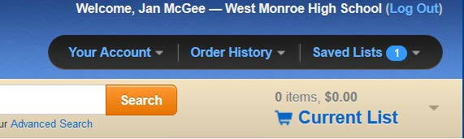Go to www.titlewave.com, log in, and locate “Current List” on the right-hand side of the window.

- Select the down arrow to the right of “Current List.”

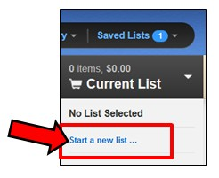
- Select “Start a New List.”

- 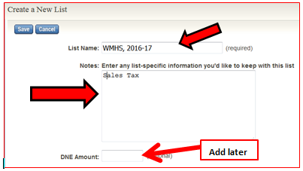Enter the name of your list. If you have any specific notes, you may add them in the Notes section. You may leave the DNE amount (Do Not Exceed) blank while working on your list. You will add this information when you received the amount of your book allotment.
- Select “Save” to save your list name.

Naming and Creating a New Order in Mackin:

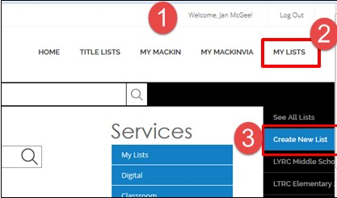
- Log in to your Mackin account.
- Select “My Lists” on the upper right-hand side of the window.
- From the dropdown menu, select “Create a New List.”

- 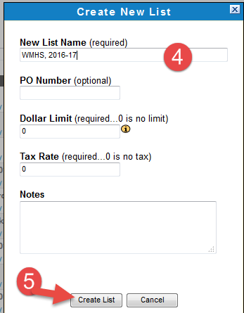Name your list with your school name and the school year. You can add the P.O. number and the dollar limit (Do Not Exceed Amount) later.
- Select “Create List.”

- As you look through professional journals or do professional reading, log in and add new selections throughout the year so your book order will not be overwhelming at the last minute.

- Be sure to include a copy of each of the LYRC books on your book order.

- Remember that your total order must be 1 ½ times the amount of your allotment. Your allotment will be roughly what it was the previous school year. You can estimate $3.70 per student. So if your allotment is $1,000.00, your order will need to be $1,500.00.
- Remember to read the book reviews carefully. Read between the lines!

Advanced Search Features in Titlewave

- Log in to your Titlewave account.

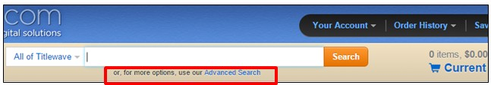
- Directly below the “Search” box, you will see, in tiny print “or, for more options, use our Advanced Search.” Select “Advanced Search.”

- The advanced search feature allows you to search for books in a number of ways—and in combinations.
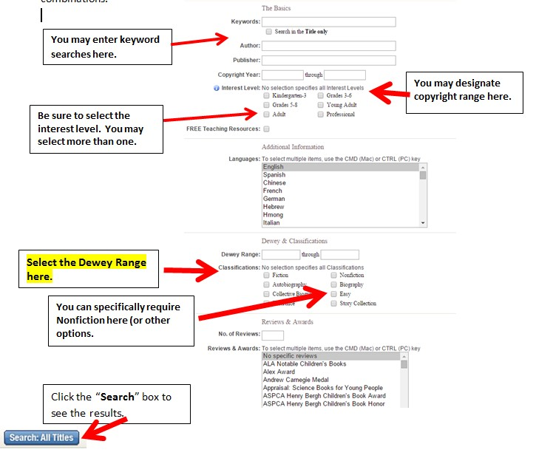

Using the Advanced Search Feature in Mackin

  - 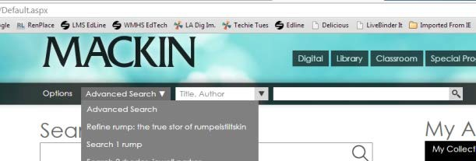Log in to you Mackin account.

  - On the left side of the “Search” box, you will see a dropdown box labeled “Advanced Search.” Use the dropdown arrow to select the first option: Advanced Search.

  - The Advanced Search features are similar to Follett.

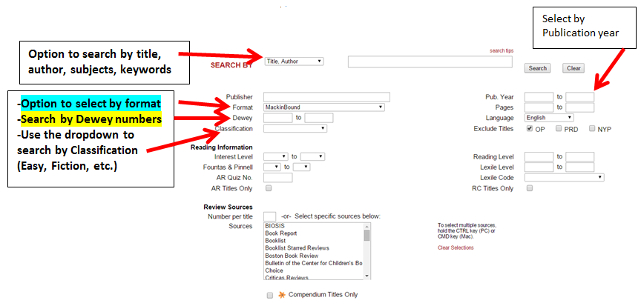

  - Set up your requirements and click “Search.”

How to Share Your Follett Order

- Your book order must be open.

- Below the title of the book order, you will see a menu. Select “Share.”
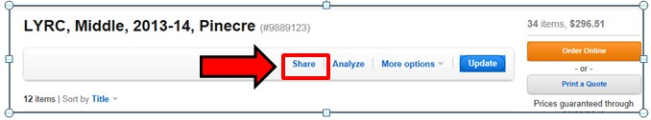

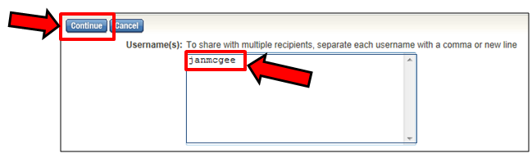
- The next window will display a box for my Username. Type “joyrpowell or amintor in the box.

- Press “Continue.”

- Select “Share This List.”
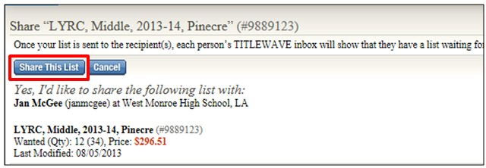
- Your list has been shared.

Mackin: Sharing Your Order

- Log in to your Mackin account.

- 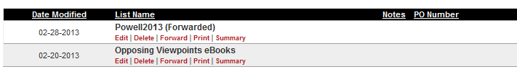Go to “My Mackin” to “My Lists.”
- Choose the list you wish to share.

- Select “Forward.”

- Forward the order to me using this email address: jpowell@opsb.net or mintor@opsb.net

- 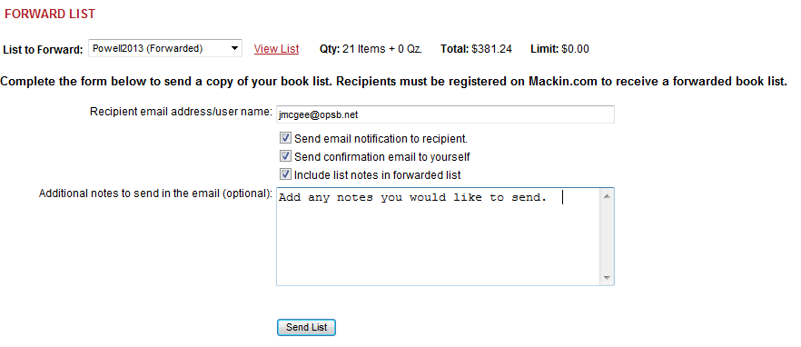Click “Send List.”

Submitting the Book Orders: General Information

- You will receive an email from me which gives you the total amount of your allotment, plus some additional book order instructions.

- Once you have shared your book orders online, you will need to submit a “hard” paper copy. Your hard copy must be accompanied by the following things”

  - Signature of principal directly on the printed hard copy

  - Book Order cover sheet

- Instructions for printing your book order from both jobbers will be on the following pages, as well as a sample copy of the cover sheet.
- I will not be able to check your book order until I have received the hard copy with signatures, etc.

- Once I have checked your book order, you will receive a “Book Order Feedback” form which will include any comments I have on your order. If you need to make any changes to your order, these changed will be detailed on the “Comments” form. Please make these changes in a timely manner and resubmit the order with a new signature and cover sheet. I will get back to your order as soon as I can.

- I frequently must return book orders because the librarian often fails to include a copy of the LYRC books (Louisiana Young Readers’ Choice) for the next school year. You will receive a copy of these books in your Back-to-School inservice packet. Please check to see that you have included a copy of each book on your orders.

- Be sure to include the “Do Not Exceed” amount on each order.

- Be sure to check each order to see that you have only included books with the correct bindings.

How to Print Your Titlewave Book Order in Annotated Form

- 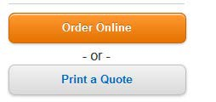Open your Titlewave list. On the far right of the screen, select the white button labeled “Print a Quote.”

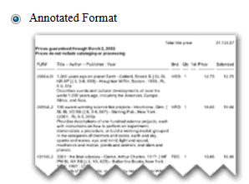
- The Print Format window will open. Select the box labeled “Annotated Format.”

- 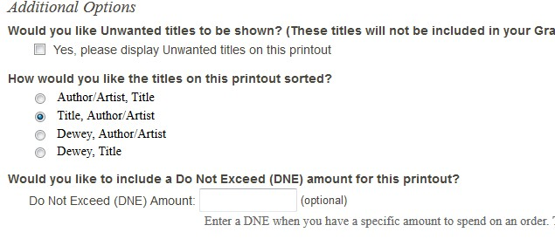In the “Additional Options” section, make the following selections:
Leave unchecked
Enter Do Not Exceed amount

- 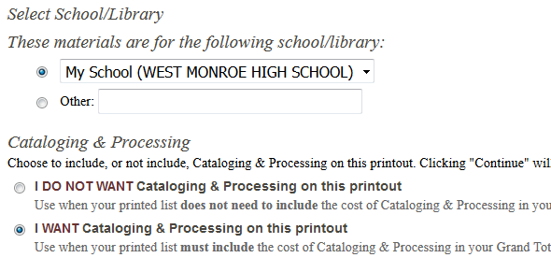Your school name should be selected School/Library

- Select “I WANT cataloging and processing on this printout.”


- Select the “Continue” button.

- 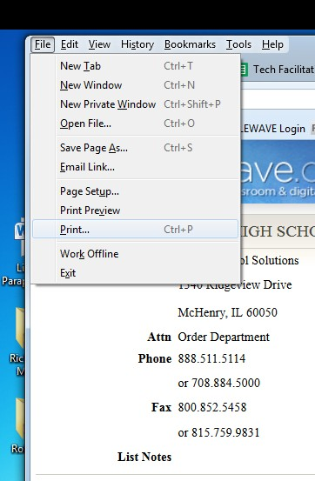Your order will be visible on the screen.
- Use the File > Print option in your browser to print the order.

Mackin: Printing Your Order in Annotated Format

  - Login to your Mackin order. Locate “My Mackin” on the menu and select “My Lists.”
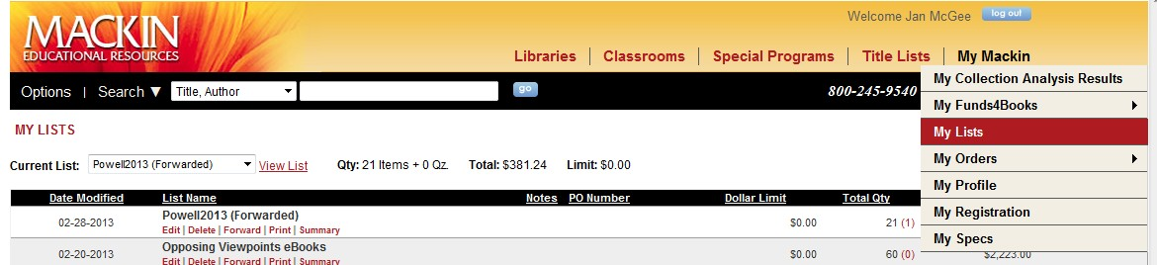

  - A list of any Mackin orders you have created will open. Choose the correct order and select
“Print.”
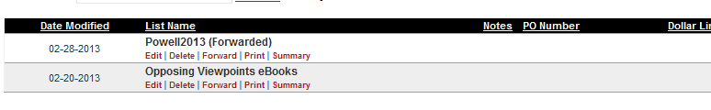

  - The “Print List” options will open. Select the following options:
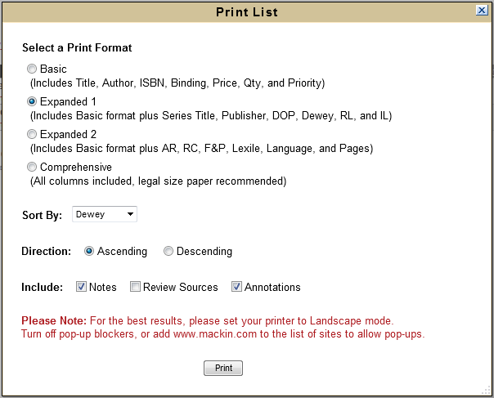
  - Choose “Expanded 1” option.

  - Sort by: Dewey

  - Direction: Ascending

  - Include: Check Notes and Annotations
  - Print

NOTE: If your order does not print, you may need to turn off pop-up blockers. When the “Alert” message opens, select “Always Allow.” Also, Mackin recommends that you set your printer to print in Landscape mode.

Book Order Feedback and Comments
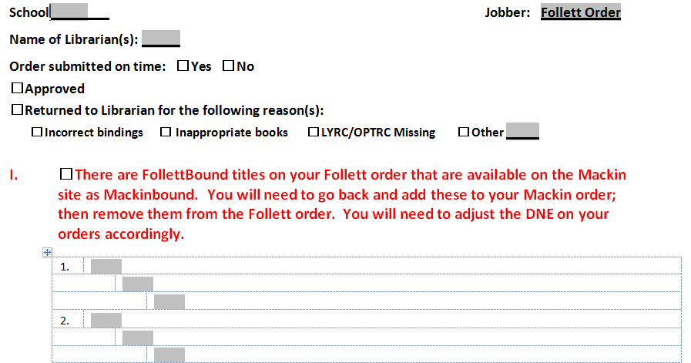
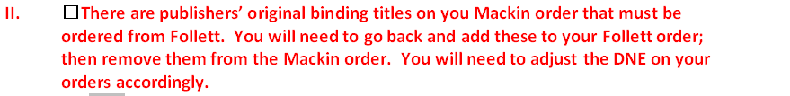

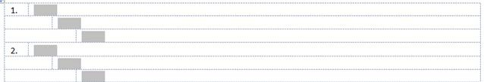
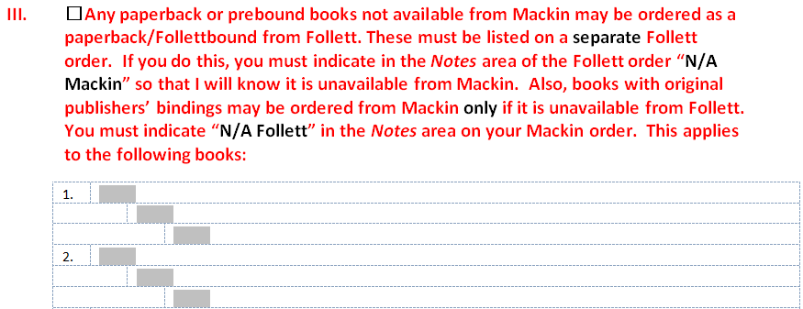

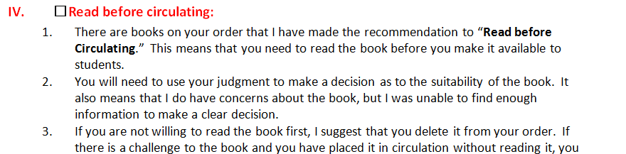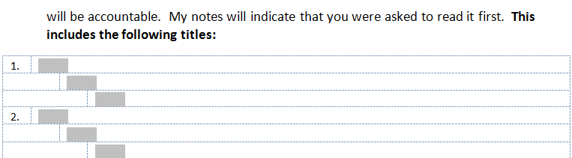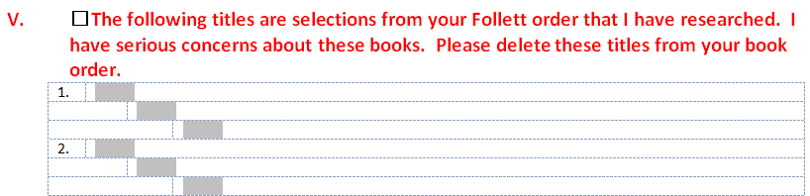
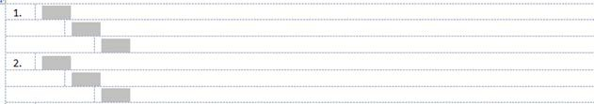

How to Include the Mackin DNE Amount in Your Printout

    - Go to “My Mackin” to “My Lists.”
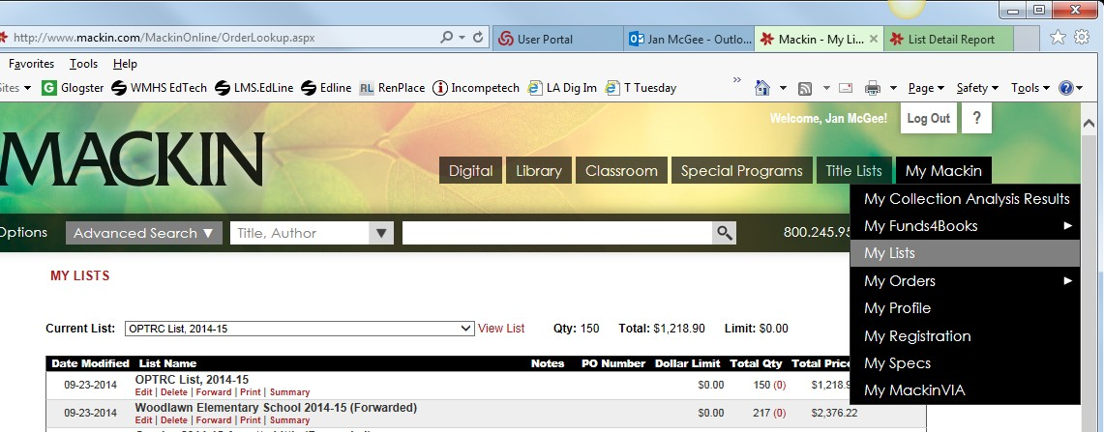

    - 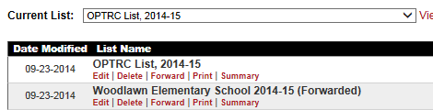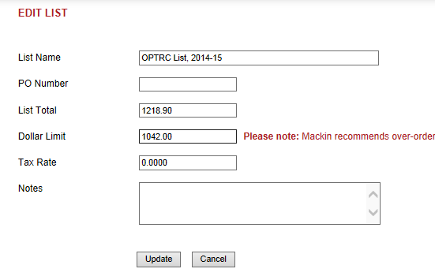A list of your Mackin orders will open. Select the red “Edit” button below the name of your current order.
    - Beside “Dollar Limit” type in your DNE (Do Not Exceed) amount and click the “Update” button.

How to Include the Follett DNE on your Titlewave Order
How to Rename Your Titlewave Order

- Open your Titlewave order.
- Select “More Options.” A dropdown list will appear.
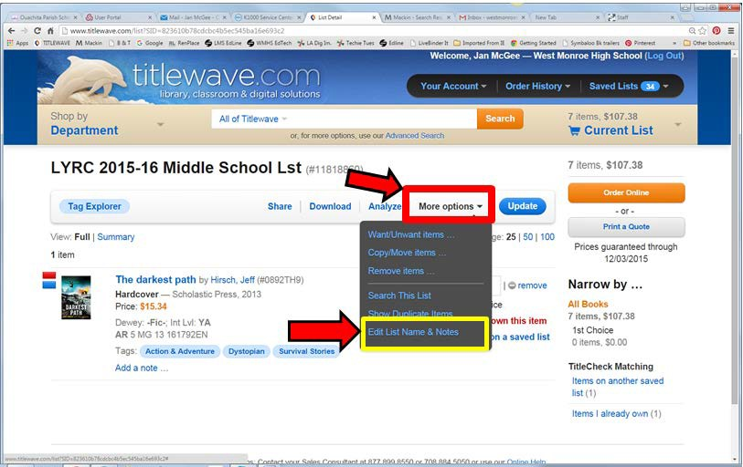
- Select the last item on the list: “Edit List Name & Notes.”

- The next screen will display the “List Name.” You may edit the name of your order in the box beside List Name. You may also add or change the DNE amount here.
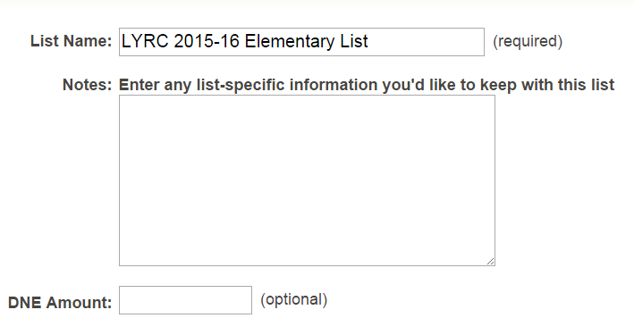

- Click the “SAVE” button to save your changes.

P.O. Number and Instructions

After your order has been approved, I will send you an email which contains the Purchase Order number for your book order. If you have ordered from both jobbers, I will send both P.O. numbers along with some additional instructions.
The purchase order number for your book order is below. Use this P.O. number to submit your order online for the specified Jobbers.
Your purchase order number is:

Jobber | PO Number | DNE Amount
Follett
Mackin
When you submit your order:
  - Be SURE to re-enter the Do Not Exceed amount that is listed in the DNE column. If you fail to enter the correct DNE amount, your school will be responsible for any purchases that exceed your book allotment amount.
  - Be sure to indicate that you want to receive your MARC records as a download.
  - Beside Bill To: Use Robert B. Jones, Purchasing Agent, 100 Bry, Monroe, LA 71201
  - Beside Deliver To: Use your name and school address.

After your book order has been submitted:
- I will follow up by sending you the hard copies of the purchase order. Please file these. You will need them after your books arrive.
- When your book order arrives, check off each book on the packing list. Make a copy of the packing list and send the copy to me on the pony.
- Send the original copy of the packing list AND the pink copy of the purchase order to Paula Presnall in Purchasing. Be sure to write “Received” and sign the pink copy. If your books come in several shipments, do not send the pink copy to Paula until all of your books have arrived.
- The green copy of the purchase order is for your records. Please file this along with a copy of your book order.

How to Place a Book Order Using Titlewave (Follett Order)

- Log in to Titlewave and open your book order.

- Have your P.O. number (purchase order number) and your Do Not Exceed amount printed out or available in your email.

- Locate and select the orange “Order Online” button on the right.
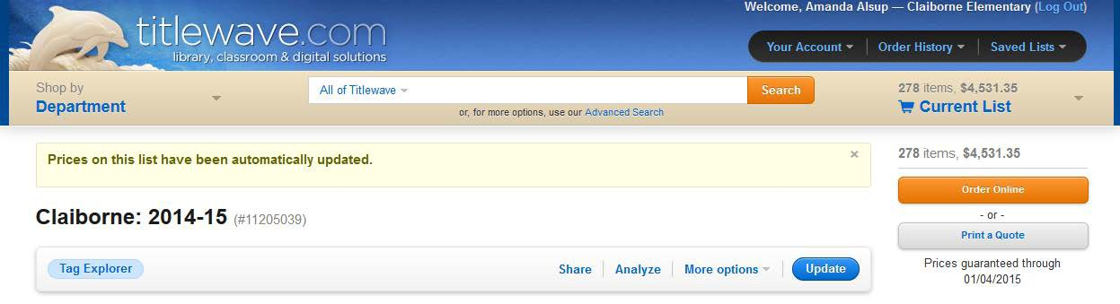

- The screen heading will be “Titles to Order.” You will be asked, “Which titles would you like included with this order? Check all that apply.” If you have ordered books that will not be published until December, be sure to select “Not Yet Published.” If your order includes ebooks, you will also have the option to select those as well.

- Press “Continue” after checking the items you would like to have included.
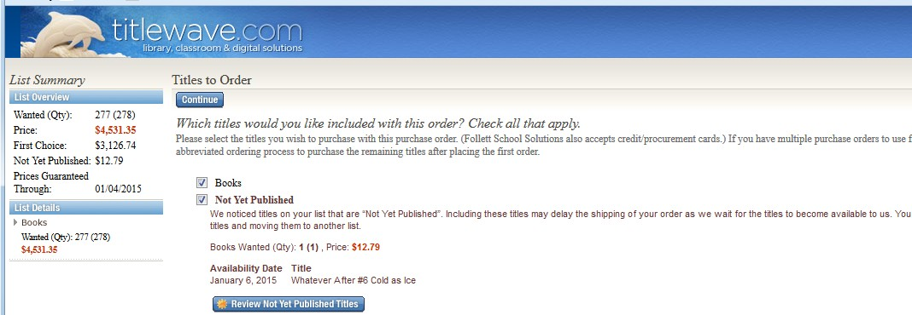
Do this after checking the appropriate boxes below

Do this first!

- 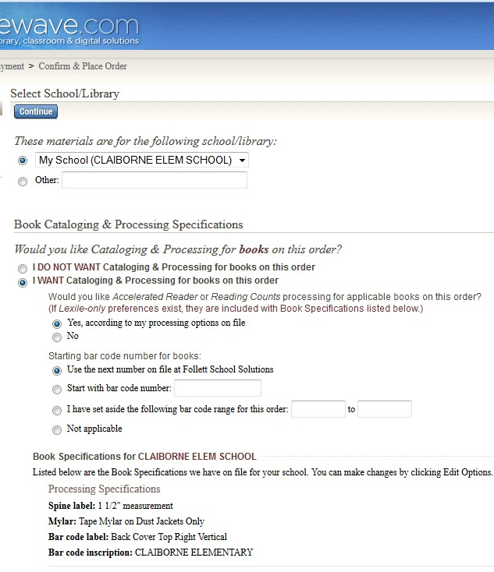Check that your school name is selected.

- Under Book Cataloging & Processing Specifications:

  - Select “I WANT cataloging & processing books on this order.”

  - If you have Accelerated Reader, check “Yes, according to my processing options on file.”

  - Starting barcode number: select “Use the next number on file at Follett School Solutions.”

  - Select “Continue.”

- Purchase order information:

  - 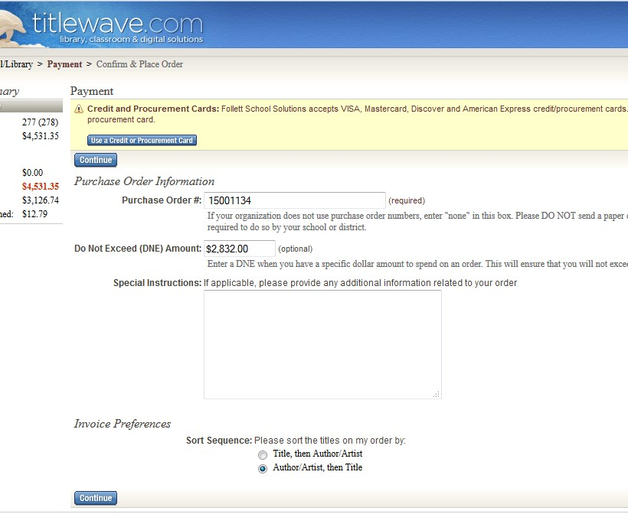Type your purchase order number in the blank.

  - Type in your “Do Not Exceed” amount.

  - Select “Continue.”

- 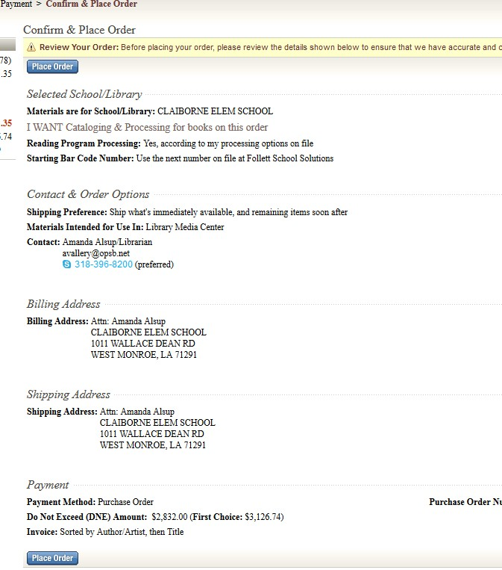Confirm and Review: Look over your information. Be sure that your contact information is on the order.
Atten: Robert B. Jones
Example

  - Verify your contact information with email address and telephone number.

  - Billing Address:
Atten: Robert B. Jones Ouachita Parish School Board 100 Bry
Monroe, LA 71201

  - Shipping Address: Atten: Your Name Your School Address City, State, Zip

  - Select: Place Order.

Placing Your Mackin Order

- Log in to your Mackin account and open your current book order.

- 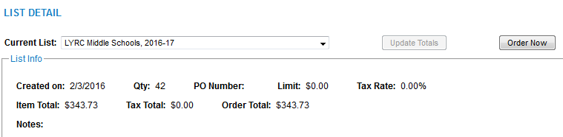Your list name will be visible under “List Detail.” The “Order Now” button will be on the right side. Select “Order Now.”

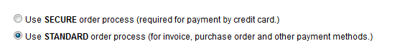
- On the next screen, you will see “SEND ORDER” in large print. Select “Use Standard order process (for invoice, purchase order, and other payment methods.)”
- Select “Continue.”

- 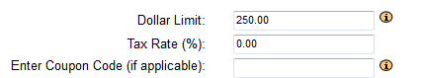The SEND ORDER window will open. Enter the “Do Not Exceed” amount beside “Dollar Limit.”

- 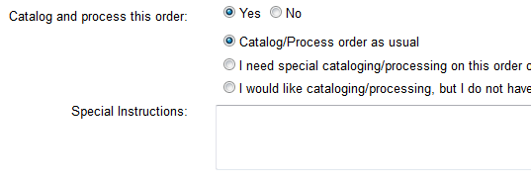Select “Yes” beside “Catalog and Process this order.”
- Select
“Catalog/Process order as usual.”
- Click “Next.”

- The SEND ORDER window opens. Your school name should be visible. If you are a new librarian, you will need to be sure that your email address is in the “Confirmation Email” box. There are “Edit
| Delete” buttons to make any changes that need to be made. Be sure that the billing address matches the address in the example.

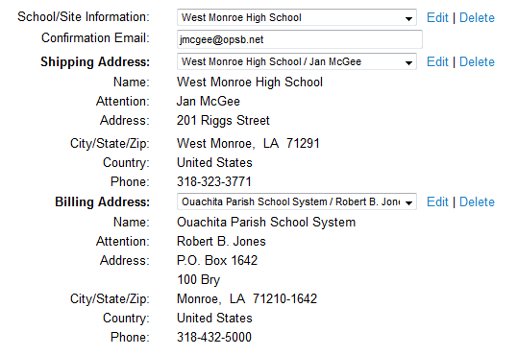Example:

- Select “Next.”

- The SEND ORDER window opens.

  - Beside “Payment Method” select “Purchase Order,

  - Type your P.O. number in the box below.

  - 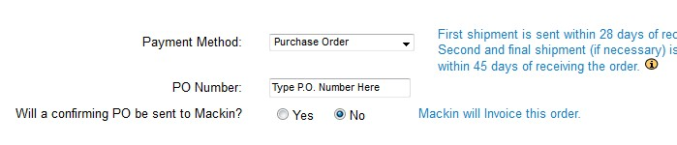Select “No” to “Will a confirming PO be sent to Mackin?” because we are not sending a paper copy of this P.O. number and order.

- Click “Next.”

- 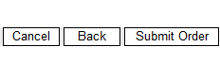You will see a summary of your order details. Check over it for errors.

- Select “Submit Order.”

Book Order Checklist Cover Sheet 20__- 20__

School

Name

1. |  | I have printed a paper copy of my book order.
2. |  | My printed book order has been printed using the “Annotated” version so that annotations are visible.
3. |  | My book order is at least 1½ times the amount of my book  order.
If my order includes ebooks or Playaways, the total does not exceed more than ¼ of my total book order.
Please indicate the total amount used for ebooks or Playaways
$ .
4. |  | My principal has signed the front page of each book order.
5. |  | I have shared my Follett order online with “janmcgee”.  I have shared my Mackin order online with “jmcgee@opsb.net”.
6. |  | I have attached my book order checklist and completed all items.
7. |  | I have included at least 1 copy of each of my LYRC Books.
 |  | My Total Book Allotment:
 |  | Follett DNE amount
 |  | Mackin DNE amount
 |  | Total Amount of combined DNE amounts (Add these together. Sum cannot exceed total allotment.)

Ouachita Parish School System Library Materials Selection Policy

- Statement of Policy

(Re: Library Collections)

The library media collections in the Ouachita Parish School System shall reflect the highest possible standards of quality in factual or fictional content. The collections should be adequate in both quality and quantity to support the curriculum, as well as to provide opportunities for the educational and cultural development of students using state guidelines. Printed or audio-visual materials should reflect the Philosophy and Educational Goals which are officially adopted by the Ouachita Parish School Board. The selection policy includes (1) philosophy; (2) responsibility for selection of materials;
(3) selection principles, objectives, criteria and format of materials included: (4) selection of sensitive materials; (5) policy in regard to gifts and donations; (6) aids used in selection; (7) procedures for handling questions or complaints; and (8) a form for use by stakeholders to request reconsideration of materials.

- Principles for the Selection of Library Media

- Library media resources are selected to provide students and teachers opportunities for research, reading, and lifelong learning; to support and enrich the curriculum; and to meet the diverse needs of the learning community and fully engage students in the learning process through reading, viewing, and listening for understanding and enjoyment.
- Library media resources are made available in print, non-print, and electronic format and through local, state, or worldwide networks.
- Library media resources are selected on the basis of high standards of excellence in content, usefulness, comprehensiveness, and authoritativeness.
- The library media collection is broadly inclusive, presenting the world as one in which all people share common interests and experiences, portraying themes of universal and timeless interest, and accurately representing persons with disabilities and various ethnic cultures and lifestyles.
- The library media collection is developed and evaluated collaboratively to provide all members of the learning community, including students, teachers, administrators, parents, and community, participation in the library media program.
- The library media collection is kept current and in good repair. The collection is systematically evaluated on a regular basis.
- Outdated, worn, and inappropriate materials are discarded, based on local and state policies and professional standards.

- Library resources are not excluded because of the race, nationality, or the social, political, or religious views of the author and reflect diverse points of view regarding current issues.
- Acquisition of resources is guided by the reading, examination, and checking of professionally developed standard selection aids and media review tools and, whenever possible, examination of resources under consideration for purchase.
- Any attempted censorship of library resources will be challenged in order to maintain the local district’s responsibility to provide information and intellectual enrichment for students and teachers. The local Board of Education is legally responsible for all matters relating to the operation of its library media centers. The local school board is responsible for adopting a written selection policy and statement of procedures for meeting the challenge of censorship.

LIBRARY MATERIALS SELECTION POLICY
Policies for library media programs are established at the district level and should be consistent with state guidelines. National guidelines and publications from the American Association of School Librarians will provide additional support in the development of policy statements. One of the most important of these is the materials selection policy. The library materials selection policy states the philosophy and broad goals of library media collections, establishes the legal responsibility for selection, provides guidance for school personnel and the community, and establishes procedures to ensure consistency in practice. The selection policy should include the following sections: (1) philosophy; (2) responsibility for selection of materials; (3) selection principles, objectives and criteria and format of materials included; (4) selection of sensitive materials; (5) policy in regard to gifts and donations; (6) aids used in selection; (7) procedures for handling questions or complaints; and (8) a form for use by citizens to request re-consideration of materials.

In addition to the district-level policy, it is recommended that individual schools have a school selection policy published in the school handbook along with other library policies. The school level policy should contain: (1) statement acknowledging the district policy and the school’s responsibility to uphold district policy; (2) goals and objectives of the library media center; (3) information on grade levels and special constituencies served; (4) purposes of the collection and specific collection goals (automatic inclusion of award winning books, local and state materials, special emphasis to support a magnet program, etc.); and (5) selection tools used and an explanation of how faculty, students, and parents contribute to the selection process. In other words, an individual reading a school selection policy should have a clear picture of the school population served, how the library media center supports the instructional and personal interests of students, and how it contributes to the overall educational mission of the school.

- Requirements for Selection of Materials
  - General Requirements
    - Standard selection tools and collection development guides are used to select new materials, evaluate the quality of the collection, and support decision- making when discarding items.
    - Books: A minimum of 10 books per pupil to create a balanced collection of current, relevant, and useful books. Multiple copies may not be counted toward fulfillment of this requirement.
    - Non-Print: Access to a variety of non-print and electronic resources, including software, CD-ROM, and online reference resources as shown in the chart which is in the Guidelines for Library Media Programs in Louisiana.
    - Reference: A collection of print and electronic resources that support the instructional program of the school, including any unique curriculum focus, and special needs and interests of students and teachers.
  - Specific Requirements
    - A combination of print, electronic, and online resources are provided to meet required guidelines.
    - The general circulation print collection contains a varied mixture of non-fiction books supportive of the school curriculum and fiction books selected to meet the varied and diverse needs of the student population.
    - Paperbound editions account for no more than 25 percent of the required collection.
    - Titles in general disrepair or with substantial physical damage are removed and, if appropriate replaced on a yearly basis.
    - The non-fiction collection contains a broad selection of the best of current informational books representing subject areas that are part of the general collection as well as subjects of interest and concern to adolescents.
    - The fiction collection provides access to titles representing the best of classic and current children’s and young adult literature as appropriate, addressing current interests and concerns of children and adolescents and representing the range of reading levels present in the student body.
    - Non-fiction books containing significant factual errors and outdated information or addressing subjects no longer relevant to current curricular needs are removed and replaced on a yearly basis according to an established schedule.
    - The fiction collection shows evidence of regular weeding to remove irrelevant and outdated titles.
    - Electronic resources are available through a local area network.
    - Current subscriptions to age- and curricular- appropriate online databases are maintained.
    - Print materials and electronic resources mounted on the school file server in the Basic collection areas in which information changes rapidly have a copyright date

within the past five (5) years. These areas include: science, technology, political science, and geography. Other areas may have some older copyrights, but updated editions are purchased on a regular basis.
    - General encyclopedias, both print and electronic, are removed from the library collection within 10 years of their publication date. Of the four basic sets required, one print set is less than two years old and one is less than five years old. The electronic requirement is met by either a current (i.e., no more than two years old), full-text edition in fixed media or online, available through the school local area network.
    - Annual one-volume reference publications such as almanacs and handbooks are updated at least every 2 years.

Access to reliable, appropriate online reference tools is made available through at least one of the listed retrieval systems: (1) bookmarks/favorites, (2) icons or menu choices, (3) library/school and/or district web page, (4) embedded links in the online library catalog, (5) cataloged web resources.

***Each core subject at every grade level has been identified with Comprehensive Curriculum /Standard and Benchmarks activities which could be addressed with the aid of library media materials, web links, or online reference tools.***

_ _

Guidelines for Library Media Programs in Louisiana.

***See pages 25-35 for specific school guidelines for your school’s grade levels in the Guidelines for Library Media Programs in Louisiana.***

Responsibility for Ordering Materials

Responsibility for the purchase of library materials is legally vested in the Ouachita Parish School Board. The School Board delegates to appropriate professional staff members the responsibility for developing recommendations for the purchase of instructional materials for the library. The primary jobber/vendor is determined through the bid process and then approved by the School Board.

The ordering of library materials and equipment is the responsibility of the professionally- trained Library Media Specialists who are familiar with the district’s established curriculum standards, pedagogy, and policies for the instruction of students in the classroom. The Library Media Specialists shall compile the purchase requisition for library materials. Purchase requisitions for library materials shall be approved and signed by both the school principal and the Library Media Program Coordinators. Upon receipt of the library books the LMS will examine the books and materials prior to placing them on the shelves. The library media specialist will also notify the Purchasing Department personnel (Paula Presnall) when the shipment arrives so that the bill may be paid.

Criteria for Selection of Instructional Materials

The following criteria will be considered in the selection of any instructional materials for students in the Ouachita Parish School System:

- The value and purpose of the material in relation to the educational goals and objectives of written core curriculum guidelines

- Reputation of the author, editor, and/or publisher

- Validity and timeliness of the material

- Durability or permanence of the material

- Importance of the content in contributing to the needs and interests of students, while meeting the core curriculum guidelines

- Readability level of the intended audience.

- Quality and artistic value of the literary style as well as the narrative content. (The narrative content of library materials reflects the same standard for oral and written communication which are expected in the classroom.)

- Suitability of the physical format and the graphics for intended users.

- The costs of the material in relation to the instructional usefulness and the learning needs of students.

- Unbiased reviews of the material in reputable catalogs, periodicals, or professional selection guides.

Video/DVD Policy

It is the policy of the Ouachita Parish School System to provide visual materials which are appropriate for student viewing and which support the instructional program. Videotapes, DVD’s, and television programs/movies are one of the many learning tools used for curriculum reinforcement. Use of this media is consistent with developmental educational theory where children learn best through multi- sensory exposure to information. On limited occasions videos, DVD’s, or television programs may be used in the classroom to inform, not solely to entertain.

Each classroom experience for students using visual materials will be a part of the teacher’s daily lesson plan that supports state content standards and benchmarks. Teachers must preview all visual materials before instructional use (even those non-rated) in order to deem the material reasonable and appropriate for the specific grade level. Classroom activities conducted by the teacher during or after viewing the materials will support the development of the objectives being addressed in the lesson plans. The accompanying and/or follow-up instructional experience may include such activities as: creative writing, correlating art ideas, developing graphic organizers, identifying literary elements, analyzing characters, sequencing events, describing plots and subplots, identifying cause/effect, etc.

Only G rated movies will be shown in grades PK – 5. Any “PG-13 or PG” movies (or an excerpt) used in the classroom to directly support the curriculum in grades 6 – 12 must have prior written approval by the principal/principal designee. (It is not common practice that full length commercial movies are shown in any middle or high school classrooms.) No movies rated “R” will be shown in the classroom at any grade level.

Any commercial movie must have the written approval of the principal. See the suggested sample form below for each principal to sign giving the teacher permission to show movies in the classroom.

Movie Title Rating
Teacher Requesting Length
Subject Date Grade
Lesson Plan Activities correlating to movie content:
Check One [ ] Approved [ ] Denied
Principal/Designee Signature

Gift Books and Other Donated Materials

Donations of books, computer software, materials, or other instructional media will be accepted with the understanding that they must meet the same selection criteria as media purchased by the Ouachita Parish School Board.

Procedures for Dealing with Questioned Materials

No duly selected materials whose appropriateness is challenged shall be removed from the school until notification by the Superintendent in concurrence with the recommendation of a review committee or upon formal action of the Ouachita Parish School Board.

Procedures to be observed

- All requests/complaints shall be directed to the building principal.

- The principal or a designated representative will attempt to resolve the complaint informally by explaining the philosophy and goals of the school district as they relate to the material.

- If the complaint is not resolved informally, the complainant will be supplied the written policy for materials selection and the procedures for requesting the “reconsideration of materials.” The policy packet will contain a printed form which the complainant should complete and return to the principal before further consideration will be given to the complaint/request.

- If the completed form requesting reconsideration has not been received by the principal within two weeks, the issue will be considered closed.

- Upon receipt of a completed form, the principal will forward the form along with the questioned material to the review committee. If they cannot resolve the issue, it will be forwarded to the Superintendent.

- The superintendent will appoint a committee consisting of an appropriate instructional supervisor/curriculum specialist, and one or more community representatives.

- After reading the questioned material, the committee will meet to discuss the material in relation to the Policy for Selection of Materials and will prepare a report containing its recommendation on disposition of the matter. The report will be sent to the Superintendent.

- The Superintendent will notify the complainant of the committee’s recommendation. If the complainant does not concur, he/she may present an appeal to the Ouachita Parish School Board which shall make a FINAL determination.

- The FINAL DISPOSITION of the challenged material may result in one of the following:

  - Restricted access to students
  - Retained without restrictions

  - Removal from all libraries in the district
  - Transferred to another library (such as a high school level)
  - Removal from the school library media center

- These established procedures should be followed systematically in dealing with each question whether the question originates from a staff member inside the school or from the local community.

*** To access more information on this topic, access <www.ala.org> and search for the topic “Dealing with Challenges.”

REQUEST FOR RECONSIDERATION OF MATERIALS

Request initiated by

Telephone Address

City Zip code

Complainant represents: Self

Organization/Group

School

Material about which you are requesting reconsideration:

Book
Video/DVD
Magazine
Newspaper

Audio Recording
Electronic Resource
Other

Title of material:

Author/Producer:

- What brought this material to your attention?

- What concerns do you have about the material? Be specific please.

- What do you feel will be the negative effect of this material on the student?

- Have you examined the entire work?

- Are there other resources which you would suggest as a substitution for this material?

If so, what would these be?

- What would you prefer the school do about this material?

Do not assign or recommend it to my child

Withdraw it from all students

Re-evaluate the material

Signature Date

In-House Book Order Policy

When there is a question or difference of opinion with a selection or selections on a book order:

  - The librarian needs to show that the selection follows our selection guidelines, with the selection meeting a curriculum need or being provided for recreational reading. To support the curriculum requirement, the librarian should provide the subject and specific GLEs to demonstrate the specific need.
  - The librarian should be prepared to show that there are no other books on that topic available on an age or grade appropriate level.
  - The librarian needs to provide written documentation (book reviews).
  - for fiction book to show that the book is age/grade appropriate. This documentation should be taken from reputable book review sources such as School Library Journal, School Library Media Connection, Horn Book, etc. (Publishers’ Weekly is considered to be a trade publication. Reviews taken from Publishers’ Weekly should be balanced with professional library journal reviews.)
  - The librarian needs to document that she has discussed the selection with her administrator and his/her response.
  - The librarian should bring copies all of the above information to a meeting with the library coordinator and library supervisor.

Section 4:

Processing Books & Other Items

Processing Books, Writing & Stamping
Descriptive Cataloging Guidelines Basic Catalog, Add a Copy
Basic Cataloging with MARC Search How to Print Barcode Labels
How to Print Spine Labels Editing Spine Labels
Downloading MARC Records from Book Jobbers
Importing MARC Records into Alex. Suggested Codes for Book and Non- Book Materials

Processing Books: Writing and Stamping Ownership

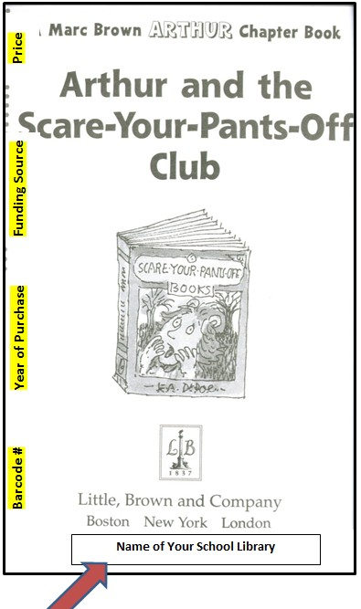
Follow these Steps

Title Page

- Turn to the "True Title Page." (Sometimes books have a page before the "True Title Page" with the title only. The "True Title Page" has the publisher, etc. on it.)
- Turn the book sideways so that you will be writing parallel to the crease. On the far right, use a pen to write the barcode #.
- Skip over and write the year of purchase (2012-13).
- Space over and write the funding source (Sales Tax).
- On the far right, write the price. It will be on the packing slip.
- Use the library ownership stamp (there should be a stamper that says "Woodlawn Elementary Library" in the library somewhere. Stamp toward the bottom of the page.

Page 19

- Turn to page 19.
- Write the barcode # toward the bottom of the page (left margin—approx. where you wrote it on the title page))
- Stamp page 19.

Back Cover

- Stamp the back inside cover.
- Stamp the top edge of the book. (You usually have to open the covers to stamp the edge.)
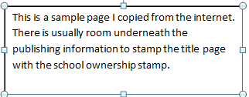

Descriptive Cataloging Guidelines

- Statement of Responsibility: The Author’s Name should be typed: Last name, First name (as below). This is VERY important. When your students search for a book by the author’s last name, they will not be able to find it unless it has been entered properly. If you type “Barbara Parks, Barbara will show up as the LAST NAME. NEVER use all capital letters.
- Title of Book: Type the complete title of book in sentence form. Capitalize 1st letter of 1st word and any proper nouns). NEVER use all capital letters.

    - Abbey and the mystery baby
    - Al Capone does my shirts
    - Afternoon on the Amazon
Incorrect:
AFTERNOON ON THE AMAZON

- Call Numbers: Use the call prefix, such as F, E, or a Dewey number PLUS the first three letters of the author’s last name (unless the book is a biography. If the book is a biography, use the first three letters (or then entire name) of the person about whom the book was written. You must space between the prefix and the call letters.
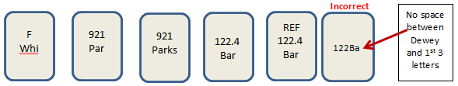
b. Example:

- There should NOT be slashes or unusual letters in your call numbers. Anytime you do a MARC search and download a MARC record, you need to check the call number for correctness. Slashes like the examples below give you the option to use a longer Dewey number. If you choose to use the longer number, you MUST remove the slash. If you choose not to use the longer number, remove the slash and everything after the slash. Be on the alert for unusual prefixes that transfer from the MARC download.
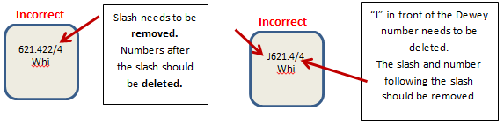

- Be alert for downloaded call numbers that “just don’t make sense.” Just because a call number downloads from MARC Search doesn’t mean it is an acceptable call number.

- Many times a MARC Search download will not provide a call number. You will still need to create a call number for your book. The next part of this tutorial will cover basic processing in Alexandria using Title Assistant and MARC Search.

NOTES:

Downloading MARC records from Titlewave

- Use the Explorer browser to log in to your Titlewave account.

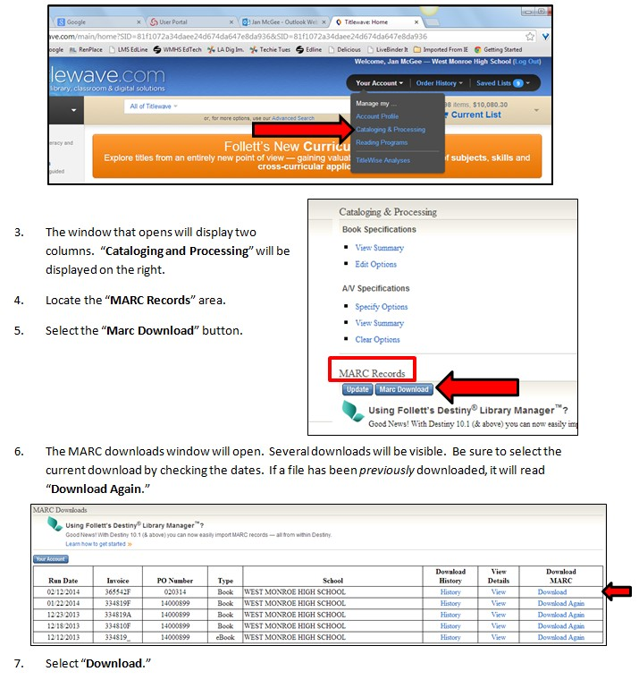
- Use the dropdown box under “Your Account” to select “Cataloging and Processing.”

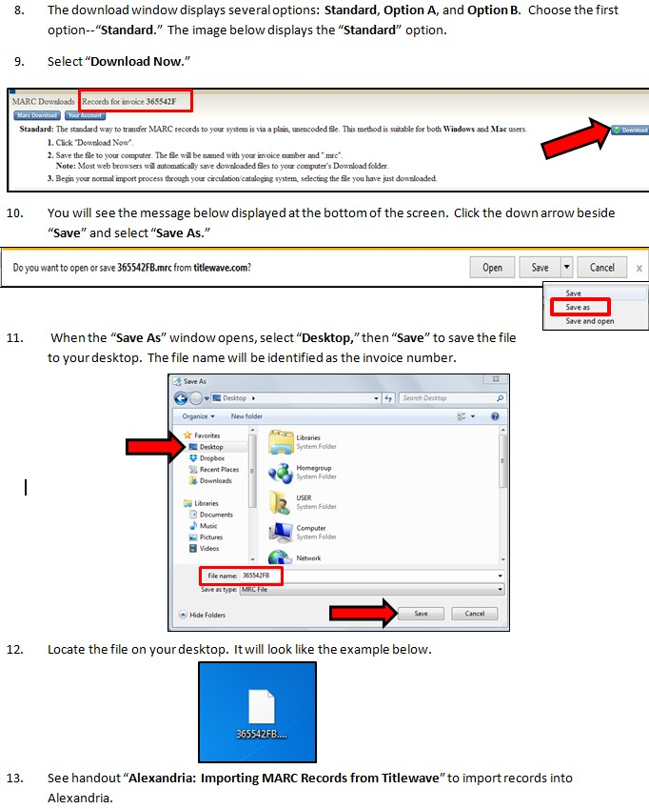

Downloading MARC Records from Mackin
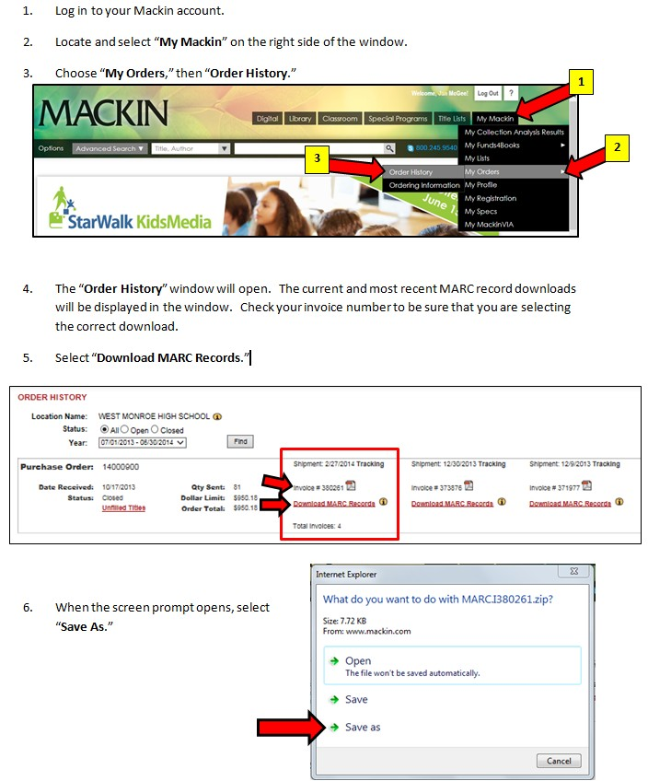

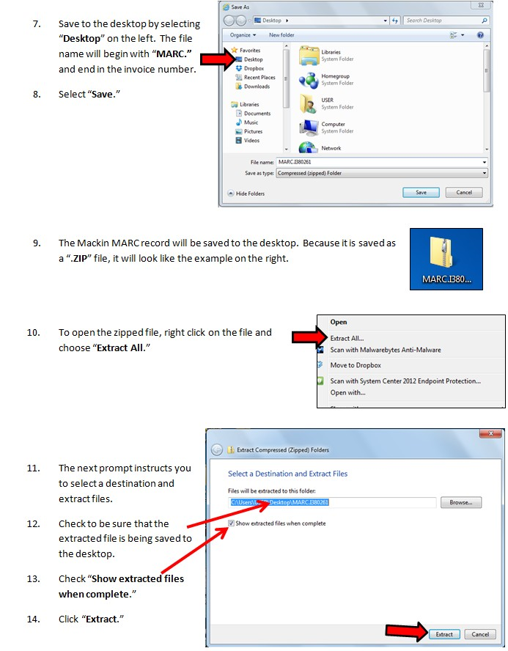

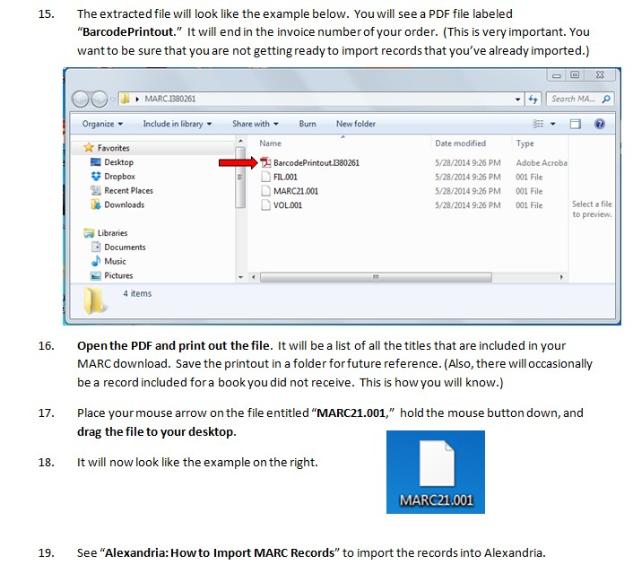

Suggested Codes for Library Materials

Easy Fiction E

Fiction F or FIC

Big Books BB

Biography 921, B or 92

Louisiana Collection LA

Oversize O

Professional Collection P or PC

Reference R or REF

Story Collection SC

Short Stories SS

Web Page Link

Suggested Codes for Non-book Materials

Audio Books/ Books on Tape BOT

Audio Cassette Player/ Audio Cassette Recorder CPR

Book on CD BOCD

Calculators CALC

Cameras CAM

Carts CRT

Cassette Player/ Cassette Recorder CPR

CD (Music) CD

CD-ROM CD-ROM

Digital Cameras DCAM

DVDs DVD

DVD Player DVDP

eBook eBK

Equipment EQ

Globes GL

Kits KT

MAPS MAP

Microscopes MIC

Models, Dolls, Puppets, Dioramas, Exhibits, Displays DM Specimens, Samples, Regalia (Demonstration Model)

Multimedia Projectors MMP

Overhead Projectors OH

Pictures, Study Prints, Reproductions, Art Prints, PIC Posters, Charts

Study Guides, Manuals, Scripts, Handbooks MAN

Television (includes TV/VCR/DVD Combo) TV

Video Cassette Players VCRP

Video Tapes VC or VT

DVD Player DVDP

Lap Tops LPT

Web Page Link

Z39.50 Addresses, Preferences

If your MARC searches are constantly coming up empty, you may find that you need to add a few more Z29 addresses to your search address book.

Type | Availability | Name | Address | Database | Port
Z39.50 | Available | Boston Library  Exchange--NOBLE | innopac.noblenet.org | INNOPAC | 210
Z39.50 | Available | Academic - University of  Virginia | virgo.lib.virginia.edu | SIRSI | 2200
Z39.50 | Available | DC - Special - Library of  Congress | z3950.loc.gov | VOYAGER | 7090
Z39.50 | Available | FL - Special - Florida  State Library | fllibcat.dos.state.fl.us | DEFAULT | 2200
Z39.50 | Available | MA - Special - Boston  Athenaeum Library | www.bostonathenaeum.org | VOYAGER | 7090
Z39.50 | Available | CA - Public - Marin  County Public Library | 199.88.71.7 | INNOPAC | 210
Z39.50 | Available | OH - Special - OhioLINK | olc1.ohiolink.edu | INNOPAC | 210
Z39.50 | Available | PA – Special - ACCESS  Pennsylvania Database | 205.247.101.11 | INNOPAC | 210
Z39.50 | Available | UT - Academic -  Brigham Young University | catalog.lib.byu.edu | SIRSI | 2200
Z39.50 | Available | UT - Public - Salt Lake  City Public | salty.slcpl.lib.ut.us | INNOPAC | 210
Z39.50 | Available | CA - Public - Sacramento Public  Library | www.saclibrarycatalog.org | INNOPAC | 210
Z39.50 | Available | LA - Special - State Library of Louisiana | ipac.state.lib.la.us | sll | 210

Section 8:

Weeding

Weeding Guidelines, Q & A General Criteria for Weeding
Weeding Criteria by Dewey Classification
How to Discard Materials How to Scan to Weeded File How to Print a Weeded List
Deleting Books in the Weeded File

Ouachita Parish Library Media Specialists

Weeding Guidelines
For Ouachita Parish School Librarians February 2014-2015

Contents
Questions and Answers 3 - 4
General Criteria for Weeding 5
Weeding Criteria by Classification 6
How to Discard Materials 7
Final Notes 8
How to Scan to Weeded File & Delete 9 - 11

Answer: Weeding is the professional process of removing material from the School Library to ensure that the collection is ACCURATE, CURRENT and RELEVANT to the curricular and recreational programs of the school.
Just as you weed your garden, pull the literary weeds from the reference garden.

Answer: The Primary purpose of a school library is to support the curriculum.
A weeded library . . . . . .
    - Highlights the gaps and imbalances in subject areas (useful for collection development)
    - Has a reputation for reliability of materials
    - Has a collection that is smaller and easier to use
    - Does not run out of space
    - Removes the outward illusion of a well-stocked resource center when in fact materials may not be accurate, current, or relevant
    - Is a tidy library that looks appealing and is inviting to use
Answer: Weeding is a CONTINUOUS process that should become part of the routine of library work.
Examine materials as you check them in and out and as you shelve them. Ideally, go through the entire collection once a year. Given the demands on library staff’s time, it might be less overwhelming to do several sections at a time (ex. This year 000-300, next year 400 – 700). That that is still too ambitious, do several shelves at a time. Keep a record of where you start and finish.

Answer: The important thing is TO DO IT!

Answer: Who Weeds? Ideally, librarians who have knowledge of the weeding guidelines, and 3 C’s (the collection, clientele, and the current curriculum.)

Answer: If volunteers are used, strict guidelines should be suggested and the teacher-librarian should validate any books selected for withdrawal. Do not hesitate to use the opinions of subject specialists in your school in your decision-making.

Answer: EVERY ITEM in the library is a candidate for weeding. This requires distancing yourself from the collection that is near and dear to your heart and evaluating it critically. You might start with reviewing the specific needs of your school.

Answer: The MUSTIE formula might also aid in deciding what to weed:
Misleading and/or factually inaccurate
Ugly (worn out beyond mending)
Superseded by a new edition or a better source Trivial (of no discernible literary or scientific merit) Irrelevant to the needs and interests of your school
Elsewhere (the materials may be obtained from another source)

Answer: The goal should be QUALITY over quantity. You and your library users will find the “good stuff” if your selection is limited but current. Ideally, it is better to have NOTHING than materials that contain incorrect or irrelevant information. Student should be offered only the best available information.

Answer: If you can afford it, replace the item with something newer and better. In reality, with a shrinking library budget, a balanced approach to weeding is inevitable. See also (When should I weed” (page 2).

Answer: Keep in mind the other resources you have access to that can supplement your collections (online resources, periodicals, CD-ROMSs, nearby school libraries, public libraries, and library contacts). Ultimately, how much to weed is a site-based
decision based on numerous factors. See also “Why Weed” page 2.
Answer: Yes. Keep classics, award winners, and the “sacred cows” except when a more attractive format is available. Many of these books may now be in the “public domain,” which may mean that these books are available online through the Gutenberg Project. Keep any materials about local history, school yearbooks, and anything published by or about your school. Gifts DO NOT fall into this category—they should be treated as regular items and be subject to
the same weeding criteria.

GENERAL CRITERIA FOR WEEDING
Curriculum Related | - Does the material match current curriculum?  - Does it match a grade level/reading level of your students?  - Is the material relevant?  - If the item is a textbook, is it up to date and does it provide some reference value?
General Content | - Is the item well organized? Does it include a table of contents and indexes (if appropriate)?  - Einstein or Jack and Jill? Are students interested?  - Is the information inaccurate or misleading? Is there an updated edition?  - Does the author, editor, or publisher have a reputation for quality?  - Are the visuals appropriate (pictures, charts, graphs, tables, maps, etc.)?  - Overall, does your collection represent various points of view, various subjects?  - Overall, does your collection address specific learning styles and maturity levels and needs of students?
Date | - Is the title more than 12-15 years old? Has it circulated in the past 5 years?  - Copyright date alone should not be the sole criterion for weeding book. Keep in mind that some books are timeless. Classics such as Goodnight Moon, published in 1947, will always be in demand. The same applies for Dr. Seuss, etc. Do your copies need to be replaced?  - Award books, such as Newbery and Caldecott Award books should remain a part of your collection unless they are in poor condition. Are replacements available?  - Does a newer edition exist?
Physical Condition | - Is the item dirty? Is it infested with insects? Is gum or mildew present? Has it suffered water damage?  - Is the item dusty? (probably an indication of its lack of use)  - Is the spine broken? Is the cover damaged or missing? Is the videotape worn out?  - Are the pages brittle, faded, ripped, dingy, defaced with writing, or missing?  - Do you need bionic eyes to read print that is too small or faded? Poor illustrations? Are the visuals or illustrations dated?  - Is the item visually attractive?  - Do you have the means, time, or know-how to repair or mend the item?  - Will the item withstand normal student use?
Copies | - Multiple copies are often not needed. When in doubt, keep the copy in the best condition.  - Keep duplicates only if it is a high demand item or if items needed for group work.
Circulation | - How often, if ever, has the material been checked out?  - Is the material used IN the library (reference)?
Censorship Issues | - Stereotyping, biases and prejudices all have to be taken into account when weeding. Use the guidelines of your school administration concerning these issues. See also the Ouachita Parish Procedure for Challenging Library Materials.

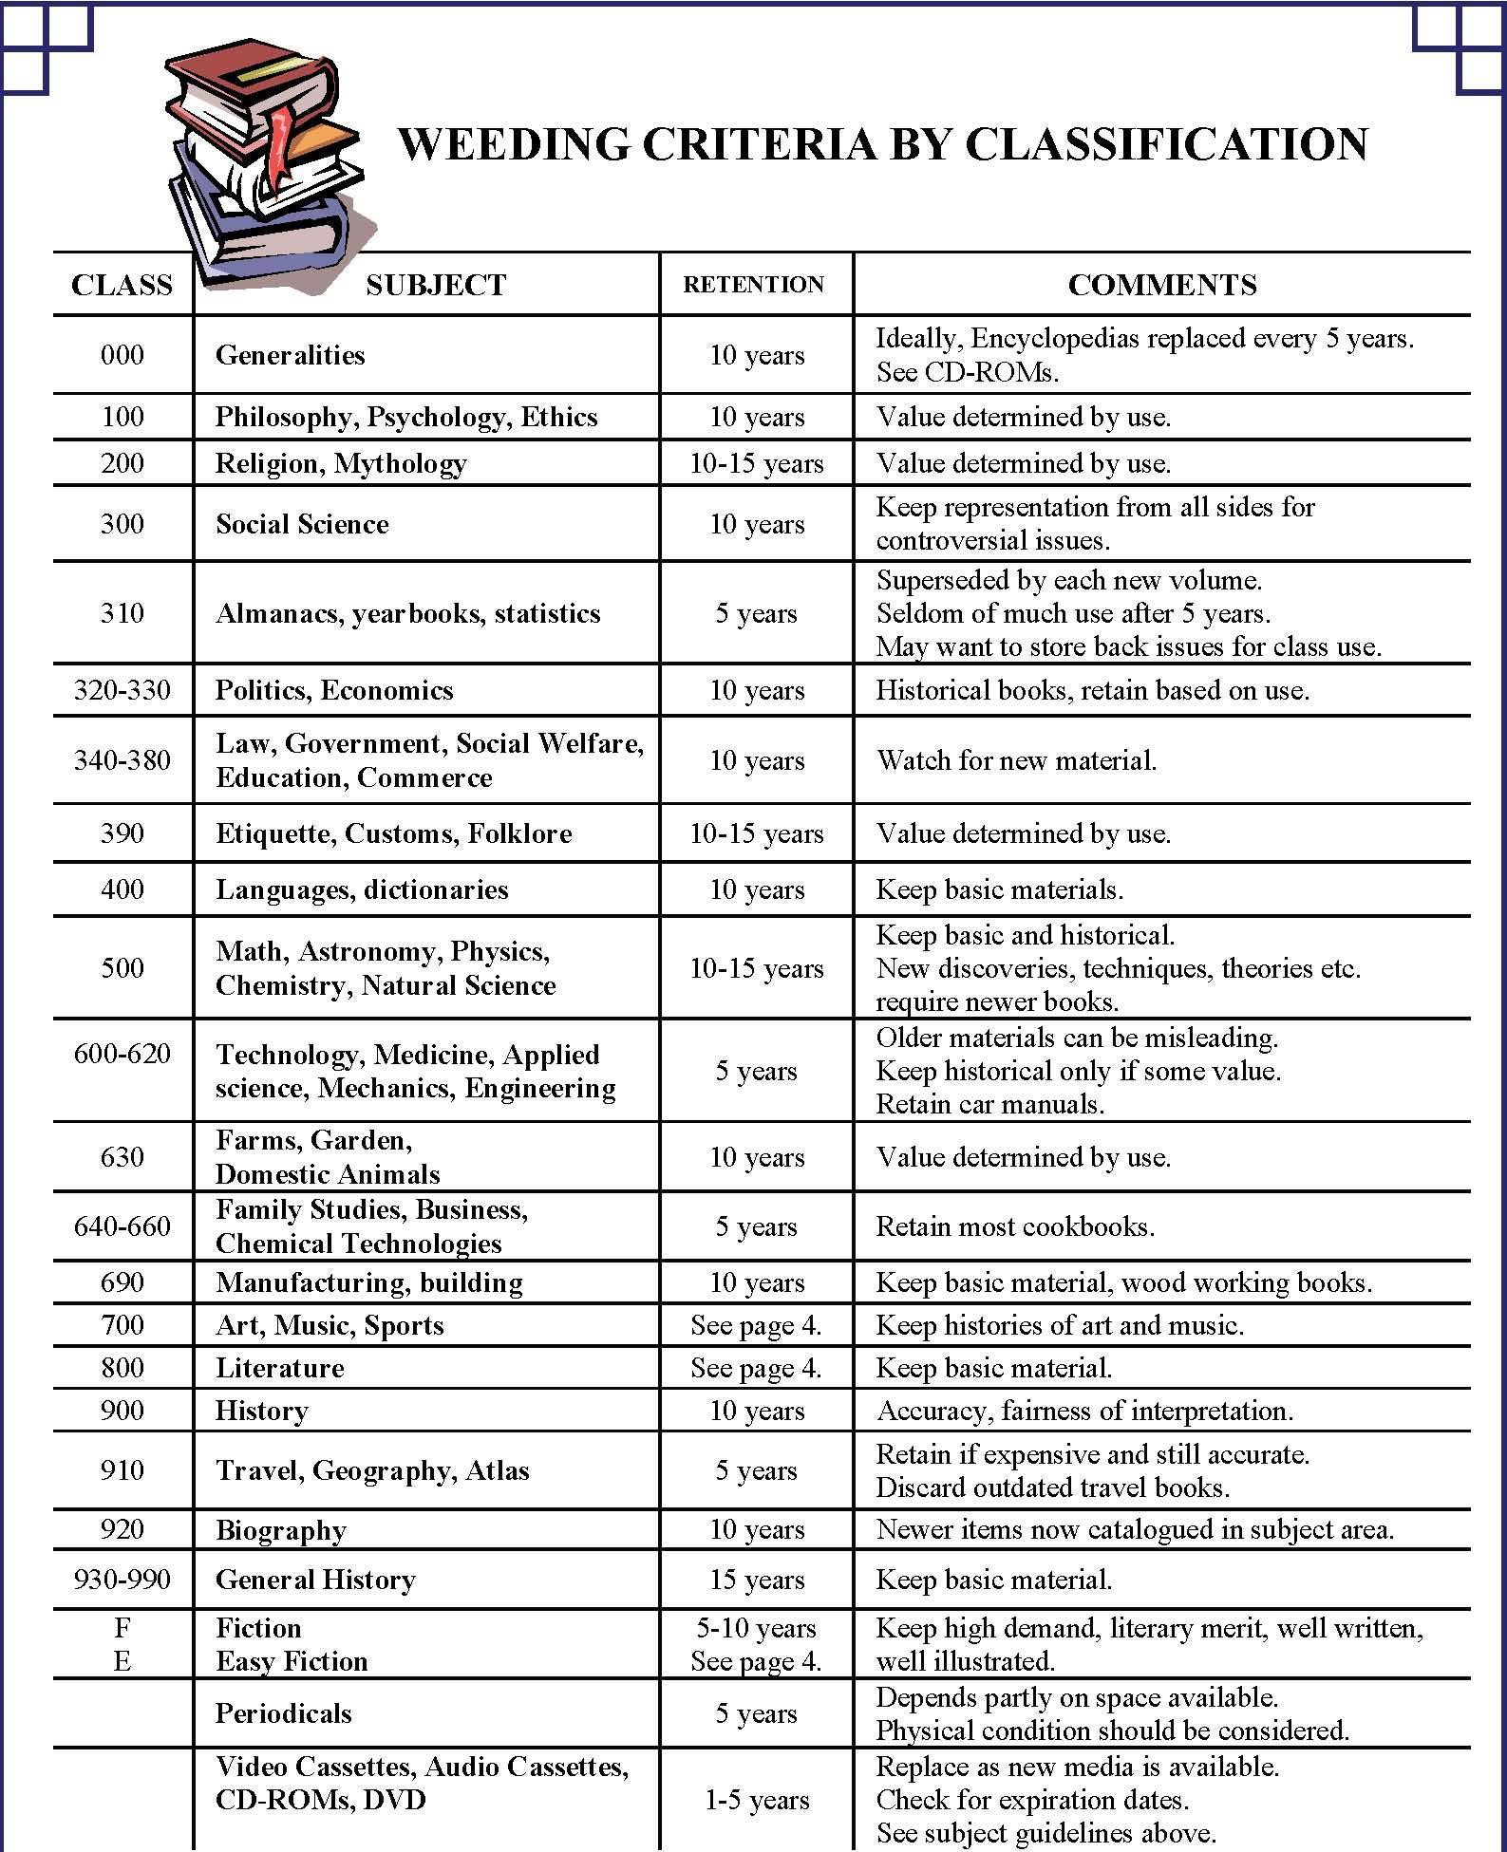

How to Discard Materials

1. Remove it. | - Determine items for withdrawal. See “General Criteria for Weeding” (page 4).  - Take materials off the shelves and place on a cart near checkout computer so they can be scanned into the “Weeded File” (instructions using for weeded file attached).  - After scanning materials into the weeded file, move books to an area clearly labeled “withdrawn” that is removed from the rest of  the collection (a book truck, a table in the back of your office, a box).
2. Stamp it & Deface it. | - Stamp “Discard” or “Withdrawn” on the front and inside covers.  - Remove old card pockets and checkout cards. If these materials make their way back to the library, they can easily be identified as discarded items.  - Remove the barcodes from the books (after scanning books into the weeded file).
3. Delete from Catalog | - Follow steps on handout attached to weeding handout to remove the weeded books from the collection.  - Be sure to do this before you inventory or these books will show up as missing.
4. Get RID of it! | - Some materials in good condition may be candidates to give away. You might want to let staff within your school know that you will be having a give-away. Generally, however, if an item has been weeded from your collections, it doesn’t belong in someone else’s collection.  - Old, worn Accelerated Books: Even worn and tattered AR books can go to some of your classroom teachers for students who cannot check out library books because they have not returned their books to the library. This provides supplemental classroom reading materials for any student who needs an extra book. (When I did this, I also stamped “Discarded” on the edges of the books. If the books find their way back in the library, I could spot them immediately.)  - You may want to try some art projects with the books. Google “Altered Books,” “Repurposed Books,” or “Uses for old books.” There are some amazing projects online that you might want to try.  - Do not throw books into the trash can so that they are visible. Box them up, tape up the boxes so they are sealed. Ask maintenance to place them in the dumpsters.

Final Notes. . . . .
Weeding is not one of the most desirable jobs in the library, but it is one of the most important.

There is no blueprint for the weeding process. Every school and every collection is unique. As courses and curricula change; as new subjects appear and the old disappear; and as students’ interests and awareness broaden, great challenges are presented to school libraries.

Make your school administration, teachers, clerical staff, custodial staff, and library volunteers aware of your weeding project. Explain weeding guidelines and convey both the importance of weeding and your belief in the process. You might even want to show them some obvious examples of books that should not be in the collection. All of these preparatory steps may provide you with backup and support if/when people question what you are doing. In addition, you might then gain support for financing the replacement of weeded materials.

Remember: A weeded library is a healthy library. Your collection will grow and flourish if there is room for your new books to shine. Weeding allows room to display new books with fronts facing out, it allows room for signage and displays. Students will be able to explore your collection and delight in the treasures on your shelves.

Section 10:


Accelerated Reader and
S.T.A.R. Reading
Things You Need to Know Setting Up Renaissance Place
Setting Up Your Classes and Students Enabling Tests
Setting Up Date and Time Restrictions Classroom Settings: Individual Student Settings Setting AR Goals
Printing AR and STAR Passwords Printing STAR Summary Reports Clearing “Locks” in S.T.A.R. Renaissance Home Connect
Printing AR Diagnostic Student Reports
Point Club Summaries Printing AR Book Labels
Using STAR Results to Assess Collection Needs Needs Assessment Form
AR Code of Conduct
Setting up a Testing Window in S.T.A.R.
A.R. Rewards and Parties
A.R. on Pinterest.com

Accelerated Reader: Things You Need to Know

- Accelerated Reader is a computer-managed motivational reading program used by elementary school libraries (and some middle school libraries in Ouachita Parish) and throughout the country.
- STAR Reading is the assessment tool created by the Accelerated Reader program used to measure reading levels, and thereby reading progress.
- Accelerated Reader is a TOOL—just as a hammer is a tool. The tool is neither bad nor good, depending on the person or people welding the tool.
- For an AR program to be successful, you will need cooperation and “buy in” from your administration and your faculty. This is not something that happens overnight. It takes hard work and a lot of love to build an Accelerated Reader program.
- Adding motivational and promotional activities will help “grow” your program. Above all, this program is to help motivate and promote a lifelong of reading.

- It is imperative, at the beginning of each year, that you discuss what constitutes “cheating” in the A.R. program. You also need to fully discuss Cheating Consequences. There are two examples of AR Code of Conduct in this section. You are welcome to use either, combine them, or create your own. I strongly advise that you have your students AND their parents sign and return them.

  - Please include a statement regarding receiving assistance from an adult or student. (This would not include an adult who is reading a test aloud to the student. However, provisions are available in the AR program for “Read Aloud” options to be enabled for specific students.)

  - Post an A.R. Code of Conduct in your library.

  - Revisit this Code of Conduct policy during the school year.

STEP l:
Setting up Renaissance Place

- Use the following URL: https://hosted102.renlearn.com/212137.

- This will take you to the “Home” screen for Renaissance Place. (This is also the link you can set up on your library page on School Messenger for your students for testing or bookmark on your computers under “Favorites.”)

- Select “I’m a Teacher/Administrator.”

- Type in your login and password. (You may be asked to update.)

- Select “Courses and Classes.” You will be taken to the “Courses and Classes Screen.”
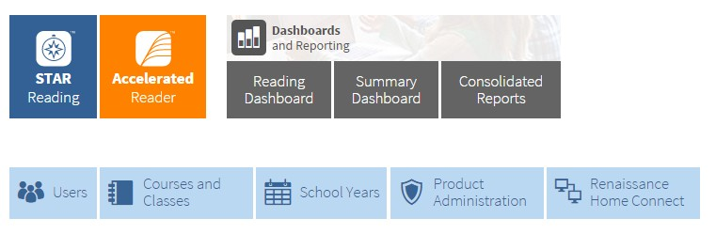
STEP 2

Setting up Your Classes and Students

This section deals with setting up and registering your students in your classes.

- 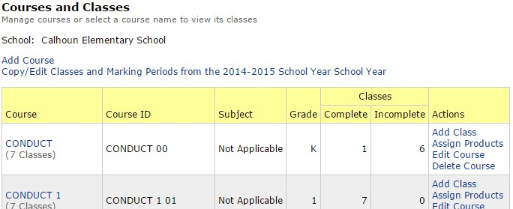Courses and Classes: Because the data is imported from WebPams, it includes all teachers, all students, and all classes for your school. Elementary schools will only use “Conduct” classes, which appear first on the “Courses and Classes” list. Middle and high schools will select either “English classes” or “Language Arts” classes—not both.

- Scroll down to the first conduct class that uses AR in your school. Using first grade as an example, I will select “Conduct 1.” If you are enrolling kindergarten students in AR, select “Conduct 00.”) (see above screen shot.)
- Click “Conduct 1.” (Click directly on the words.”)
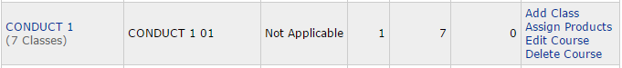
- This will open the “Add Class” window for the first grade classes. Because the classes are not set up, you will need to select the “Incomplete Classes” tab to view the classes. As you set up each class, the class will move to the “Complete Classes” tab.
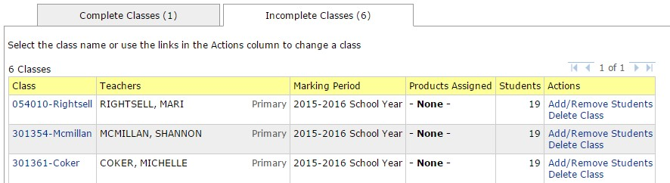
- Under the “Class” column, select the name of the first teacher.

- 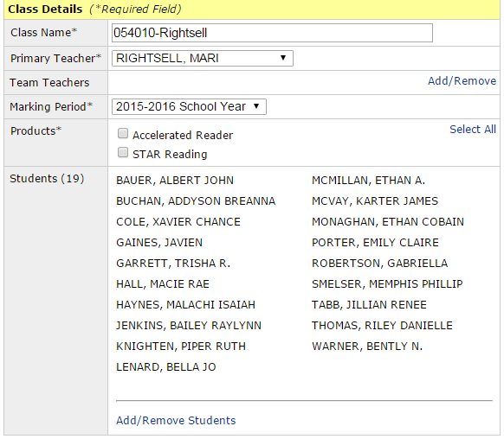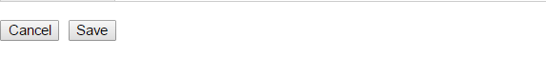A screen will open with the teacher’s name and a list of the students.

- Locate “Products.” You will see a list of the products your school has purchased. They will be unchecked. (Some schools may show AcceleratedMath if they have purchased it.)
- Check the check boxes to select your products and click “Save.” Do this with each class in each grade so that all of your classes will be enrolled in AR and STAR.

STEP 3: Enabling Tests

Once you have the students enrolled in classes, you have one more step. You must make the AR tests, Literacy Skills tests, and STAR tests (in some cases) available to them. If a student tries to test before you do this, he will get a message that says “This test is not available.” These are the steps.
- Go to the “Home Screen” on the RenPlace website.

- Select Accelerated Reader to open the popup menu.

- Select “Manage Quiz Availability.”
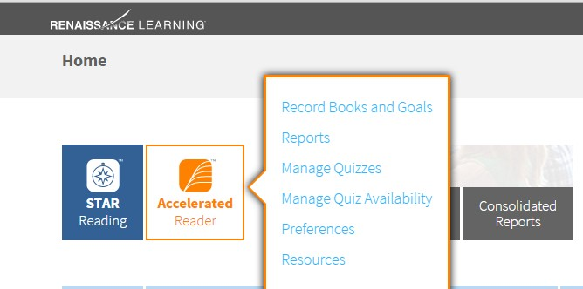

- On the screen, you will see there are three types of quizzes, Reading Practice, Vocabulary Practice, and Literacy Skills Tests. To get started, select “Reading Practice.”
- It will take you to a screen that shows the beginning of a complete list of all available AR tests. The first time you look, it will show that they are not available. At the bottom of the screen, there is a button that says, “Activate all Quizzes.” Click the button. It will take a few minutes while it goes through and activates all of your AR quizzes.
- If you are not directed to “Activate all Quizzes” you may see a prompt button that says “Update Selected Quiz Availability.” Select this button to update any tests that have been added by Renaissance. They are constantly adding new tests to the program.
- Go back and do the same thing for the Vocabulary Practices quizzes and the Literacy Skills Tests if your school has purchased these components.
- YOU DO NOT HAVE TO DO THIS FOR EACH TEACHER. This is a one-time activation.

PART 4

Setting up Date and Time Restrictions

  - Start from the “Home Screen.” Select Accelerated Reader and use the popup menu to select “Preferences.”

  - The “Preferences” window will open. There are many special preferences you can set up for your school. You can see these by selecting “Student Quizzing.” You may find it necessary to customize your program for your school. Now, we are concerned primarily with date and time restrictions.
  - Select “Date and Time Restrictions.”
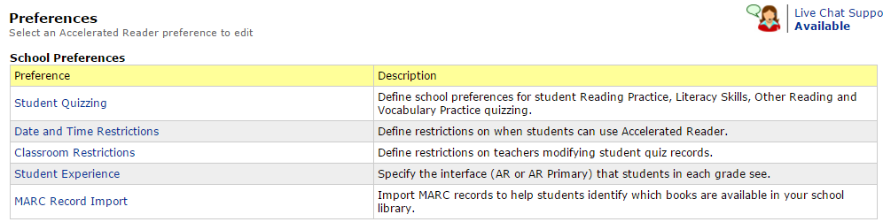

  - 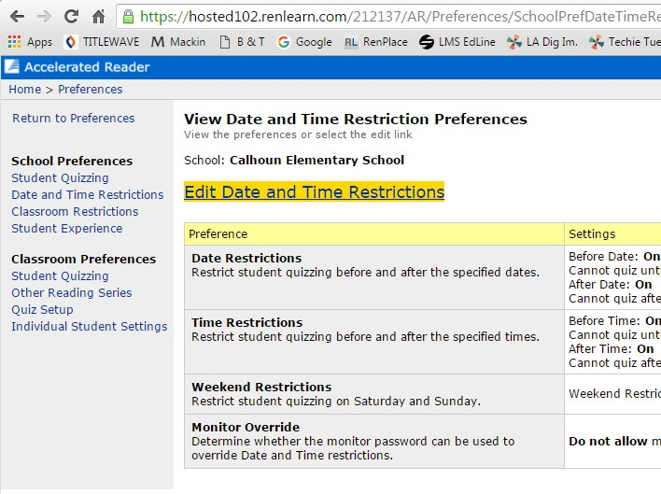The “Edit Date and Time Restrictions” window will open.

  - To make changes in this section, click the title bar “Edit Date and Time Restrictions.”

  - It is very important that you set these restrictions to protect the integrity of your program.

  - Date Restrictions: Set the date for the day you open the library and begin seeing classes. It is strongly recommended that you demonstrate “How to Take an AR Test” with your lower grade, or new students before they begin testing.

  - Time Restrictions:

    - Before School: Be sure to set this up so that students are unable to test until school begins each day, unless you allow testing in the library before school.

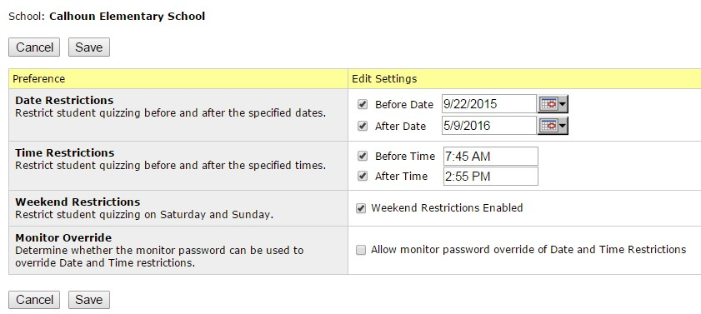
    - After School: Do not allow testing after school. Set this time for when your afternoon bell rings. If you plan to have a Family Reading Night event or other special program, you may change this for the special program, but be sure to reset this the next morning.

    - Weekend Restrictions: This should be checked. You do not want students who might be at the school over the weekend to have the ability to take AR tests.
    - Monitor Override: Do not check this unless you are the only person in the school who knows the monitor password.
    - SAVE any changes that you make.

NOTE: One of the biggest problems we have had with Accelerated Reader has been with children or family members of school personnel. Be PROACTIVE so this does not become a problem.

  - 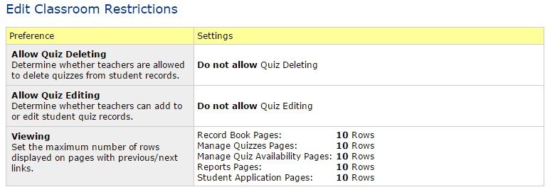Edit Classroom Restrictions: Use the classroom restrictions in the example below to set up your guidelines. Be PROACTIVE.
PART 5: CLASSROOM SETTINGS: INDIVIDUAL STUDENT SETTINGS

- To set individual student settings, start at the “Home” screen, select “Accelerated Reader”
and select “Preferences” from the popup menu.

- From the “Classroom Preferences” menu, select “Individual Student Settings.”
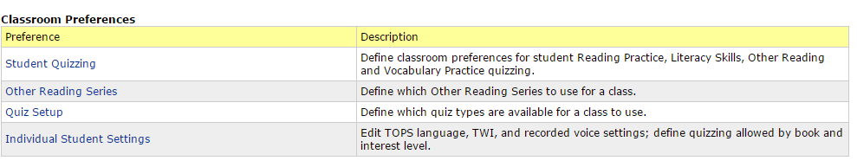

- 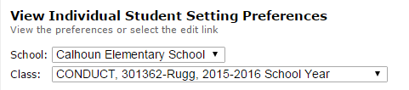Select the class you need by using the dropdown menu underneath the name of your school.
- 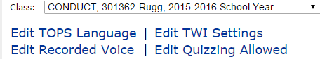The names of the students in the class will be displayed in the area below the teacher’s name. To make changes, select any of the
four options by clicking directly on the options.

- 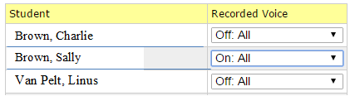If you have students who need “tests read aloud” select “Edit Recorded Voice.” Use the dropdown box beside that student to select “On.” Select “Save” at the bottom of the screen.

- Adjusting Levels of Books for Students: If students are testing on books that are either too difficult or too easy, you can adjust the levels either by class, or by student. To do this, select “Edit Quizzing Allowed.”

- 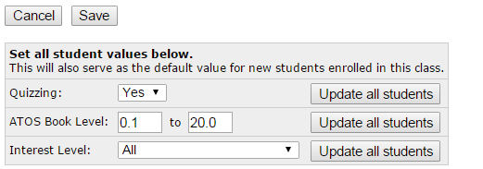To set this up for the entire class, change the numbers beside “ATOS Book Level” and click “Update All Students.” Click “SAVE.”

- 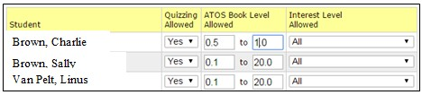To change individual students, select the student and change the ATOS level to a more appropriate level for that student. Click “SAVE.”

- Log in to Renaissance Place.
Setting AR Goals

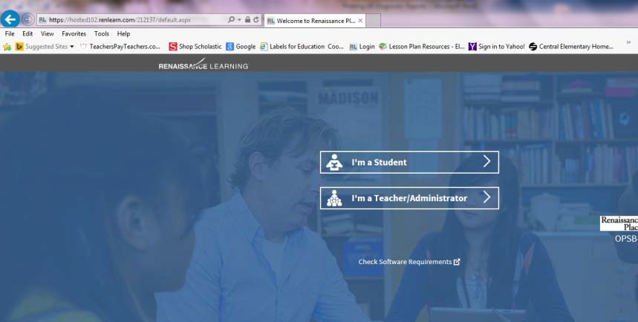
- Click “Accelerated Reader, Independent Reading.”
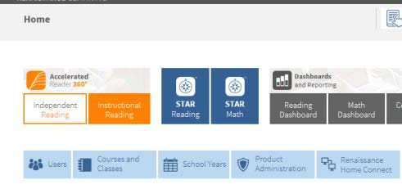

- Select “Record Book and Goals.”
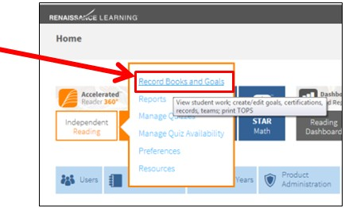

- Select the first class, and then select “Reading Practice Goals.” (Note: Elementary schools use the “Conduct” class for each grade. Middle and high schools use the English and Language Arts classes.)
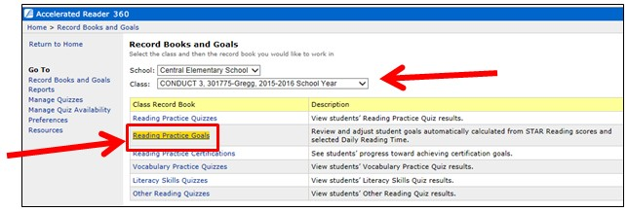
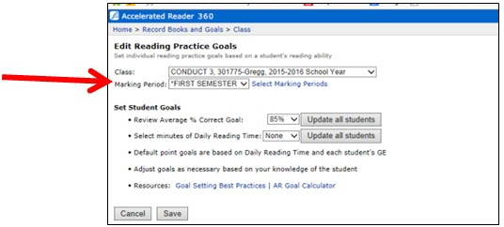
- Choose “Marking Period” from the drop down menu.
- You can choose to “Update All Students” at once or enter goals one at a time using STAR test results and the Goal Setting Chart attached. (If you have STAR tested, use the results from the “STAR Summary
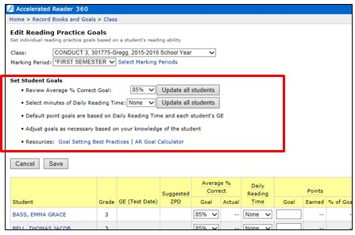
Report.”)

NOTE: For “Daily Reading Time”

- 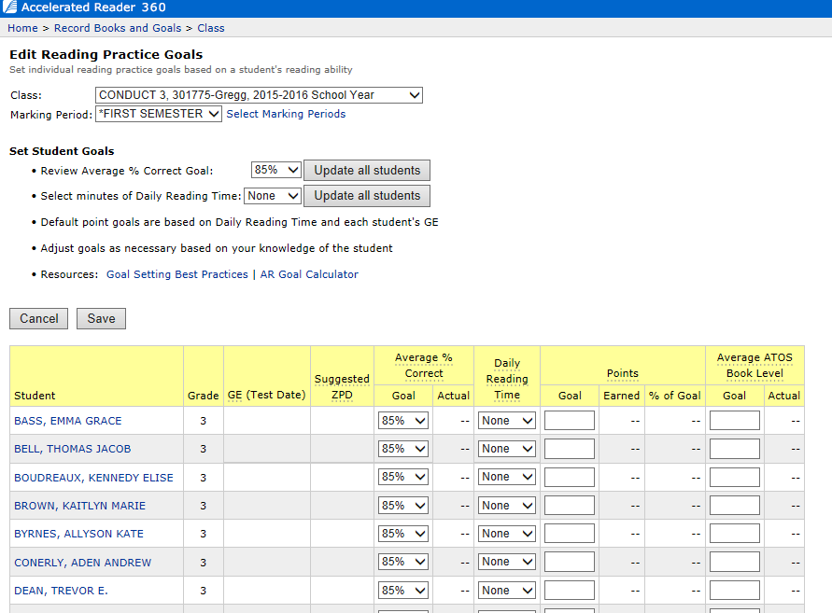Select “SAVE.”

- Repeat for each class.

Note: The number of points a student should earn during the marking period is determined by each student’s ZDP (Zone of Proximal Development, which is given on the STAR Summary Report) and the number of estimated minutes a student will read per day.

Printing AR and STAR Passwords

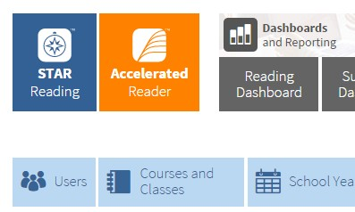To Print AR and STAR passwords for student by class, follow these steps.

  - From the Home page select “Users.” The “Personnel, Students, and Parents” window will open.

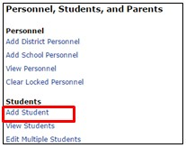
  - Select “View Students.”

  - Your school should be selected already.

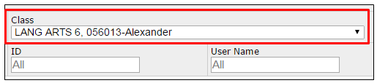
  - Under the” Class” drop-down menu on the right to locate the ELA teacher by last name and class section.

  - Click “Search.”

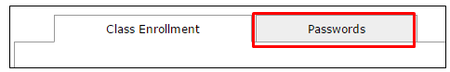
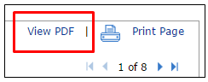
  - Once the results are returned, select the “Passwords”” tab.
  - Click the “View PDF” link on the far right of the screen.

  - 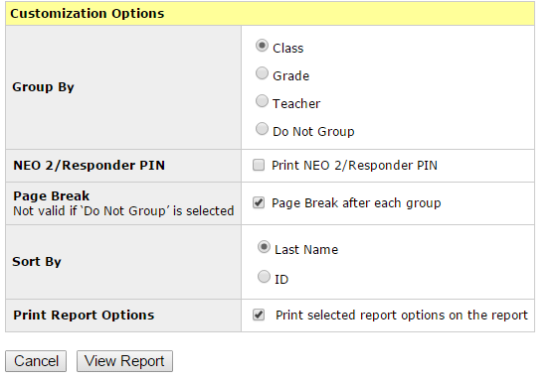Customization Options:

    - Group by: “Class”
    - Uncheck: “NEO 2/Responder PIN”
    - Check “Page break after each group.”

    - Sort By: “Last Name”

    - Check “Print selected report options on the report.”

  - Next click “View Report.” The report will be generated as a PDF. You can then print out the report.
  - You will need to select each class and then print the report.

  - TIP: Print two copies of each report when the report in generated.

  - Give one to the classroom teacher to cut into strips in advance to pass out to the students when they arrive for testing.
  - Keep one as a master copy (when the teacher misplaces hers).

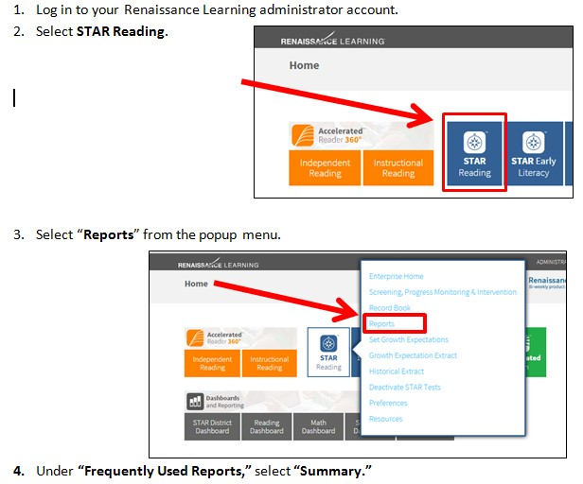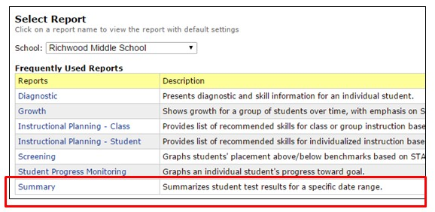Printing the STAR Summary Reports

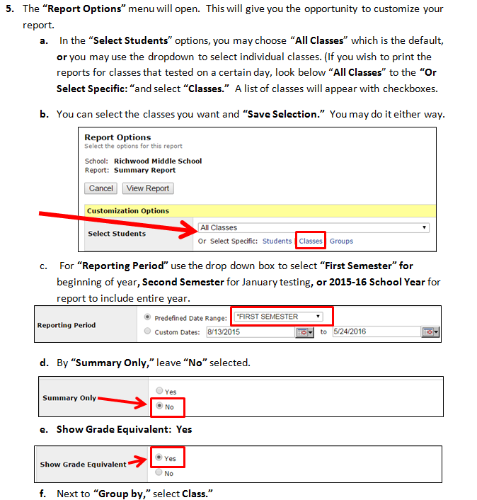
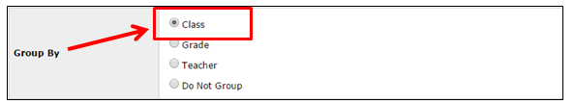

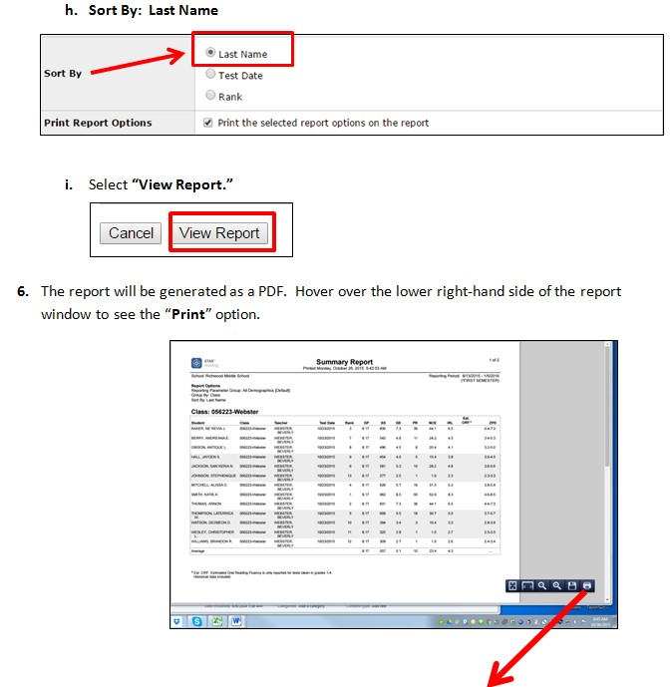

Clearing “Locks” in STAR

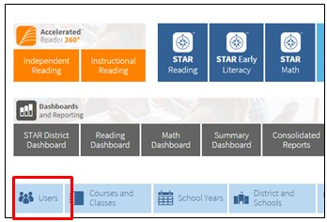
- From the Home screen, go to “Users.”

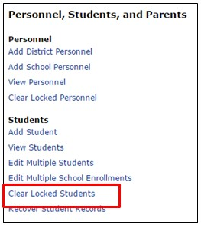
- Under “Personnel, Students, and Parents,” select “Clear Locked Students.”

- 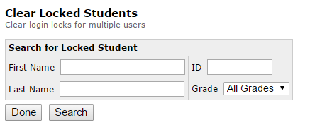Click “Search” button. A list of all locked students will appear.
- You can either clear all locked students (there is a button to “Clear All”) or clear the individual student by selecting his name from the list and selecting “Clear.”

Renaissance Home Connect
- Go to Renaissance Place and log in as the administrator.
- Select the tab for “Renaissance Home Connect” (blue tab).
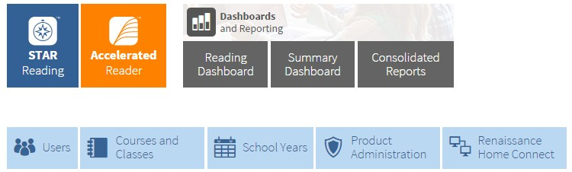

- 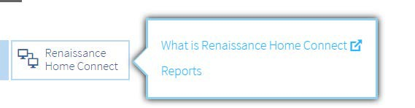A popup box will appear.
- Choose “Reports.”

- In the “Reports” screen, select “Informational Letter.”
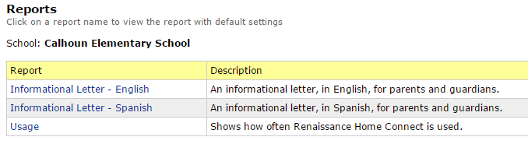

- 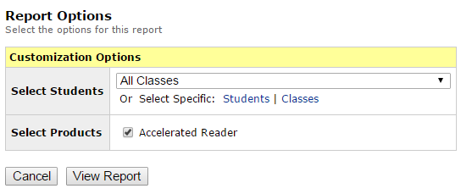This will open the “Reports Options— Customization Options” window.

- Where it says “Select Students,” I would select by specific class so that you can print out one class at a time. (If you want to print them all, go ahead.)
- Click “View Report.” This will generate individual parent letters for each student in the class. (There is a specific letter for each student.) It explains Renaissance Home Connect and how it works. The letters are generated as a PDF file to facilitate printing. The letter contains the URL and the login and password for the parent.

- 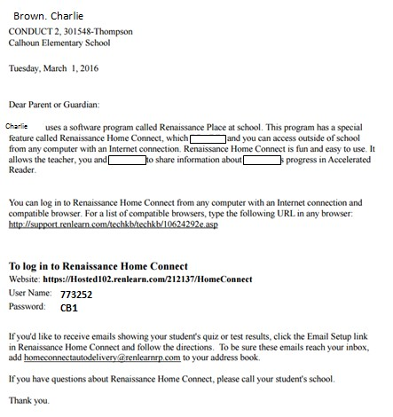It also explains how to parent can set up their email to receive AR test results.
- I would also suggest that you place a link to Renaissance Home Connect on your library page for easy access.
- Home Connect does not allow students to test at home.

Printing AR Diagnostic Student Reports

- 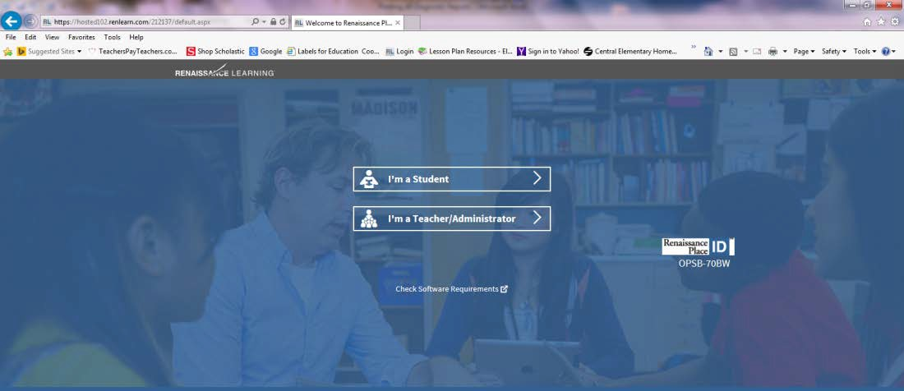Log in to Renaissance Place.
- Click “Accelerated Reader, Independent Reading.”
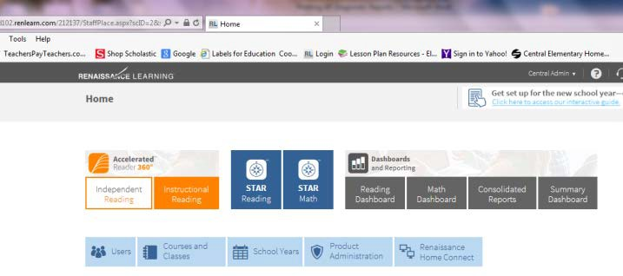

- 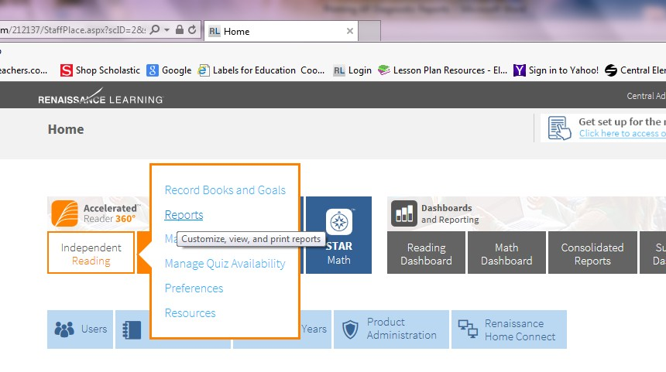Select “Reports.”

- 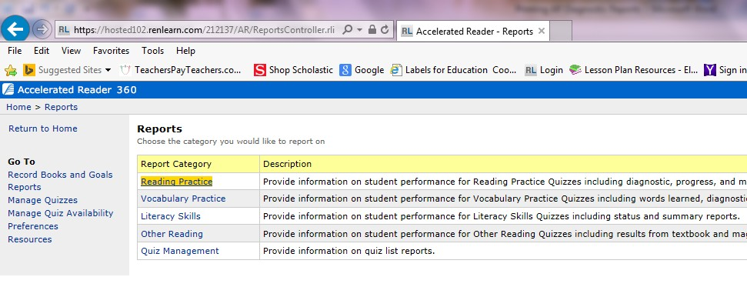Select “Reading Practice.”

- 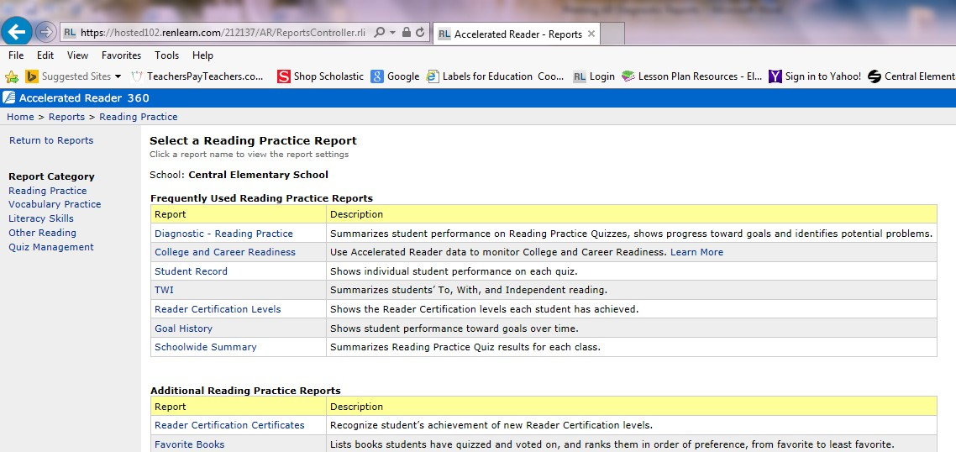Select “Diagnostic–Reading Practice.”

- Change the Reporting Period to the “Current Marking Period” (same as six weeks).
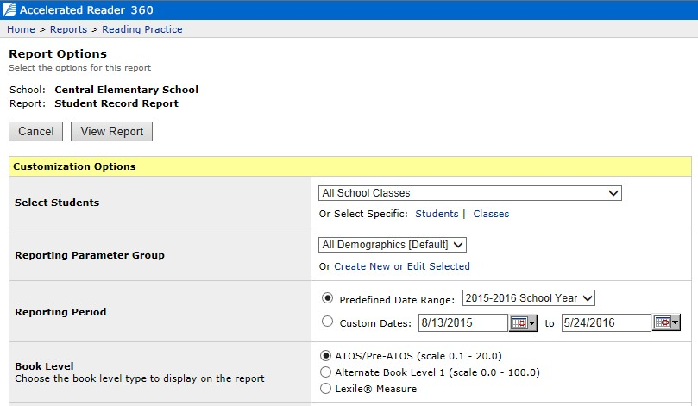
- Check “Page Break after Each Group.”
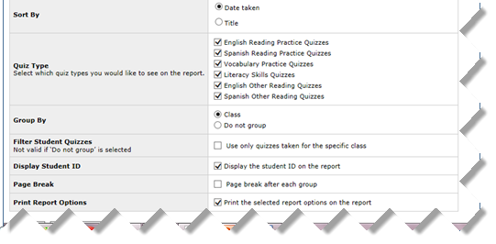

- Select “View Report.”
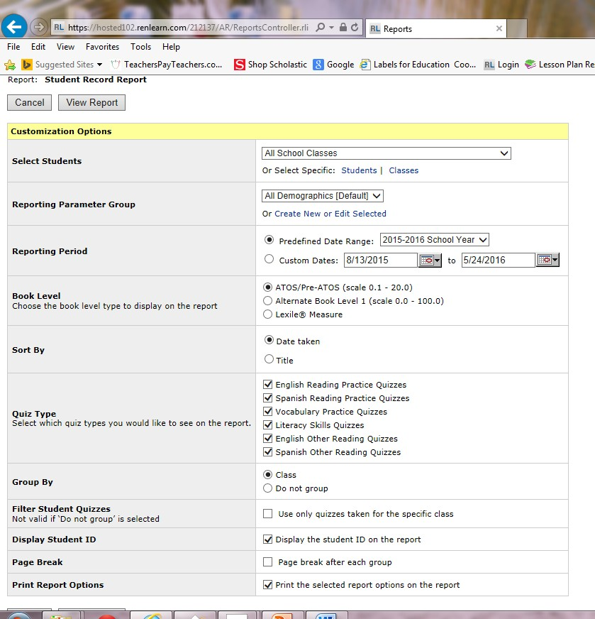

- “Print” report.

Printing Point Club Summary

  - Log in to Renaissance Place.

  - Select “Accelerated Reader, then, Independent Reading.”

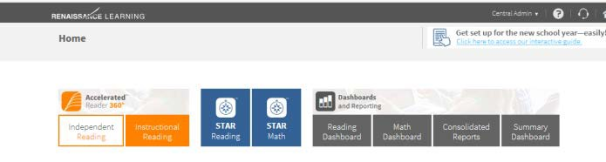
  - Select “Reports.”
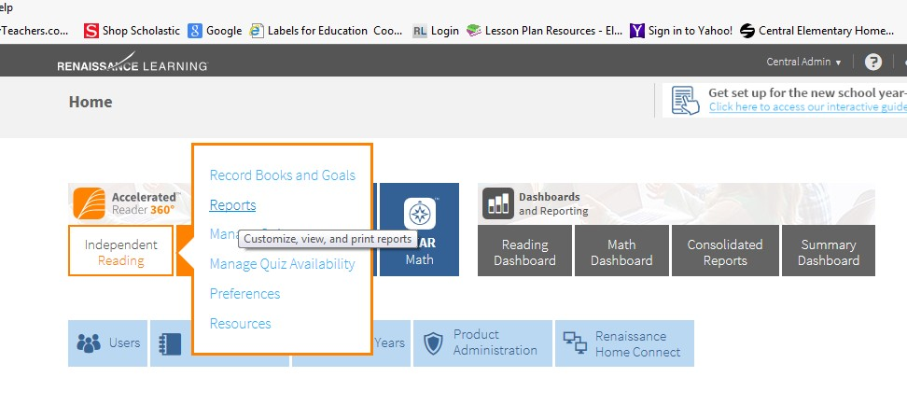

  - Select “Reading Practice.”
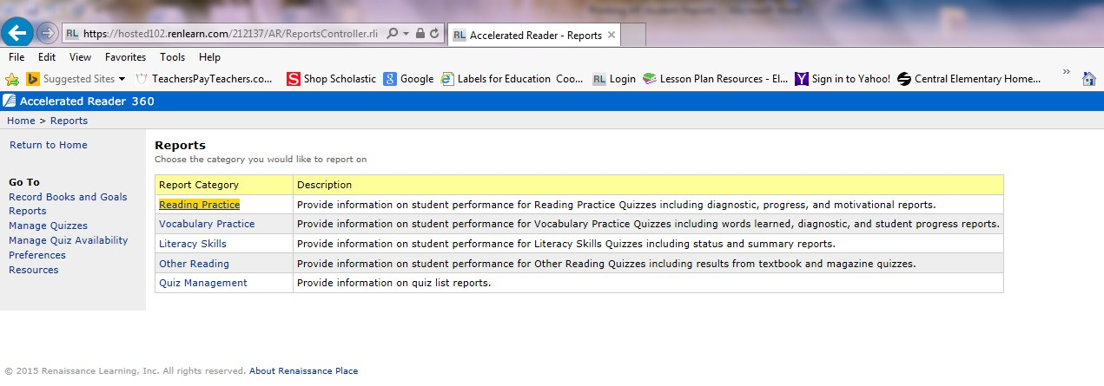

  - Select “Point Club Summary.”
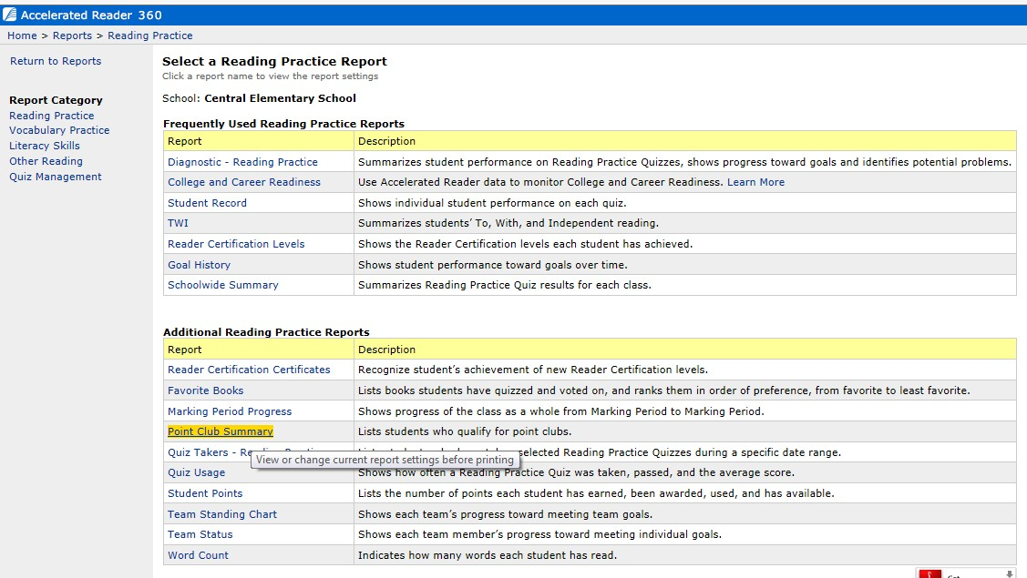

  - 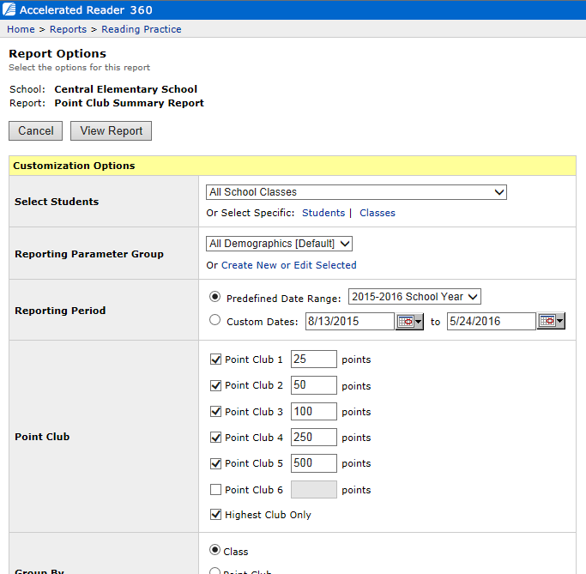Change point clubs to 25, 50, 75, 100, 150, and 200 (depending on which clubs you are recognizing).

  - 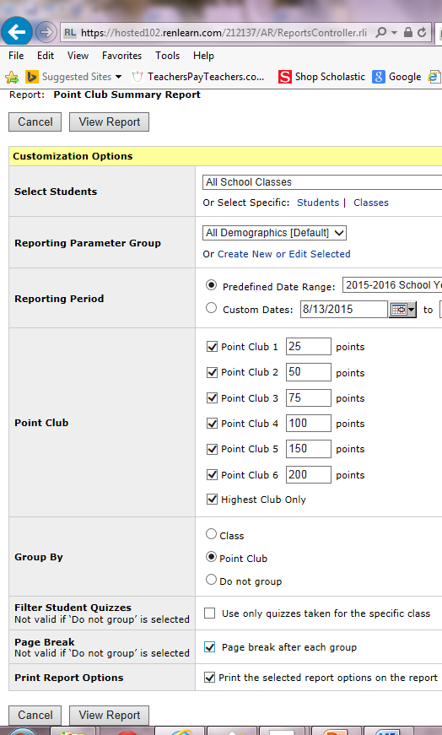Select: “Highest Club Only.”

  - Group by: “Point Club.”

  - Page Break: “Page Break after Each Group.”

  - Select “View Report.”

  - Print.

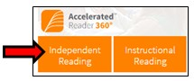
Printing AR Book Labels for AR Books

- Login to your Renaissance Account.

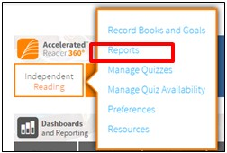
- Select “Independent Reading” from the menu.

- Select “Reports” from the popup menu. The
Reports menu will open.

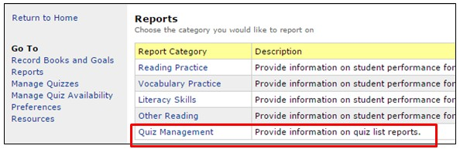
- Select “Quiz Management” from the Reports menu. The Quiz Management Reports men will open.

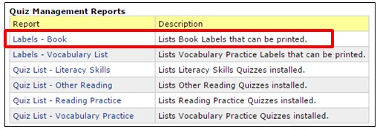
- Select “Labels – Book” from the menu.

- Select your Customization Options: (Some of these options are personal preferences, such as the “number of labels” you wish to print. Some librarians just want a label inside the book. Some prefer a label on the inside and the outside.)
- 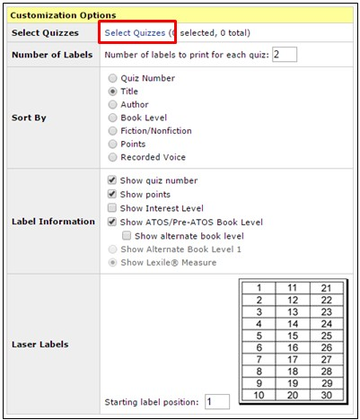Select Quizzes: Click “Select Quizzes” to search for quizzes. (See bottom of page for more information on selecting quizzes.)

- Sort By: Book title. The labels will print out alphabetically by title, which makes it easier to locate the labels when you are ready to use them.
- Label Information: I check the following:
  - Quiz Number
  - Points
  - ATOS Level

- Laser Labels: If you are using a partially used sheet of labels, select where on the page you need to start printing.

Selecting Quizzes
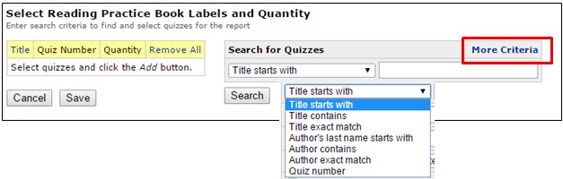
- To select quizzes, you make search by “Title starts with” or several other variations. Use the dropdown arrow next to “Title starts with” to select your preference. You may also search by the author’s name.

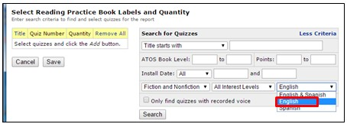
- TIP: Before you begin searching for titles, select “More Criteria” at the top right of the window. You will see some additional selections that will allow you to broaden or narrow your search. Be sure that “English” is selected as the language instead of “English and Spanish.” This will “weed” additional titles when you search.
- When your title comes up, place a check in the checkbox beside the title. Be sure to click the “Add” button to add the titles to your list before searching for the next title.
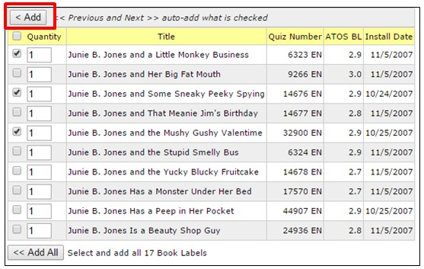

- When your list is complete, press “SAVE.” This takes you back to the “Labels Customization” screen.

Printing AR Labels

  - 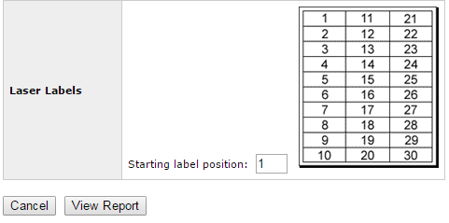At the bottom of the customization screen, you will see the “View Report” button.

  - Press “View Report.” The report will be generated as a PDF and will appear on the screen. DO NOT TRY TO PRINT YET.

  - To get the labels to print correctly, you must use Avery Label Size 5160.

  - Hoover your mouse near the bottom of the report so that you can see the Adobe Menu.
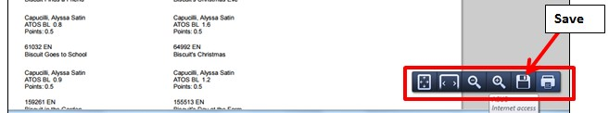
  - Select the SAVE button and save the label document. It will automatically save as a PDF. (It should save to your “Downloads” file.)

  - Open your saved file. Go to “File > Print” on the menu at the top of the document. Press “Print.”
This will open the ADOBE print menu, which is what you need to set up the printer specifications.

  - 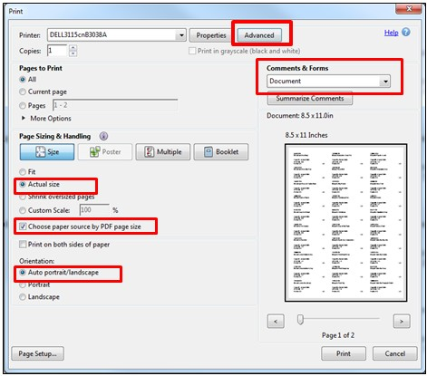Comments & Forms: Use the dropdown box to select “Documents” instead of “Documents and Markups.”

  - Page Sizing & Handling:

  - Check “Actual size”

  - Check “Choose paper source by PDF page size.”

  - Orientation: Auto portrait/landscape.

  - Click the “Advanced” button at the top of the window to open the “Advanced” options.

  - 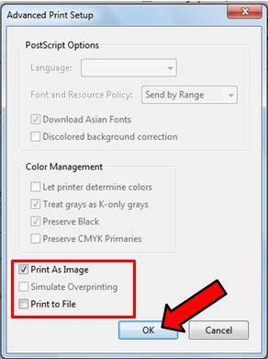The “Advanced Print Setup” will open. Check the “Print as Image” checkbox.
  - Be sure that the “Print to File” checkbox is
unchecked.

  - Click “OK.” This will take you back to the Adobe print window.

  - Have your labels in the printer. Be sure to follow the instructions on your printer as to whether the labels should be label-side up or label-side down.

  - Click “Print.” Your labels should print and stay aligned to the label squares.

Using STAR Results to Assess Collection Needs

    - Login in to Renaissance Place.

    - Select STAR Reading, then “Reports” from popup menu.
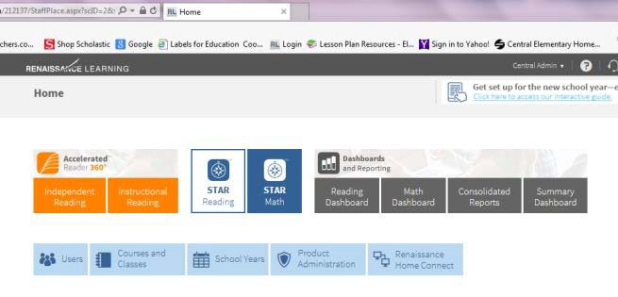

    - 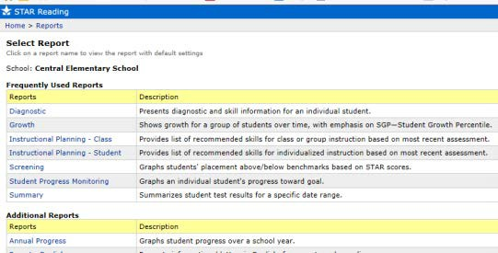Select “Summary” from the “Frequently Used Reports Menu.”

    - 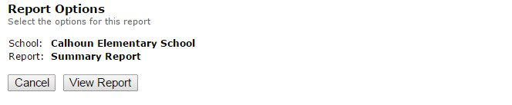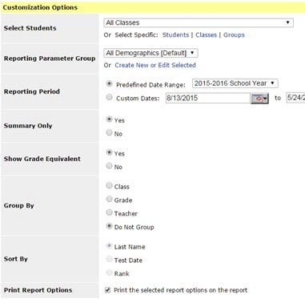Select the reporting period from the beginning of the testing year.
Select “View Report” after report is set up.

    - Next to “Summary Only,” select “Yes.”

    - For “Group By,” select “Do Not Group.”

    - Select “View Report” (top of window)

    - 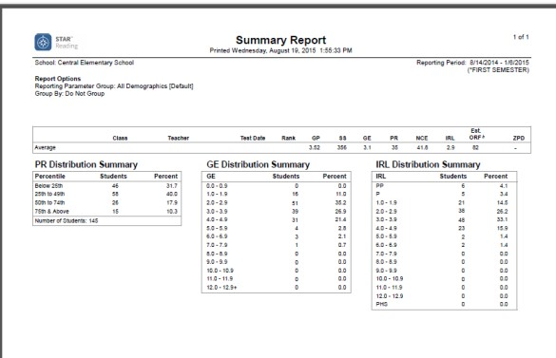“Print” report. (Right-click to print)

    - Use this data to complete the “Students from STAR Test at Grade Equivalency” column of the
Needs Assessment. (Needs Assessment form is at end of this handout.)
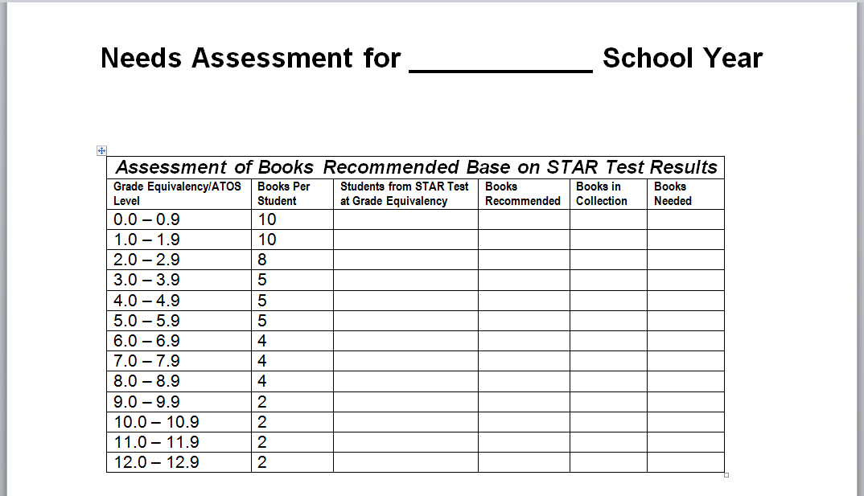
    - Calculate “Books Recommended” by multiplying the “Books Per Student by Students from STAR Test at Grade Equivalency.”

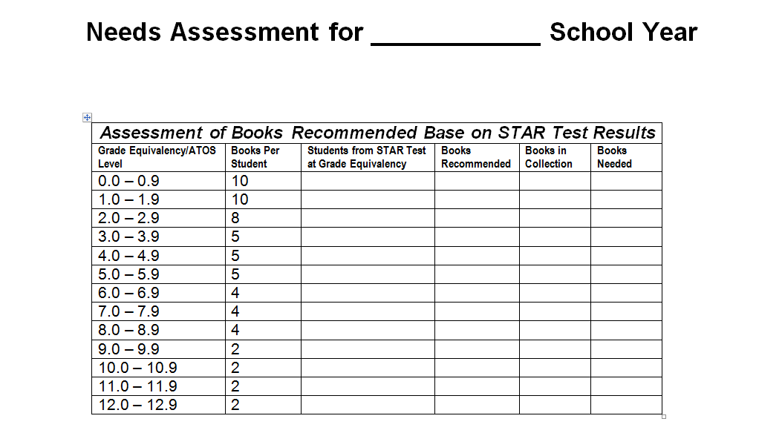

Needs Assessment for School Year

Assessment of Books Recommended Base on STAR Test Results
Grade  Equivalency/ATOS Level | Books Per Student | Students from STAR Test at Grade Equivalency | Books Recommen  ded | Books in Collectio  n | Books Needed
0.0 – 0.9 | 10
1.0 – 1.9 | 10
2.0 – 2.9 | 8
3.0 – 3.9 | 5
4.0 – 4.9 | 5
5.0 – 5.9 | 5
6.0 – 6.9 | 4
7.0 – 7.9 | 4
8.0 – 8.9 | 4
9.0 – 9.9 | 2
10.0 – 10.9 | 2
11.0 – 11.9 | 2
12.0 – 12.9 | 2

Accelerated Reader Code of Conduct


The purpose of the Accelerated Reader program is to encourage reading and improve reading skills. With t his in mind, students are expected to follow the rules described below:

  - Students may only take tests on books they have read or that someone has read to them.

  - Students may not take a test on a book which has been made into a movie unless they have read the book.

  - Students may not use Cliff notes, classic comic books, videos, or abridged versions of the book to try to pass the test.

  - Students may not take tests for other students.

  - Students may not discuss AR questions or answers with other students.

  - Students must not reveal their password to anyone other than a parent or teacher.

  - Students may NOT discuss AR questions or answers with other students.

  - They may NOT do anything that would be considered cheating.

  - Students may not receive outside help to take a test.

Consequences
Students who break the rules w i ll face the following consequences:

- The test or tests involved in the cheating incident w ill receive a score of 0.

- The student will not be able to earn any rewards in the AR program for the remainder of the 6-week grading period.
I agree to follow the Accelerated Reader Code of Conduct described above.

Student Signature

I have discussed the AR rules with my child and he/she agrees to follow them.

Parent Signature

ACCELERATED READER CODE OF CONDUCT

Students are expected to abide by the following the rules while participating in the AR program:

- They may only take quizzes on books they have read or have been read to them in the past month.

- They may only take quizzes at their assigned reading level, unless approved by their teacher.

- They may only take a quiz on a book that has been made into a movie if they have read the book.

- They may NOT use Cliff notes, videos, or abridged versions of the book to take a quiz.

- They may NOT take tests for other students.

- They must NOT reveal their password to anyone other than a parent or teacher. •They may
NOT discuss AR questions or answers with other students.

- They may NOT do anything that would be considered cheating.

Students who choose to break the rules will face the following consequences:

- The quiz or quizzes involved in the cheating incident(s) will receive a score of zero.

- The student will not earn any rewards in the AR program for the six-week grading period.

It is our hope that all parents will encourage and support their child's efforts in the Accelerated Reader program. After all, those who read well become well read!
I agree to follow the Accelerated Reader Code of Conduct described above.

Student Signature

I have discussed the AR rules with my child and he/she agrees to follow them.

Parent Signature

To Set up a Testing Window in S.T.A.R.
(Requires Administrative District Password)

To set up or edit Screening Dates for use with STAR Interventions you will need administrator access (Jan McGee or Crystal Armstrong).
- From the “Home” page select the appropriate “STAR” product > Screening > Progress Monitoring & Intervention.
- Click on View Screening Dates (from list on left side of window)

- You can edit the names and dates of existing screening periods and click Add Screening Dates to create more (up to a total of 10).

AR Tech Support says:

  - You can edit the existing window (as long as it's not over 30 days) or add a new one as per above.
  - You can add one by clicking on “Add Screening Dates” at the bottom of the window.
  - When finished, click Save.

AR Parties:
Accelerated Reader Rewards and Parties
(Shared by School Librarians in Ouachita Parish)

I reward with a party each 6 weeks. I do things like pizza parties, popcorn/movie, nachos, etc. I then reward students who have consistently reached their goals to an end of the year trip. We have been to Education in Motion at Magic Springs several times, we've camped at Lake DeGray, Geyser Falls, etc. Due to a shortage of bus drivers last year, we went to Johnny's Pizza and then a movie. They loved that too.

I also randomly take their AR logs and reward students when they come to library if they have filled the log out correctly. Or I may check and see who had the most AR points for the week and surprise them with a gift from my treasure/treat box!

This year, I've started surprising classroom teachers whose students are reading and testing with a nice treat. This 6 weeks, I chose 3 teachers and did their after school duties. Next 6 weeks, I'm going to do lunch duty for some lucky teachers, 3rd 6
weeks, take a couple of classes at the end of the day for a Drop Everything and Read and give the teacher a 20 minute break! (Stephanie Judd, Boley Elementary School)

AR Activities:

We reward every six weeks and then a big event at the end of the year. Ideas for 6 weeks goals met: Snowcones and extra recess, Cokes/Chips with extra recess (students enjoyed this because the Principal was outside and shared a coke with them), Ice Cream Sundae party, movie and popcorn/drink, Skatetown (students have to pay for this one).
End of the year AR Reward, Requirement: Students must meet their 6 weeks goal five times in order to go to the big AR reward: Circus Theme (games in the gym with a person making balloon animals, and we had a magic show to end the day). It was a lot of fun especially since the teachers and volunteers dressed up like clowns and I was dressed as the ring master.
We have gone to the Delhi Safari. Students fed and petted animals, played games and we had a hamburger/hot dog grill.
One year our theme was "Reading is Your Ticket to the Magical Mystery Tour." Students were given each six weeks a clue as to what the end of the year trip will be. It is displayed on the outside wall of the library along with our reading banner. They are curious and motivated to read. (Audrey Hudnall, Jack Hayes Elementary)

AR Incentive Parties: Here are some AR incentive party ideas I've used in the past.
We have an AR party at the end of each six weeks. From 12:00 to 3:00, I have a different grade level come in to the multi-purpose room for 25 minutes of activities.
- Super Hero themed "minute to win it" activities at different stations manned by parent volunteers. ex: super breath station (bubbles), super hero relay ( students wore super hero masks and did an obstacle course), super hero names ( students used a hidden code to write their super hero name on a sticker for their shirt), pass the kryptonite (played like hot potato with glow sticks). Most of the games were found on Pinterest.
- Winter themed "minute to win it" activities-snowball relay (cotton balls on spoons), snowball toss, snowball bounce (with white balloons), decorate/ice cookies, etc. and others found on Pinterest.
- Rent inflatable bouncers or obstacle courses and set up in multi-purpose room
- New Orleans Saints Play 60 came and spent a couple of hours at the school.
- Dance parties- I have ULM athletes come and lead the students in line dances. (they love this)
- Pirate themed party- cut out two pirate ships from plywood with holes as the windows and split students up into two teams and had 900 water balloons ready for them to throw at each other. Also had water squirters. (kids had to have a change of clothes that day)
- Pirate theme- had GPS's that students used to find coordinates do a treasure hunt to find the pot of gold. (big treasure chest with bags of gold (candy)
- Fill your bucket theme-minute to win it activities found on internet
- Ice cream social-students pick from assortment of toppings
- End of year field trip for any student that meets each six weeks AR goal: Kiroli Park, Uncle Robert's Orchard. (Tracey Whitehead, Sterlington Elementary)

Monster Bash

I usually just google ideas for themes but this six weeks happens to be our book fair and the theme is funny monsters so We are having a monster bash this six weeks with monster music (The Monster Bash) and monster snacks such as worms and dirt, etc. and the decorations will be mostly the ones I used for the book fair so I save a little money. We do something every six weeks and we are planning a field trip the 6th six weeks for the top 25 readers to Sci-Port in Shreveport. (Doná
Delgado, Riverbend Elementary)

AR Top 20

I recognize the top 20 AR readers every six weeks. I give them a certificate and some kind of prize (bookmark, coupon, pencil, etc.). I announce on the TV station which grade level and which teacher has the most points. I also announce the top readers. At the end of the year, I have a luncheon for my top 30 readers. I have food donated and I give them certificates. My

top 3 readers are recognized and I buy a book for the top reader. The teacher with the most AR points at the end of the year gets a free period off. Last year, I had an open mic (poetry reading) taking place during the same time I was watching the winner's class. The students enjoyed the open mic and some even participated. The teacher chose the period after her planning period so she was able to go home for lunch. She plans on winning again!
(Lisa Hightower, Riser Middle School)

AR Parties and Point Clubs

We have an AR party each six weeks. We do something different each time. (Snow cones, pizza, donuts) End of the year trip is to the Lambright Center in Ruston and then we have a pizza party after at the school.

100 Point Club gets a t-shirt and their name goes in a drawing for prizes like 100 suckers, 100 pieces of gum, etc. (Amanda Alsop, Claiborne Elementary)

AR Competitions

I have several AR competitions that have proven successful here at Riser Elem. I have popcorn & coke and a movie, the 1st six weeks, 2nd six weeks we do nachos & coke, 3rd six weeks- nachos & coke, 4th six weeks raising cane, 5th six weeks students get to have lunch in a special area, where they are served a nice desert. The 6th six week they get to have a Sock Hop, the students are allowed to come in and dance for one hour. They are also served popcorn during the dance.
AR Chairperson

Our parent/teacher organization appoints an AR chairperson to plan our AR activities. The K- PALS also pay for the activities.
There is a reward after each six weeks for students who have met their goals. Some of the rewards are:
- Walking to Kiroli Park and spending a couple of hours playing on the playground and hiking the trails
- Popcorn, drinks, and movie
- Bingo, drinks, and pizza
- Make-your-own ice cream sundae party with door prizes
- End-of-the-year awards for students who met their AR goals each six weeks of the school year varies:
- Field trip
- Party - students got treat bags with a $25 Books A Million gift card
(Melba Collum, Kiroli Elementary)

Six Weeks Incentives:
- At the end of each 6 weeks there are incentives for those that have met their goal.
- Names are posted outside the library for students in the Top Ten and 100 point club. Top Ten lists the top ten students out of the entire school who have attained the highest number of points earned in that six weeks. The 100 point club acknowledges students in the entire school who have reached 100 points or more each six weeks. At the end of the school year, any student with 100 AR points or more has their name put into the drawing for a crisp $100 bill given away!
- Students who earn any of the following: Top Ten and/or scores two 100’s on their AR report each six weeks (100/A for getting all their AR points that six weeks, and a second 100/A on their comprehension score that six weeks) are rewarded with a library pizza lunch each six weeks and are also rewarded ribbons at each six weeks awards assembly.
- At the end of the school year, any student who has over 100 points will awarded a necklace medal at the end of the year awards assembly. I also reward the top ten students with the most points overall
- At the end of the school year, those students who show growth from the August STAR test to the May STAR test will be rewarded with a party cart treat (a cart that has a variety of candy prizes purchased from Sam's club)!
- Each six weeks awards assembly I have purchased ribbons for students who are in the following clubs: Top Ten, Get two 100's on reports, and 100 point club.
- If you get your AR points for that six weeks with at tleast 85% or higher in comprehension, everyone's name goes into a drawing done at the awards assemblies for a
$15 cash prize. (Lark Girod, Swartz Upper Elementary)

6-week Rewards for Meeting Goals

I think with elementary school students that they need some type of reward each six weeks for meeting goals. A reward half a year away is really hard for them to keep focused on. I do something each six weeks for those who meet their AR goal. It can get expensive but I try to choose more inexpensive ideas. This year my theme is Louisiana with gators and a Cajun flair.
My first AR party, we had:
- zydeco music-free,
- swamp water(lime Koolaid with gummy worms)- about $15.00
- alligator eggs(Easter eggs filled with candy and extra book check out coupons)- $10.00
- guess the growth(an alligator that you put in water and it gets bigger) with a prize for the closest guess-$5.00
- some alligator games that I ordered off amazon(blow up gator that you throw rings around the tail, crocodile dentist, and crocodile soccer)-$30.00

The next six weeks is going to be sports related - Saints and LSU - I have some West Ouachita cheerleaders and football players coming out to lead some games and activities - football through the hula hoop, cheers, obstacle course, LSU connect 4. Not positive about the activities but third six weeks is going to be camo/Duck Dynasty related, 4th six weeks - Mardi Gras, 5th six weeks - to Black Bayou.
I also take the students with 100 points or more to Tech's Lambright center for a field trip at the end of the year. We black light bowl, climb the rock wall, and swim in the outdoor pool.
If students earn their goal every six weeks, they receive a medallion at the end of the year awards ceremony.
Also, the million word readers get a box of Millionaire Candy at the awards ceremony with a trophy. (Alicia Minter, Central Elementary)

6-Weeks Parties

My first year, I had a party every six weeks. I gave each student a goody bag filled with treats related to my theme of the year. They were also given a snack at each party. Since my Box Tops money was taken away, I have had to trim the parties down to a snack only with no treat bags. I try to make the snacks fun like Coke floats, popcorn bar, etc.
End of the year field trips have been to Sci-port, Lambright Center at La. Tech (by far the best) & lunch at Cheeburger, Cheeburger, and one year I rented a water slide & had it delivered to the school. Students played on it all day, ate pizza & had Kona Ice bring their snow cone truck.

(Sherry Carver, Woodlawn Elementary)

Ideas for AR rewards
Movie and popcorn in the auditorium with popcorn; Game day (sack races, relays etc.); ice cream sundae party; Art project with the Art Museum.
(Amelia Brister, Calhoun Elementary School)

Library Motivation

Monster Pencil Pull--Murphy the Monster came during the month of Oct. During morning recess, students paid .25 to pull a pencil out of Murphy. If the pencil was colored on the tip, the student won a sucker. In any case, the student kept the pencil. It was a lot of fun, we only broke even so it is not recommended as a fund raiser unless you charge more per try. I also recommend limiting the number of tries a student can purchase, as the students brought $10 and $20 dollar bills. It was a huge success as a way to get the students excited about coming to the library during recess.
(Amelia Brister, Calhoun Elementary School)

AR Incentive Plan: Game On
Students who meet their individual six weeks’ AR goal will be able to experience the fun-filled parties below:
1st Six Weeks- “Fill Your Bucket”
Students will go to several stations of fun minute to win it activities and snacks.

2nd Six Weeks- “Inflatable Fun”
Students will jump on inflatable bounce houses and race on a giant inflatable obstacle course.
3rd Six Weeks- “Winter Games”
Students will go to several stations of winter themed minute to win it activities.

4th Six Weeks- “Line Dance Party”
Students will follow the lead of the visiting ULM athletes as they show the students how to dance to popular line dances.

5th Six Weeks- “Crunch Time Party”
Students will be given fresh, hot popcorn and a drink.

6th Six Weeks- “End of Year Field Trip”
Students that have met their AR goal each six weeks this year will be able to go on a grade level field trip to Lambright Center at Louisiana Tech. (Tracey Woodhead, Sterlington Elementary)

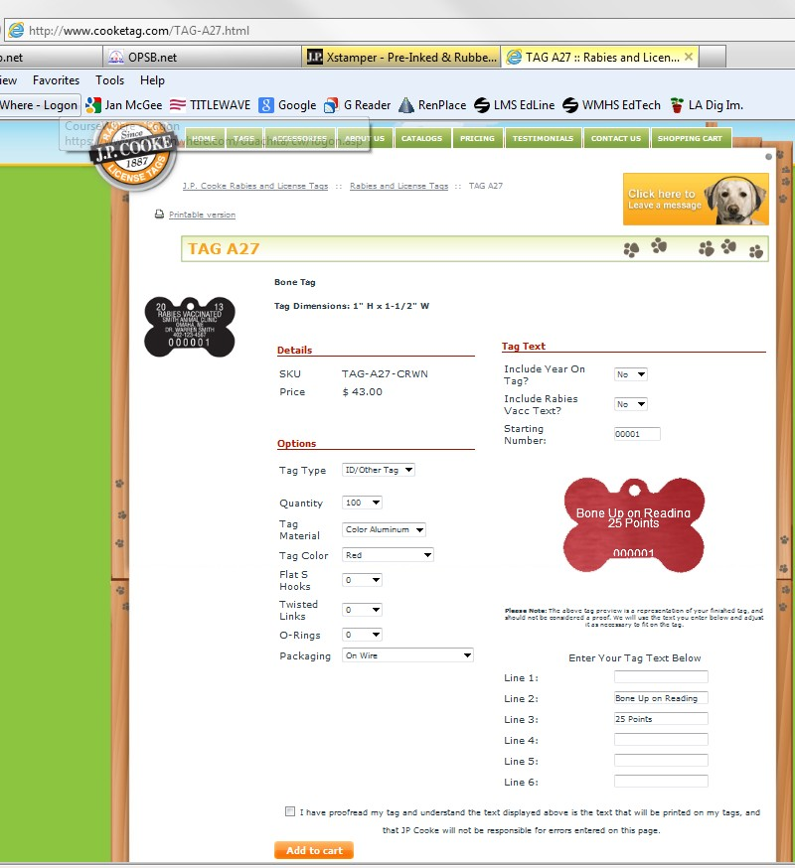J. P. Cooke Dog Tags for Accelerated Reader http://www.cooketag.com/Tags/

Tracey Moncrief used “Dog Tags” as rewards. (Yes, I’m talking about tags like the ones you get for your pets.) The tags are customizable and come in colors if you want. She also provided a plain “dog tag” chain so that students could collect their tags and wear them with pride.
They we relatively inexpensive and may be ordered in bulk.

Accelerated Reader on Pinterest.com

Help! My Child Keeps Failing AR Tests!!!! Tips for Parents and Teachers (includes free downloads) https://www.pinterest.com/pin/118923246385936528/ http://blog.heidisongs.com/2013/11/help-my-child-keeps-failing-ar-tests.html

Creative Lesson Café: Teaching ideas for the Primary Classroom
Free incentive ideas and pay materials, free labels, etc. http://creativelessoncafe.blogspot.com/2014/07/a-is-for-accelerated-reader-ideas-and.html

AR Level and Goal Bookmarks for the Year (Teachers Pay Teachers) https://www.pinterest.com/pin/384494886913945639/

AR School Challenge: Water Fight 2013
https://www.pinterest.com/pin/155022412146427800/

AR Brag Tags, by Kidsrcute https://www.pinterest.com/pin/500110733595769899/

Awesome Accelerated Reader
Webquests, Printables, Childrens’ Literature Links, Scavenger Hunts with AR Books,
Puzzlemaker.com http://www.vickiblackwell.com/awesomear.html

AR Punch Cards (Teachers Pay Teachers) https://www.pinterest.com/pin/63894888438433019/

AR BookScanner App ( itunes app: $1.99)
AR BookScanner is an app that will scan the ISBN barcode on a book and give you the title, author, AR 1quiz number, number of words, book level, points, and an area of interest.

PointScan: Scan My Book (Google App. $0.99 for Android devices)
Scan the ISBN number on a bookto receive a book’s AR™ level, point value and quiz number.
https://play.google.com/store/apps/details?id=com.straightpathapps.pointsscanfree

Bead-Azzling Readers (AR Beads)

Bead system for AR rewards https://www.pinterest.com/pin/530580399825990050/
http://firstgrademagic.blogspot.com/2012/01/bead-azzling-readers.html
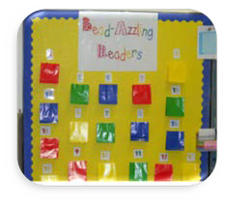
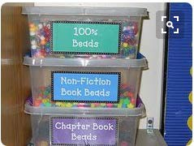

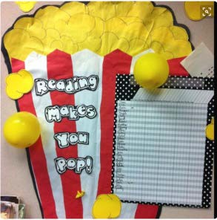Balloon Pop AR Incentive:
Every 10% of their goal they earn, the student pops a balloon. Inside the balloon is a post it with a reward written on it- like tickets, in class snack, etc. Totally motivates students to read. https://www.pinterest.com/pin/230457705901977504/

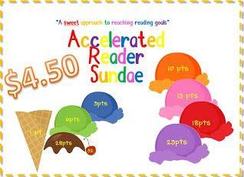
Accelerated Reader Sundae: A Sweet Approach to Reading Goals (Teachers Pay Teachers)
https://www.pinterest.com/pin/259308891017649820/

Reading Strategies Posters and Freebie
https://www.pinterest.com/pin/255579347583643848/

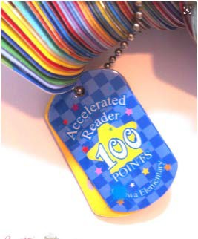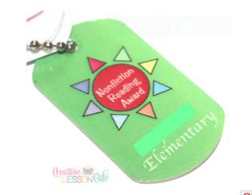Reading Incentives from School Life: Patch tags, brag tags, patch bands, custom silicone wristbands, etc.
http://www.schoollife.com/

Section 11:

Instructional Role of the Teacher-Librarian

Section 12:
Library Programming

Discipline in the Library Reading Initiatives
LYRC OPTRC
Dr. Seuss: Read Across America
Children’s Book Week Teen Read Week
Reading Incentives and Ideas Library Songs & Chants

Discipline in the Library

Good Library Discipline requires high expectations, a discipline system with consequences, and a good system for moving students to different parts of the library, and in and out of the library. Students are in the library for from 30-45 minutes. It is difficult to put into place a complicated system when classes are coming in back-to-back throughout the day. The suggestions below are tried and true methods for maintaining discipline in the library.

- Consistency and clear expectations! What works in Harry Wong’s First Days of School works in the library! I start the first day the students come to the library and we practice how to come in the door, how we are assigned seats, what procedures we follow during checkout time, and how we move about the library during the library period. We practice returning library books with the barcodes on top for faster check-in, we practice the procedures for checking out books, and we practice lining up at the door when we leave. We practice it until every child knows how and where to go. When they come to the library the next time, we do it all over if necessary. If they have learned to follow the procedures, we move on to bigger and better activities. Occasionally, we have to revisit something, but it is amazing how well they do if the expectations are clear and consistent.

- I number my tables. Students are assigned to a numbered table. The students go to the shelves and check out their books by table number. The students also line up to leave the library using this procedure. Students are given index cards with their check-out number and AR Reading Levels on them to use during check-out time. As I call their names, they receive their card and then go to the shelves to find their library books. For Pre-K and K I use laminated construction paper as name mats. After I finish my story, the students go to their seats as I state their name and the color of their name mat.

- I used laminated, colored shapes taped to the center of the tables. I also used corresponding colored “duct” tape lines in my storytelling area so that I could send the “red” table to the red line, etc. I made sure the lines were far enough apart that the students would not be crowded in the story area.

- I just rely on basic classroom management techniques, such as using positive reinforcement for good behavior. I occasionally use bookmarks or "Gator Bucks" (our school's token system) as rewards for good behavior. To make transitions from teaching time to check out time smoother, I use their “library sticks” to call them over to the books. (Library sticks are just Popsicle sticks with their name and ID number on them.)

- The main thing is that I treat the library and checking out books as an awesome privilege! If they misbehave, I don't let them check out books. They can come back on their recess time to check out. I really rarely have to do that, though. And I NEVER send children to the office for discipline. I figure I can control them myself for the 45 minutes they are in here. In my experience, the more structured you are and the more you keep them busy, the less likely they are to misbehave. These things are true with my K-2 kids and in the past when I was K-6...and Title I :)

- For both lining up and going to the shelves to check out, I call the table numbers, alternating each week. For behavior, I have a prize wheel that I use to reward students each week. The

number they land on is the jar they choose from with both candy and non-candy treats. Each week I reward in a different way - winning table, winning students, boys vs. girls. I tell students that I am looking to see who is following all rules and procedures, including using shelf markers, using their library voices, good listeners, etc.

- From a retired elementary librarian: A few thoughts after almost 37 years:
- Full moons really do affect students--especially elementary students.
- Weather changes affect students also.
- If the classroom teacher can't control them, you will have a hard time also. (Watch hall movement and assemblies)

- My best practice: Wait them out. Go to my desk sit quietly or do some work. The students will notice and the older students will say out loud, "She's waiting." This saves on the voice and emotions.

- Fighting and arguing with students wears you out emotionally. Your day is shot.
- Prayer!!! Pray daily for the students and classes that give you trouble. It works.
- At story time or class time, give the students just a few minutes to tell you anything they need to say. It helps.

- Giving out stickers, pencils, or stamps on hands to good students helps.
- For older students, have a stuffed animal or some figurine to place it on the table of good students. Move it to a new table of good students or leave it there. At the end of library, give the table that has the object on it a treat.

- With the little ones, we always put a bubble in our mouth when moving or lining up. The older children know that when my hand goes in the air, it is time to be silent!! We check out books by picking the quietest table. We always line up by tables.

- When I move the younger grades from the story rug to the tables on the other side of the library, I put small colored pails—a different color for each table-- (from Hobby Lobby) on the tables. I just call the first four students names and tell them to go to the blue table, etc. They still sell these pails at Hobby Lobby. I was able to get six different colors for the six tables. I put pencils in the pails when pencils are going to be used. I call students to check out by tables.

- I have numbered colored popsicle sticks 1-25. I draw a stick at the end of the class. If the student whose number was drawn has not broken any rules, he/she can get a treat from the treat shelf. I have the tear-out sports cards from Sports Illus. for Kids magazine, pencils, and scratch-and- sniff bookmarks from Highsmith on the shelf. They all like the bookmarks the best. Any student who has to be warned 2 times about behavior gets his/her name sent to the teacher for a conduct mark.

- I used the colored table/colored line system. I also met the students at the door and placed a sticker on the front of each student’s shirt around the neckline when a class entered. If the students followed the rules, etc., the entire library period, they were able to keep their stickers.

If someone misbehaved, didn’t follow library rules, etc., I pulled that sticker and threw it away. The teachers knew immediately who had misbehaved when they were picked up because they no longer had a sticker. A few years later, DEMCO came out with large colored vinyl dots that a friend of mine used. They held up much better than the colored floor tape.

- I have the word “Books” posted in the library. If the class starts misbehaving, I start taking away letters. Each letter is worth one point. If the class is good, they have earned five points. When the class earns 30 points, they earn a game day or a movie in the library. Most of my classes seem eager to earn their free day and like to keep up with how many points they have compared to other classes. Right now, I keep track of the points in a notebook, buy I plan to get a chart I can hang up so the kids can keep track of their progress. Also, if the class keeps all 5 letters for the day, I give the entire class a piece of candy, bookmark, etc. I'm spending a lot of money on candy, but it’s definitely worth it! There are times when the majority of the class is good and just one or two children acting up and then I usually just take the treat away from those couple.

- Our school also has "gold slips" that classes can earn. When a class acts exceptionally good, they get a gold slip. Anyone that works in the school can give the class a gold slip. If my class keeps all of their points, they get a gold slip from me. The class at the end of the nine weeks that has the most gold slips gets a small party. The gold slips are nice because the teachers see that their students were exceptionally good during the class. My classes like getting a gold slip almost as much as they like getting the candy!

- I do 'good behavior parties' when students fill up their bead jars, and at these parties, I usually show a fun movie (a sing-along Clifford video) and serve popcorn and Kool-Aid. I schedule their good behavior party at the teacher's convenience. It is not done during their normal library class time. I find that this also reinforces support from the teacher because her class earns a bit of extra planning time for her! I also announce and congratulate the winning classroom on the announcements.

- I also put on a music CD for the students to listen to while they're signing out their books. It's to remind them to keep their voices low so they can hear the music.

Reading Initiatives
Louisiana Young Readers’ Choice for Elementary and Middle Schools (LYRC)
LYRC is a state-wide reading enrichment program founded in 1999. The purpose of the program is to foster a love of reading in the children of Louisiana by motivating them to participate in the recognition of outstanding books.

  - The elementary students must read at least three books from the current LYRC list of fifteen books to be eligible to vote for their favorite book. We announce both our parishwide and statewide winners.

  - Middle school students must read at least two books from the current LYRC list of twelve books to be eligible to vote.

The Louisiana State Library provides a promotional PowerPoint presentation, posters, bookmarks, brochures, and motivational activities and lesson plans for each LYRC level. In many cases, identified book trailers are also provided. To participate, the school librarian must include at least one copy of each book on her library book order. The Ouachita Parish Library coordinator provides an additional copy of each book, additional PowerPoints, and an executable LYRC screen saver for both the elementary and middle school librarians.
It is recommended that the librarian purchase (through fund raisers, PTO funds, mini-grants, etc.) additional copies of each book. The more copies available, the greater access the students will have to check out and read the books. It is the responsibility of the school librarian to introduce the books, generate excitement, and to motivate the students to read as many LYRC books as possible. Students may vote by paper ballot, through School Messenger ballot, by computer generated options such as a google form, or by voting machines. (Librarians wishing to use the voting machines must make arrangements with the Registrar of Voters early in the school year.)

The Louisiana Young Readers’ Choice website also has downloadable promotional materials, annotated bibliographies, paper ballots, study guides, and graphics on their website: http://www.state.lib.la.us/literacy-and-reading/louisiana-young-readers-choice.
All votes must be submitted to the state library and the library coordinator by February 1 of each year.

LYRC Activities
  - Every school librarian uses the introductory PowerPoint and book trailers.
  - Student had an opportunity to collect specially created “LYRC stamps” in order to attend a LYRC Fair, in which student will have an opportunity to celebrate all of their hard work. We had weekly spotlight for each LYRC book.

  - Installed the LYRC screensaver on all library computers
  - Read some short books aloud, read a “good part” from most of the other books to generate excitement.

  - Posted posters in each classroom and in the hallways
  - Created a prominent display in the center of the library with poster and books.
  - Students who were eligible to vote were invited to a “LYRC Reveal” party in the spring to announce the winning books.

  - Used a “Speed Dating with Books” activity to introduce LYRC books. Created a lot of excitement.

How Do I Determine Which Students are Eligible to Vote?
  - Some librarians used AR test results to determine voter eligibility.
  - Some used student reading logs, AR reports, and circulation records for individual students.
  - 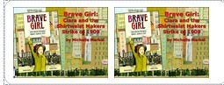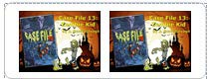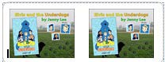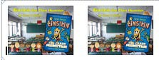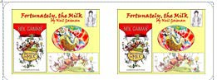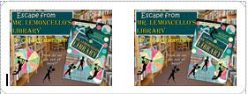LYRC Stamps and Passports: Erikka McBride, librarian at Robinson Elementary, created LYRC passports, then created passport stamps for each LYRC books using Avery labels. As students read and tested, they received LYRC stamps for their “passports” to determine if they read enough books. The stamps were wildly popular. The librarian challenged her students and teachers to collect as many stamps as possible. She used 2 stamps per label, full sheets of each label (Avery Label size 5160). When students earned 5 stamps, they earned a trip to the treasure chest.
2

  - 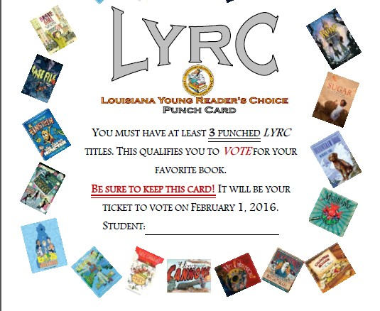Punch Cards: Valente Lawson-Hollis, at Shady Grove Elementary, used Punch Cards this year. She created the punch cards 6 per page, printed, and distributed to the students. She found a Fleur de Lis hole puncher at a local craft store to ensure the validity of the punch. When her students tested successfully on a LYRC book, she punched their punch card.

  - One librarian read a minimum of three books to each class and made a note of the students who were absent that day. Those who were absent were required to read a book on their own to make up for the one that they missed.

  - 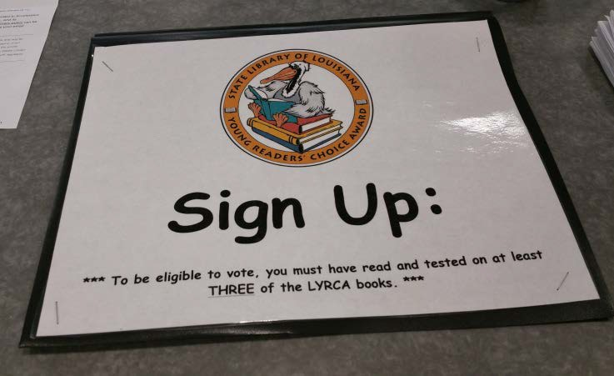One librarian created a spreadsheet that contained student names and the title of each LYRC book. When the student passed an AR test for a particular book, she put a checkmark to indicate this. She also double checked my results by pulling up their AR records. On the paper ballot, she highlighted each book that the student had read.

Tracey Woodhead, Sterlington Elementary

Sustainability: Activities librarians used to continue to promote LYRC after initial program launch.
  - Some librarians used a different lesson activity from the lessons, websites, and author links available on the LYRC website.

  - For every 100 achieved on a LYRC title, I would ring my desk bell and yell the student's name and call them a bookworm. (i.e., "John is a bookworm!") They would then receive a gummi worm for this accomplishment. In addition, for every book read and tested on over the required three books, that was a score of 100, the student received 2 extra gummi worms (one for reading an additional title and one for scoring a 100). (Valente Lawson-Hollis, Shady Grove Elementary)

  - One librarian randomly checks the AR logs to reward students who had read the most LYRC books that week or who had read a LYRC chapter book that week.

  - One librarian kept a binder arranged by grade and teacher. Students were listed alphabetically on their teacher’s page. The titles of the LYRC books were listed across the top the page in columns. Using an honor system, students were responsible for checking off the titles they read.

  - Some librarians have pizza or popcorn parties for the students who were eligible to vote after voting has been completed.

  - Winner Reveal: Some librarians schedule a winner “reveal” to announce the school winners and compare to parish and state winners.

The Biggest Stumbling Blocks:
  - Not having enough copies of the LYRC books.
    - Some librarians have asked for additional funds for books from the PTO, from Title I, or from the principal.

    - Some librarians hold fundraisers each year in order to have their own discretionary money for additional copies of books.

    - Some librarians write mini-grants (such as Junior League mini-grants) to purchase additional copies.

  - Need for Increased Teacher Support
    - You may have to start small to generate teacher support.
    - Some librarians generate teacher support by encouraging the teachers to read AND vote for their favorite LYRC books. (Teachers are allowed to vote.) They have even announced the favorite “teacher” winners.

    - Some use a digital camera to photograph classroom teachers with their favorite LYRC books, then, post the photos in the library. (The bigger the photo, the better.)

    - One librarian created a google doc that encouraged brief teacher feedback.

Dr. Suess’ Birthday: Read Across America
This year, with Dr. Seuss week, I did lots of baking!!!! In a larger school, librarians could ask for teacher assistance with baking a couple of dozen cupcakes. :)

- K-1st grade: We read One Fish, Two Fish, Red Fish, Blue Fish. I made blue Jello. Each child was given a red Swedish fish to place on top of their blue Jello. YUM!

- 2nd Grade: Justin Bieber (YouTube) read The Cat in the Hat to the students. Then we used Oreos as the base of our hat and placed cut up strawberries and cut up bananas as our hat. (For those who did not like bananas, they used cut up large marshmallows).

- 3rd Grade: Tim Tebow (YouTube) read Green Eggs and Ham to the students. I gave each table of four students, two bowls of white icing which they stirred in food coloring to turn green. After icing their cupcakes green, we placed a mini vanilla wafer as our yolk. Green egg cupcakes!

- 4th and 5th Grades: We watched the 1972 version of The Lorax on YouTube. Then we used cupcakes, green icing (grass), pretty paper straws (tree trunk), cotton candy (tree top) to make our truffula trees!

- Kids love making edible crafts. HUGE hit! (from Stephanie Judd, Boley Elementary)

Dr. Seuss Week--PTO came to read to each class during library time so we had a week of Dr. Seuss
fun. They also provided Cat in the Hat shaped cookies for each class. (From Amelia Brister, Calhoun Elementary)

Dr. Seuss Week--We celebrate Dr. Seuss schoolwide all week the first week in March. During Dr. Seuss week I coordinate activities with the classroom teachers. I do a Dr. Seuss storytime in the library and Cat in the Hat games on pbskids.org in the computer lab. Our students have dress up days. We do simple things like Wacky Wednesday where you wear clothes inside out, Silly Socks Day, etc. The students eat green eggs and ham for breakfast in the school cafeteria. They do art activities in the classroom and display their work in the halls. It is a fun week for our PreK and K students! (Annette Little, Crosley Elementary)

Seuss-ify Yourself Sample Flyer, Pinecrest Elementary School
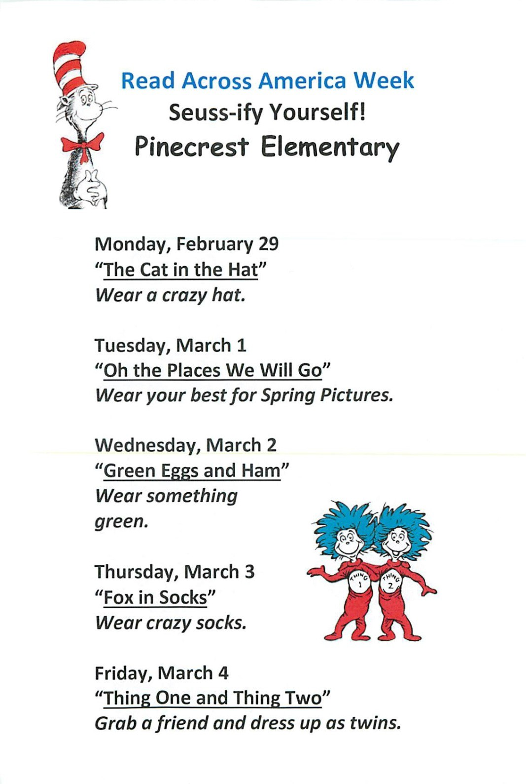

From Stephanie Robinson, Pinecrest ElementaryNEA Read Across America Activities http://www.seussville.com/Educators/educatorReadAcrossAmerica.php

Children’s Book Week & Teen Read Week

Children’s Book Week is the week elementary schools celebrate children’s books. It was originally celebrated the week before Thanksgiving, but the Children’s Book Council moved the date to April several years ago. This has been unfortunate for school libraries because this week is during testing, which has caused the celebration to almost disappear in elementary school libraries. To remedy this, Ouachita Parish has moved Children’s Book Week to the second or third week in October, which is the same week we celebrate Teen Read Week. Because it is an arbitrary date, we have given school librarians discretion to meet the needs of their particular school to avoid conflicts.

Book Week and Teen Read Week Suggestions and Activities
Bookmark Contest: Using a blank bookmark template, students design a bookmark about reading or about their favorite book. We had a panel of judges come to select 1st, 2nd, and 3rd place ribbon prizes. I liked to use a different activity per grade level. It made judging easier and the students had to “graduate” to the more complicated projects.

Book Character Day (or Storybook Day): Students come to school dressed as their favorite book character. Prizes may be given for best costume, most original, etc.

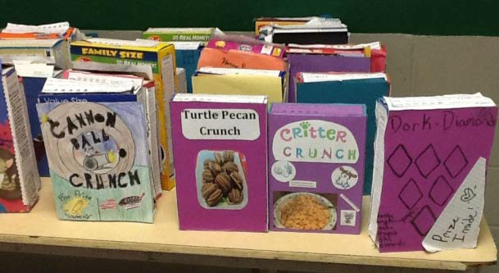Cereal Box Books: Students must select a teacher- approved fiction book from the school, parish, or home library. Students will read their self-selected book and create a cereal box book report at home. Students will decorate a real cereal box with illustrations and information related to the book they read using the directions on attached sheets.

Dioramas: Students used shoe boxes to create a scene
from their favorite book. They added the title and author on the top of the box.
(Jan McGee, Mitchell Elementary)

Door Decorating Contest: Teachers and students decorate classroom doors with a reading theme.

Potato Characters: Decorate a potato as your favorite book character. I turned it into a contest and had school sponsors come and judge. Potatoes were displayed in the hallway. The kids loved it. The school sponsors donated prizes for the honorable mentions and the library provided Wal-Mart gift certificates of $10, $15, and $20 for 1st, 2nd, and 3rd place. (Amelia Brister, Calhoun Elementary)
Egg-Citing Characters: Decorate an egg as a favorite book character. (I taught the students how to blow to yolk from the eggs using a straw when I introduced the activity.) We had classroom and grade level winners with prize ribbons. (Jan McGee, Mitchell Elementary)

Pumpkin People: The students decorate a pumpkin as a favorite book character. Classroom and grade level winners with prize ribbons. (Alicia Minter, Central Elementary)
Save the Ugly Books: Students select and read a book that has lost its original dust jacket. They design an original new dust jacket, including a short summary for the inside jacket (without revealing the ending), and a short review (their own) for the back flap. I always pulled books ahead of time so that the books being covered were “worthwhile.” I also measured and cut white paper to fit around the

book like a book jacket. When students completed the project, we had judges come in to award 1st, 2nd, and 3rd prize ribbons. Afterwards, I added a spine label and barcode before covering the new dust jackets with mylar jackets. You would not believe the pride those students took in showing off their projects. They came in for years to find the “special” book they had “saved.” (Jan McGee, Mitchell/Elementary)
3 Cheers for Books!: Cheerleaders from one of the high schools were invited to come during Book Week. Instead of football cheers, the cheerleaders wrote book cheers to perform for the student body. This has been a wildly popular event. (Amelia Brister, Calhoun Elementary)

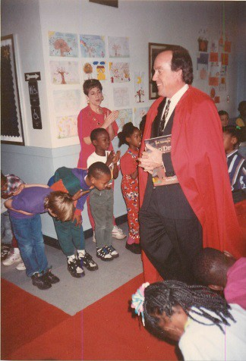Royal Reader: We always celebrated Book Week with visits from the Royal
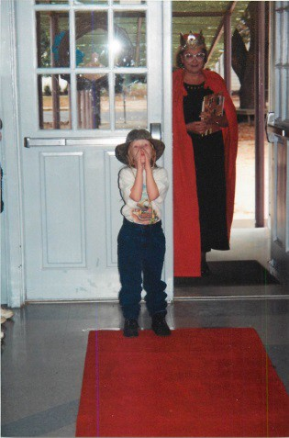Reader. The Royal Reader visit is done with a lot of pageantry and ceremony to make it special. We usually did this by grade level. We invited a different member of the community each day to serve as the Royal Reader during Book Week. I made a red cape for the R.R. to wear. We also purchased a “pageant” crown. Someone donated a section of red carpet that we taped down from the front door of the school all the way to the library and we used a recording of “Pomp and Circumstance” to play when the Reader entered. The Reader always carries books instead of a scepter. The students line up
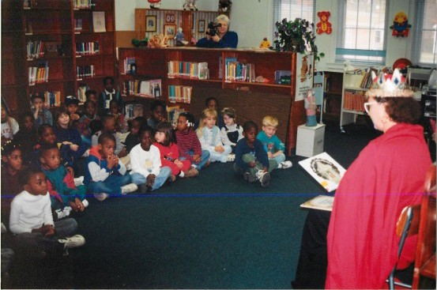down both sides of the red carpet. The Reader waits outside to be announced by a student (usually one who has performed well in earning AR points). A second student walks behind and carries the train of the cape. The announcer cries, “Make Way for the Royal Reader!” The music starts, the Reader enters, the students bow, and as the Reader passes the students, they stand and applaud. The students continue to clap until the Reader is seated in the library. Then, the students file into the library, and sit on the floor around
the Reader for a story. We have used the mayor, the school superintendent, school board members, the school principal, etc. I don’t tell them in advance about the crown and robe, but everyone is always willing to come back after they receive such a royal welcome! The children loved it! (Jan McGee, Mitchell Elementary)


Storybook Pumpkins

Dear Parents,

Ouachita Parish Schools will celebrate Children’s Book Week on October 19th – 23rd , Sterlington Elementary will celebrate by sponsoring a Storybook Pumpkin Contest for 3rd-5th grade students who would like to enter. At home, students decorate a pumpkin as their favorite book character, and bring the decorated pumpkin to the library on Wednesday, October 19th. The pumpkins will be on display for judging from Wednesday, October 21st until Friday, October 23rd from 8:00 a.m.-2:45 p.m. Winners will be announced on Friday, October 23rd.

Literary Pumpkin Contest Rules

- The theme of the pumpkin decorating is “My Favorite Storybook Character.”
- Pumpkins may be painted, drawn or colored with magic markers, but NOT carved. Acrylic paints or permanent markers work best. Watercolors tend to run. Yarn, pipe cleaners, fabric scraps, cardboard, glitter, construction paper, etc. may be used to decorate the pumpkin. Paste or glue may also be used.
- CARVED pumpkins will NOT be accepted.
- There may be only ONE (1) entry per student.
- Each entry should be clearly identified with an attached card including the following information:
Side 1 – student’s name, grade, and class.

Side 2 – storybook character, book from which the character is found or the actual book can be brought to sit beside the pumpkin.
- Entries are due on Monday, October 19. Please bring them to the library. Prizes will be awarded for 1st, 2nd, and 3rd place. Criteria will be originality, creativity, and relevance to the book, and the decisions of the judges are final.
- There will be a Certificate of Participation awarded to each student.
- Pumpkins may be picked up between October 26th- October 30th. Pumpkins not picked up by the above dates will be discarded.
- Participation is totally voluntary and should be done on the student’s own time.

It will be exciting to see what literary characters the creative boys and girls of Sterlington Elementary School will create. Please feel free to call me if you have any questions. Thank you for supporting your child in this project.
Sincerely,
Tracey Woodhead Librarian

Reading Incentive Programs

Reading Incentive Programs differ from “Book Week” Programs in that they usually cover a more extended period of time—often throughout the year. Reading incentive programs may be a component of the Accelerated Reader program or vice versa. Below are some examples of Reading Incentive Programs used by Tracey Woodhead at Sterlington Elementary School.

- 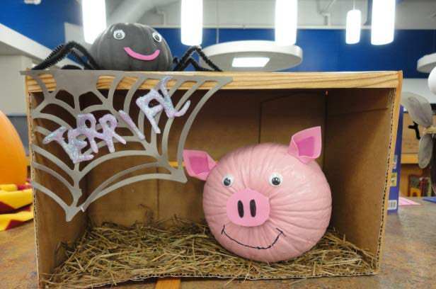Children's Book Week-During that week, we have a Storybook Character Pumpkin Contest. (see attached).

- 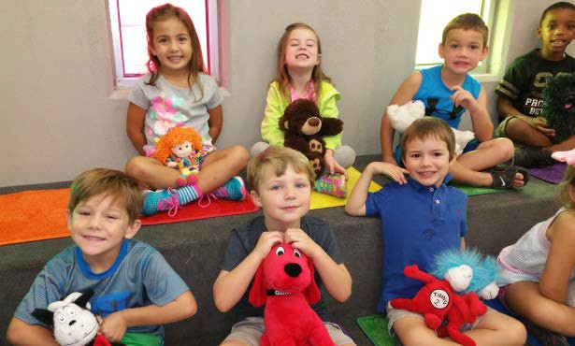Reading Buddies- Pre-K and kindergarten classes have reading buddies to sit and listen to stories with when then come to the library story center. (see attached)

- AR parties-Each six weeks, students are awarded for meeting their individual AR goal with AR Parties. The parties are usually planned to go along with the school year's theme. At the end of the year, students that have met their goal each six weeks get to go on a field trip. This year we will be going to Louisiana Tech Lambright Center. (see this year's AR incentive plan)

- 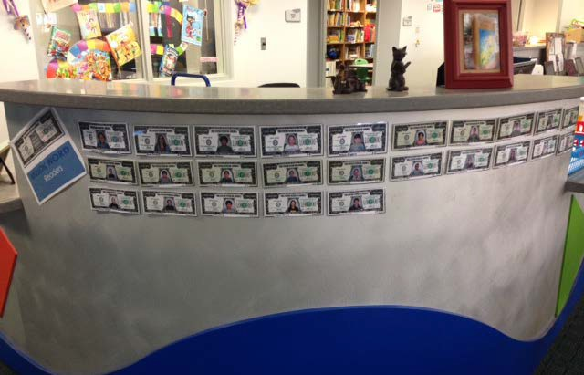Million Word Reader Club-Students who read a million or more words during a school year get their picture taken in a million dollar bill and then hung in the library, get a million dollar pencil, a certificate, and a trip to Eskamoes at the end of the year. Also their name is announced during afternoon announcements the day they reach a million words (see attached letter to parents).


Dear Parents of Million Word Readers,

The Million Word Readers for this school year will be walking to Eskamoes this Friday, April 24th, around 12:45 to be rewarded for all of their amazing reading. There are 32 children in the whole school that were able to do this! We are super proud of these students! Eskamoes will be giving the students a tour of the restaurant. Also, we’d like to reward them with a free scoop of ice cream with a topping of their choice for all of their hard work. Please sign and return this slip below by April 23rd. Thanks for all you do and for encouraging your child to read!
Tracey Woodhead, Librarian

My child, , has permission to walk to Eskamoes with Mrs. Woodhead and Mrs. Bowlin on Friday, April 24th.

- Grandparents' Book Fair Week-Grandparents come and eat with their grandchildren that week and visit their classes and book fair.

- 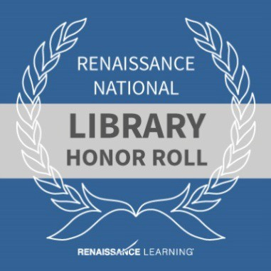AR Point Clubs-Students that reach 50, 75, 100, and 200 points get on the AR point Club bulletin board in the main hallway in school.

- Empowered Educator Program-Classrooms that meet the criteria for National Honor Roll with the Renaissance Learning Program receive banners to hang by their room and the school receives a giant sized flag to hang in library when the criteria has been met for school level National Honor Roll. Also the classroom gets their name announced during afternoon announcements when they reach national honor roll status.

- Library Soda Shop and Album Covers: (Lisa Hightower, Riser Middle School). Mrs. Hightower held a Soda Shop in the library for the teacher with the most AR points. The students were to pick their favorite book and create an album cover describing the book. The students were required to have the following information on their album covers: Title and Author, an image related to text, a list of at least five songs and singers that would go with the story, a quote from the book that captures the feel of the story.
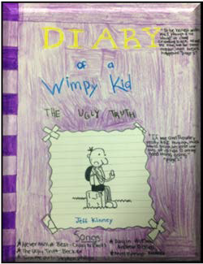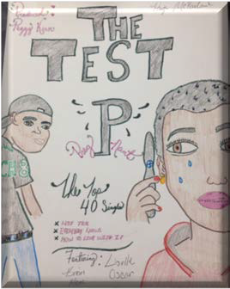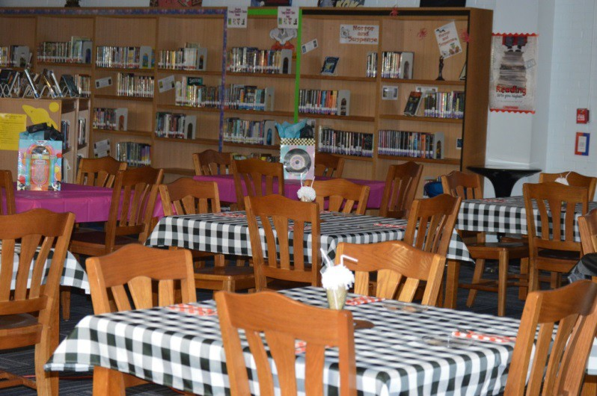

- Collection Building with Birthday Book Clubs
Honor your child’s birthday by sponsoring a new book for the school library. See sample form from Woodlawn Elementary Library, compliments of Sherry Carver.


You can honor your child’s birthday by sponsoring a new book for Woodland’s Library.

For a donation of $20 (covers the cost of the book, accompanying AR quiz if available, and all processing costs) your child will receive the following when his or her birthday arrives:
  - Your child will get to select a book from our Birthday Batch of new picture books, chapter books, and nonfiction books
  - A bookplate will be placed in the book

  - Your child will have his or her picture taken with the new book and the picture will be placed on the Birthday Board
  - Your child will receive a birthday card & bookmark

  - Your child will be the first one to check out the book and when the book is returned it will be placed into circulation for all to enjoy
Birthday Book Club orders will be sent in 2 times this year; once in September and once in January.
Would you like to honor a teacher, student, or other family member by donating a book for another special occasion? Contact Mrs. Crutchfield for more information.

Woodland Elementary Birthday Book Club
Yes, I would like to donate a book to Woodland’s library in honor of my child’s birthday. A $20 donation is enclosed (checks should be made payable to Woodland Elementary School.)

Child’s Name Birthday

Donated By Teacher’s Name
Thank you!!

September order recognizes birthdays from August 1 - January 31 Order forms due to the Media Center by September 30
January order recognizes birthdays from February 1 - July 31 Order forms due to the Media Center by January 31

Cereal Box Book Report

Students must select a teacher-approved fiction book from the school, parish, or home library. Student will read their self-selected book and create a cereal box book report at home. Students will decorate a real cereal box with illustrations and information related to the book they read using the directions below.

Front of Box (16 pts.): Us a piece of white or colored paper to cover the front of your cereal box. (You will probably want to create the cover before gluing it onto your ox.” Include the name of the cereal and a picture. Invent a name for the cereal that is related to the title of the book and sounds like a cereal. Do not use the exact title of the book. Choose a shape for the cereal as well as colors and ingredients that all relate to the book. For example, for Harry Potter and the Sorcerer’s Stone, you might invent a cereal called “Wizard Wands,” a toasted oat cereal in the shape of miniature lightning wands.

Right Side (16 pts.): Make a list of ingredients that include the story elements Characters and Setting. Under the heading “Ingredients,” list the main characters and write a sentence about each one. You can use the template on the attached sheet or cover the side with paper and do it your own way. Just make sure you include the main characters and the setting.

Left Side (16 pts.): Write a summary that includes the main problem and solution of the book. Try to use words that will “grab” readers’ attention and make them want to buy your cereal. You can use the attached template or do this your own way.

Back of Box (16 pts.): Design a game that is based on the story. It can be a puzzle, a word search, a word scramble, a maze, a crossword puzzle, a hidden pictures illustrations, or any other fun activity that might be found on the back of the cereal box. Make sure that it includes information from the book.

Top of Box (16 pts.): Include the title, author, number of pages, and number of stars you would give this book if you were a book critic. The maximum number of stars would be 5. You can use the template or create the top of the box yourself as long as you include the things listed above.

Prize (16 pts.): Cereal boxes often include a prize. Your prize must be something the main character could have used in the book or something that reminds you of the main character. You can even include a picture of the prize on the front of your box to let the reader know what is inside the box.

CEREAL BOX BOOK REPORTS ARE DUE AT SCHOOL ON:

***You will find all templates for this project attached to this sheet. If students need any glue, scissors, markers, or colored paper from school, they are more than welcome to borrow upon request.
Thank you,

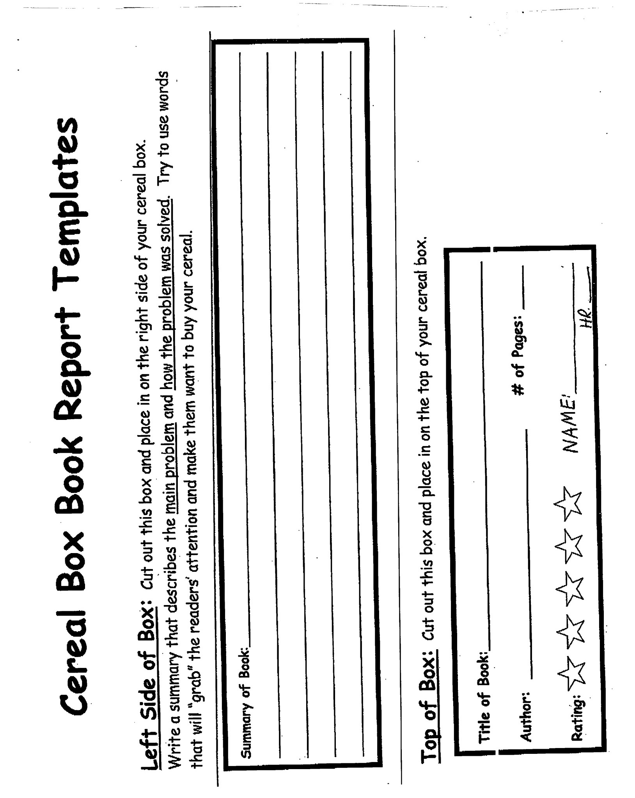

Ingredients
Characters:

Setting

Right Side of Box
Cut out this box and place it on the right side of your cereal box.

Characters:
List the main characters and write a sentence about each one. For example, if you were using the story Charlie and the Chocolate Factory, you might include the following characters:
Charlie Bucket: He is a poor boy who finds the last golden ticket and wins a trip to Willy Wonka’s Chocolate Factory.

Willy Wonka: He is the lively owner of the chocolate factory who allows six children and a member of their family to spend a day at his magical factory.

Setting:
Use complete sentences to tell where the story takes place. You may find that there is more than one setting in the story. For example, if you were using the story Charlie and the Chocolate Factory, you might write:

The beginning of the story takes place in Charlie Bucket’s very small house that he shares with his large family. Once Charlie finds the golden ticket and wins the contest, the rest of the story takes place in Willy
Wonka’s amazing chocolate factory.
e 20
Section 12, pag

Plays, Skits, or Programs

100 Free Scripts Based on Children’s Books (free download): https://www.dramanotebook.com/plays-for-kids/scripts-based-on-childrens-books/

Readers’ Theater Scripts and Plays by Aaron Shepard
http://www.teachingheart.net/readerstheater.htm

Three Piggy Opera Mini Musical (paperback and CD): $17.95
There are many other plays in this series. I used this play with 2nd grade students and we performed for the entire school during Book Week.
https://www.musicmotion.com/Musicals-Creative-Dramatics/mini-musical-three-piggy-opera- paperback-cd.asp

Year-Round and Seasonal Elementary Library Songs
If You Want to Hear a Story
(To the tune of "If You're Happy And You Know It")

If you want to hear a story, take a seat. If you want to hear a story, take a seat.
If you want to hear a story, check your hands and check your feet.
If you want to hear a story, take a seat.

If you want to hear a story, clap your hands. If you want to hear a story, clap your hands.
If you want to hear a story, Yes a really good story,
If you want to hear a story, clap your hands.

If you're eyes and ears are open we can start (clap clap) If you're finger's to your lips then we can start (clap clap) If you're hands are in your lap, then the story can begin If you're eyes and ears are open we can start. (clap clap)

The Library’s Like a Candy Store
(To the tune of "Row, Row, Row Your Boat")

The library's like a candy store, Only for your brain,
You can find most anything; It’s almost like a game.

Getting our Wiggles Out.
(Pre-Storytime Chant)

I wiggle my fingers, I wiggle my toes,
I wiggle my shoulders I wiggle my nose.
I get all the wiggles out of me.
I open my eyes so I can see the story. I open my ears so I can hear the story.
And I zip my lip so I can be a good listener.

"I Borrow my Books"
(Song before checking out books)
(To the tune of “My Bonnie Lies Over the Ocean”)

I borrow my books from the library.
I borrow my books for a week.
I borrow my books and I'll read them. And I'll bring my books back next week.
Bring Back, Bring Back. I'll bring back my library books next week, Bring Back, Bring Back. I'll bring back my library books next week.

Hands Go Up
(To the tune of “Twinkle, Twinkle Little Star”)

"Hands go up and Hands go down.
I can turn around and round. I can jump upon two shoes.
I can listen so can you
I can sit I'll show you how. Story time is starting now."

Going to the Library (Chant) http://www.songsforteaching.com/tomchapin/librarysong.htm

I'm going down to the library Picking out a book
Check it in, check it out.

Gonna say “hi” to the dictionary.
Picking out a book, Check it in, check it out.

Pre-Storytime Song
(To the tune of "She'll Be Comin' Round the Mountain")

If you're ready for a story find a seat (clap clap clap) If you're ready for a story find a seat (clap clap clap) If you're ready for a story, open eyes and open ears If you're ready for a story find a seat.

If Your Book is Your Friend
(To the tune of “If You're Happy And You Know It”)

If your book is your friend, give it a hug If your book is your friend, give it a hug
If your book is your friend, you can read it to the end If your book is your friend, give it a hug.

Pre-Storytime Chant

I wiggle my fingers, I wiggle my toes,
I wiggle my shoulders, I wiggle my nose.
Now the wiggles are all out of me, And I am as still as I can be.

We’re Going to the Library
(To the tune of “Do you know the Muffin Man”)

We're going to the library, the library, the library We're going to the library to listen to a story.

We're going to the library, the library, the library We're going to the library to check out books today.

Read a Book
(To the tune of “If You’re Happy and You Know It”)

If you have some extra time, read a book. (READ A BOOK) If you don't know what to do, read a book. (READ A BOOK) Many places you will go,
Many people you will meet,
If you have some extra time, read a book. (READ A BOOK)

(The kids sing the READ A BOOK chorus. Can also alternate with boys and girls singing alternate parts)

Noisy Nora
(To the tune of “Frere Jacques”)

Noisy Nora Noisy Nora Why so loud Why so loud
Some of us are thinking Some of us are reading Quiet down....
Quiet down....

Hi-Ho Librari-O (Author/Illustrator song by Judy Freeman) (To the tune of “The Farmer in the Dell”)

The author writes the words, The author writes the words, Hi-Ho Librari-O,
The author writes the words.

The illustrator draws The illustrator draws Hi-Ho, Librari-O
The illustrator draws.

The publisher makes the book. The publisher makes the book.
HI HO Librari-o, the publisher makes the book.

The copyright tells us when. The copyright tells us when.
HI HO Librari-o, the copyright tells us when.

Read, Read, Read
(To “Row Row Row Your Boat” by Jan McGee)

Read, read, read your books, Read one every day.
Reading and learning and also enjoying A helping every day.

Tramp, Tramp, Tramp
(To “Tramp, Tramp, Tramp,” a.k.a. “Jesus Loves the Little Children” by Jan McGee)

Tramp, tramp, tramp, the books are marching From the school into your homes,
And beneath the starry skies They will have to televise,
That the boys and girls of (Your school name) Read at home.

Tramp, tramp, tramp, the kids are reading.
Accelerated Readers all are we.
As we total all our points, Knowledge, wisdom shall anoint. Love of reading will stay with us All our lives.

Jingle Books
(To “Jingle Bells” by Jan McGee)

Reading through our books Before we take our tests In a special little nook
We know we’ll do our best. Oh, the points, we’ve earned, Make our spirits bright.
What fun to choose a prize we’ve earned For getting questions right.
Chorus:
Oh! Jingle books, jingle books, reading every day.
Oh, what fun to earn our points By reading every day.

Oh! Jingle books, jingle books, reading every day.
Oh, what fun to earn our points By reading every day.

If You Want to Read Non-Fiction
(To the tune of “She’ll Be Comin’ Round the Mountain”)

If you want to read non-fiction,
look this way! (Point to the non-fiction section)
If you want to read non-fiction, look this way!
If you need some information, turn your head to this location.
If you want to read non-fiction, look this way!

If you want to read a story, look this way!(Point to the fiction section)
If you want to read a story, look this way!
If you want a work of fiction, turn your head to this location.
If you want to read a story, look this way!
(Adapted fromhttp://northside.woodfordschools.org/Media_Center/library_songs.htm.)

*Toni Buzzeo wrote a book earlier this year called The Library Doors. The curriculum guide is on her website. http://www.tonibuzzeo.com/librarydoorscurriculumguide.pdf

* There is a complete storytellers’ handbook available on the LMNET wiki: http://lmnet.wikispaces.com/file/view/storytimehandbook.pdf

Pumpkin Carols

Pumpkin Wonderland

(To “Winter Wonderland”) Screech owls hoot, are you listening?
'Neath the moon, all is glist'ning,
A real scary sight, we're happy tonight, Waitin' in a Pumpkin Wonderland.

Witches fly, on their broomsticks, Ghosts glide, aren't they mystic?
A frightful delight, we know we're alright, Waitin' in a Pumpkin Wonderland.

In the patch, we're waitin' for Great Pumpkin, We've been waiting for this night all year. This year we will prove to the great pumpkin We can grow a pumpkin patch that is sincere.

Later on, while we're eating What we got trick-or-treating, We'll share all our sacks,
And chew on our snacks, Waitin' in a Pumpkin Wonderland.

I'm Dreaming of the Great Pumpkin
(To “White Christmas”)

I'm dreaming of the Great pumpkin, Just like I do this time each year.
When he brings nice toys To good girls and boys
Who wait for him to appear.

I'm dreaming of the Great Pumpkin, With every pumpkin card I write, May your Jack-o-lanterns burn bright
When the Great Pumpkin visits you tonight.

Great Pumpkin Is Coming To Town
(To“Santa Clausis Coming toTown”)

Oh,youbetter notshriek, You better not moan, You better not howl, You better not groan,
The Great Pumpkinis coming totown.

He'sgoing tofindout Fromfolksthathemeets, Whodeserves tricks
Andwho deservestreats,
The Great Pumpkinis coming totown.

He'll searchin every pumpkin patch Haunted houses farand near,
Tosee ifyou'vebeen spreading gloom Or bringing lots of cheer.

Oh,youbetter notshriek, You better not moan, You better not howl, You better not groan,
The Great Pumpkinis coming totown.

Pumpkin Carols Usedwith the play, “Looking for G.P.”—a play about books andreading by Jan McGee
—adapted from It’s the Great Pumpkin,Charlie Brown! By Charles M. Shulz. See Jan McGeeforcopyofscript.)

Schulz, Charles M. It's the Great Pumpkin, Charlie Brown. Lincolnwood, IL: Publications International, 2011. Print.
Schulz, Charles M. The Peanuts Book of Pumpkin Carols. Place of Publication Not Identified: Hallmark, 1966. Print.

Section 13:

Self-Evaluation & Compass Evaluation
Self-Evaluation First Impression
Work It, Baby! Creating a Fierce Library Work It, Baby! Promotion Strategies Suggested Titles for Themed Displays Bibliography and Suggested Reading Resources for Your Virtual Library
Plan of Action for Library Promotion COMPASS Evaluation
COMPASS: School Librarian Rubric / Scoring Guide COMPASS Observation Instrument
COMPASS Evaluation Analysis: Links to Information & Examples of Evidence & Artifacts
COMPASS Evaluation with Examples, Competency by Competency
Teaching and Learning Tools for OPSB Subscription- Based Databases
Preconference Interview for Administdrators, Suggested Questions & Topics

Self-Evaluation
“To be prepared for an external evaluation, practice with a mirror.”



Coombs, Samantha, BSc. Self-Reflection. London. Web. 25 Aug. 2015.
<https://media.licdn.com/mpr/mpr/shrinknp_1000_1000/AAEAAQAAAAAAAARWAAAAJDFmNGNhZGMxLWI2ZTctNG MzZS1hNTQ0LTkxOWE1N2JhYTAxOA.jpg>.

First Impression
Enter your library as if you were a new student walking into your library for the first time. What is your first impression? Circle appropriate suggested answers and then briefly describe your specific library. FYEO! (For Your Eyes Only)

- What is the ambianceof your library? Is it warm and inviting?
Dark and Gloomy?
Cold and sterile?
Cluttered and neglected?

- What do people see in the first ten feet upon entering your library?

- Approachability to library staff –
Friendly and welcoming? Helpful and encouraging? Stern and curt?
Crabby and short-tempered (but not just at 2:00 on Friday afternoon)?

- Describeyour library’s signage. Neat and attractive?
Sloppy and tattered?
Old and dated?

- Displays –
Fresh and current? Old and dusty?
Nonexistent?

- Bookshelves –
Attractive and enticing to your readers? Room on shelves to highlight books?
Shelves packed with out-of-date books?
Ragged and torn spinelabels and book covers?

- Reading Promotion –
Books availablein different formats, such as print, ebooks, Playaways, etc.? “Good Reads” spotlighted throughout library?
Current reading programs/events advertised, such as book clubs, LA Young Readers’ Choice? Nothing visiblebut shelves and shelves of book spines?

- Visiblestoragecabinets and shelves –
Cabinet doors closed and open shelves neat and tidy? Storage areas overloaded with papers and stuff?

- Work surfaces, such as circulation desk, librarian’s desk – Organized and uncluttered?
Messy and in disarray?

- Library’s web site –
A dynamic web presence?
Just a web page with your name and hours? Web site? Why is that needed?




Work It, Baby!
Create a Fierce Library!!

Presented by Annie Miers, LMS and Elizabeth P. Dumas, LMS

Link to Presentation:
https://www.dropbox.com/s/5rq99p62a8l5tt0/Work%20It%2C%20Baby%20presentation_edited.ppt?dl=0



Work It, Baby! Create a Fierce Library
Promotion strategies to help you take your library to the next level
Annie Miers, LMS
miers@opsb.net
Elizabeth P. Dumas, LMS dumas@opsb.net
Riser Middle School, West Monroe, LA
Good Hope Middle School, West Monroe, LA
Ouachita Parish School System

Marketing brings buyers and sellers together. In a library the patrons become “buyers”and the library “sells”oroffers services
4 Ps of Marketing
Product Price Place
Promotion
Merchandising is related to marketing, especially promotion

Know Your Customers – 1st key element in yourmarketing equation

Know Your Library Collection – Providing students with what they want – 2nd key element in marketing

Bottom line – It will be much easierto attract tweens and teens to yourlibrary if they see more items in the collection that they have requested and that reflect theirlives.

Collection Maintenance
Clean, repair, orreplace fixtures as needed. Avoid clutter!
Look with a critical eye – Ask an outsiderto critique the library’s appearance. Weed!

Merchandising Your Collection
Merchandising in the library – the distribution orplacement of items in yourlibrary that makes the patrons more aware of yourcollection, with the ultimate goal of enticing patrons to borrow those materials.

Goal of Merchandising Your Library: Allow patrons to see items they might not be familiarwith and to check out items on impulse. Successfulmerchandising efforts allow browsers to choose something in addition to what they originally set out to find.

Visual Merchandising in Libraries
Face Front Shelving Thematicdisplays
Mix fiction and nonfiction Featured Collections

Shelving by Genre - Shelve genres togetherorplace genre stickers on spines.

Techniques of Display
P.O.P.–point of purchase
Cross-merchandising/cross-promoting Book Bundles

Getting started
Keep a calendarlisting of all displays. Plan ahead.
Develop an idea/resource file of display ideas. Create a preliminary sketch of display if needed. Take photograph of all displays.
How long should adisplay remain? Booklists

Components of Display
Color - single most important element in drawing attention to yourdisplay Lighting – very important, display must be well lit to draw attention
Signage – Signage and illustration can enhance adisplay and make it more memorable and attractive. Signs should look professional, not sloppy.

Display Locations
Transition zone – first 10 feet inside entrance Drift to the right

Location
Shelf tops, tables, windowsills, even floors, any flat surface visible to patrons is a good spot fora display.
Ends of aisles – "Prime Real Estate" Ceiling
No bulletin board? Use sturdy easel

Props, Fabric, Boxes for lifts to create tablescape

Promoting Your Library and Its Resources – Friendly staff ! “Did you find what you were looking for?”
“Would you like fries with that?” “Ask Me” badges

Friendly, Fun Events in the Library
School sponsored events
State programs – LYRC, LTRC National programs
Children’s Book Week Teen Read Week Teen Tech Week

Branding Your Library
The Unquiet Librarian – Buffy Hamilton

Your Virtual Library
Library open 24/7
See the school library as a virtual as well as a physical space Links to:
Online catalog Subscription databases Reference sources Locally selected websites
eBooks/Online Interactive books

Booktrailers
Favorite Author Websites Curriculum Support
Pathfinders
Citation how-tos
Information Literacy Skills instruction

Marketing Your Virtual Library
On-Paper In-Person
Promotional Items
Virtual

Social Media
Consider district policies. You may need to be the change agent.
Facebook, Twitter, Blogs, Wikis, YouTube channel

QR Codes
Promoting books and authors using QR code technology QR Station in the Library

Your Plan of Action for Promoting the Library

Some Suggested Titles for Themed Displays
Back to School – Letters on Background to resemble scrabble Walk a mile in Someone Else’s Shoes – Biography
Choose Your Adventure Watch out for Thrillers
Freedom to Read – Banned Book Week
The Horror! – Halloween, display Science Fiction and horror books
Mom! I’m bored!!! Summer for Unplugged – 101 activities that don’t need batteries or electricity -
display craft books and good fiction
Journeys – display books with setting in a far away location, books about other countries Murder – Mannequin under table staged to indicate he was murdered – rope off area with yellow caution tape
O Zone – Oprah book club titles
Read the Movie; Books always have cool “Bonus Material” Salute to Service – Books for branches of armed services As they say… So many books… So little time.
What’s your Problem? – Bibliotherapy Kiss the Frog – Romance books
Blast off with a good book! – space theme Books Bite! – Vampire and horror books Cat in the Hat
Everything Chocolate! I Enjoy Being a Girl
Sail Away with a Good Book Gobble Up a Good Book
Books That Bite@Twilight – Stephanie Myer’s book series Catch Some Winter Reading Blues – books with blue covers “Red” Any Good Books Lately? – books with red covers
Recipe for Murder – large aluminum bowl filled with mysteries and a large wooden spoon Fall for Books – Fall theme
We’re Batty about Books – Halloween
Let’s Talk Turkey – small turkeys holding book titles ‘Tis the Season for Reading
Jolly Holidays – joke books
Put Your Heart into Reading – Valentine’s Day
Color Your World with Reading – color theme, mix colors or use books with covers all in one chosen color
Run, Don’t Walk to Your Nearest Library and Read – Use sneakers as props A Garden of Good Books
Walk Awhile in Someone Else’s Shoes – biographies, use different kinds of shoes for props Quack! Open a Book! – duck decoy as prop
Read it! Read it! – frog theme

Snow Better Time to Read – winter
Tell Us What You Love – interactive display where students can recommend a favorite book New Books @ <name of your library>
Scarf up a Good Book – wintertime, use scarves as props Season’s Readings
It’s a Mystery to Me Read up a Storm
Information is Our Bag- nonfiction books with gift bags as props Hats Off to Reading – hats as props

Bibliography and Suggested Reading

Church, Audrey. Your Library Goes Virtual. Linworth Books, 2007.

Harvey, Carl. The 21st Century Elementary Library Media Program. Linworth Publishing, 2010.

Nichols, Mary Anne. Merchandising Library Materials to Young Adults. LibrariesUnlimited, 2002.

Blogs
The Daring Librarian Blog - Gwyneth Anne Jones http://www.thedaringlibrarian.com/

The NeverEndingSearch Blog – Joyce Valenza http://blog.schoollibraryjournal.com/neverendingsearch

The Unquiet Librarian - Buffy Hamilton http://theunquietlibrarian.wordpress.com/

Other Resources
Embedded Booktalks Using QR Codes at an Elementary School http://sites.google.com/site/northernelementarylibrary/

Resources for Your Virtual Library
Free ebooks:

- Google Books - http://books.google.com/
- International Children’s Digital Library - http://en.childrenslibrary.org/
- Planet ebook - http://www.planetebook.com/
- Project Gutenberg - http://www.gutenberg.org/ebooks/

Authors’ Websites:

- Children’s and YA Book Authors and Illustrators (Cynthia Leitich Smith’s great site) – http://www.cynthialeitichsmith.com/lit_resources/authors/on_the_web/auth-illA-I.html

- Great Websites for Kids
http://www.ala.org/gwstemplate.cfm?section=greatwebsites&template=/cfapps/gws/displ aysection.cfm&sec=16

Book Trailers:

- Book Trailers for All - http://booktrailersforall.com/
- Book Trailers for Readers - http://www.booktrailersforreaders.com/


My Plan of Action for Library Promotion

- Turn books out “front-facing” with cover forward.

- P.O.P. - Point of Purchase - Place 1-2 books with “rec” sign on circulation desk.

3.

4.

5.

6.

7.

8. “Did you find everything you were looking for?” “Would you like fries with that?” ☺

2011 Annie Miers and Elizabeth P. Dumas

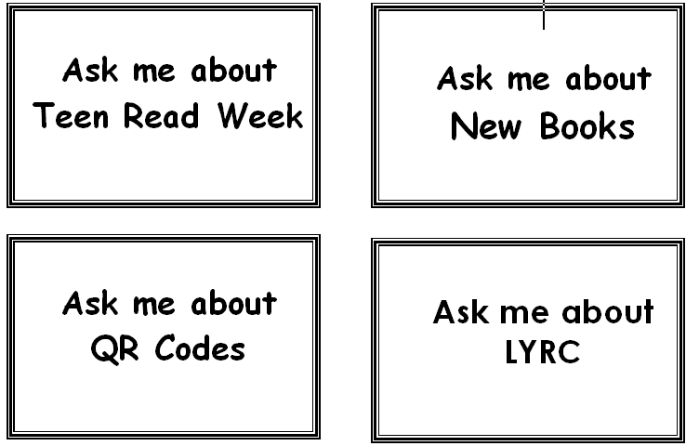

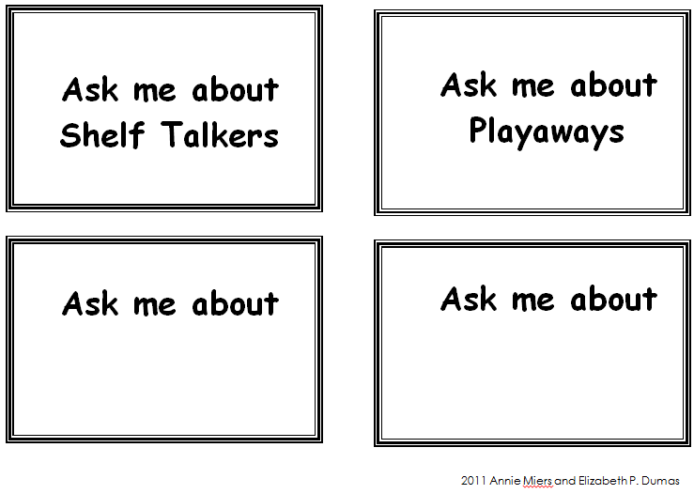

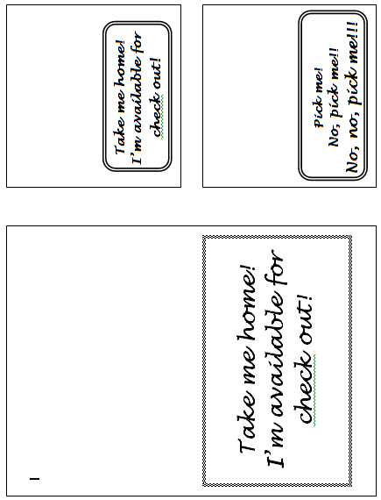

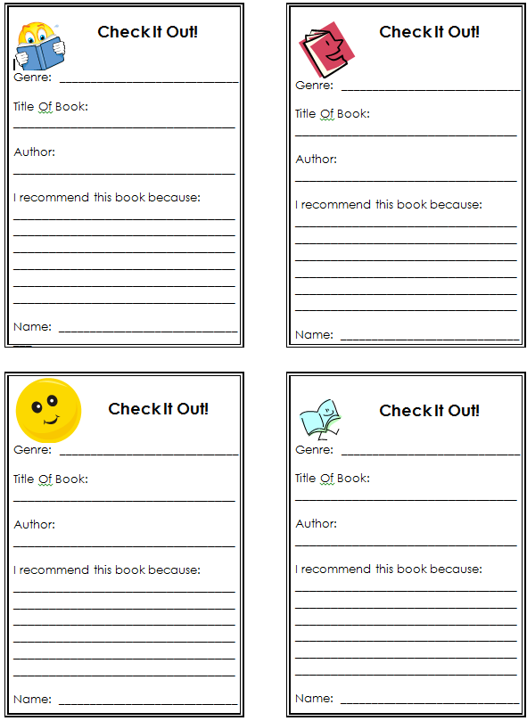

Creating a QR Station in Your Library
Section 13, page 16

How to Read QR Codes on a PC using a Webcam
You will need awebcam installed on yourcomputer. Also, check to see if you have Adobe AIRinstalled on yourcomputer. Download at http://get.adobe.com/air/5
- Go to http://www.dansl.net/blog/?p=256
Scroll down and follow steps under Howto use QRreader.

- Afterclicking on Step 2: Download, click Open on File Download screen.

- 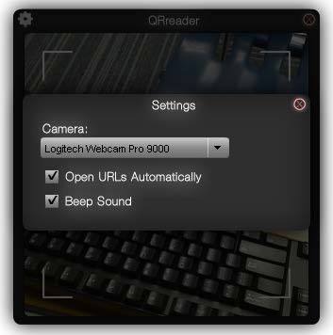After QRreader is installed, go to Desktop and open the program. Click on the “gear” icon in upper left corner to open the Settings. Under Camera make sure the correct make and model of your webcam is displayed. Check both boxes. Then click right corner to close.

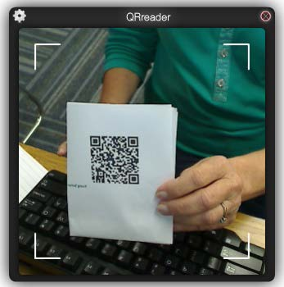You should see the QRreader window open and the webcam is on. Hold paper with QR code up to the webcam.
QRreader’s white brackets will turn red when the code is read. The web site should automatically open on your computer.

QR Codes for Your Library
Book Trailers for All at http://booktrailersforall.com/index.htm includes QRcodes forall the book trailers on this site.
Creating yourown QR codes for websites is easy. Try this easy-to-use QRcode generator– Kaywa QR Code Generator at http://qrcode.kaywa.com/

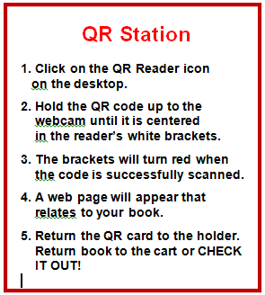

Compass
Evaluation for School Librarians

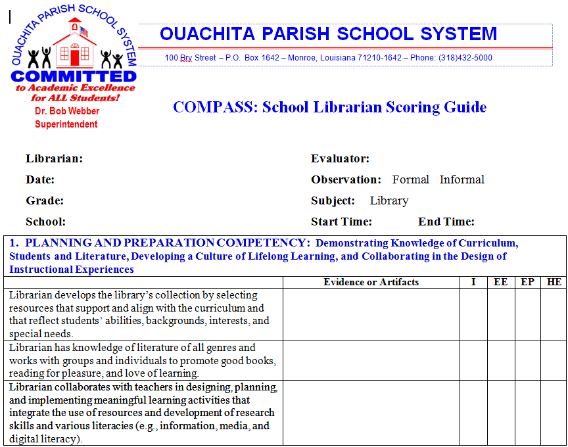

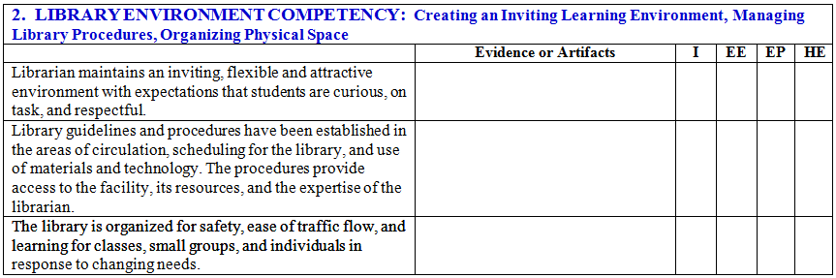

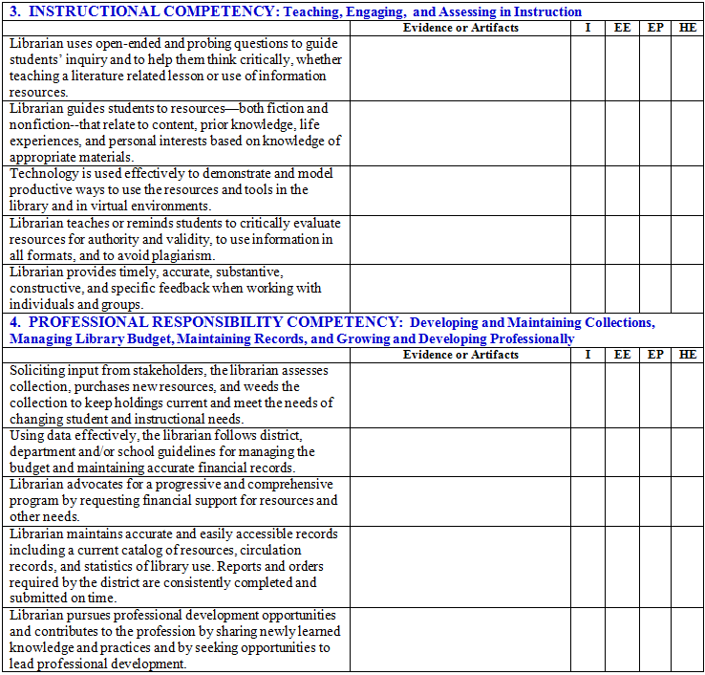

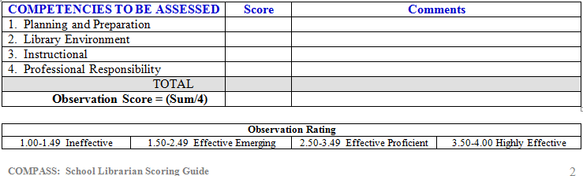

COMPASS OBSERVATION for SCHOOL LIBRARIANS in OUACHITA PARISH

OBSERVATION ANALYSIS

- PLANNING AND PREPARATION COMPETENCY:
Demonstrating Knowledge of Curriculum, Students and Literature, Developing a Culture of Lifelong Learning, and Collaborating in the Design of Instructional Experiences

Highly Effective | Effective: Proficient | Effective: Emerging | Ineffective | Specific Evidence or Artifacts
- The librarian consistently develops the library’s collection by selecting resources that support and align with the curriculum and that reflect students’ abilities, backgrounds, interests, and special needs. | - The librarian often, but not always, develops the library’s collection by selecting resources that support and align with the curriculum and that reflect students’ abilities, backgrounds, interests, and special needs. | - The librarian sometimes develops the library’s collection by selecting resources that support and align with the curriculum and that reflect students’ abilities, backgrounds, interests, and special needs. | - The librarian rarely develops the library’s collection by selecting resources that support and align with the curriculum and that reflect students’ abilities, backgrounds, interests, and special needs. | - Collection Development policy, including library mission statement, selection criteria, and policy for dealing with questioned materials  - Resource selection tools (e.g., reputable professional journals, online review sources, notable lists)  - Needs assessment based on school data  - Needs assessment based on student data  - Resources requested by teachers  - Resources requested by students  - “Consideration” folder

- Librarian has an extensive knowledge of literature of all genres and consistently works with groups and individuals to promote good books, reading for pleasure, and love of learning. | - Librarian has some knowledge of literature of all genres and often (but not always) works with groups and individuals to promote good books, reading for pleasure, and love of learning. | - Librarian has little knowledge of literature of all genres and seldom works with groups and individuals to promote good books, reading for pleasure, and love of learning. | - Librarian has very little or no knowledge of literature of all genres and rarely works with groups and individuals to promote good books, reading for pleasure, and love of learning. | - Knowledge of literature  - Reading promotion through initiatives such as:  - Author visits  - Book clubs  - Book displays  - Book talks  - Reading programs  - Recommended reading lists based on curriculum units, genres, current events, popular topics, etc.  - Collaboration with teachers to promote good books in content areas and for recreational reading  - Survey of students’ interests  - Readers’ advisory strategies  – one-on-one and whole group
- Librarian consistently collaborates with teachers in designing, planning, and implementing meaningful learning activities that integrate the use of resources and development of research skills and various literacies (e.g., information, media, and digital literacy). | - Librarian often, but not always, collaborates with teachers in designing, planning, and implementing meaningful learning activities that integrate the use of resources and development of research skills and various literacies (e.g., information, media, and digital literacy). | - Librarian sometimes collaborates with teachers in designing, planning, and implementing meaningful learning activities that integrate the use of resources and development of research skills and various literacies, (e.g., information, media, and digital literacy). | - Librarian rarely collaborates with teachers in designing, planning, and implementing meaningful learning activities that integrate the use of resources and development of research skills and various literacies, (e.g., information, media, and digital literacy). | •Collaboration with teachers  - Collaborative planning forms  - Librarian’s lesson plans  - Bibliographies of resources for learning activities  - Research model used (e.g., Louisiana Information Literacy Model, Big6)  - Demonstration and modeling of available free and subscription-based databases
1. Observation evidence, notes, comments: |  |  |  | 1. Performance Level

- LIBRARY ENVIRONMENT COMPETENCY :

Creating an Inviting Learning Environment, Managing Library Procedures, Organizing Physical Space

Highly Effective | Effective: Proficient | Effective: Emerging | Ineffective | Specific Evidence or Artifacts
- Librarian consistently maintains an inviting, flexible and attractive environment with expectations that students are curious, on task, and respectful. | - Librarian often, but not always, maintains an inviting, flexible and attractive environment with expectations that students are curious, on task, and respectful. | - Librarian sometimes maintains an inviting, flexible and attractive environment with expectations that students are curious, on task, and respectful. | - Librarian rarely maintains an inviting, flexible and attractive environment with expectations that students are curious, on task, and respectful. | - Inviting environment with displays and/or centers to attract students to books or activities  - Attractive environment free of clutter, dust, and dated materials (e.g., posters, displays)  - Flexible spaces for program needs  - Library Behavior Manage- ment plan
- Library guidelines and procedures have been established in the areas of circulation, scheduling for the library, and use of materials and technology. The procedures provide optimal access to the facility, its resources, and the expertise of the librarian, and are consistently used. | - Library guidelines and procedures have been established in the areas of circulation, scheduling for the library, and use of materials and technology. They often, but not always, function consistently resulting in some inconsistencies in access to the facility, its resources, and the expertise of the librarian. | - Library guidelines and procedures have been established in the areas of circulation, scheduling for the library, and use of materials and technology. They sometimes function consistently resulting in unreliable access to the facility, its resources, and the expertise of the librarian. | - Library guidelines and procedures are minimal and rarely provide access to the facility, its resources, and the expertise of the librarian. | - Student routine/procedures established and understood. Students know what to do, where to move.  - Circulation procedures  - Scheduling procedures  - Self-directed use  - Traffic flow  - Library calendar / schedule

- The library is very effectively organized for safety, ease of traffic flow, and optimal learning for classes, small groups, and individuals in response to changing needs. | •The library is organized for safety, ease of traffic flow, and learning with some flexibility for accommodating classes, small groups, and individuals in response to changing needs. | - The library is organized for safety and ease of traffic flow is adequate. Learning is sometimes hindered due to limited flexibility for accommodating classes, small groups, and individuals in response to changing needs. | - The library is not organized for safety and has poor traffic flow. Optimal learning is not possible because of poorly organized space that does not meet changing needs. | - Safety considerations  - Traffic flow  - Signage supporting self- directed use (e.g. major areas of the library, shelf labels, book labels, computer log in information )  - Functional spaces for classes, small groups, and individuals according to needs
2. Observation evidence, notes, comments: |  |  |  | 2. Performance Level

- INSTRUCTIONAL COMPETENCY:
Teaching, Engaging, and Assessing in Instruction

Highly Effective | Effective: Proficient | Effective: Emerging | Ineffective | Specific Evidence or Artifacts
- Librarian consistently uses open-ended and probing questions to guide students’ inquiry and to help them think critically, whether teaching a literature related lesson or use of information resources. | - Librarian often, but not always, uses open-ended and probing questions to guide students’ inquiry and to help them think critically, whether teaching a literature related lesson or use of information resources. | - Librarian sometimes uses open-ended and probing questions to guide students’ inquiry and to help them think critically, whether teaching a literature related lesson or use of information resources. | - Librarian rarely, if at all, uses open-ended and probing questions to guide students’ inquiry and to help them think critically. | - Questioning techniques (e.g., relevance/quality of questions, open-ended questions, effective use of students responses and ideas, HOTS questions)  - Comprehension questions asked during and after teaching a lesson in information resources or sharing story with students  - Appropriate “wait” time used to encourage critical thinking  - Many students actively engage in the discussion
- Librarian consistently guides students to resources—both fiction and nonfiction--that relate to content, prior knowledge, life experiences, and personal interests based on extensive knowledge of appropriate materials. | - Librarian often, but not always, guides students to resources—both fiction and nonfiction-- that relate to content, prior knowledge and life experiences, and personal interests, based on wide knowledge of appropriate materials. | - Librarian sometimes guides students to resources—both fiction and nonfiction--that relate to content, prior knowledge and life experiences, based on limited knowledge of appropriate materials. | - Librarian rarely, if at all, guides students to resources—either fiction and nonfiction-- that relate to content, prior knowledge and life experiences, possesses little or no knowledge of appropriate materials, or refers students to inappropriate materials. | - Knowledge of instructional materials and resources  - Resource lists for content units/lessons (e.g., Internet Hot Lists, Pathfinders, bibliography of resources, etc.)  - Instruction in use of district- provided subscription databases  - Library web site – “virtual library” of resources available 24/7  - Makes recommendations of fiction and nonfiction books, based on students’ academic needs and recreational reading interests-- both one- on-one and/or whole group.

- Technology is consistently used effectively to demonstrate and model productive ways to use the resources and tools in the library and in virtual environments. | - Technology is often, but not always, used effectively to demonstrate and model productive ways to use the resources and tools in the library and in virtual environments. | - Technology is sometimes used effectively to demonstrate and model productive ways to use resources and tools in the library. | - Technology is rarely used, if at all, or is ineffectively used. | - Appropriate projection methods to teach a skill or share literature  - Digital media using a variety of current devices to teach skill or share literature  - Student use of age appropriate technology skills during library visits  - Appropriate methods for research with technology shared as needed  - Demonstration and modeling of online utility and publishing tools (e.g., web sites and software used for brainstorming, curating resources, creating flyers and brochures, working collaboratively)
- Librarian consistently teaches or reminds students to critically evaluate resources for authority and validity, to use information in all formats, and to avoid plagiarism. | - Librarian often, but not always, teaches or reminds students to critically evaluate resources for authority and validity, to use information in all formats, and to avoid plagiarism. | - Librarian sometimes teaches or reminds students to critically evaluate resources for authority and validity, to use information in all formats, and to avoid plagiarism. | - Librarian rarely, if at all, teaches or reminds students to critically evaluate resources for authority and validity, to use information in all formats, and to avoid plagiarism. | - Instruction in resource selection and evaluation– fiction and nonfiction  - Directions to recommended and fee-based resources, instead of comprehensive web search engines and web sites of unverified origin  - Instruction in citing sources during research  - Examples of bibliographic citations for self-directed use (e.g., laminated example sheets, citation poster at reference section and computer stations)

- Librarian consistently provides timely, accurate, substantive, constructive, and specific feedback when working with individuals and groups. | - Librarian often, but not always, provides timely, accurate, substantive, constructive, and specific feedback when working with individuals and groups. | - Librarian sometimes provides timely, accurate, substantive, constructive, and specific feedback when working with individuals and groups. | - Librarian rarely, if at all, provides timely, accurate, substantive, constructive, and specific feedback when working with individuals and groups, or gives feedback that is negative or inappropriate. | - Recommendations for possible search terms and strategies for students working on research topics  - Recommendations for next logical steps in research and directions to alternate search strategies  - Use of formative assessment techniques to check for understanding
3. Observation evidence, notes, comments: |  |  |  | 3. Performance Level

4. PROFESSIONAL RESPONSIBILITY COMPETENCY:
Developing and Maintaining Collections, Managing Library Budget, Maintaining Records, and Growing and Developing
Professionally
Highly Effective | Effective: Proficient | Effective: Emerging | Ineffective | Specific Evidence or Artifacts
- Soliciting input from stakeholders, librarian consistently assesses collection, purchases new resources, and weeds the collection to keep holdings current and meet the needs of the changing student and instructional needs. | - Soliciting input from stakeholders, librarian often, but not always, assesses collection, purchases new resources, and weeds the collection to keep holdings current and meet the needs of the changing student and instructional needs. | - Librarian sometimes assesses collection, weeds collection, or solicits input from stakeholders prior to purchase of resources. | - Librarian rarely, if at all, assesses collection, weeds collection, or solicits input from stakeholders prior to purchase of resources. | - List of requested resources  - Data used to assess collection  - Survey data from stakeholders  - Periodic collection analysis  - Solicitation methods for resource suggestions  - Book selection methods  - Materials selection policy  - Ordering procedures  - Weeding collection – practices and procedures  - Weeding statistics reports
- Using data effectively, librarian consistently follows district, department and/or school guidelines for managing the budget and maintaining accurate financial records. | - Using data effectively, librarian often, but not always, follows district, department and/or school guidelines for managing the budget and maintaining accurate financial records. | - Using data effectively, librarian sometimes follows district, department and/or school guidelines for managing the budget and maintaining accurate financial records. | - Librarian rarely, if at all, follows district, department and/or school guidelines for managing the budget and maintaining accurate financial records. | - Budget management plan  - Financial procedures for handling money  - Receipts (e.g., fines, lost books)  - District and/or state allocations  - Library generated income  - Lost book payments  - Library purchases
- Librarian consistently advocates for a progressive and comprehensive program by requesting financial support for resources and other needs. | - Librarian often, but not always, advocates for a progressive and comprehensive program by requesting financial support  for resources and other needs. | - Librarian sometimes advocates for the library program by requesting financial support for resources and other needs. | - Librarian rarely, if at all, advocates for the library program by requesting financial support for resources and other needs. | - Newsletters  - Library website  - Exterior funding sources  - Grants

- Librarian consistently maintains accurate and easily accessible records including a current catalog of resources, circulation records, and statistics of library use. Reports and orders required by the district are consistently completed and submitted on time. | - Librarian often, but not always, maintains accurate and easily accessible records including a current catalog of resources, circulation records, and statistics of library use. Reports and orders required by the district are often, but not always, completed and submitted on time. | - Librarian sometimes maintains accurate and easily accessible records including a current catalog of resources, circulation records, and statistics of library use. Reports and orders required by the district are sometimes completed and submitted on time. | - Librarian rarely, if at all, maintains accurate and easily accessible records including a current catalog of resources, circulation records, and statistics of library use. Reports and orders required by the district are rarely, if at all, completed and submitted on time. | - Catalog of resources  - Cataloging procedures  - Inventory reports  - Circulation statistics  - Annual reports and orders (e.g., reading programs data, end-of-the year reports, book orders)
- Librarian consistently pursues professional development opportunities and consistently contributes to the profession by sharing newly learned knowledge and practices and by seeking opportunities to lead professional development. | - Librarian often, but not always, pursues professional development opportunities and often, but not always, contributes to the profession by sharing newly learned knowledge and practices and by seeking opportunities to lead professional development. | - Librarian sometimes pursues professional development opportunities, does not contribute to the profession by sharing newly learned knowledge and practices, and does not seek opportunities to lead professional development. | - Librarian rarely, if at all, pursues professional development opportunities and does not contribute to the profession by sharing newly learned knowledge. | - Earns Continuing Learning Units  - Attendance at local, state, or national professional library conferences  - Participation in online communities, such as LM_NET  - Presentations at local, state, or national professional library workshops, in-services, and conferences  - Publication of original library- related articles in local, state or national periodicals and/or through web-based platforms (e.g., personal websites, blogs, wikis, etc.)
4. Observation evidence, notes, comments: |  |  |  | 4. Performance Level

Adapted from the Londonderry School District w/ attribution to and permission to adapt her work from Susan Ballard © 2005, rev. 2009

COMPASS OBSERVATION ANALYSIS FOR SCHOOL LIBRARIANS IN OUACHITA PARISH
Links to Information and Examples of Evidence and Artifacts

To assist librarians in the Ouachita Parish School System prepare a professional portfolio for their observation and evaluation, links to pertinent information and various examples of evidence and artifacts have been added to this version of the librarians’ rubric. These various items are simply suggestions for librarians to consider as they compile documentation for their portfolios.

Sources for the information come from -

  - Library Media Specialists School Messenger Web page (LMS Web)
  - http://www.School Messenger.net/pages/Ouachita_PSB/MainMenuFolder/Departments/Library_Medi a_Specialists (You may need to sign in to School Messenger first.)
  - Jan McGee, Coordinator of Library Programs, posts important information and forms on this School Messenger web page for OPSB school librarians.

OPSB Library Media Specialists’ Handbook (Old Handbook)
•
http://www.School Messenger.net/files/_HPGvh_/40eb90f1aaec36a53745a49013852ec4/LMS_Hand book.pdf
•
http://www.School Messenger.net/pages/Ouachita_PSB/MainMenuFolder/Departments/Library_Medi a_Specialists (You may need to sign in to School Messenger first.)
  - The handbook is posted on the OPSB Library Media Specialists School Messenger Web page under CONTENTS > Old Library Media Specialists Handbook.

Guidelines for Library Media Programs in Louisiana Schools 2004 (Guidelines)
  - https://www.louisianabelieves.com/docs/default-source/teacher-toolbox- resources/library-guide.pdf?sfvrsn=2
  - This document is the current state guidelines for Louisiana school libraries. Although some sections need to be updated, the document still has information that can be helpful.

- Links to other helpful documents and web sites are also included. (These links are also in red.)

Section 13, Page 30

COMPASS OBSERVATION for SCHOOL LIBRARIANS in OUACHITA PARISH

OBSERVATION ANALYSIS

- PLANNING AND PREPARATION COMPETENCY:
Demonstrating Knowledge of Curriculum, Students and Literature, Developing a Culture of Lifelong Learning, and Collaborating in the Design of Instructional Experiences

Highly Effective | Effective: Proficient | Effective: Emerging | Ineffective | Specific Evidence or Artifacts
- The librarian consistently develops the library’s collection by selecting resources that support and align with the curriculum and that reflect students’ abilities, backgrounds, interests, and special needs. | - The librarian often, but not always, develops the library’s collection by selecting resources that support and align with the curriculum and that reflect students’ abilities, backgrounds, interests, and special needs. | - The librarian sometimes develops the library’s collection by selecting resources that support and align with the curriculum and that reflect students’ abilities, backgrounds, interests, and special needs. | - The librarian rarely develops the library’s collection by selecting resources that support and align with the curriculum and that reflect students’ abilities, backgrounds, interests, and special needs. | - Collection Development policy, including library mission statement, selection criteria, and policy for dealing with questioned materials  ➢Handbook>Philosophy>Mission Statement  ➢Handbook pp. 51-62  - Resource selection tools (e.g., reputable professional journals, online review sources, notable lists)  - Needs assessment based on school data  - Needs assessment based on student data  - Resources requested by teachers  - Resources requested by students  - “Consideration” folder  ➢Handbook p. 83

- Librarian has an extensive knowledge of literature of all genres and consistently works with groups and individuals to promote good books, reading for pleasure, and love of learning. | - Librarian has some knowledge of literature of all genres and often (but not always) works with groups and individuals to promote good books, reading for pleasure, and love of learning. | - Librarian has little knowledge of literature of all genres and seldom works with groups and individuals to promote good books, reading for pleasure, and love of learning. | - Librarian has very little or no knowledge of literature of all genres and rarely works with groups and individuals to promote good books, reading for pleasure, and love of learning. | - Knowledge of literature  - Reading promotion through initiatives such as:  - Author visits  - Book clubs  - Book displays  - Book talks  - Reading programs  - Recommended reading lists based on curriculum units, genres, current events, popular topics, etc.  - Collaboration with teachers to promote good books in content areas and for recreational reading  ➢LA Young Readers’ Choice http://www.state.lib.la.us/literacy-and- reading/louisiana-young-readers-choice  - Survey of students’ interests  - Readers’ advisory strategies – one-on-one and whole group
- Librarian consistently collaborates with teachers in designing, planning, and implementing meaningful learning activities that integrate the use of resources and development of research skills and various literacies (e.g., information, media, and digital literacy). | - Librarian often, but not always, collaborates with teachers in designing, planning, and implementing meaningful learning activities that integrate the use of resources and development of research skills and various literacies (e.g., information, media, and digital literacy). | - Librarian sometimes collaborates with teachers in designing, planning, and implementing meaningful learning activities that integrate the use of resources and development of research skills and various literacies, (e.g., information, media, and digital literacy). | - Librarian rarely collaborates with teachers in designing, planning, and implementing meaningful learning activities that integrate the use of resources and development of research skills and various literacies, (e.g., information, media, and digital literacy). | •Collaboration with teachers  ➢Handbook p. 29+  ➢Guidelines p. 14-16  ➢Guidelines > PreK-12 Information Literacy Skills pp. 80 – 124  ➢Common Core Standards  http://www.corestandards.org/ELA- Literacy  Note that librarians can play a vital role in supporting the CC Standards, especially in Reading:Literature, Reading: Informational Text, and Writing-Research to Build and Present Knowledge.  ➢AASL Learning Standards  ➢Literacy in the Digital Age http://www.schrockguide.net/literacy-in- the-digital-age.html  - Collaborative planning forms  ➢Handbook p. 88, 89  - Librarian’s lesson plans  ➢Handbook pp. 84, 88, 89

- Bibliographies of resources for learning activities
- Research model used (e.g., Louisiana Information Literacy Model, Big6)
➢Handbook pp. 34-37, 70-76
➢The Big6 http://big6.com/
- Demonstration and modeling of available free and subscription- based databases
1. Observation evidence, notes, comments: |  |  |  | 1. Performance Level

- LIBRARY ENVIRONMENT COMPETENCY :
Creating an Inviting Learning Environment, Managing Library Procedures, Organizing Physical Space

Highly Effective | Effective: Proficient | Effective: Emerging | Ineffective | Specific Evidence or Artifacts
- Librarian consistently maintains an inviting, flexible and attractive environment with expectations that students are curious, on task, and respectful. | - Librarian often, but not always, maintains an inviting, flexible and attractive environment with expectations that students are curious, on task, and respectful. | - Librarian sometimes maintains an inviting, flexible and attractive environment with expectations that students are curious, on task, and respectful. | - Librarian rarely maintains an inviting, flexible and attractive environment with expectations that students are curious, on task, and respectful. | - Inviting environment with displays and/or centers to attract students to books or activities  - Attractive environment free of clutter, dust, and dated materials (e.g., posters, displays)  ➢LMS Web > Contents > “Work It,
 |  |  |  | Baby!” presentation – Library
 |  |  |  | promotion, merchandising tips
 |  |  |  | - Flexible spaces for program
 |  |  |  | needs
 |  |  |  | - Library Behavior Management
 |  |  |  | plan

- Library guidelines and procedures have been established in the areas of circulation, scheduling for the library, and use of materials and technology. The procedures provide optimal access to the facility, its resources, and the expertise of the librarian, and are consistently used. | - Library guidelines and procedures have been established in the areas of circulation, scheduling for the library, and use of materials and technology. They often, but not always, function consistently resulting in some inconsistencies in access to the facility, its resources, and the expertise of the librarian. | - Library guidelines and procedures have been established in the areas of circulation, scheduling for the library, and use of materials and technology. They sometimes function consistently resulting in unreliable access to the facility, its resources, and the expertise of the librarian. | - Library guidelines and procedures are minimal and rarely provide access to the facility, its resources, and the expertise of the librarian. | - Student routine/procedures established and understood. Students know what to do, where to move.  - Circulation procedures  ➢Handbook pp. 68-69  - Scheduling procedures  - Self-directed use  - Traffic flow  - Library calendar / schedule  ➢Handbook p. 74  ➢LMS Web> Contents > AR Code of Conduct  ➢LMS Web > Contents > Month by Month Guide to School Library  Management
- The library is very effectively organized for safety, ease of traffic flow, and optimal learning for classes, small groups, and individuals in response to changing needs. | •The library is organized for safety, ease of traffic flow, and learning with some flexibility for accommodating classes, small groups, and individuals in response to changing needs. | - The library is organized for safety and ease of traffic flow is adequate. Learning is sometimes hindered due to limited flexibility for accommodating classes, small groups, and individuals in response to changing needs. | - The library is not organized for safety and has poor traffic flow. Optimal learning is not possible because of poorly organized space that does not meet changing needs. | - Safety considerations  - Traffic flow  - Signage supporting self-directed use (e.g. major areas of the library, shelf labels, book labels, computer log in information )  - Functional spaces for classes, small groups, and individuals according to needs
2. Observation evidence, notes, comments: |  |  |  | 2. Performance Level

- INSTRUCTIONAL COMPETENCY:
Teaching, Engaging, and Assessing in Instruction

Highly Effective | Effective: Proficient | Effective: Emerging | Ineffective | Specific Evidence or Artifacts
- Librarian consistently uses open-ended and probing questions to guide students’ inquiry and to help them think critically, whether teaching a literature related lesson or use of information resources. | - Librarian often, but not always, uses open-ended and probing questions to guide students’ inquiry and to help them think critically, whether teaching a literature related lesson or use of information resources. | - Librarian sometimes uses open-ended and probing questions to guide students’ inquiry and to help them think critically, whether teaching a literature related lesson or use of information resources. | - Librarian rarely, if at all, uses open-ended and probing questions to guide students’ inquiry and to help them think critically. | - Questioning techniques (e.g., relevance/quality of questions, open- ended questions, effective use of students responses and ideas, HOTS questions)  - Comprehension questions asked during and after teaching a lesson in information resources or sharing story with students  - Appropriate “wait” time used to encourage critical thinking  - Many students actively engage in the discussion
- Librarian consistently guides students to resources—both fiction and nonfiction--that relate to content, prior knowledge, life experiences, and personal interests based on extensive knowledge of appropriate materials. | - Librarian often, but not always, guides students to resources—both fiction and nonfiction-- that relate to content, prior knowledge and life experiences, and personal interests, based on wide knowledge of appropriate materials. | - Librarian sometimes guides students to resources—both fiction and nonfiction--that relate to content, prior knowledge and life experiences, based on limited knowledge of appropriate materials. | - Librarian rarely, if at all, guides students to resources—either fiction and nonfiction-- that relate to content, prior knowledge and life experiences, possesses little or no knowledge of appropriate materials, or refers students to inappropriate materials. | - Knowledge of instructional materials and resources  ➢Guidelines pp. 35-37  ➢OPSB Subscription-Based Databases – World Book Web, Gale, Discovery Ed LPB Streaming, Maps 101 Everyone’s library web page should include links to these databases.  - Resource lists for content units/lessons (e.g., Internet Hot Lists, Pathfinders, bibliography of resources, etc.)  - Instruction in use of district-provided subscription databases  - OPSB Subscription-Based Databases – World Book Web, Gale, Discovery Ed LPB Streaming, Maps 101  *See information below about  teaching tools for some of the OPSB subscription-based databases.

- Library web site – “virtual library” of resources available 24/7
- Makes recommendations of fiction and nonfiction books, based on students’ academic needs and recreational reading interests-- both one-on-one and/or whole group.
- Technology is consistently | - Technology is often, but | - Technology is sometimes | - Technology is rarely | - Appropriate projection methods to
used effectively to | not always, used effectively | used effectively to | used, if at all, or is | teach a skill or share literature
demonstrate and model | to demonstrate and model | demonstrate and model | ineffectively used. | ➢School Library SmartBoard
productive ways to use the resources and tools in the library and in virtual environments. | productive ways to use the resources and tools in the library and in virtual environments. | productive ways to use resources and tools in the library. |  | http://pinterest.com/SherryPhili/school- library-smart-board/  - Digital media using a variety of current devices to teach skill or share literature  - Student use of age appropriate
 |  |  |  | technology skills during library visits
 |  |  |  | ➢NETS for Students
 |  |  |  | http://www.opsb.net/downloads/technology/NETS_for_Students.pdf
 |  |  |  | ➢LA PreK-12 Tech Standards
 |  |  |  | http://www.louisianaschools.net/lde/uploads/13338.pdf
 |  |  |  | - Appropriate methods for research with
 |  |  |  | technology shared as needed
 |  |  |  | - Demonstration and modeling of online
 |  |  |  | utility and publishing tools (e.g., web
 |  |  |  | sites and software used for
 |  |  |  | brainstorming, curating resources,
 |  |  |  | creating flyers and brochures, working
 |  |  |  | collaboratively)
 |  |  |  | ➢AASL Best Websites for Teaching
 |  |  |  | and Learning
 |  |  |  | http://www.ala.org/aasl/standards-
 |  |  |  | guidelines/best-websites/2013
 |  |  |  | ➢Web 2.0 Teaching Tools
 |  |  |  | http://www.web2teachingtools.com/
 |  |  |  | ➢LA Digital Immigrants
 |  |  |  | http://ladigitalimmigrants.wikispaces.com/

- Librarian consistently teaches or reminds students to critically evaluate resources for authority and validity, to use information in all formats, and to avoid plagiarism. | - Librarian often, but not always, teaches or reminds students to critically evaluate resources for authority and validity, to use information in all formats, and to avoid plagiarism. | - Librarian sometimes teaches or reminds students to critically evaluate resources for authority and validity, to use information in all formats, and to avoid plagiarism. | - Librarian rarely, if at all, teaches or reminds students to critically evaluate resources for authority and validity, to use information in all formats, and to avoid plagiarism. | - Instruction in resource selection and evaluation– fiction and nonfiction  - Directions to recommended and fee- based resources, instead of comprehensive web search engines and web sites of unverified origin  ➢OPSB Subscription-Based Databases – World Book Web, Gale, Discovery Ed LPB Streaming, Maps 101  *See information below about teaching tools for some of the OPSB subscription-based databases.  - Instruction in citing sources during research  - Examples of bibliographic citations for self-directed use (e.g., laminated example sheets, citation poster at reference section and computer stations)
- Librarian consistently provides timely, accurate, substantive, constructive, and specific feedback when working with individuals and groups. | - Librarian often, but not always, provides timely, accurate, substantive, constructive, and specific feedback when working with individuals and groups. | - Librarian sometimes provides timely, accurate, substantive, constructive, and specific feedback when working with individuals and groups. | - Librarian rarely, if at all, provides timely, accurate, substantive, constructive, and specific feedback when working with individuals and groups, or gives feedback that is negative or inappropriate. | - Recommendations for possible search terms and strategies for students working on research topics  - Recommendations for next logical steps in research and directions to alternate search strategies  - Use of formative assessment techniques to check for understanding  ➢Handbook pp. 37-40  ➢Guidelines pp. 77-79  ➢List of Formative (Informal) Assessment Strategies  http://www.aft.org/pdfs/teachers/teach11materials/t11_providingh3.pdf  ➢Assessments & Rubrics  http://www.schrockguide.net/assessment-and-rubrics.html
3. Observation evidence, notes, comments: |  |  |  | 3. Performance Level

4. PROFESSIONAL RESPONSIBILITY COMPETENCY:
Developing and Maintaining Collections, Managing Library Budget, Maintaining Records, and Growing and Developing
Professionally
Highly Effective | Effective: Proficient | Effective: Emerging | Ineffective | Specific Evidence or Artifacts
- Soliciting input from stakeholders, librarian consistently assesses collection, purchases new resources, and weeds the collection to keep holdings current and meet the needs of the changing student and instructional needs. | - Soliciting input from stakeholders, librarian often, but not always, assesses collection, purchases new resources, and weeds the collection to keep holdings current and meet the needs of the changing student and instructional needs. | - Librarian sometimes assesses collection, weeds collection, or solicits input from stakeholders prior to purchase of resources. | - Librarian rarely, if at all, assesses collection, weeds collection, or solicits input from stakeholders prior to purchase of resources. | - List of requested resources  ➢Handbook p. 83  - Data used to assess collection  ➢Titlewave.com > Collection Development > TitleWise Collection Analysis  - Survey data from stakeholders  - Periodic collection analysis  - Solicitation methods for resource suggestions  ➢Handbook p. 83  - Book selection methods  - Materials selection policy  ➢Handbook pp. 51-62  - Ordering procedures  ➢These procedures are included in the book allotment letter sent to each librarian in early Fall by Jan McGee.  - Weeding collection – practices and procedures  ➢LMS Web> Contents> Weeding Guidelines  - Weeding statistics reports  ➢Alexandria Reports options  ➢Guidelines p. 56-64
- Using data effectively, librarian consistently follows district, department and/or school guidelines for managing the budget and maintaining accurate financial records. | - Using data effectively, librarian often, but not always, follows district, department and/or school guidelines for managing the budget and maintaining accurate financial records. | - Using data effectively, librarian sometimes follows district, department and/or school guidelines for managing the budget and maintaining accurate financial records. | - Librarian rarely, if at all, follows district, department and/or school guidelines for managing the budget and maintaining accurate financial records. | - Budget management plan  ➢Handbook p. 75  - Financial procedures for handling money  ➢See OPSB Fiscal Responsibility Manual  - Receipts (e.g., fines, lost books)  - District and/or state allocations  - Library generated income

- Lost book payments
- Library purchases
- Librarian consistently advocates for a progressive and comprehensive program by requesting financial support for resources and other needs. | - Librarian often, but not always, advocates for a progressive and comprehensive program by requesting financial support for resources and other  needs. | - Librarian sometimes advocates for the library program by requesting financial support for resources and other needs. | - Librarian rarely, if at all, advocates for the library program by requesting financial support for resources and other needs. | - Newsletters  - Library website  - Exterior funding sources  - Grants
- Librarian consistently maintains accurate and easily accessible records including a current catalog of resources, circulation records, and statistics of library use. Reports and orders required by the district are consistently completed and submitted on time. | - Librarian often, but not always, maintains accurate and easily accessible records including a current catalog of resources, circulation records, and statistics of library use. Reports and orders required by the district are often, but not always, completed and submitted on time. | - Librarian sometimes maintains accurate and easily accessible records including a current catalog of resources, circulation records, and statistics of library use. Reports and orders required by the district are sometimes completed and submitted on time. | - Librarian rarely, if at all, maintains accurate and easily accessible records including a current catalog of resources, circulation records, and statistics of library use. Reports and orders required by the district are rarely, if at all, completed and submitted on time. | - Catalog of resources  - Cataloging procedures  ➢Handbook pp. 77-78  - Inventory reports  ➢Handbook p. 72  - Circulation statistics  ➢LMS Web> Contents > Annual Reports > Circulation Stats / Library Trends template  - Annual reports and orders (e.g., reading programs data, end-of- the year reports, book orders)  ➢LMS Web> Contents > Annual Reports  ➢Alexandria Reports options
- Librarian consistently pursues professional development opportunities and consistently contributes to the profession by sharing newly learned knowledge and practices and by seeking opportunities to lead professional development. | - Librarian often, but not always, pursues professional development opportunities and often, but not always, contributes to the profession by sharing newly learned knowledge and practices and by seeking opportunities to lead professional development. | - Librarian sometimes pursues professional development opportunities, does not contribute to the profession by sharing newly learned knowledge and practices, and does not seek opportunities to lead professional development. | - Librarian rarely, if at all, pursues professional development opportunities and does not contribute to the profession by sharing newly learned knowledge. | - Earns Continuing Learning Units  - Attendance at local, state, or national professional library conferences  ➢LASL 2.0 wiki -  http://lasl2.wikispaces.com/  ➢LALAMP http://lalamp.org/  ➢LA Library Association  http://llaonline.org/  ➢American Library Association  http://www.ala.org/membership/  ➢OPSS Techie Tuesdays – Contact Jan McGee jmcgee@opsb.net  - Participation in online communities, such as LM_NET  ➢To subscribe to LM_NET  http://lmnet.wordpress.com/  ➢Create a Personal Learning Network http://www.schrockguide.net/creating- your-pln.html

- Presentations at local, state, or national professional library workshops, in-services, and conferences
- Publication of original library- related articles in local, state or national periodicals and/or through web-based platforms (e.g., personal websites, blogs, wikis, etc.)
4. Observation evidence, notes, comments: |  |  |  | 4. Performance Level

Adapted from the Londonderry School District w/ attribution to and permission to adapt her work from Susan Ballard © 2005, rev. 2009

COMPASS OBSERVATION ANALYSIS FOR SCHOOL LIBRARIANS IN OUACHITA PARISH

Teaching & Learning Tools for OPSB Subscription-Based Databases

- World Book
Look at the bottom of each home page for World Book Kids, Student, and Advanced for these links – Online Tutorial, Training Guide, and Educator Tools. At these links you will find a range of resources, including correlations from World Book content to state curriculum correlations and Common Core Standards, links to lesson plans and activities, professional education links, video tutorials, and scavenger hunts for students. Each version of World Book offers tools to help teachers, librarians, and students learn about and use World Book.

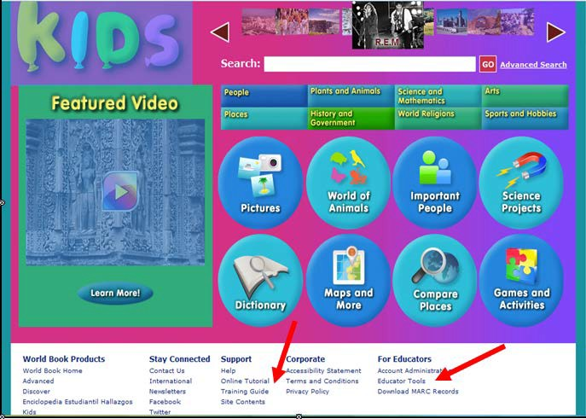

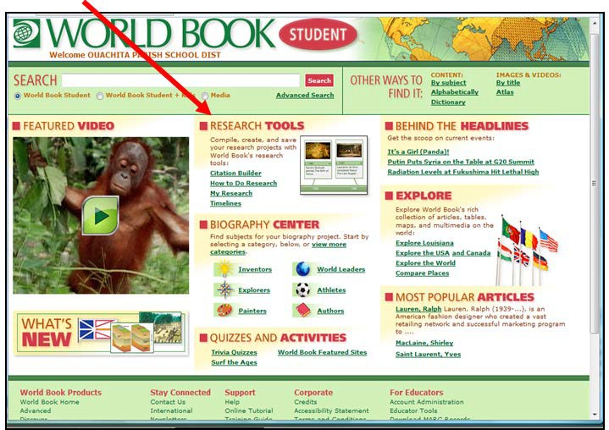
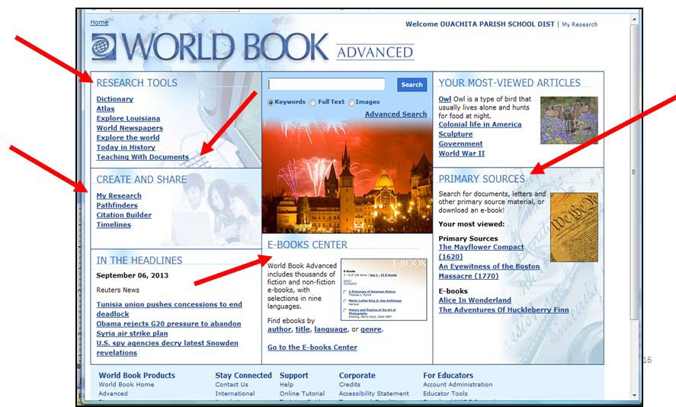

- Gale/InfoTrac

Gale/InfoTrac offers many excellent databases for students and teachers. Two of the most popular ones offer teaching and learning tools – Kids InfoBits for elementary grades and Student Resource Center Junior for middle school.
YouTube has video tutorials for some of the Gale databases. Search “Gale Cengage” to see what is available. This one is for Kids InfoBits - Gale's Kids InfoBits - Searching and Browsing: http://www.youtube.com/watch?v=4t57RV-rBVA
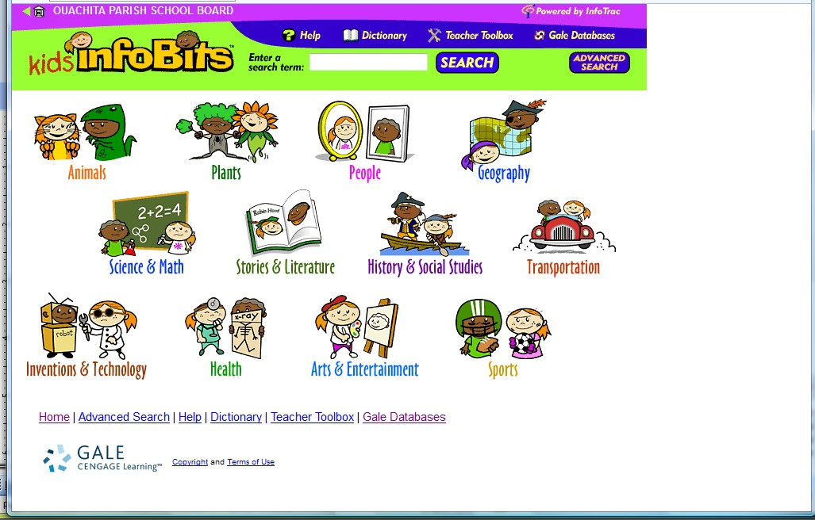

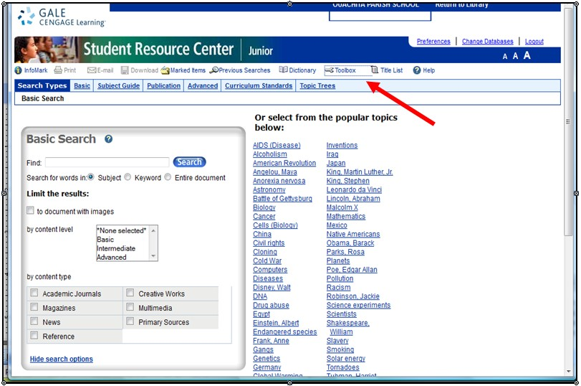

Preconference Interview for Administrators Suggested Questions and Topics

The questions below are questions I formulated after I was contacted by several administrators regarding the librarian rubric. The questions are basically, what to ask and what answers to anticipate. There are suggestions for the type of artifacts one might expect, etc.

Rubric: Read over the rubric and become familiar with it.

Library Lesson Plan: The librarian will need to have her lesson plan available when you have your pre- observation conference so you can discuss what you expect to see. Competency 3 deals directly with the lesson plan and lesson observation.

Discuss with the librarian in general terms about some of the competencies on the rubric that cannot be observed during a lesson (Competencies 1, 2, 4). (These are the documents, artifacts, etc., that will be compiled by the end of the year in the librarian’s portfolio. I would also anticipate that the librarian would be able to discuss the artifacts, data, and/or documents. I have included some questions that would be helpful in having a conversation about the data and/or artifacts. ) Because it is early in the year, many of these things will not be available at this time. A general discussion will more or less address the need for the documentation and let the librarian know that you will be expecting to see these things toward the end of the year (second observation or final conference). I would ask:

Competency 1: Planning and Preparation Competency 1.1:
How will you demonstrate the manner in which you develop the library collection? What resources do you use? Do you have a Collection Development Policy? How do you select library materials? (There are specific suggestions for artifacts and evidence on the rubric such as a collection development policy, selection tools such as professional journals, online reviews, notable lists, consideration file for teacher requests, consideration file for student requests—digital or paper file)

Competency 1.2
What do you do to promote a love of reading at your school? How do you communicate this to your students? (Artifacts: book talks, book displays, book clubs, reading programs such as Accelerated Reader, Children’s Book Week, Teen Read Week, interest inventories, LA Young Readers’ Choice programs, etc.)

Competency 1.3
How do you collaborate with your teachers to develop your students’ research skills and various literacies? (Collaboration with teachers-- Artifacts: collaboration forms, lesson plans, bibliographies, demonstration and modeling of subscription-based databases)

Competency 2: Library Environment Competency Competency 2.1
What do you do to create an attractive, flexible library environment? (Observation and/or and portfolio: Attractive environment free of clutter, up-to-date signage, posters, displays, library appears warm and inviting, etc. )

Competency 2.2
How do you manage library guidelines and procedure for circulation, use of materials and technology? (Artifacts and/or documents: Established circulation procedures, library rules, self-directed use, library calendar / schedule available, students know what to do, where to go)

Competency 2.3
How is the library arranged for traffic flow? Are you able to meet the needs of large and small groups? (By observations of students in library, by organization of space, signage to support self-directed use)

Competency 3: Instructional Competency: Teaching, Engaging, and Assessing in Instruction Competency 3.1 Questioning Techniques: (Direct observation)
Competency 3.2 Knowledge, Use of Instructional Materials and Resources (Print and Digital): (Direct observation)
Competency 3.3 Demonstrates consistent and effective use of technology (Direct observation) Competency 3.4 Teaches and/or reminds students to critically evaluate resources and avoid plagiarism. (Direct observation)
Competency 3.5 Provides timely, accurate, substantive,, construction and specific feedback when working with individuals and groups. (Direct observation)

Competency 4: Professional Responsibility Competency Competency 4.1
How do you analyze and/or evaluate your library collection to address future needs? How do you determine what materials need to be weeded/replaced? (Lists of requested resources, survey data from teachers, established weeding procedures, usage, age of collection, and/or inventory reports generated through the library automation system. Excel spreadsheet mapping collection age from previous years, showing gains and losses, weeded materials.)

Competency 4.2
What methods do you use to maintain financial records in your library for handling fees, receipts, library generated income, library purchases? (Budget management plan, receipts for fines, lost books) district allocations, etc.)

Competency 4.3
How does your library advocacy help to support requests for additional financial support? (Newsletters, library website, exterior funding sources, grants)

Competency 4.4
How do you evaluate the overall progress of your library program and library usage? How do you use this data to measure your program growth from year to year? How does your program compare to schools of comparable size and socioeconomic levels?
(Portfolio: Inventory reports, circulation records, data from reading programs, annual reports, parishwide reports/spreadsheets containing library data from other schools in the parish. Excel Spreadsheet mapping circulation increases/decreases from previous years. Spreadsheet mapping Accelerated Reader increases/decreases from previous years. Spreadsheet mapping LYRC increases from previous years. Also answers from direct interview with librarians)

Competency 4.5
How do you pursue opportunities to develop professionally as a librarian? How do you contribute to the profession through sharing new knowledge? How do you use online communities for professional development? (Earns Continuing Learning Units, attendance at local, state, or national professional library conferences, participation in online communities such as LM_NET, presentations at local, state, or national professional library workshops, in-services, and conferences, publication of original library- related articles in local, state or national periodicals and/or through web-based platforms (e.g., personal websites, blogs, wikis, etc.)

Section 14:

State Library Standards

Part 15:
Appendix

Scanner Pairing Instructions for Alexandria Library Scanners
Needs Assessment for A.R. Books Book Order Cover Sheet
Annual Report Form


1831 Fort Union Blvd, Salt Lake City, Utah 84121 800-347-6439 • 801-943-7277
www.companioncorp.com

Wireless Linear Imaging Scanner
Installation Guide
If there is another scanner attached to your machine, it should be removed at this time. Connect the USB Data cable with attached Receiver to an open USB port on your computer. If you are on OS X, a keyboard configuration wizard may appear before continuing, please close the wizard. To properly program your scanner, first place this page on a flat surface, then scan the following codes in the numbered order.
Step 1  Begin Configuration: | 
Step 2  Restore Factory Defaults | 
Step 3  Enable all default codes: | 
Step 4  Enable Interleaved 2 of 5: | 
Step 5  Configure US keyboard code: | 
Step 6  Scan if using on Macintosh: | 
Step 6  Scan if using on Windows: | 
Step 7  End Configuration: | 

Section 15, Page 3 Appendix

1831 Fort Union Blvd, Salt Lake City, Utah 84121 800-347-6439 • 801-943-7277
www.companioncorp.com

Scanner LED Indicator
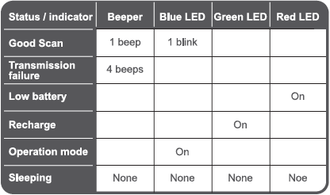

Receiver LED Indicator
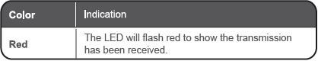

If you have any questions or problems, please contact Technical Support at 1-800-347-4942.

Section 15, Page 4 Appendix

Book Order Checklist Cover Sheet 20 - 20
School Name

1. |  | I have printed a paper copy of my book order.
2. |  | My printed book order has been printed using the “Annotated” version so that annotations are visible.
3. |  | My book order is at least 1½ times the amount of my book  order.
If my order includes ebooks or Playaways, the total does not exceed more than ¼ of my total book order.
Please indicate the total amount used for ebooks or Playaways
$ .
4. |  | My principal has signed the front page of each book order.
5. |  | I have shared my Follett order online with “janmcgee”.  I have shared my Mackin order online with “jmcgee@opsb.net”.
6. |  | I have attached my book order checklist and completed all items.
7. |  | I have included at least 1 copy of each of my LYRC Books.
 |  | My Total Book Allotment:
 |  | Follett DNE amount
 |  | Mackin DNE amount
 |  | Total Amount of combined DNE amounts (Add these together. Sum cannot exceed total allotment.)

Needs Assessment for Accelerated Reader for
School Year

Assessment of Books Recommended Based on STAR Test Results
Grade Equivalency/ATOS  Level | Books Per  Student | Students from STAR Test  at Grade Equivalency | Books  Recommended | Books in  Collection | Books  Needed
0.0 – 0.9 | 10
1.0 – 1.9 | 10
2.0 – 2.9 | 8
3.0 – 3.9 | 5
4.0 – 4.9 | 5
5.0 – 5.9 | 5
6.0 – 6.9 | 4
7.0 – 7.9 | 4
8.0 – 8.9 | 4
9.0 – 9.9 | 2
10.0 – 10.9 | 2
11.0 – 11.9 | 2
12.0 – 12.9 | 2

Ouachita Parish School System
Annual Report for School Librarians 20 - 20

Signature of Principal

School |  | Librarian(s)
Student Enrollment as of October 1, 2015
Total Number of Books in Collection: (Exclude textbooks and classroom sets.) Include
Fiction, Non-Fiction, Easy, Easy Non-Fiction, Reference, Professional Collections, Paperbacks, LA
Collections, eBooks, and other Special Collections that circulate.)
Average Number of Books per Student (Divide # of bks by enrollment)
Average Circulation per Student (Divide Total Annual Circulation by no. of students)
Total Annual Circulation ( type total and attach report) |  | Yes | No
Average Age of Collection  (Super Summary Report) |  | Yes | No
Final Circulation Report Attached |  | Yes | No
LYRC Summary Report Submitted Online |  | Yes | N/A
Final Accelerated Reader Report Attached  Attach Schoolwide Summary for 2015-2016 School Year |  | Yes | N/A
Printout of Top 30 Circulated Books Attached  Attach Top 30 Circulated Items Report to Annual Report |  | Yes | No
Super Summary Attached |  | Yes | No
Printout of Final Overdue Books Attached |  | Yes | No

Category | Number
Total Easy Books (if applicable)
Total Fiction (include fiction paperbacks)
Total Non-Fiction (include biography & non-fiction paperbacks)
Total Short Stories & Story Collection
Total Reference
Total Professional Collection
Total Louisiana Collection
Total “Other” (do not include textbooks or classroom sets)
Total Books in Collection (DO NOT include textbooks)
Total Videos and DVDs
Total Audio Books (include books on tape, books on CD, Playaways)
Total Number of eBooks (attach eBook summary from service)
Total Number of books (real & virtual) in Library
Total Number of Classes Scheduled in Library
(For Middle Schools & High Schools)
Total Number of Classes Scheduled in Library
For Elementary (# classes per week times number weeks open)

Section 15, page 7 Appendix

