
Computer Science Integration School
11060 Fontaine Blvd,
Colorado Springs, CO 80925
Phone: (719) 391-3470
Principal: Shawnda Zahara-Harris
K-5 Principal: Sarah Arrellano

Computer Science Experience Guide

The progression of Computer Science Education in grades K to 8. Focus areas are:
- CS Skills & Habits of Mind
- Computer Basics & Digital Citizenship
- Programming
- Robotics

“You would never send your child to a school that didn’t teach math. We’re not trying to prepare kids for jobs. We’re trying to prepare kids for life.”

Hadi Partovi, Founder of Code.org

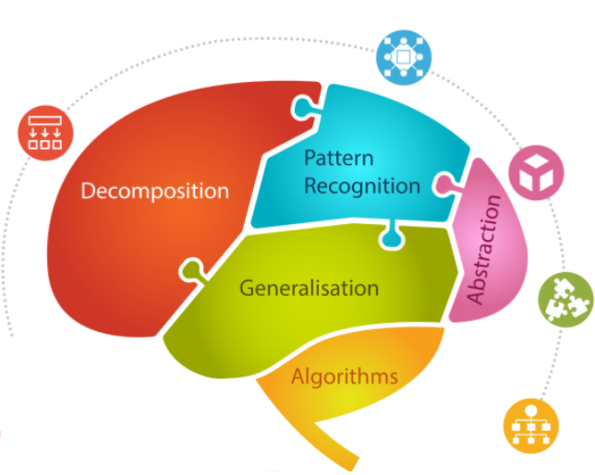

Computational Thinking Model
Decomposition - Breaking the problem into smaller parts
Pattern Recognition - Seeing repetition or similarities
Abstraction - Taking the detail out of the problem (the big picture)
Generalization - Using a solution from one problem to solve another problem (transfer)
Algorithms - Ordered steps to solve a problem

Kindergarten
Computer Basics & Digital Citizenship
- Understand passwords
- Use touchscreens
- Logging in
- Computer/device care
- Keyboarding skills
Programming
- Kodable
- Simple Block programming
- Simple Sequences
- Simple Loops
- Debugging
Robotics BeeBots & Coding Critters

1st Grade
Computer Basics & Digital Citizenship
- Understand and use passwords
- Intro to Chromebooks
- Keyboarding skills continued
- Mouse skills
- Computer/device care
Programming
- Scratch Jr.
- Block programming
- Sequences
- Events
- Loops
Robotics Ozobots (color coding), QuestBots
2nd Grade
Computer Basics & Digital Citizenship
- Continue keyboarding skills
- Mouse skills
- Troubleshoot hardware and software problems
- Understand password security
- Computer/device care
Programming
- Sequencing
- Loops
- Events
- Debugging
- Collect and use data
Robotics
- Ozobots (block coding)
- Dash Robot (block coding)
- Sphero (drive)

3rd Grade
Computer Basics & Digital Citizenship
- Keyboarding mastery and stamina
- Mouse skills
- Troubleshoot hardware and software problems
- Understand password security
- Computer/device care
- Introduction to networking
- Collect, organize and present data
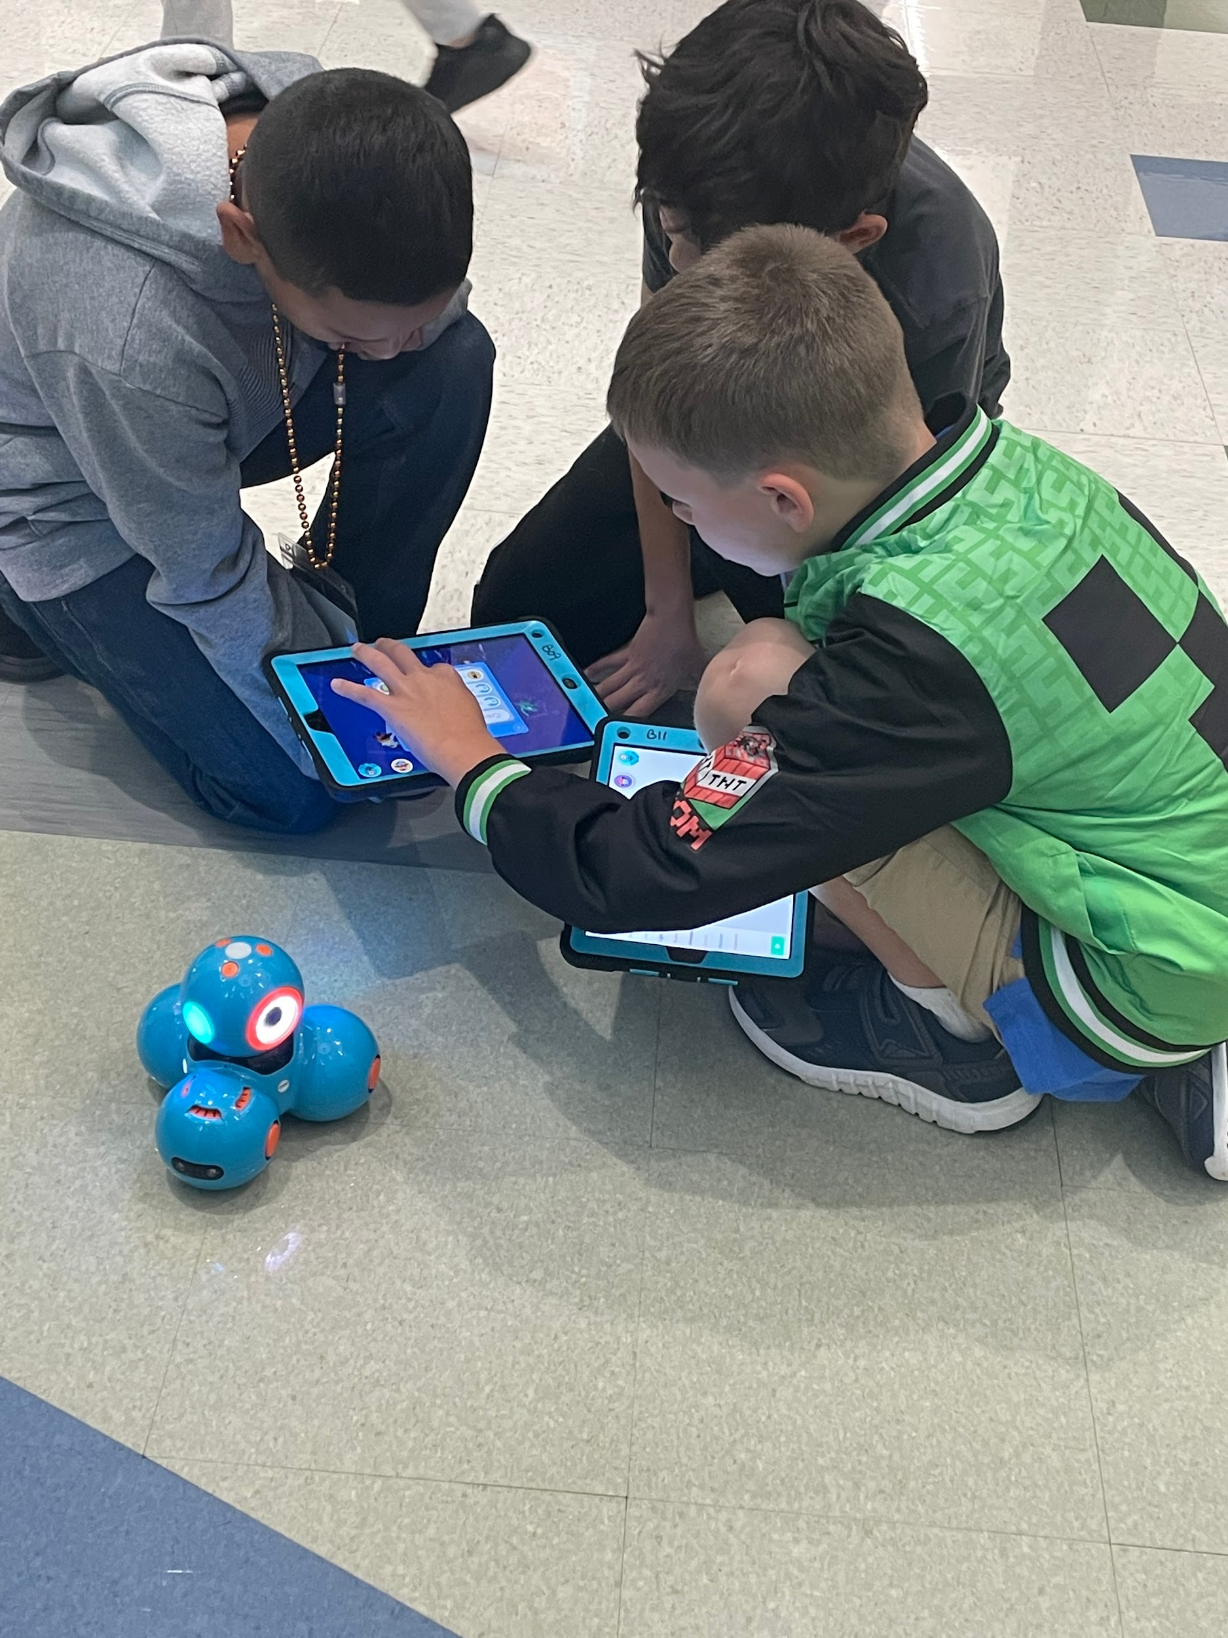
Programming
- Scratch
- Events
- Loops
- Conditionals
- Debugging
- Relay programming
Robotics
- Dash & Sphero (Block programming)

4th Grade
Computer Basics & Digital Citizenship
- Troubleshooting of hardware, software, login, connectivity issues
- Cyber security and password
- Digital intellectual property
- Hardware and software integration
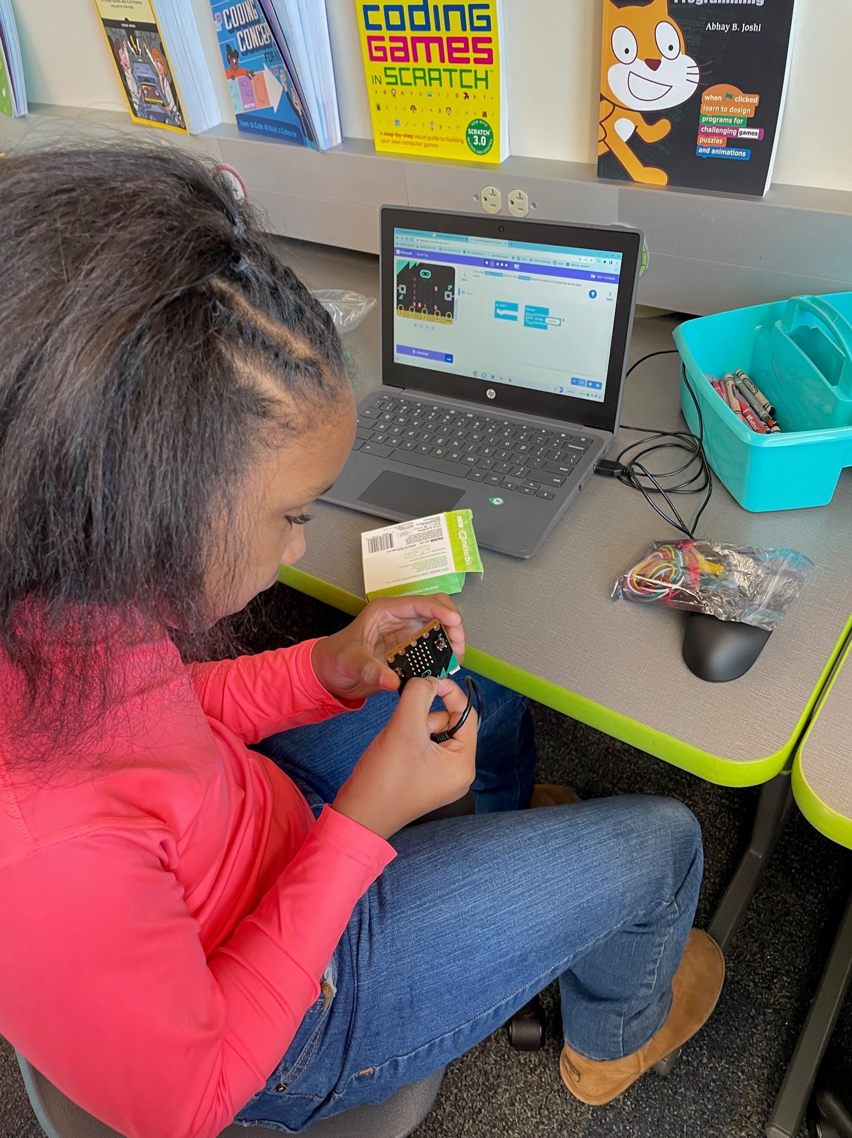
Programming
- Scratch
- Nested loops
- Functions
Physical Computing
- Micro:bits
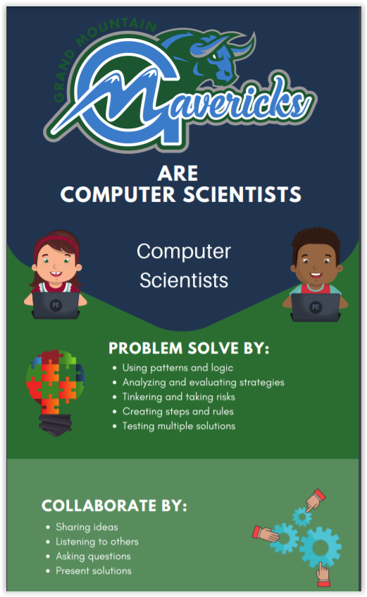

5th Grade
Computer Basics & Digital Citizenship
- Hardware and software integration
- How the internet works
- Protecting personal information
- Digital intellectual property
- Engage in positive, safe, legal, and ethical behavior when using technology
- Understand the impact of social media

Programming
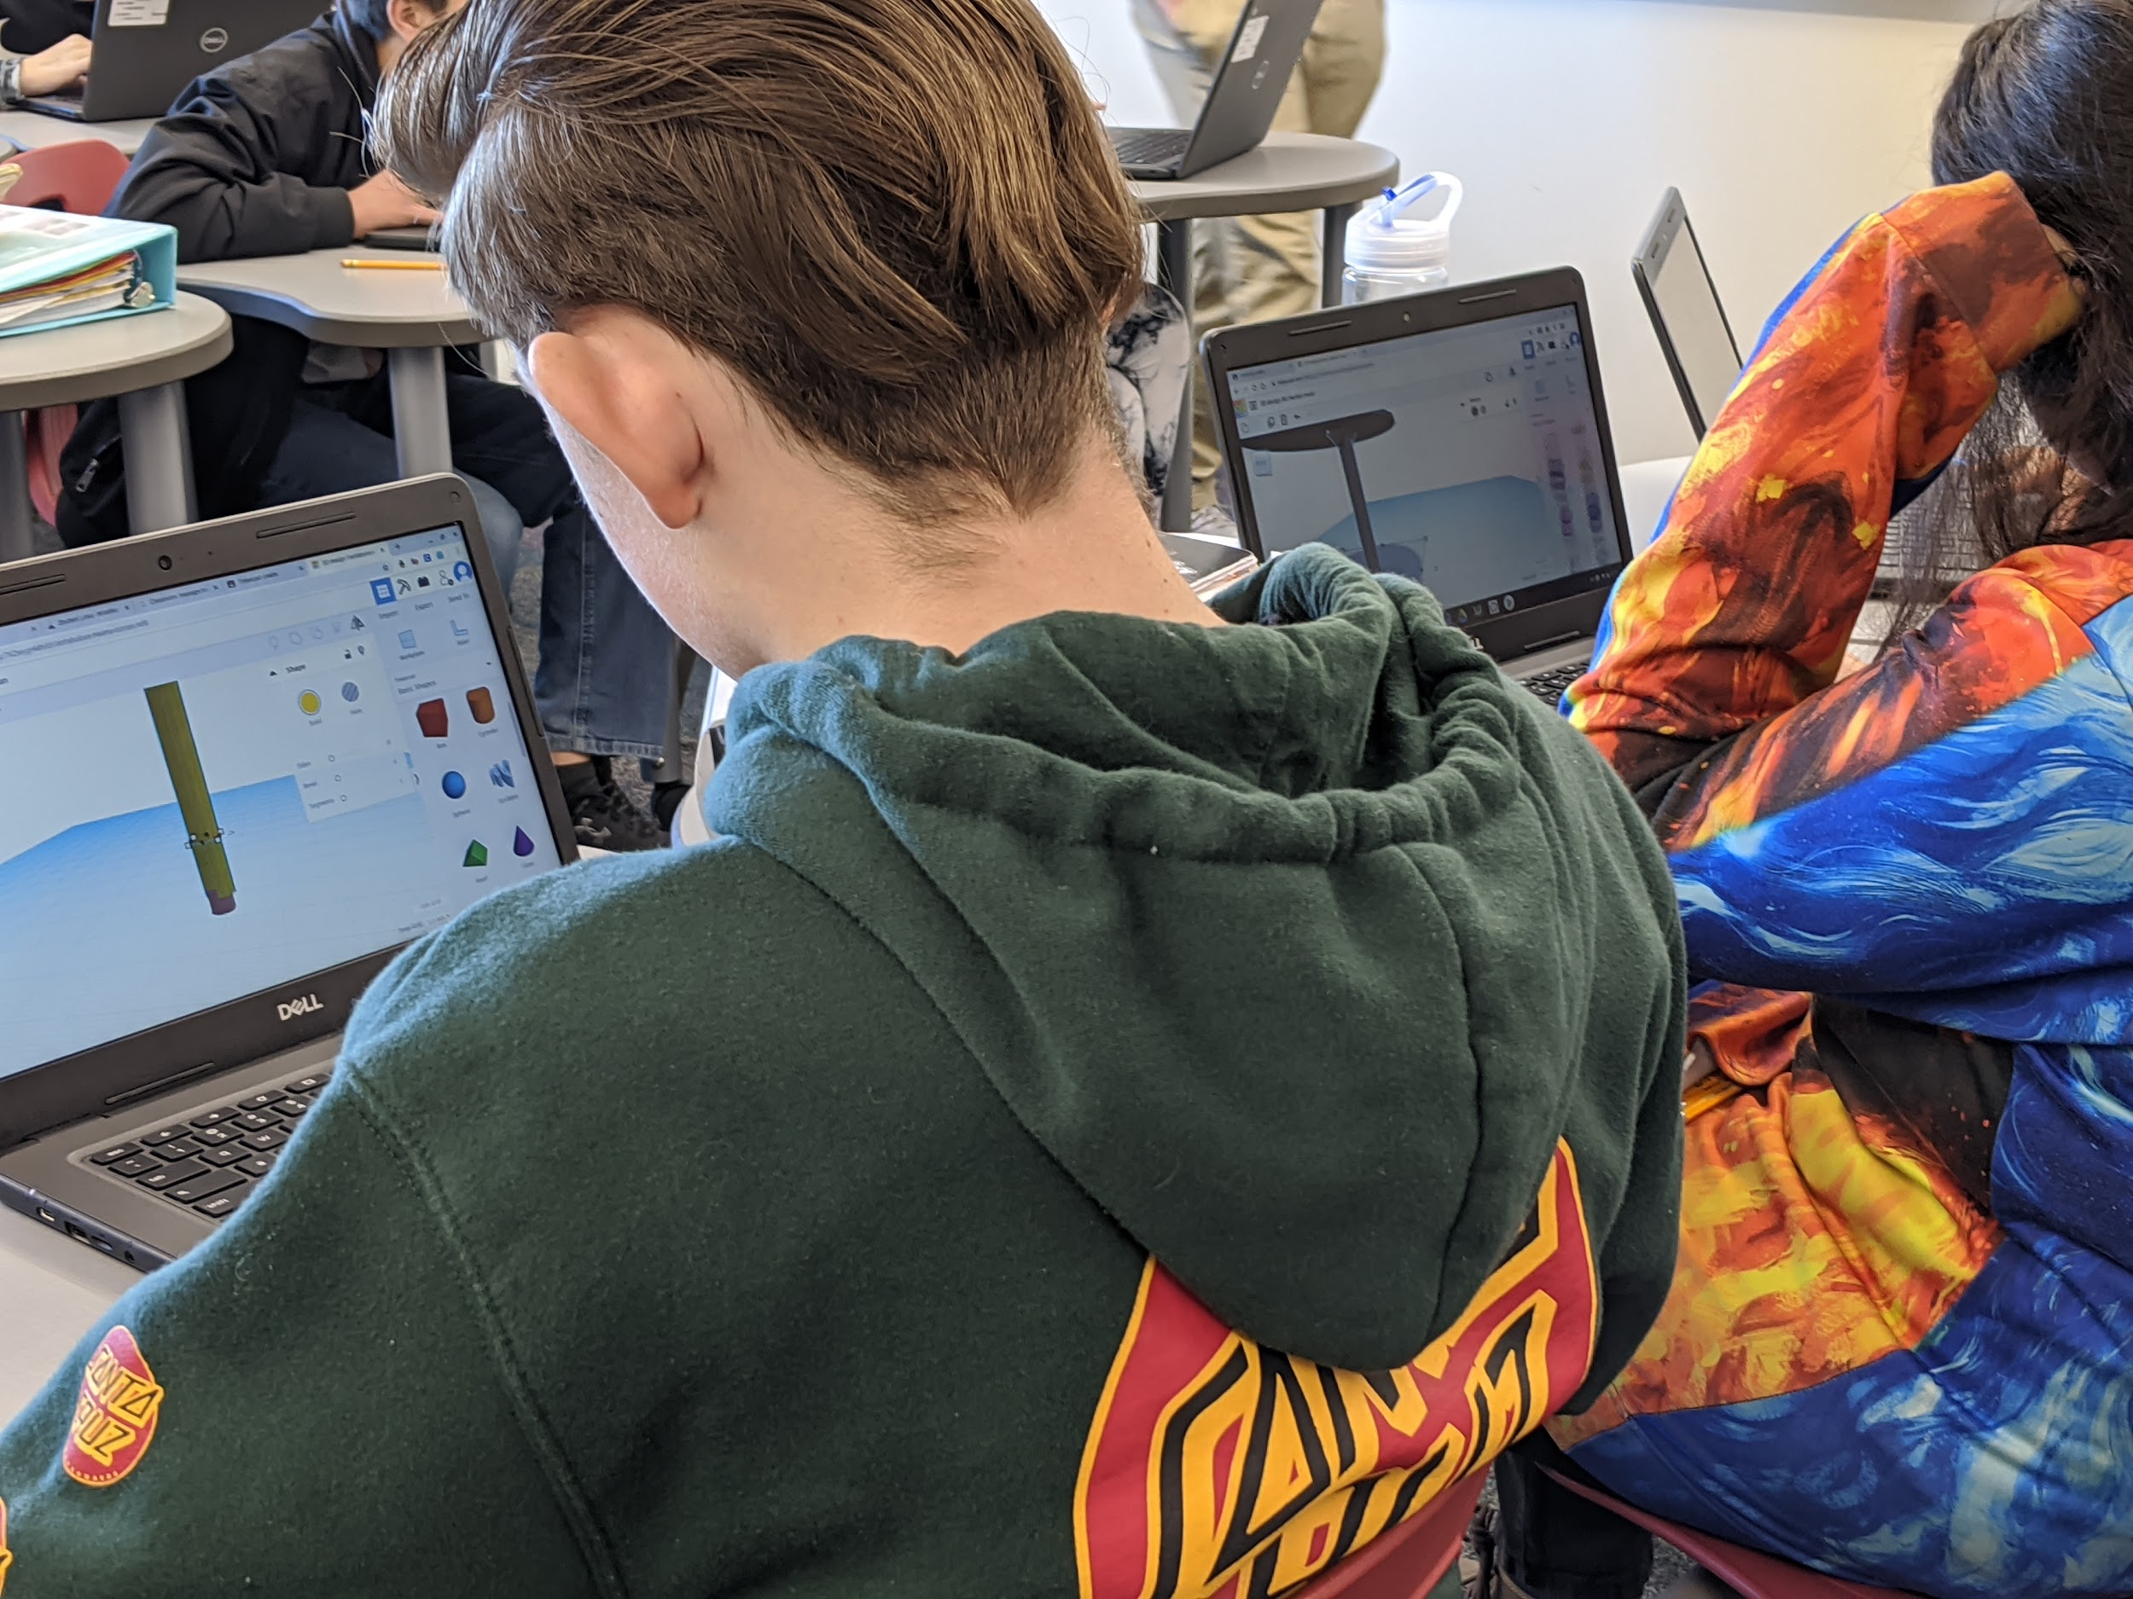
- Scratch
- Elementari
- Variables
Robotics
- Cubelets
Physical Computing
- Micro:bit

6th - 8th Grade
Physical Computing
Innovators and Makers (Intermediate)
Advanced Robotics (Advanced)
Programming
CS Discoveries
Design & Modeling (Intermediate)
Web Design (Intermediate)
App Creators (Intermediate)
CS Principles (Advanced Placement)
Robotics
Automation and Robotics (Intermediate)
Flight & Space with Drones (Intermediate)
Advanced Robotics (Advanced)
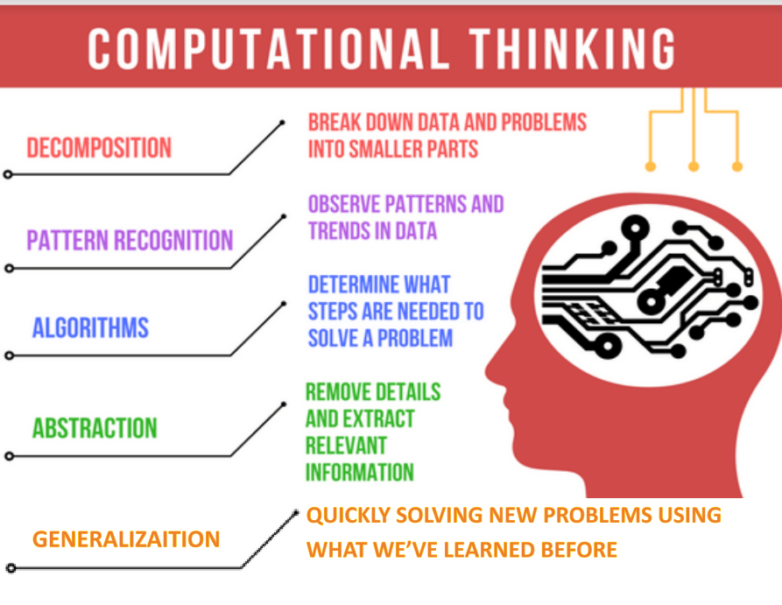
Specials
Art - TinkerCAD and 3D Printing
Music - MaKey MaKey, Dash, BeatBots
P.E. - Computational Thinking Skills
Spanish - Elementari, Scratch

