Student Email Instructions

Go to: www.students.pittschools.org or you may go to the Parent/Student Links tab on the Hope Middle School webpage.

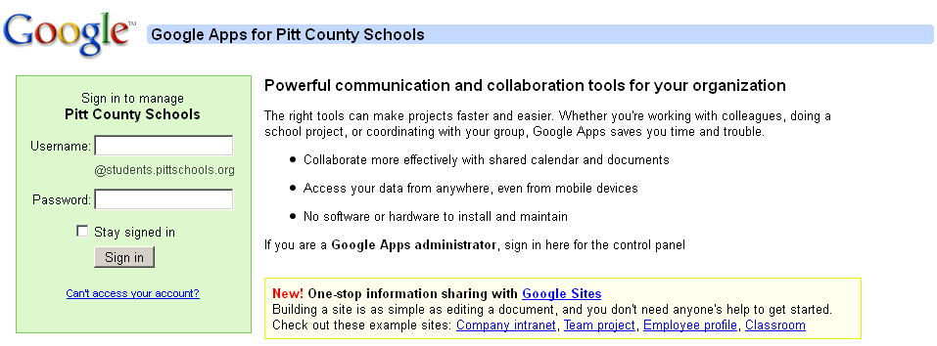
Your username is the same login that you use to login the computer – example: davisma

Your password is the same password that you use to login the computer.

It is recommended that you take the checkmark √ out of the Stay signed in box.

The first time that you login, you will have to read and accept the terms of Google.

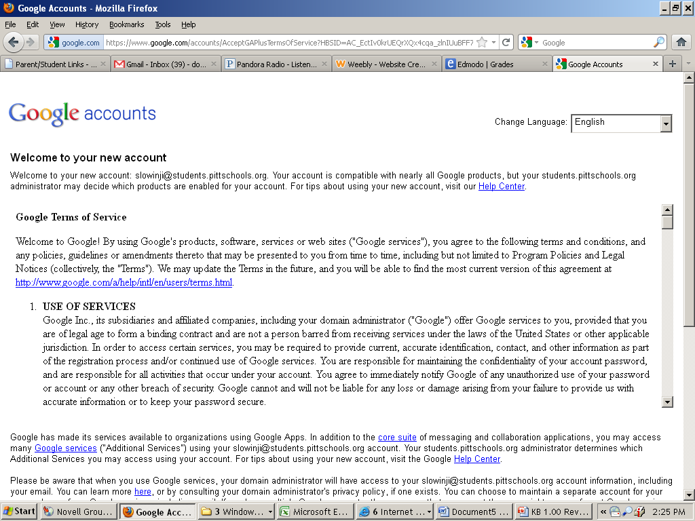
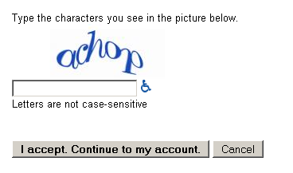
After you have read all of the terms, you have to type the characters shown in the picture and click on the I accept. Continue to my account button.

The page will look like this:

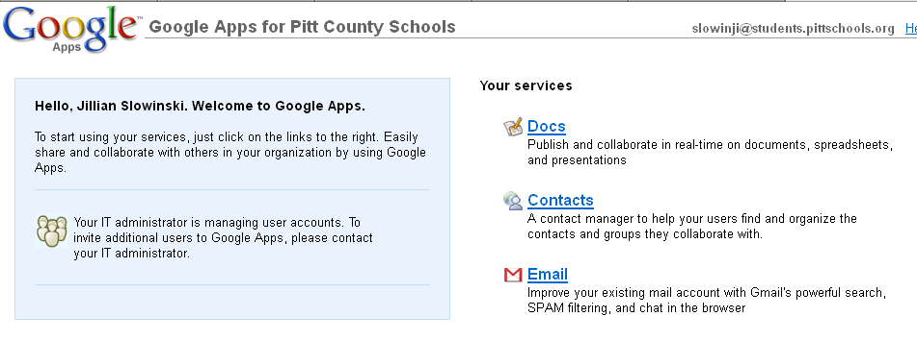

Click on Email

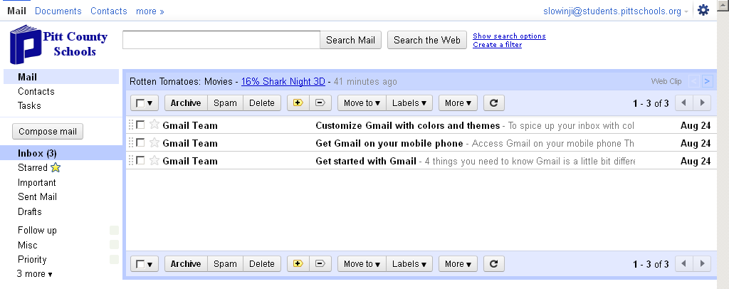

You will likely
have 3 messages from the Gmail Team.

Use the Compose Mail button to send an email.

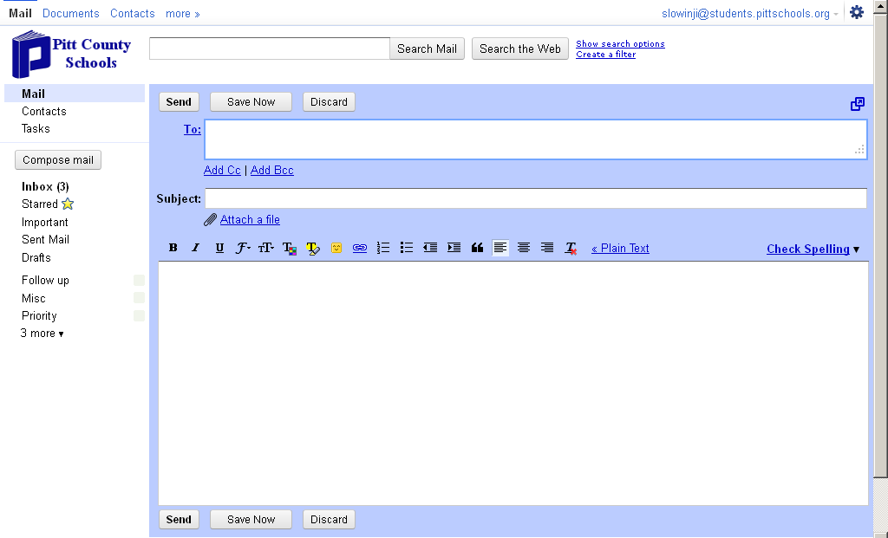
Type the email address
in the To:

Always include a Subject
in the Subject line

Click on Attach a file if
to include a file with your
email.

Type your message in
the big, white box.

Click on Send.

Remember there are filters set up to prevent the use of inappropriate language.

Always sign out of your account before exiting. Click on your name in the top right & click on sign out.

