CALPADS
June 2021

2020-21 School Year

CALPADS EOY
- EOY 1-4 Snapshot started on May 10, 2021
- Deadline July 30, 2021
  - LEAs are required to approve their EOY submissions by July 30, 2021. SELPAs are not required to approve LEA submissions by this deadline
  - CDE will send a letter to the superintendents and charter school administrators of any districts or charter schools that do not approve one or more of their EOY submissions by the July 30, 2021 deadline.
- Amendment Window deadline August 27, 2021
  - LEAs and SELPAs must both approve all EOY submissions by the close of the amendment window, on August 27, 2021, in order for the submissions to be certified

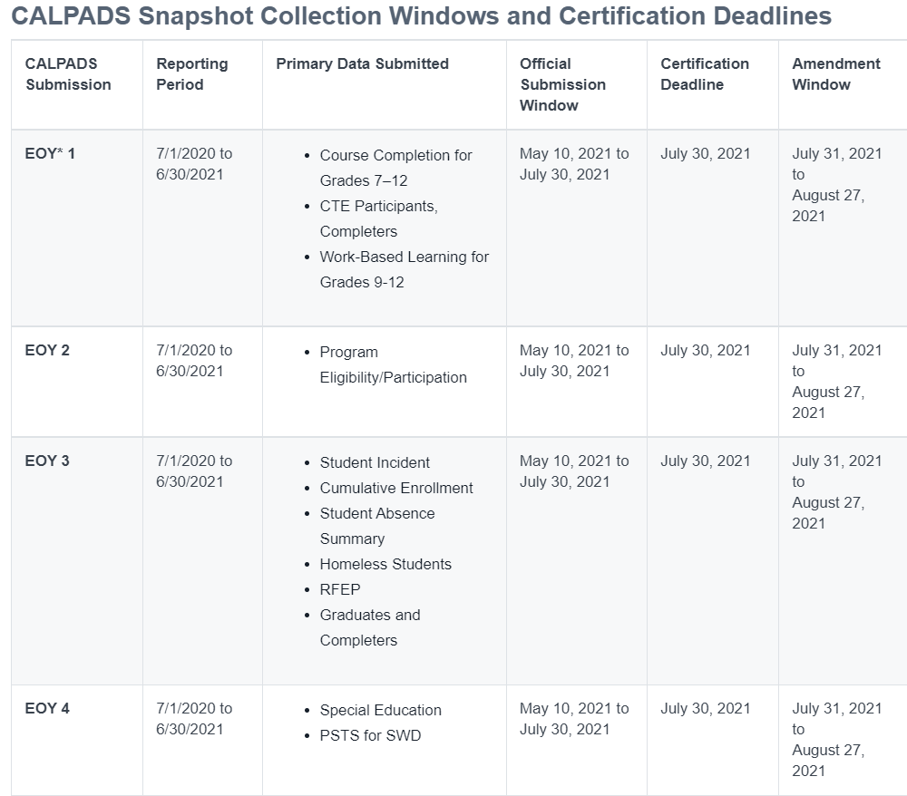

Graduation Rates and Graduate and Completer Counts
To avoid cohort graduation rate issues, LEAs should make sure all cohort students are correctly exited and LEAs should carefully review this information in their CALPADS 15.1 and 15.2 cohort reports. When the CDE publicly reports the data, the CDE cannot accommodate the correction of data that LEAs fail to submit correctly or properly review within the established data submission and review timeframes.

Start Preparing for 2021-22 School Year

