CALPADS
August 2021

2021-22 School Year

CALPADS EOY
- EOY 1-4 Amendment Window deadline August 27, 2021
  - LEAs (EOY 1-4) and SELPA (EOY 3 & 4) must both approve EOY submissions by the close of the amendment window, on August 27, 2021, in order for the submissions to be certified

Graduation Rates and Graduate and Completer Counts
To avoid cohort graduation rate issues, LEAs should make sure all cohort students are correctly exited and LEAs should carefully review this information in their CALPADS 15.1 and 15.2 cohort reports. When the CDE publicly reports the data, the CDE cannot accommodate the correction of data that LEAs fail to submit correctly or properly review within the established data submission and review timeframes.

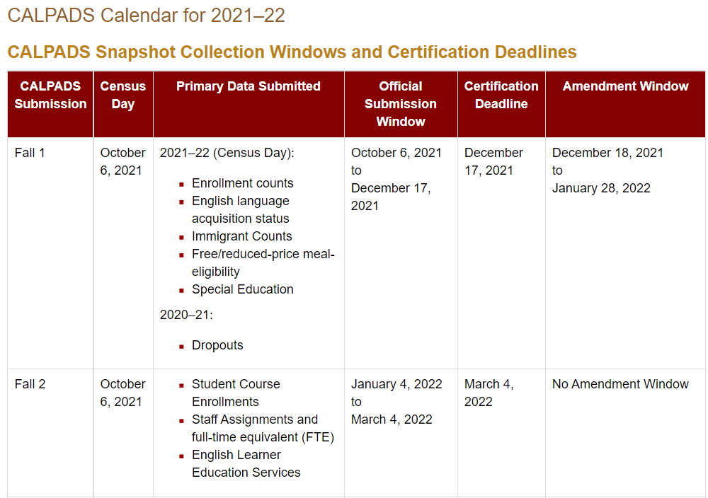

CALPADS Update Flash #211

The CALPADS Data Used to Identify Students Who Become Eligible Over the Summer
To identify students who become newly eligible during the summer (June 1 through August 15), on October 1, 2021, the CDE will extract, from the CALPADS Operational Data Store (ODS), students who were enrolled in a SPB/NSLP participating school in May 2021 and who are now FRPM eligible based on:
- An FRPM program record (181/182) in CALPADS with a start date between June 1 and August 15, 2021. These program records should be based on a NSLP application or alternative income information form, received by the school between June 1 and August 15, 2021, and subsequently approved, or
- A homeless or migrant program record in CALPADS with a start date between June 1, 2021, and August 15, 2021.
The CDE will also pull students who were directly certified for the first time in the June, July or August Direct Certification match, or who were identified for the time as a foster youth in a weekly statewide match conducted between June 1 through the second week in August.

Independent Study

Hot Topic: Independent Study Changes New legislation requires that local educational agencies (LEAs):
1. Revise their board policies
2. Revise written agreements (Traditional IS)
3. Develop learning agreement (Course-based IS)
4. Provide opportunities for live interaction and synchronous instruction
5. For the 2021–22 school year only, school districts and county offices of education (COEs) shall offer IS as an educational option

Independent Study AB130

Independent Study Toolkit

Nationwide Waiver to Allow the Seamless Summer Option through School Year 2021-2022

FNS is allowing SSO operations to continue when school is open during the regular school year, effective July 1, 2021, through June 30, 2022. This flexibility is available to all school food authorities in states that opt to participate under this waiver, and may be used at any school, regardless of its location or the type of SSO site it is operating. This waiver is intended to benefit all school food authorities that elect; to use it, so that every school has the ability to provide a safe and efficient meal service in the school year 2021-2022. USDA Food and Nutrition Service

Guidance for 2021−22
While the USDA has not officially stated whether schools operating under the SSO waiver may still collect NSLP applications, based on previous guidance and the obvious need for LEAs to collect NSLP applications for P-EBT purposes, the CDE believes that LEAs have two options for collecting the needed FRPM eligibility data in 2021−22 for LCFF and P-EBT:
- Collect the data using alternative household income forms. The LCFF statute established the Alternative Household Income form to collect the FRPM-eligibility status of students enrolled in schools that do not collect NSLP applications because they do not participate in NSLP, or because they operate an NSLP program under the Community Eligibility Provision (CEP) or Provision 2 or 3, which prohibits the collection of NSLP applications altogether or just in base-years. Data collected from alternative household income forms is acceptable for LCFF and P-EBT. The forms may be distributed and collected online and electronic signatures are acceptable.
- Collect the data using the NSLP application. LEAs collecting NSLP applications must adhere to all NSLP rules, which includes verifying a percentage of those applications.

Sample Alternative Household Income Form

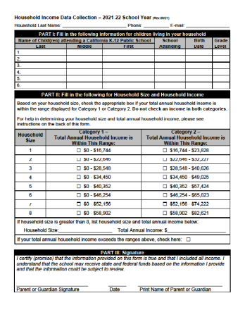

Upcoming Trainings/User Group Meetings

- Aeries User Group Meeting
  - September 15th
  - 10:00 – 12:00
  - ZOOM

- SchoolWise User Group Meeting
  - September 15th
  - 1:00 – 3:00
  - ZOOM

