CALPADS DBUG
April 2022

2021-22 School Year

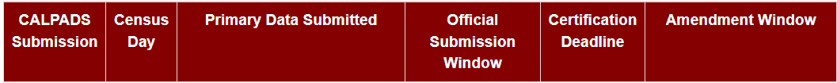

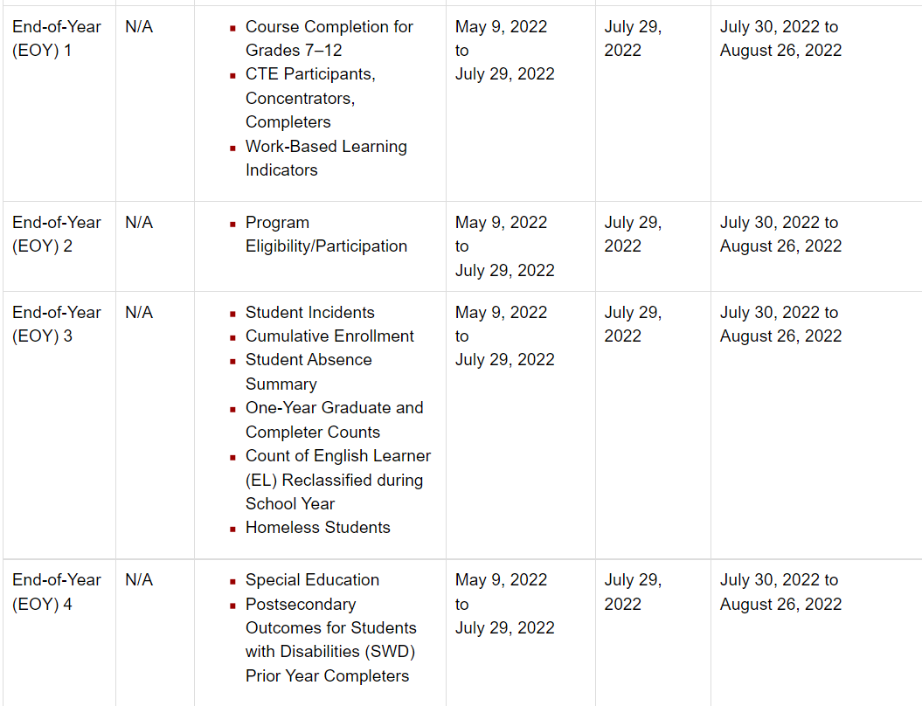

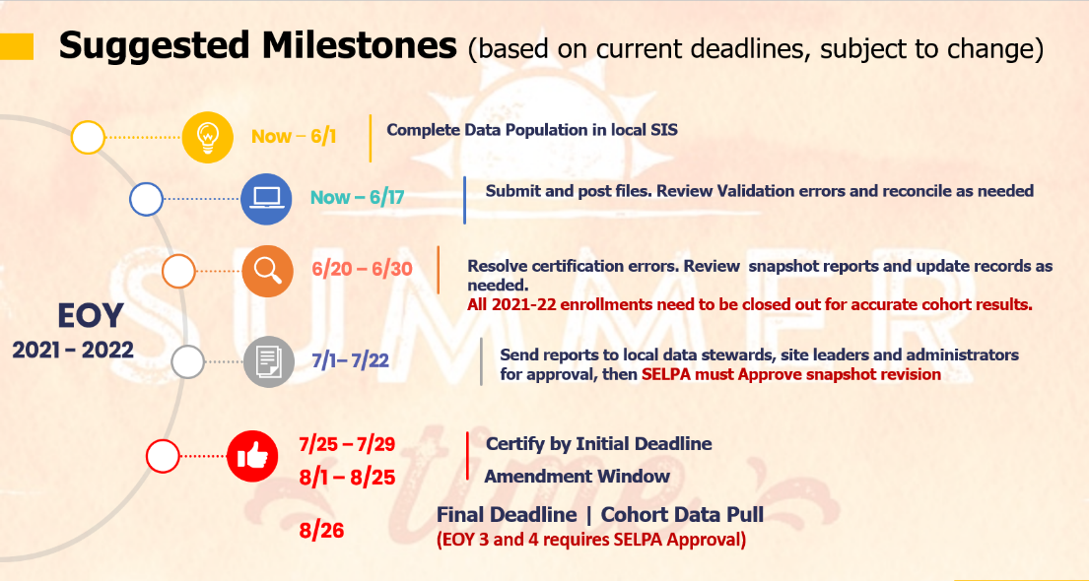

End of Year Checklist
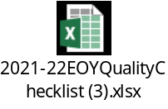
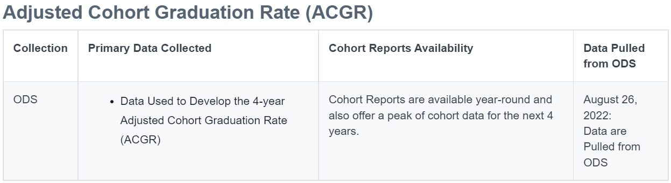
Future 4-year Cohort Outcome
- Allow a user to select a future cohort year. (Report 15.1 and 15.2)
- Will run 4 separate cohort years at a time.
- Users can see their cohorts earlier and will be able to verify their first-time 9th grade records sooner.
- Will be accessible continuously throughout the whole year

CALPADS Frequently Asked Questions

CALPADS Redesign Update
- Benefits
  - Reduces the time it take to post a file
  - Provides visibility to all data discrepancies even outside of submission and certification windows
  - Letter to Superintends

CALPADS 2022-23 School Year
- CALPADS will require Highest Education Level for both parents
- Please include this on enrollment Forms

Reminders
The Direct Certification extract and Foster Youth data for AY 2021-2022 will be purged from the system after 6/30/2022. We recommend you download the data for reference.

Download the Direct Certification Extract before 6/30/2022

Run and download the Foster Youth Reports before 6/30/2022

