CALPADS DBUG
June 2022

2021-22 School Year

Data Release of Teaching Assignment Monitoring Outcome on DataQuest

These data reports are embargoed until the CDE public release scheduled for Thursday, June 30, 2022.

Password: CHALKBOARD
Notification of Private “Pre-Release” Preview of the Teaching Assignment Monitoring Outcome Data for the 2020–21 Academic Year

CALPADS Calendar

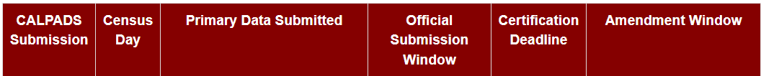
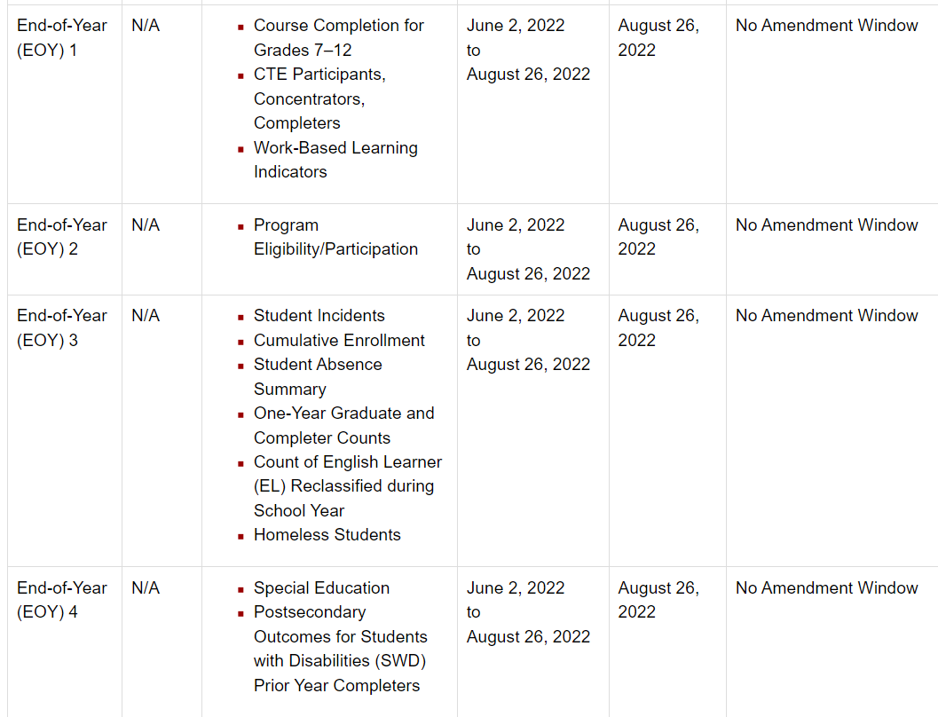

CALPADS Redesign Update

CALPADS Weekly Update
- CALPADS is sending out a weekly update on known issues, resolved issues, and issues currently being worked on
- CALPADS Q&A Live on Wednesday and Friday at 3:00
- Known Issues List
- Subscribe to CALPADS Listservs
- CALPADS CSIS Training Channel on YouTube

CALPADS Frequently Asked Questions

CALPADS 2022-23 School Year

Reminders
The Direct Certification extract and Foster Youth data for AY 2021-2022 will be purged from the system after 6/30/2022. We recommend you download the data for reference.

Download the Direct Certification Extract before 6/30/2022

Run and download the Foster Youth Reports before 6/30/2022

CALPADS Training
Date: June 29, 2022
Time: 9:30 – 12:00
Location: ZOOM

Aeries/CALPADS Training
Date: July 6, 2022
Time: 9:30 – 12:00
Location: ZOOM

SchoolWise Training
Date: TBA
Time: 9:30 – 12:00
Location: ZOOM

