Wayne County Schools

POLICY ON ADMINISTRATION OF MEDICATION
The following guidelines are for the safety of all schoolchildren. These guidelines must be followed if medication of any type, including over-the-counter medicines, are necessary for your child during the school day including field trips. School personnel who are authorized to give medications must be trained in accordance to ensure compliance with 201 KAR 20:400, KRS 156.502, and 702 KAR 1:160. This training is only valid for one school year.

The parent or legal guardian may come to the school and give the medication to the child at the prescribed times.

You may obtain a permission form for medication administration from the school nurse or school office staff. This form must be taken to your child’s doctor to be signed and completed listing the medication to be given, reason for medication, dosage, and time to be given, duration and route of administration. The parent or legal guardian of the student must also sign this form. This form is used for prescription and over the counter medication needed at school by your child. Any change in prescribed medication, dosage, route or frequency requires a new permission form signed by the physician and parent/guardian and a new prescription bottle/label from the pharmacy indicating the change.

The first dose of any new medication should be given at home.

All medication must be given to the School Nurse by the parent or legal guardian. Medications will not be transported to or from school on the school bus.

Prescription medication must be brought in the current original container with the prescription label attached. The prescription label must match the instructions on the medication form signed by the physician. The pharmacy will be able to give you an extra empty prescription bottle for the school so that you will have the current prescription bottle at home and school.

Over-the-counter medications, medicines that do not require a prescription, must be brought in the original container with signed physician and parent/guardian approval to be given at school. Please check the expiration date on these medications before bringing them to school.
You may discuss with your doctor an alternative schedule for administration of medication, for example, medication given outside of school hours.

STUDENT SELF-MEDICATION
In certain situations, a written physician authorization will allow a student to carry self-administered medication which includes Epipen®, diabetic supplies, seizure rescue medication or asthma inhaler. An authorization form must be on file and completed by the physician and parent/guardian. The authorization form must be renewed each school year. STUDENTS MUST NEVER SHARE ANY MEDICATION WITH ANOTHER STUDENT.

OVER THE COUNTER MEDICATION
If your child’s school has a full-time on-site school nurse contracted through the Cumberland Family Medical Center Healthy Kids Clinic, annual registration forms with parental permission must be completed and returned before any over-the counter medication can be given by the on-site nurse. In the absence of the Cumberland Family Medical Center Healthy Kids Clinic nurse, other school personnel CANNOT give over the counter medication without a current permission form for administration of medication signed by the physician, and parent/guardian.

FIELD TRIP MEDICATION ADMINISTRATION
Prescribed medication ordered by a physician and non-prescription over-the-counter medication which are essential for your child to take during and/or after school hours while attending a school-sponsored event/field trip shall be given according to the instruction noted on the Permission Form for Medication. The medication must be brought to the school nurse in the current labeled container with the amount needed for the field trip only.

School personnel who are trained in Medication Training for Unlicensed School Personnel (UAP) WILL NOT administer any medication to students unless we have received both the medication form properly completed and signed by the doctor and parent/guardian and the medication in the appropriate container. There will be no exception to this policy.

REMINDER: NO STUDENT MAY BRING MEDICATION ON THE SCHOOL BUS WITH THE EXCEPTION OF PHYSICIAN APPROVED SELF-ADMINISTERED MEDICATIONS (Epipen®, diabetic supplies, seizure rescue medication or asthma inhaler)

WAYNE COUNTY SCHOOLS WILL ADDITIONALLY FOLLOW CFMC, INC ADMINISTRATION OF MEDICATION FORM/CONTROLLED SUBSTANCE ADMINISTRATION PROTOCOL

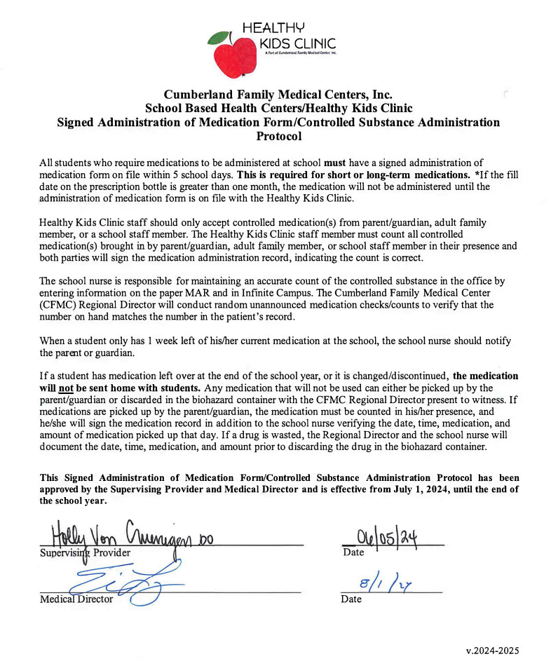

REVISED: 11-2024

