Capital Farm Credit Scholarship Application Guide

- Log into Survey Monkey (if you do not already have an account, you will need to register).
- Find Capital Farm Credit Youth Scholarship Program and select “More”
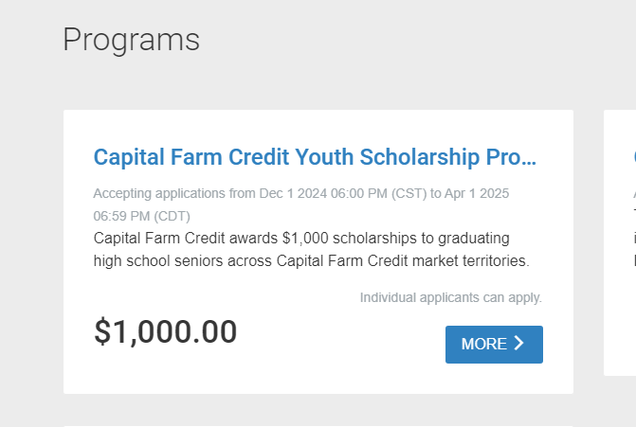
- Read eligibility requirements and select “Apply” if you are eligible.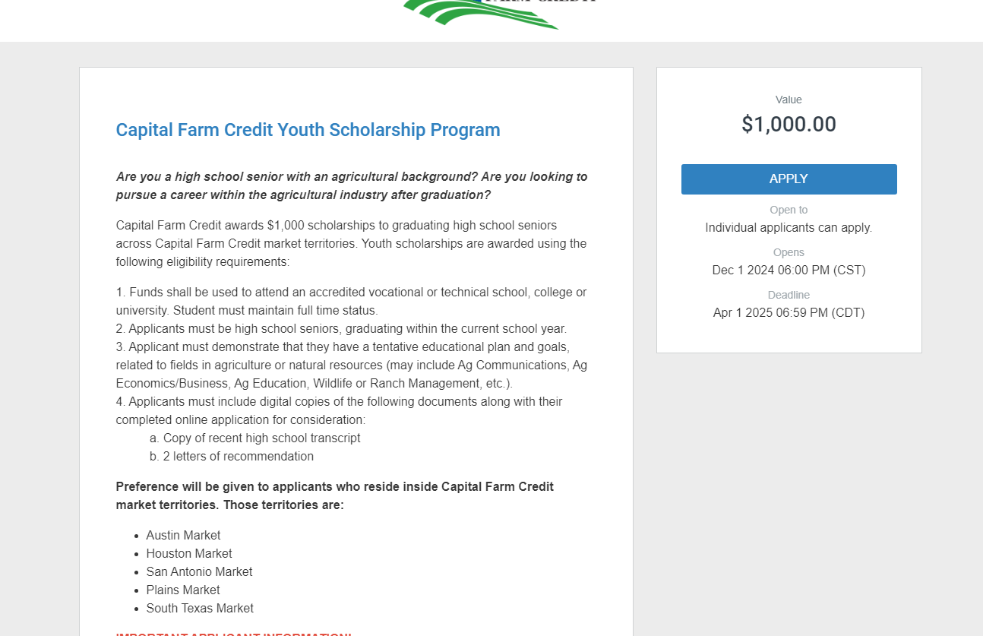

- Please make sure to Name your application with your FULL NAME and COUNTY in which you reside.
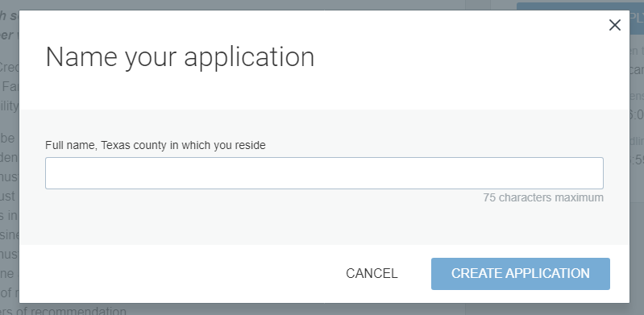
- Your application requirements will be listed under “Your Tasks”. All 3 Tasks must be fully completed to submit your application.
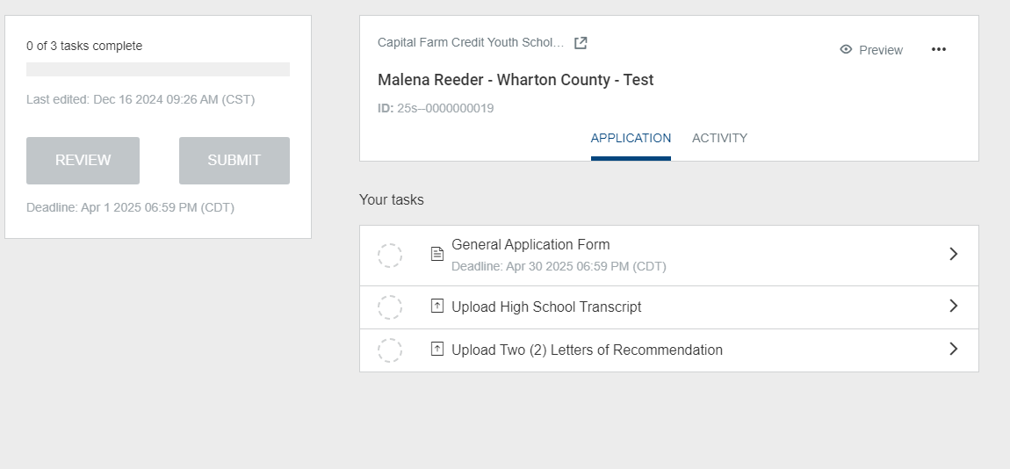

- Inside each task, there will be a “Save & Continue Editing” and “Mark as Complete” button. Please only mark as complete if you do not plan to make any further changes.

- Once all 3 tasks have been marked as “Complete”, you must still Submit your application. Once submitted, you should receive an email confirmation.
