Zones of Regulation

At Jackson Elementary this year, teachers are using the Zones of Regulation to help students manage their feelings! Here is some information about these zones.

The Zones are a cognitive behavioral approach to teach self-regulation skills through identifying feelings in four different colored zones. The Zones also provide framework to teach coping strategies to help students control their emotions. This then helps students move towards independent regulation of their feelings.

The Four Zones
Red Zone: Intense emotions such as anger, rage, and explosive behavior

Yellow Zone: Elevated emotions such as frustration, anxiety, excitement, silliness, or nervousness

Green Zone: Calm states such as happy, focused, content, and ready to learn

Blue Zone: Down feelings such as sad, tired, sick or board

Students are able to use these zones to name their feelings and then discuss and practice strategies (coping skills) to calm down, or get back into the green zone. Some examples of coping skills are drinking water, taking a deep breath, taking a walk, taking a break, stretching, coloring, reading, talking to an adult, squeezing a stress ball or anything else that helps to calm them down. You can practice these skills with your student(s) at home!

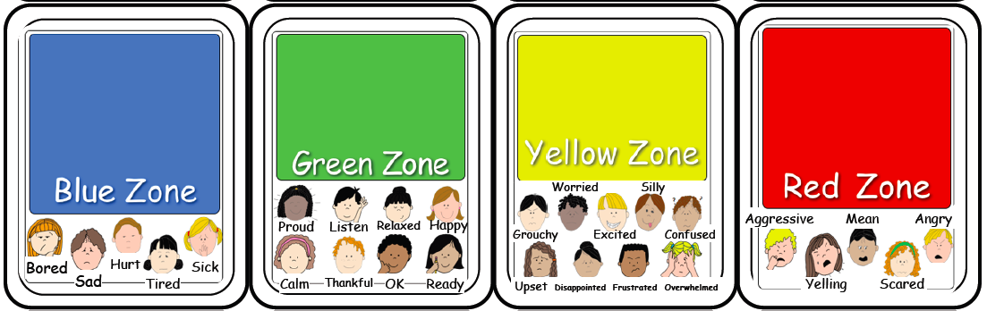

To find out more information, please visit: https://zonesofregulation.com/index.html

