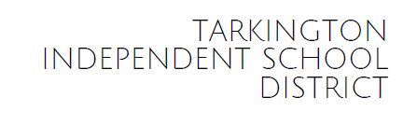

December 11, 2024

Dear Parent or Guardian:
Texas law now requires school districts to distribute information to parents and guardians about the safe storage of firearms. The attached information will help you learn about options for, as well as how to talk to your child and others about, the safe storage of firearms.
In 2021, 4,613 Texans experienced gun-related deaths. The Texas Department of State Health Services (SHS) reports that 55% of Texas firearms deaths in 2020 were suicides and that 59% of all suicides in Texas were by firearms. Suicide attempts involving firearms have a 90% fatality rate. Restricting access to guns is critical in reducing acts of violence, whether as self-harm or towards others. Acts of mass violence and interpersonal violence often end in suicide.
It is unlawful to store, transport, or abandon an unsecured firearm in a place where children are likely to be and can obtain access to the firearm. Under Texas Penal Code 46.13, a person commits the offense of making a firearm accessible to a child if the child gains access to a readily dischargeable firearm, and the person with criminal negligence:
- Failed to secure the firearm; or
- Left the firearm in a place to which the person knew or should have known the child would gain access
The penalty for allowing a child access to a firearm can range from a Class C misdemeanor (punishable by a $500 fine) to a Class A misdemeanor (punishable by a $4000 fine, a year in jail, or a combination of the two).
Texas exempts the purchase of firearm safety equipment from Texas Sales and Use Tax.
Remember, a gun should be stored unloaded in a safe or locked container, with ammunition stored elsewhere. You can learn more and find additional resources from the Texas Department of Public Safety at https://safegunstoragetexas.com.
Safe gun storage is critical to preventing suicide, unintentional shootings, and other tragedies.
Sincerely,
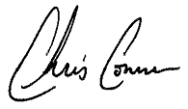
Chris Conner
Director of School and Student Services

