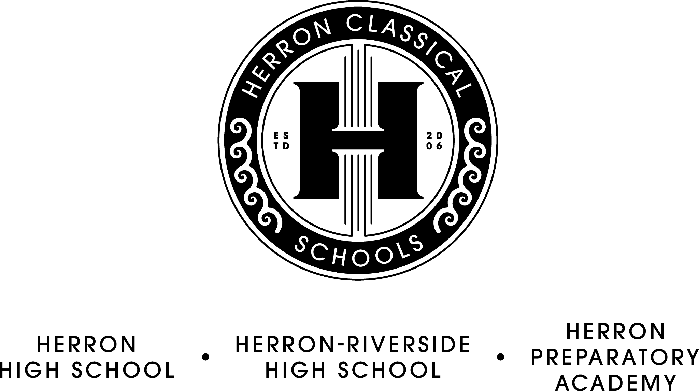

Herron Classical Schools Board Meeting Agenda
December 10, 2024, 7:30am
HCS Admin building 1715 N. Meridian

7:30 Board Meeting Agenda

1) Call meeting to order (Roy)

2) Carroll Bilbrey introduction

3) Approve minutes (Roy)

4) Treasurer’s report/Fiduciary Committee report (Miller)
- CapX report/strategic planning
- Financials
- Vouchers

5) Executive Committee report (Roy)
- Working Groups

6) Development Committee report (Sternberg)
- Fundraising update
- Campaign update

7) President’s Report (McNeal)
- Strategic opportunity
- Teacher recruitment event

Adjourn

The next board meeting will be on February 18, 7:30 AM.

