Agricultural Steering Committee Meeting
July 10, 2024
4:00 pm
Agenda
- Welcome
- LMG Update
- Pratt Circle Update
- State Budget Update
  - Letter to Delegation
  - Letter to Senator Peeler and Representative Moss
- Fundraising Committee
- May 17th Follow-Up and Next Steps
- Web Page (www.wycaa.org )
  - York Electric Article – July Magazine
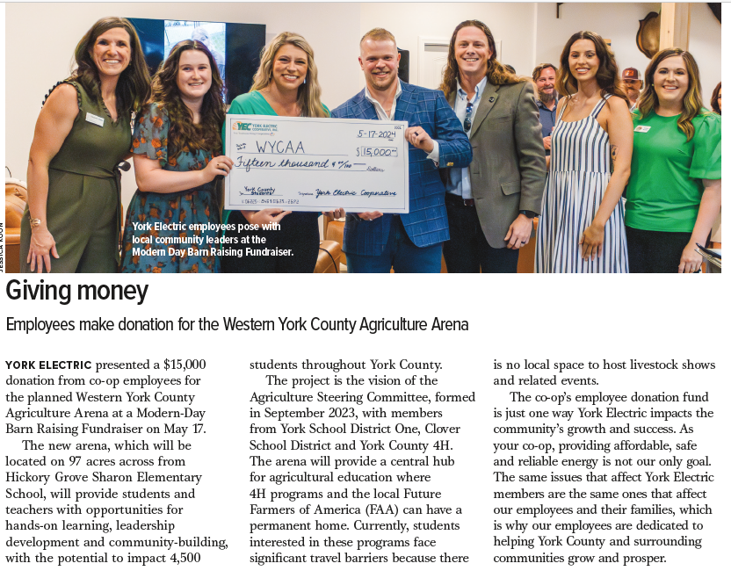
- Next Meeting
  - August 14th at 4:00 PM

